A-Level Computer Science NEA

**Maths Maze Navigator**

By Hasan Akhtar

23rd September 2022

**Contents**

1. Analysis
   1. Origin of the project (page 4)
   2. Background Research (page 6)
   3. Core Objectives (page 10)
   4. Advanced Objectives (page 12)
   5. End User Discussion (page 13)
   6. More on Prim’s algorithm (page 16)
   7. Recursive solving algorithm (page 18)
   8. Similar games and how they work (page 20)
2. Documented Design
   1. Overview (page 31)
   2. Player Class (page 60)
   3. Maze Objects (page 62)
   4. Information Objects (page 70)
   5. Starting objects (page 74)
   6. Other objects (page 80)
   7. Maths Quiz (page 82)
   8. Further updates to Main program (page 86)
   9. Sketches of the game (page 106)
3. Technical Solution
   1. Overview (page 115)
   2. Phase 1 (page 118)
   3. Phase 2 (page 129)
   4. Phase 3 (page 142)
   5. Phase 4 (page 148)
   6. Phase 5 (page 161)
   7. Phase 6 (page 178)
   8. Phase 7 (page 181)
   9. Analysis by Supervisor (page 190)
4. Testing
   1. Testing the Objectives (page 223)
   2. End-User Testing (page 228)
   3. Validation Testing (page 230)
5. Evaluation
   1. Evaluating objectives (page 232)
   2. Criticisms and Praises (page 239)
   3. Feedback (page 240)
6. References
   1. Image References (page 243)
   2. Code References (page 245)
   3. Other References (page 246)
7. Appendix
   1. Appendix A (page 248)
   2. Appendix B (page 263)
   3. Appendix C (page 291)
   4. Appendix D (page 334)
   5. Appendix E (page 341)

**Analysis**

Origin of the project

*Maze games are a very popular form of computer games and there have been many successful ones such as The Amazing Maze Game which is an arcade game developed by Midway, released in 1976, Ali Baba and 40 Thieves which is an arcade game released by Sega in 1982, Aardvark which is a video game for the Commodore 64, and Commodore 16 published by Bug-Byte in 1986, Bomberman which is a windows game released by Hudson Soft in 2003 and many, many more.*

*A link to a full list of maze games can be found* [*here*](https://en.wikipedia.org/wiki/List_of_maze_video_games)*:*

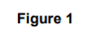

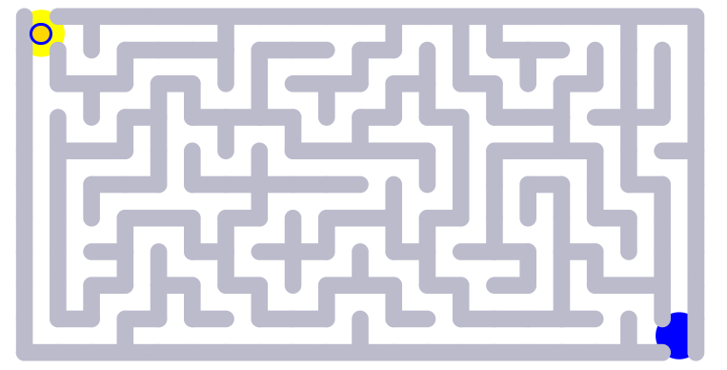

**Figure 1** - A maze game from [mathisfun.com](https://www.mathsisfun.com/games/mazes.html)

*I decided to put my own twist on the maze game and include A-level standard maths questions to grant a limited amount of moves depending on the difficulty of the question. I then had to choose topics for my questions and also the size of the mazes on each level etc. For this I asked my end-user who is a fellow A-level maths student Jacob. The interview can be seen below in the section labelled “End-user discussion” (page 13-15). I also needed to do background research on an algorithm to use for generating the maze with random paths that work (ensuring the user has at least one possible route from start to end of the maze). I ended up finding Prim’s algorithm for path finding and applying this to maze generation.*

Background Research

Prim’s algorithm was the algorithm I decided to use. Here is some more information on it.

Here is a link to a video on it: <https://youtu.be/EcwGyx1gIF0>

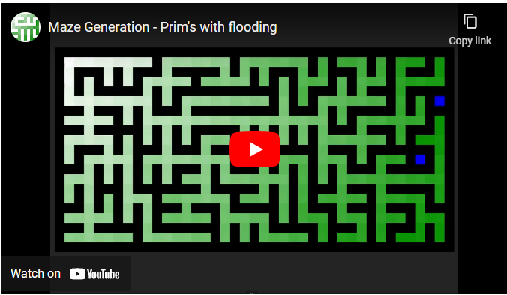

*Prim’s Maze Generator is a randomised version of Prim’s algorithm which is a method that produces a minimal spanning tree from an undirected weighted graph.*

*Prim’s algorithm creates a tree by getting the adjacent cells and finding the best one to travel to next. Generating mazes using Prim’s algorithm uses a random cell to travel to the next one. It also takes up storage proportional to the size of the maze. Here are the steps below (****Figure 2****):*

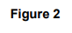

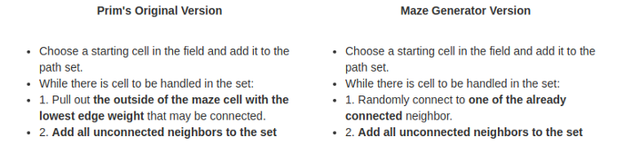

Here is a demonstration of Prim’s algorithm on a 3x3 graph from:

<https://weblog.jamisbuck.org/2011/1/10/maze-generation-prim-s-algorithm.html>

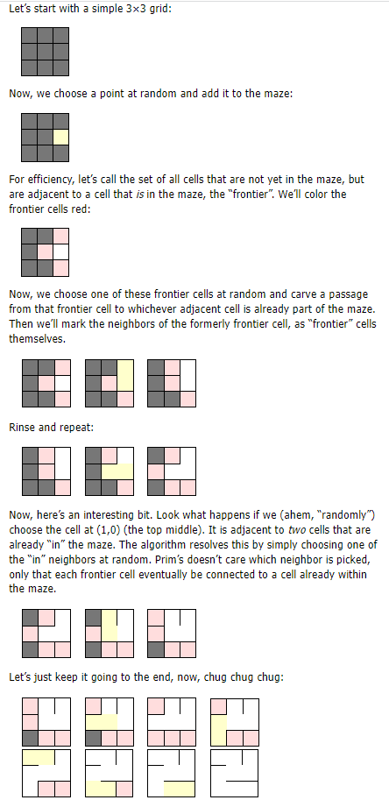













Below is an image of the tree that Prim’s algorithm creates (**Figure 3**)

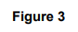

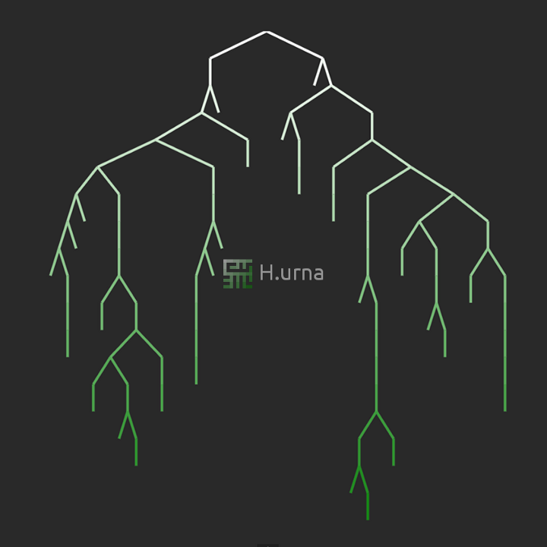

I also decided to use Merge sort to sort out the high scores in order.

*Merge sort is a linear sorting algorithm used to sort a list of integer values in descending or ascending order. It works by dividing the list until each item is in its own separate array. Then it combines items 2 at a time in order until the full array is merged together and it is in order.*

Below is an example of merge sort (**Figure 4**):

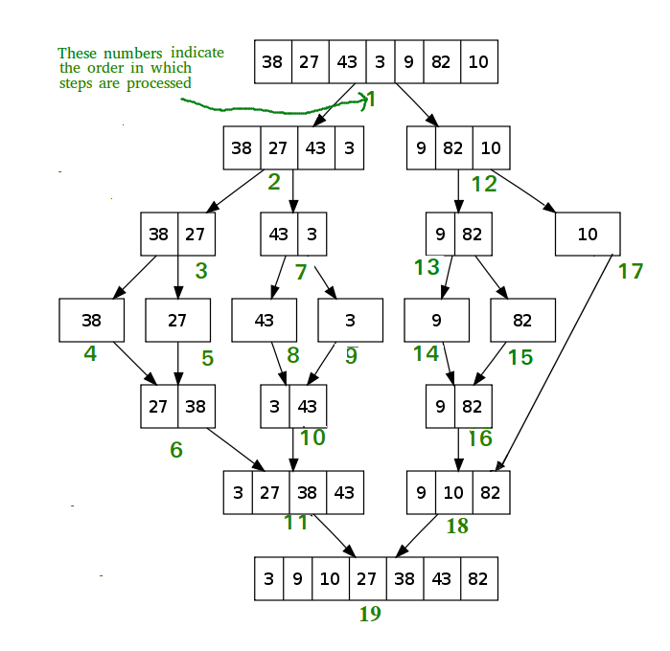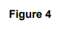

As you can see if the array is an odd number of items, the more items are taken into the first half of the array when it is divided into 2 arrays and it merges back in order.

Merge sort has its advantages. However there are disadvantages:

* Slower compared to the other sort algorithms for smaller tasks.
* The merge sort algorithm requires an additional memory space of O(n) for the temporary array.
* It goes through the whole process even if the array is sorted.

*A trace table of the merge sort algorithm below can be found in Appendix A1 [Page 248]*

Below is a pseudocode example of Merge sort:

array = [2,4,6,5,3,1,7]

SUBROUTINE sort(array):

IF array.length > 1 THEN

m ← (array.length+1) DIV 2

array1 ← array(0,m)

array2 ← array(m,m)

sort(array1)

sort(array2)

i ← 0

j ← 0

k ← 0

WHILE i < array1.length AND j < array2.length:

IF array1[i] <= array2[j] THEN

array[k] ← array1[i]

i ← i + 1

ELSE

array[k] ← array2[j]

j ← j + 1

ENDIF

k ← k + 1

ENDWHILE

WHILE i < array1.length:

array[k] ← array1[i]

i ← i + 1

k ← k + 1

ENDWHILE

WHILE j < array2.length:

array[k] ← array2[j]

j ← j + 1

k ← k + 1

ENDWHILE

RETURN array

ENDIF

ENDSUBROUTINE

OUTPUT sort(array)

Core Objectives

1. **An algorithm to generate the maze**
   1. This will be Prim’s algorithm for maze generation
   2. Other algorithms were considered but this was decided upon based on my coding skills and also its simplicity.
   3. It was also recommended by my end-user (interview on page 13-15).
2. **Maths questions that can be stored in an array**
   1. These will be based on the topics that the end-user gives (interview on page 13-15)
   2. These will be stored in a file then loaded into an array when the game runs
   3. This is an important aspect of the game as it adds creativity to the concept of the game and can also be used to improve a user’s maths skills
   4. It also makes the project unique as not many maze games incorporate the element of having maths questions that the user can answer.
3. **Ability to move character around using keyboard**
   1. This is a key idea as many of the best games use arrow keys to move around a character - without this the game wouldn’t be able to function
   2. Alternate key binds such as WASD could be added as well.
4. **Can select answers to maths questions**
   1. If the user wouldn’t be able to answer the maths questions then the game wouldn’t be able to function
   2. There will be a choice of 4 answers and each answer will have its own area on the screen that you can click.
5. **Interactive GUI**
   1. It is essential for the user to have a fun time while playing the game and a command-line interface wouldn’t suit this
   2. 2 possible graphic interface modules I could use are Pygame and Tkinter
   3. I will be using a combination of these 2 as it is easier to incorporate buttons on Tkinter but it is easier to generate a maze with a character that can traverse through it in Pygame.
6. **Scoring system**
   1. How this will be decided is a big decision in how the game will keep score
   2. Merge sort algorithm will be run on the array to sort out the high scores in descending order
   3. Score will be added based on questions answered correctly and also a bonus will be added on at the end based on how many moves were made - more points for less moves.
7. **File handling to store high scores**
   1. A file will be used to store the high scores of players who have beaten the game before
   2. The file will be opened in append mode and your score added to the document when you finish a level/beat the game
   3. Dictionaries will also be used to store the high scores in run time with them (dictionaries) allowing for an ability to sort the data.
8. **Limited number of moves**
   1. You will start of with up to 3 moves at the start of the game
   2. Moves will be used to move the player one block at a time
   3. The user will not be able to move if they have 0 moves left and a question will display thereafter for a chance to gain moves
   4. This is so the user cannot complete the maze without answering at least one maths question.
9. **Moves given after answering question correct**
   1. One move will be given if the question is not answered correctly and three moves will be given if the question is answered correctly.
10. **Set amount of lives**
    1. There will be a certain amount of lives based on the difficulty (of questions) selected by the user at the start of the game
    2. There will be 3 lives on easy, 5 on medium and 7 on hard
    3. Lives will be lost if the user crashes into a wall 5 times or answers a question wrong (as decided by end-user - interview on page 13-15)
    4. The game will end when the user loses all lives.
11. **Hints given with correct solution**
    1. The user will have an option to buy a hint
    2. This will then show them part of the correct solution to the maze
    3. Recursive solving will be used to find the correct path and store it in an array.
12. **Ability to save and load games**
    1. This will be useful as the user will then be able to close the game and pick back up from where they left off.
13. **Able to select difficulty of maths questions**
    1. This will be a menu choice at the start of the game and allow the user to choose how hard they want the maths questions to be
    2. If the user chooses harder questions, then more lives will be given.
14. **Background**
    1. This is the least important of the core objectives
    2. There is most likely a chance that there will be a background
    3. Having a background is necessary to appeal to the aesthetics of the project
    4. If there are multiple levels, each level will have a different background
    5. However, whether the background is moving or not will depend on time constraints.

Advanced Objectives

1. **Aesthetics of maze and player**
   1. The aesthetics of the maze and player will not matter as much until the concept of the game, maze generation, scoring system etc are considered and completed.
   2. The images used for the project will need to be small and will be decided depending on the theme of the overall game (decided by the end-user - interview on page 13-15).
2. **Background image**
   1. This will also depend on the theme of the overall game.
3. **Multiple levels increasing in difficulty**
   1. If there is time, multiple levels will be considered with the size of the maze increasing with difficulty of each level.
4. **Theme of levels**
   1. Each level could have its own slightly different theme.
5. **Personalised settings**
   1. These could be accessibility settings and other options which would allow the user to customise their game experience.
6. **Different game modes**
   1. There could be a time trial mode as well as a classic mode where instead of having a limited amount of moves, the user has a limited amount of time in which to complete the maze and answering questions correctly gives the user more time to complete the maze.
   2. This would be hard to implement though as “time.sleep()” would cause the whole program to stop.
   3. There could also be a mode that only focuses on answering questions (an arcade mode) and doesn’t give bonus points for completing the maze in a small amount of moves.

End User Discussion

For my end-user I selected a fellow A-level maths student called Jacob. He is quite good at maths and would be an excellent test subject for the maths side of things. I also selected my supervisor to be a fellow Computer Science student to assist me in making sure my game doesn’t have any game-breaking bugs and to help the functionality of the game be as smooth as possible. Below are the questions I asked Jacob about the program and the answers he gave.

**Q) What topics in A-level maths do you feel are the most important to appear in the game?**

A) I feel like logarithms, trigonometry and circles should come up in the hard section, graphs and transformations, differentiation and integration should come in the medium section. In the easy section should be binomial expansion, quadratics, vectors and algebra. There should also be a section for GCSE questions.

**Q) Do you prefer a game because of its graphics or the concept behind it?**

A) I believe that the concept of the game is more important as in a time constrained environment the graphics would not matter as much. However, the best games are the ones that have the best graphics but they are developed with large teams over long periods of time.

**Q) How big should the mazes be for each level?**

A) I think that the first maze should be 5 x 5, the second 7 x 7, the third 10 x 10, the fourth 12 x 12 and the last one 15 x 15.

**Q) Do you think Prim’s algorithm is a good algorithm to generate the paths of the maze?**

A) There are a few other algorithms you could have chosen such as Kruskal’s algorithm, Depth First Search and Recursive division. However I believe that Prim’s algorithm is the easiest to implement and generates a maze well enough.

**Q) What would you prefer to happen when you get a question correct e.g receive limited amount of moves, add time on to time limit etc?**

A) I would prefer for a limited amount of movies to be received when a question is answered correctly. Also 1 move could be received if a question is answered

incorrectly. Also, in a different game mode a time limit could be given and time could be added on but because of time constraints it may not be possible to add this mode.

**Q) What should happen when you get a question wrong e.g lose a life, go back moves etc?**

A) I believe that a life should be lost when a question is answered wrongly and also if the user hits a wall say 5 times. A limited amount of lives should be given depending on the difficulty. For a different game mode, maybe the user could be sent back a move or 3 moves, but given the time constraints this mode may not be a possibility.

**Q) Should you be able to undo moves and if so, how many?**

A) I think that moves should be able to be undone. This would be a key aspect of the game in making it unique and also adding functionality and appeal to the game. I think a maximum of 5 previous moves should be stored.

**Q) What should be the overall theme of the game?**

A) I believe that the theme of the game should be pirates. There are a few good maths games out there that are pirate themed such as Pirate Treasure Numicon Shape Count so I believe that this would be a good unique theme to have.

I also used an alternative end-user. Mr Ninson is a maths teacher at my school who teaches A-level maths and has a good idea about which topics should appear in the game. Below are some questions I asked him and the answers he gave.

**Q) Which topics do you feel are the weakest among A-level and GCSE maths students?**

A) I believe that these following topics should be included in the game:

* *Making mathematical proofs*
* *Sketching gradient functions*
* *Solving problems involving areas between curves and lines*
* *Understanding implicit differentiation and using it to solve modelling problems*
* *Understanding the varying methods of integration*
* *Recurrence relations and modelling with series*
* *Vectors in 3D problems*

**Q) Would you recommend this game to students to help them with their revision?**

A) Any game that supports students learning in these topics is always a good and useful learning tool.

**Q) Do you think Prim’s algorithm is a good algorithm to generate the paths of the maze?**

A) I believe that is an efficient way of generating a maze and could be put to good use

*SUMMARY:*

So, overall from these interviews, I can say that my objectives are mostly unchanged as the end-users mostly agreed with my ideas (final objectives found in Appendix A2 & A3 [Page 249-251]).

Some things that were decided by the end-users in the interviews include:

* There will be 5 categories for the questions (examples of questions found in Appendix A4 [Page 252]):

1. Easy which will include binomial expansion, quadratics, vectors and algebra
2. Medium will include graphs and transformations, differentiation and integration
3. Hard will include logarithms, trigonometry and circles
4. GCSE will include angles and right-angled triangles, graphs, sine and cosine rules, proportion, probability and more
5. Ninson’s specials will include mathematical proofs, problems involving areas between curves and lines, implicit differentiation, integration and vectors in 3D problems

* If there are multiple levels, the first maze will be 5 x 5, the second 7 x 7, the third 10 x 10, the fourth 12 x 12 and the last one 15 x 15
* Prim’s algorithm will be used as it was recommended by the end-users
* 3-5 moves will be received (depending on difficulty) when the user answers a question correctly and 1 move when the user answers a question incorrectly
* A life will be lost when the user answers a question incorrectly and when the user crashes into a wall
* The user will be able to ‘undo’ a maximum of 5 moves
* The overall theme (i.e. character and backgrounds) of the game will be pirates with different levels being set at different places in an imaginary pirate world

More on Prim’s Algorithm

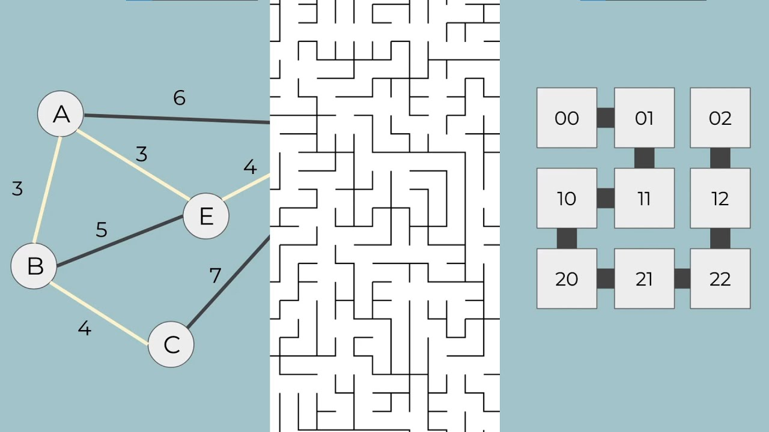

*Normally Prim’s algorithm is used to create a minimum spanning tree for path finding algorithms where a weighted graph is given and the shortest/least expensive path is the path wanting to be found. For example from this graph (****Figure 5****), the shortest path from 1 to any other node can be found using Prim’s algorithm (trace table for this in Appendix A5 [Page 260]).*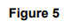

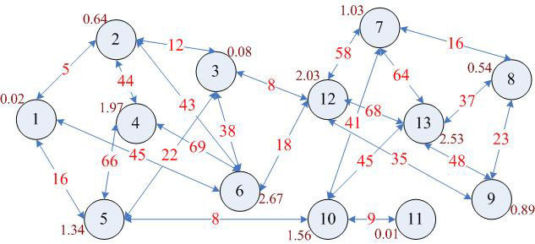

On the next page (**Figure 6**) can be seen a flow diagram of how Prim’s algorithm works.

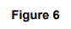

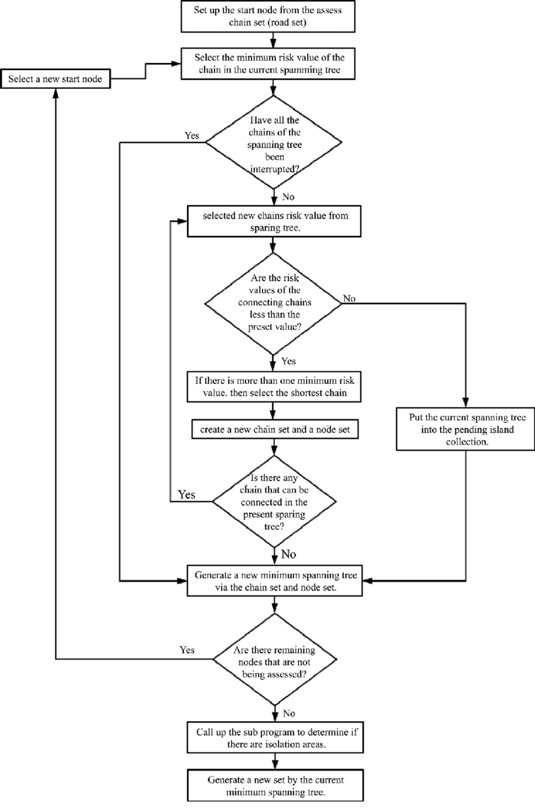

Recursive solving algorithm

*Recursive solving is where a starting X and Y value are given. If the starting X and Y values aren’t a wall, then the method will call itself using adjacent X and Y values.*

*It will make sure that it hasn’t repeated any values and if it reaches the end X and Y values, then it will save the path in a correct path array. Below is a pseudo code representation of this algorithm (more info on this in Appendix A6 [Page 262]):*

maze ← []

wasHere ← []

correctPath ← []

startX ← 0

startY ← 0

height ← 10

width ← 10

endX ← width-1

endY ← height-1

FUNCTION solveMaze(maze):

Maze ← generateMaze(maze)

FOR row = 0 TO width

FOR col = 0 TO height

wasHere[row][col] ← FALSE

correctPath[row][col] ← FALSE

ENDFOR

ENDFOR

b ← recursiveSolve(row, col)

RETURN b

ENDFUNCTION

SUBROUTINE recursiveSolve(x,y):

IF x = endX and y = endY THEN

RETURN TRUE

ENDIF

IF maze[x][y] = wasHere[x][y] THEN

RETURN FALSE

ENDIF

wasHere[x][y] ← TRUE

IF x <> 0 THEN

IF (recursiveSolve(x-1, y)) THEN

correctPath[x][y] ← TRUE

RETURN TRUE

ENDIF

ENDIF

IF x <> width - 1 THEN

IF (recursiveSolve(x+1, y)) THEN

correctPath[x][y] ← TRUE

RETURN TRUE

ENDIF

ENDIF

IF y <> 0 THEN

IF (recursiveSolve(x, y-1)) THEN

correctPath[x][y] ← TRUE

RETURN TRUE

ENDIF

ENDIF

IF y <> height - 1 THEN

IF (recursiveSolve(x, y+1)) THEN

correctPath[x][y] ← TRUE

RETURN TRUE

ENDIF

ENDIF

RETURN FALSE

ENDSUBROUTINE

OUTPUT solveMaze(maze)

Similar games and how they work

For this section I decided to find a maths game in python and also a maze game in python and analyse them. The link to the maths game is below:

<https://www.w3resource.com/python-exercises/math/python-math-exercise-63.php>

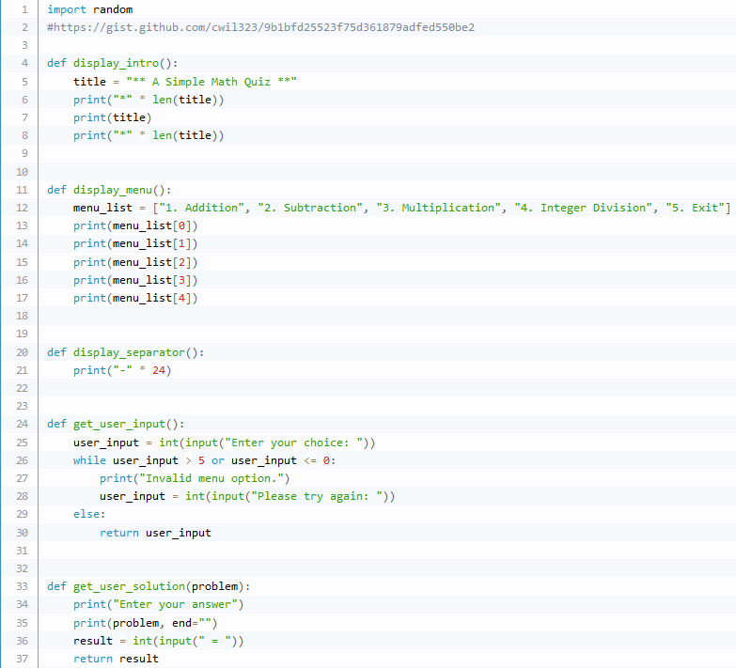

*Line 1 imports the random library to be used later on in the program*

*Line 4 sets up the ‘display_intro’ function*

*Line 5 sets the title*

*Lines 6-8 print the title with asterisks above and below it*

*Line 11 sets up the ‘display_menu’ function*

*Line 12 sets the menu list*

*Lines 13-17 prints the menu list line by line*

*Line 20 sets up the ‘display_separator’ function*

*Line 21 prints a ‘-’ 24 times*

*Line 24 sets up the ‘get_user_input’ function*

*Line 25 takes an integer input from the user and stores it as ‘user_input’*

*Line 26 sets up a WHILE loop to check for invalid menu choice options*

*Line 27 and 28 print out ann error message and take another user input*

*Line 29 and 30 are executed if the while loop conditions aren’t met and returns the user input to the main program*

*Line 33 sets up the ‘get_user_solution’ function with a parameter of ‘problem’*

*Line 34 is a print statement*

*Line 35 prints ‘problem’ with an empty string at end*

*Line 36 takes ‘result’ as an integer input from the user*

*Line 37 returns ‘result’*

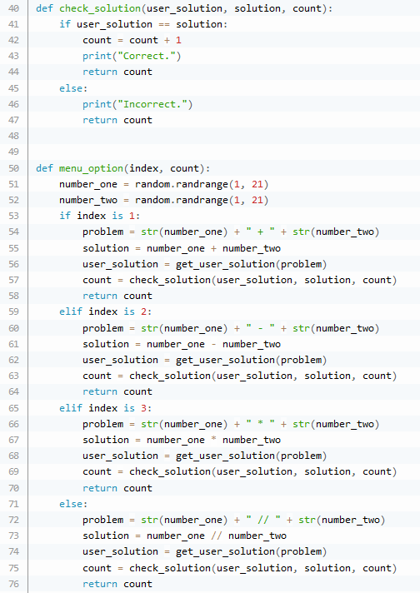

*Line 40 sets up the ‘check_solution’ method with 3 parameters*

*Line 41 - 44 is a IF statement which checks if the user solution matches the actual solution and if it does, increments the score by 1, returns it and prints ‘Correct’*

*Line 45-47 is ELSE following the IF statement and returns count and prints ‘Incorrect’*

*Line 50 sets up the ‘menu_option’ function with 2 parameters*

*Line 51 and 52 generate 2 random numbers between 1 & 21 and store them as number1 and number2*

*Line 53 sets up a series of IF statements for the ‘index number’*

*Line 54 sets the problem as a string of ‘number 1 + number2’*

*Line 55 gets the solution of ‘number1 + number2’*

*Line 56 calls the ‘get_user_solution’ function and stores the output as ‘user_solution’*

*Line 57 calls the ‘check_solution’ function and stores the output as ‘count’*

*Line 58 returns count to the main function of the program*

*Line 59 sets up the first ELIF statement for the ‘index number’ being 2*

*Line 60 sets the problem as a string of ‘number 1 - number2’*

*Line 61 gets the solution of ‘number1 - number2’*

*Line 62 calls the ‘get_user_solution’ function and stores the output as ‘user_solution’*

*Line 63 calls the ‘check_solution’ function and stores the output as ‘count’*

*Line 64 returns count to the main function of the program*

*Line 65 sets up the second ELIF statement for the ‘index number’ being 3*

*Line 66 sets the problem as a string of ‘number 1 * number2’*

*Line 67 gets the solution of ‘number1 * number2’*

*Line 68 calls the ‘get_user_solution’ function and stores the output as ‘user_solution’*

*Line 69 calls the ‘check_solution’ function and stores the output as ‘count’*

*Line 70 returns count to the main function of the program*

*Line 71 sets up the ELSE statement for the ‘index number’*

*Line 72 sets the problem as a string of ‘number 1 // number2’*

*Line 73 gets the solution of ‘number1 // number2’*

*Line 74 calls the ‘get_user_solution’ function and stores the output as ‘user_solution’*

*Line 75 calls the ‘check_solution’ function and stores the output as ‘count’*

*Line 76 returns count to the main function of the program*

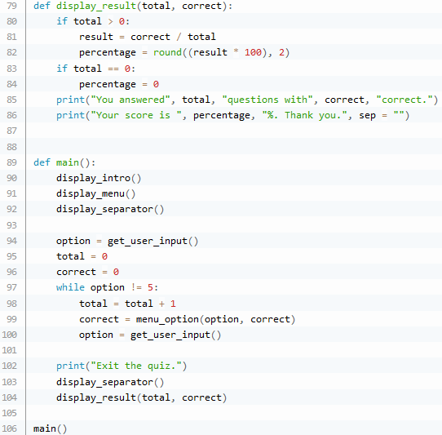

*Line 79 sets up the ‘display_result’ function with 2 parameters*

*Lines 80-82 is an IF statement for if the total is more than 0 and calculates ‘result’ as a percentage rounded to 2 decimal places*

*Lines 83-84 is an IF statement for if the total is 0 and sets ‘percentage’ to 0*

*Line 85 and 86 print the score and total*

*Line 89 sets up the ‘main’ function*

*Lines 90-92 call the ‘display_intro’, ‘display_menu’ and ‘display_separator’ functions*

*Line 94 calls the ‘get_user_input’ function and stores the output as ‘option’*

*Lines 95-96 set ‘total’ and ‘correct’ to 0*

*Line 97 creates a WHILE loop when the option isn’t 5*

*Line 98 increments ‘total’ by 1*

*Line 99 calls the ‘menu_option’ function and stores the output as ‘correct’*

*Line 100 calls the ‘get_user_input’ function and stores the output as ‘option’*

*Line 102 is a print statement to signify the end of the quiz*

*Lines 103-104 call the ‘display_separator’ and ‘display_result’ functions*

*Line 106 calls the ‘main’ function*

This is a screenshot of me playing this maths game.

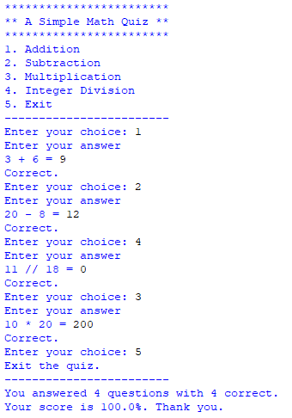

Below are some flow charts of the game (**Figure 7.1, 7.2, 7.3, 7.4**)

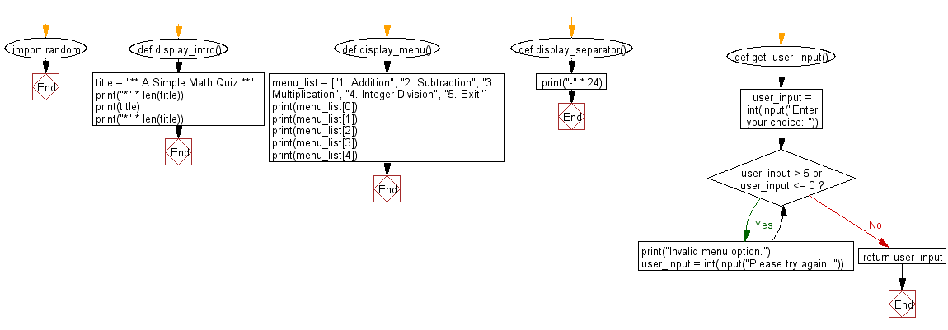

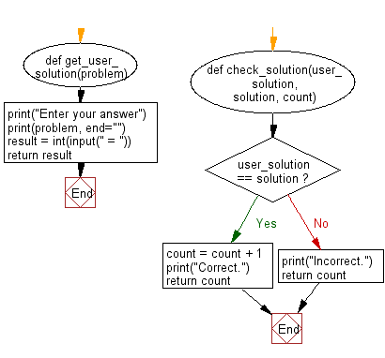

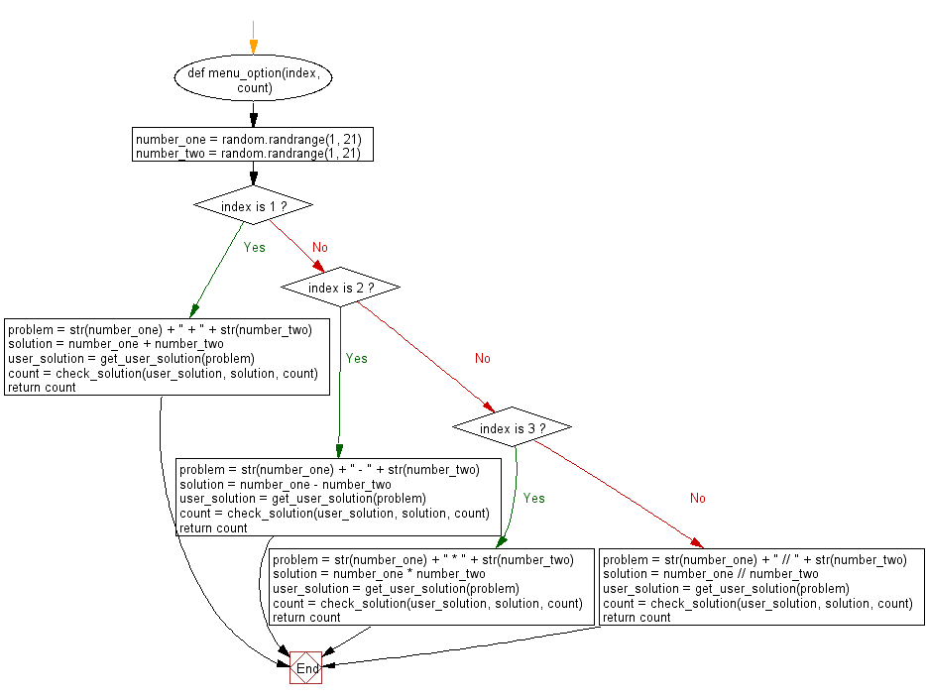



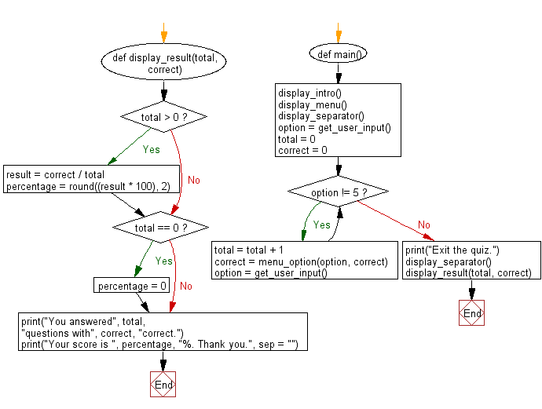

I also found a maze game in python. The link to this is below:

<https://pythonspot.com/maze-in-pygame/>

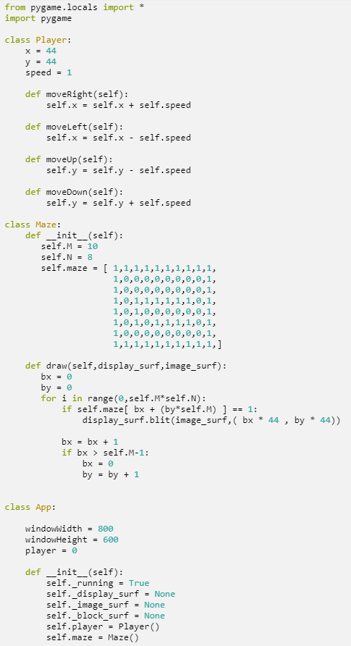

*Lines 1-2 import pygame and other necessary libraries*

*Line 4 sets up the ‘Player’ class*

*Lines 5-7 set up the attributes of the class*

*Lines 9-10 sets up the ‘moveRight’ method which increments the ‘x’ attribute by the ‘speed’ attribute*

*Lines 12-13 sets up the ‘moveLeft’ method which decrements the ‘x’ attribute by the ‘speed’ attribute*

*Lines 15-16 sets up the ‘moveUp’ method which decrements the ‘y’ attribute by the ‘speed’ attribute*

*Lines 18-19 sets up the ‘moveDown’ method which increments the ‘y’ attribute by the ‘speed’ attribute*



*Line 21 sets up the ‘Maze’ class*

*Line 22 is the constructor method of the class*

*Lines 23-32 set up the attributes of the class including an array for the maze*

*Line 34 sets up the ‘draw’ method of the class with 2 parameters*

*Lines 35-36 set the variables bx and by to 0*

*Lines 37-45 traverse through the maze array and blit the walls of the maze if the index in maze is 1*

*Line 48 sets up the ‘App’ class*

*Line 50-52 set up the ‘windowWidth’, ‘windowHeight’ and ‘player’ variables*

*Line 54 is the constructor method*

*Lines 55-60 set up the attributes for the class*

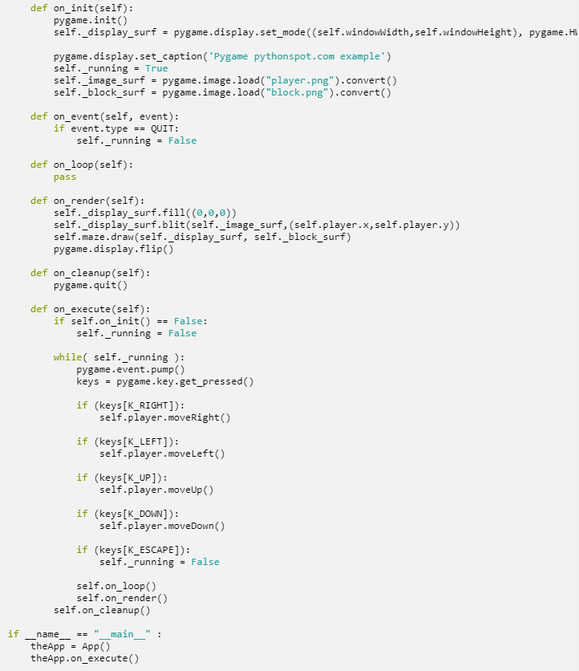

*Line 62 sets up the ‘on_init’ method of the class*

*Line 63 initiates pygame*

*Line 64 sets the window with dimensions as previously initialised variables and hardware accelerated in fullscreen mode (cannot be maximised/minimised) and overrides the attribute ‘display_surf’*

*Line 66 sets the title of the pygame window*

*Line 67 sets the ‘running’ attribute to True which is used for the game loop*

*Lines 68-69 load the images for the blocks and player and store them as attributes*

*Line 71 sets up the ‘on_event’ method of the class which takes 1 parameter*

*Lines 72-73 is an IF statement which checks if the user has pressed ‘QUIT’ and if it has been pressed then sets the ‘running’ attribute to False*

*Lines 75-76 sets up the ‘on_loop’ method of the class and does a pass*

*Line 78 sets up the ‘on_render’ method of the class*

*Line 79 fills the ‘display_surf’ with black*

*Line 80 blits the player onto the ‘display_surf’*

*Line 81 calls the ‘draw’ method of the ‘Maze’ class with 2 arguments*

*Line 82 updates the display*

*Lines 84-85 sets up the ‘on_cleanup’ method which quits pygame*

*Line 87 sets up the ‘on_execute’ method*

*Lines 88-89 uses an IF statement to check if ‘on_init’ is False and if it is breaks the game loop by setting the ‘running’ attribute to False*

*Lines 91 - 102 is the game loop which allows the player to move when an arrow key is pressed in that direction or if the ‘ESC’ key is pressed sets ‘running’ to False*

*Lines 103 - 105 call the ‘on_loop’, ‘on_render’ and ‘on_cleanup’ methods of the class*

*Line 107 is an IF statement that checks if ‘__name__’ is equal to ‘__main__’*

*Line 108 creates an instance of the ‘App’ class*

*Line 109 calls the ‘on_execute’ method of the ‘App’ class*

Here is a screenshot of me playing the game:

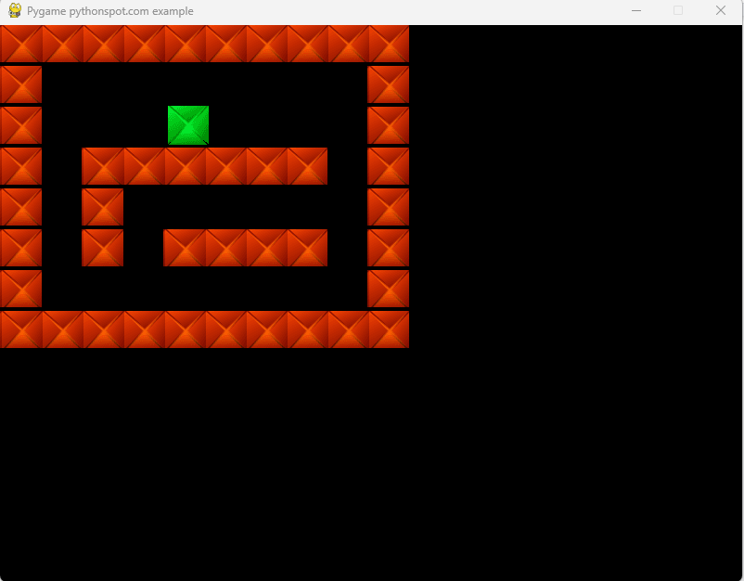

**Documented Design**

Overview

This section will show a few diagrams showing the structure of my program.

The program’s core objectives will be fulfilled using the following features:

* Start Menu (where user can select a few options including controls, instructions, quit game and also play game)
* Main game (where Score, Moves Left, Lives Left and Time Playing displayed)
* Maths Questions (where question from chosen file displayed when Moves Left are 0)
* Save game and Load game (pulls up a new screen)
* Undo moves (only if the user crashes into a wall and gets reset)
* Win screen and Lose screen (shown depending if user loses all lives or reaches end of maze)
* High scores system (User can enter in name for high score - top 10 scores shown)
* Hints system (where user will be shown correct path in exchange for points deducted off the final score)

Below is a diagram of the structure of the programs and subprograms:

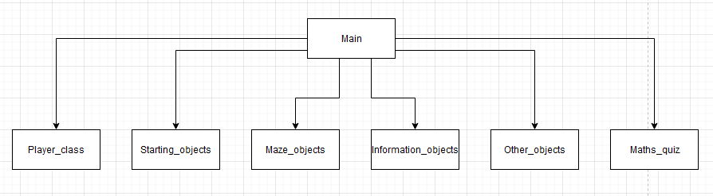

Next, shown below is a class diagram of the Main program with all the attributes and methods:

A more clear version of this image can be found in my google drive

<https://drive.google.com/file/d/1tyy97dUy4hphDkmBmRAynzaBFp51_fpN/view>

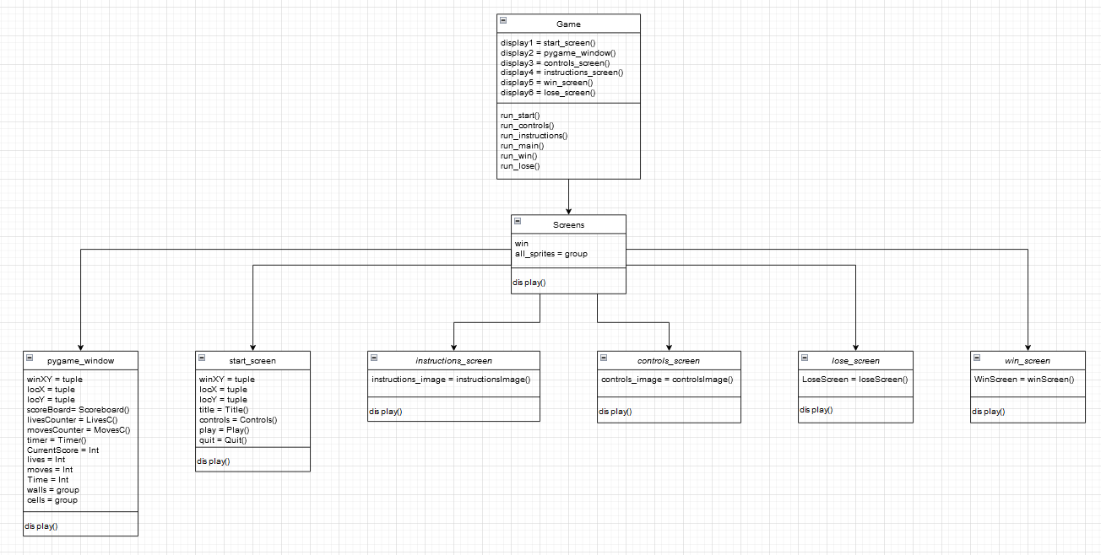

Next, shown below is diagram of the subroutine/class method calls in the program:

A more clear version of this image can be found in my google drive

<https://drive.google.com/file/d/1FalLM1YocDPUfGDF47Tkg9wT-6f4ApHW/view?usp=sharing>

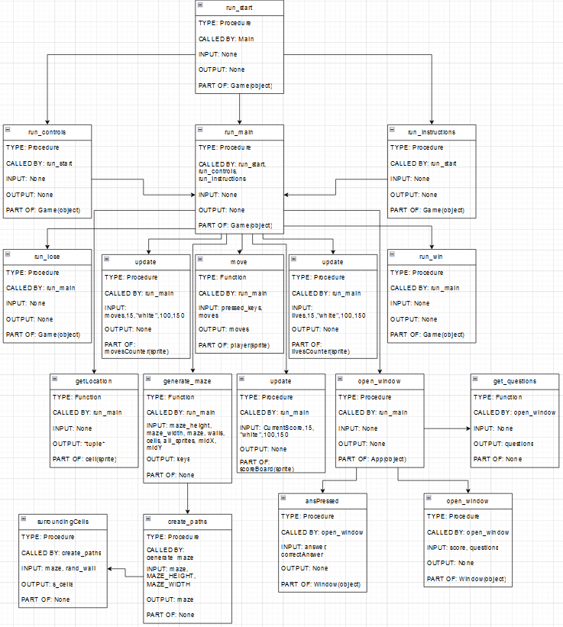

Next shown below is a Data Flow Diagram (DFD) of the whole game system

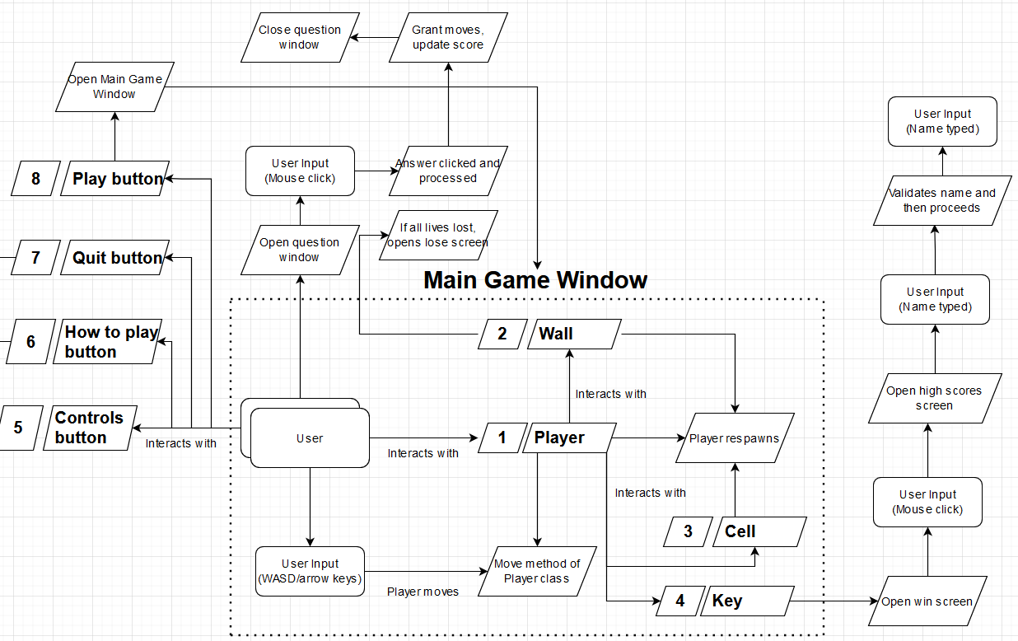

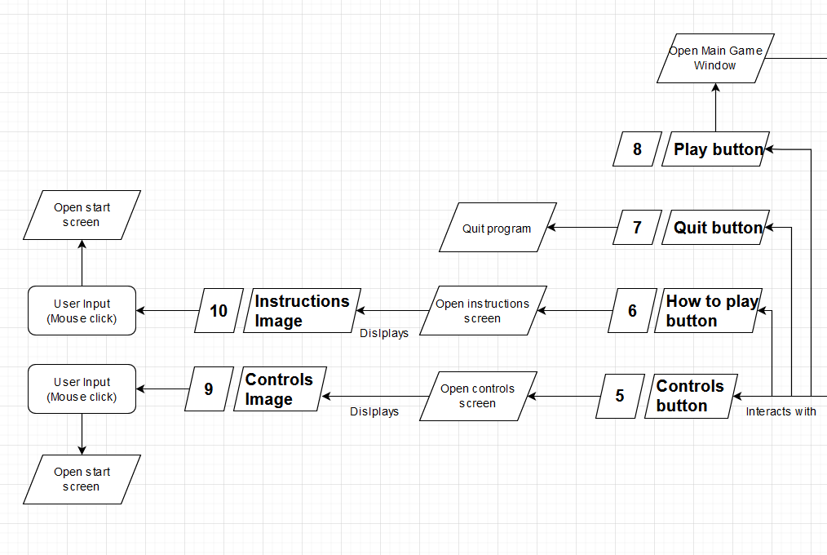

Next shown below is a table of all the variables in the program and information about them

| **Variable** | **Type** | **Data Type** | **Class/Method** | **Program** |
| --- | --- | --- | --- | --- |
| savedMaze | Attribute | Array | GameSave (Constructor) | GameSave_class |
| CurrentScore | Attribute | Integer | GameSave (Constructor) | GameSave_class |
| lives | Attribute | Integer | GameSave (Constructor) | GameSave_class |
| moves | Attribute | Integer | GameSave (Constructor) | GameSave_class |
| Time | Attribute | Integer | GameSave (Constructor) | GameSave_class |
| X | Attribute | Float | GameSave (calcPlayerPos) | GameSave_class |
| Y | Attribute | Float | GameSave (calcPlayerPos) | GameSave_class |
| coords | Attribute | Tuple (Integers) | GameSave (calcPlayerPos) | GameSave_class |
| fileLines | Attribute | Array | GameSave (loadMaze) | GameSave_class |
| maze | Attribute | Array | GameSave (loadMaze) | GameSave_class |
| playerPos | Attribute | Tuple (Integers) | GameSave (loadMaze) | GameSave_class |
| scores | Attribute | Array | HighScores (Constructor) | HighScores_class |
| nameDict | Attribute | Dictionary | HighScores (Constructor) | HighScores_class |
| line | Attribute | Array | HighScores (get_scores) | HighScores_class |
| m | Attribute | Integer | HighScores (sort_scores) | HighScores_class |
| scores1 | Attribute | Array | HighScores (sort_scores) | HighScores_class |
| scores2 | Attribute | Array | HighScores (sort_scores) | HighScores_class |
| i | Attribute | Integer | HighScores (sort_scores) | HighScores_class |
| j | Attribute | Integer | HighScores (sort_scores) | HighScores_class |
| k | Attribute | Integer | HighScores (sort_scores) | HighScores_class |
| sorted_names | Attribute | Array | HighScores  (sortNames) | HighScores_class |
| last | Attribute | Integer | HighScores (check_score) | HighScores_class |
| names | Attribute | Array | HighScores (check_score) | HighScores_class |
| lastName | Attribute | String | HighScores (check_score) | HighScores_class |
| name | Attribute | String | HighScores (saveScore) | HighScores_class |
| score | Attribute | Integer | HighScores (saveScore) | HighScores_class |
| text | Attribute | String | HighScores (saveScore) | HighScores_class |
| score | Variable | Integer | N/A | HighScores_test |
| high_scores | Variable | Class | N/A | HighScores_test |
| fileIn | Variable | File | N/A | HighScores_test |
| scores | Variable | Array | N/A | HighScores_test |
| intScores | Variable | Array | N/A | HighScores_test |
| name | Variable | String | N/A | HighScores_test |
| sortedNames | Variable | Array | N/A | HighScores_test |
| fileOut | Variable | File | N/A | HighScores_test |
| CurrentScore | Attribute | Integer | Scoreboard (Constructor) | Information_objects |
| score | Attribute | String | Scoreboard (Constructor) | Information_objects |
| font | Attribute | Font | Scoreboard (Constructor) | Information_objects |
| textSurf | Attribute | Text Surface | Scoreboard (Constructor) | Information_objects |
| surf | Attribute | Sprite Surface | Scoreboard (Constructor) | Information_objects |
| rect | Attribute | Sprite Rectangle | Scoreboard (Constructor) | Information_objects |
| W | Attribute | Integer | Scoreboard (Constructor) | Information_objects |
| H | Attribute | Integer | Scoreboard (Constructor) | Information_objects |
| score | Attribute | String | Scoreboard (update) | Information_objects |
| font | Attribute | Font | Scoreboard (update) | Information_objects |
| textSurf | Attribute | Text Surface | Scoreboard (update) | Information_objects |
| surf | Attribute | Sprite Surface | Scoreboard (update) | Information_objects |
| W | Attribute | Integer | Scoreboard (update) | Information_objects |
| H | Attribute | Integer | Scoreboard (update) | Information_objects |
| Lives | Attribute | Integer | LivesC (Constructor) | Information_objects |
| lives | Attribute | String | LivesC (Constructor) | Information_objects |
| font | Attribute | Font | LivesC (Constructor) | Information_objects |
| textSurf | Attribute | Text Surface | LivesC (Constructor) | Information_objects |
| surf | Attribute | Sprite Surface | LivesC (Constructor) | Information_objects |
| rect | Attribute | Sprite Rectangle | LivesC (Constructor) | Information_objects |
| W | Attribute | Integer | LivesC (Constructor) | Information_objects |
| H | Attribute | Integer | LivesC (Constructor) | Information_objects |
| Lives | Attribute | Integer | LivesC (update) | Information_objects |
| lives | Attribute | String | LivesC (update) | Information_objects |
| font | Attribute | Font | LivesC (update) | Information_objects |
| textSurf | Attribute | Text Surface | LivesC (update) | Information_objects |
| surf | Attribute | Sprite Surface | LivesC (update) | Information_objects |
| W | Attribute | Integer | LivesC (update) | Information_objects |
| H | Attribute | Integer | LivesC (update) | Information_objects |
| lives | Attribute | String | LivesC (set) | Information_objects |
| font | Attribute | Font | LivesC (set) | Information_objects |
| textSurf | Attribute | Text Surface | LivesC (set) | Information_objects |
| surf | Attribute | Sprite Surface | LivesC (set) | Information_objects |
| W | Attribute | Integer | LivesC (set) | Information_objects |
| H | Attribute | Integer | LivesC (set) | Information_objects |
| Moves | Attribute | Integer | MovesC (Constructor) | Information_objects |
| moves | Attribute | String | MovesC (Constructor) | Information_objects |
| font | Attribute | Font | MovesC (Constructor) | Information_objects |
| textSurf | Attribute | Text Surface | MovesC (Constructor) | Information_objects |
| surf | Attribute | Sprite Surface | MovesC (Constructor) | Information_objects |
| rect | Attribute | Sprite Rectangle | MovesC (Constructor) | Information_objects |
| W | Attribute | Integer | MovesC (Constructor) | Information_objects |
| H | Attribute | Integer | MovesC (Constructor) | Information_objects |
| moves | Attribute | String | MovesC (update) | Information_objects |
| font | Attribute | Font | MovesC (update) | Information_objects |
| textSurf | Attribute | Text Surface | MovesC (update) | Information_objects |
| surf | Attribute | Sprite Surface | MovesC (update) | Information_objects |
| W | Attribute | Integer | MovesC (update) | Information_objects |
| H | Attribute | Integer | MovesC (update) | Information_objects |
| Time | Attribute | Integer | Timer (Constructor) | Information_objects |
| time | Attribute | String | Timer (Constructor) | Information_objects |
| font | Attribute | Font | Timer (Constructor) | Information_objects |
| textSurf | Attribute | Text Surface | Timer (Constructor) | Information_objects |
| surf | Attribute | Sprite Surface | Timer (Constructor) | Information_objects |
| rect | Attribute | Sprite Rectangle | Timer (Constructor) | Information_objects |
| W | Attribute | Integer | Timer (Constructor) | Information_objects |
| H | Attribute | Integer | Timer (Constructor) | Information_objects |
| moves | Attribute | String | Timer (update) | Information_objects |
| font | Attribute | Font | Timer (update) | Information_objects |
| textSurf | Attribute | Text Surface | Timer (update) | Information_objects |
| surf | Attribute | Sprite Surface | Timer (update) | Information_objects |
| W | Attribute | Integer | Timer (update) | Information_objects |
| H | Attribute | Integer | Timer (update) | Information_objects |
| surf | Attribute | Sprite Surface | SaveButton (Constructor) | Information_objects |
| rect | Attribute | Sprite Rectangle | SaveButton (Constructor) | Information_objects |
| image | Attribute | Sprite image | SaveButton  (Constructor) | Information_objects |
| surf | Attribute | Sprite Surface | LoadButton (Constructor) | Information_objects |
| rect | Attribute | Sprite Rectangle | LoadButton (Constructor) | Information_objects |
| image | Attribute | Sprite image | LoadButton  (Constructor) | Information_objects |
| surf | Attribute | Sprite Surface | UndoButton (Constructor) | Information_objects |
| rect | Attribute | Sprite Rectangle | UndoButton (Constructor) | Information_objects |
| image | Attribute | Sprite image | UndoButton  (Constructor) | Information_objects |
| questions | Variable | Array | get_questions | Maths_quiz |
| file | Variable | File | get_questions | Maths_quiz |
| newLine | Variable | Array | get_questions | Maths_quiz |
| label1 | Attribute | Tkinter Label | Results (Constructor) | Maths_quiz |
| thisText | Attribute | String | Results (Constructor) | Maths_quiz |
| label2 | Attribute | Tkinter Label | Results (Constructor) | Maths_quiz |
| question | Attribute | Array | Window (Constructor) | Maths_quiz |
| thisQuestion | Attribute | String | Window (Constructor) | Maths_quiz |
| answer1 | Attribute | String | Window (Constructor) | Maths_quiz |
| answer2 | Attribute | String | Window (Constructor) | Maths_quiz |
| answer3 | Attribute | String | Window (Constructor) | Maths_quiz |
| answer4 | Attribute | String | Window (Constructor) | Maths_quiz |
| correctAnswer | Attribute | Array | Window (Constructor) | Maths_quiz |
| Score | Attribute | String Var | Window (Constructor) | Maths_quiz |
| movesLeft | Attribute | Integer | Window (Constructor) | Maths_quiz |
| currentScore | Attribute | Integer | Window (Constructor) | Maths_quiz |
| label1 | Attribute | Tkinter Label | Window (Constructor) | Maths_quiz |
| number1 | Attribute | Tkinter Button | Window (Constructor) | Maths_quiz |
| number2 | Attribute | Tkinter Button | Window (Constructor) | Maths_quiz |
| number3 | Attribute | Tkinter Button | Window (Constructor) | Maths_quiz |
| number4 | Attribute | Tkinter Button | Window (Constructor) | Maths_quiz |
| scoreBox | Attribute | Tkinter Entry | Window (Constructor) | Maths_quiz |
| label2 | Attribute | Tkinter Label | Window (Constructor) | Maths_quiz |
| window | Attribute | Class | Window (open_window) | Maths_quiz |
| results | Attribute | Class | Window (open_window) | Maths_quiz |
| label1 | Attribute | Tkinter Label | App (Constructor) | Maths_quiz |
| calls | Attribute | Integer | App (open_window) | Maths_quiz |
| questions | Attribute | Array | App (open_window) | Maths_quiz |
| window | Attribute | Class | App (open_window) | Maths_quiz |
| score | Variable | Integer | N/A | Maths_quiz |
| calls | Variable | Integer | N/A | Maths_quiz |
| app | Variable | Class | N/A | Maths_quiz |
| surf | Attribute | Sprite Surface | Wall (Constructor) | Maze_objects |
| rect | Attribute | Sprite Rectangle | Wall (Constructor) | Maze_objects |
| surf | Attribute | Sprite Surface | Cell (Constructor) | Maze_objects |
| location | Attribute | Tuple (Integers) | Cell (Constructor) | Maze_objects |
| rect | Attribute | Sprite Rectangle | Cell (Constructor) | Maze_objects |
| surf | Attribute | Sprite Surface | Empty (Constructor) | Maze_objects |
| rect | Attribute | Sprite Rectangle | Empty (Constructor) | Maze_objects |
| surf | Attribute | Sprite Surface | Key (Constructor) | Maze_objects |
| image | Attribute | Sprite image | Key  (Constructor) | Maze_objects |
| rect | Attribute | Sprite Rectangle | Key (Constructor) | Maze_objects |
| surf | Attribute | Sprite Surface | controlsImage (Constructor) | Other_objects |
| image | Attribute | Sprite image | controlsImage  (Constructor) | Other_objects |
| rect | Attribute | Sprite Rectangle | controlsImage (Constructor) | Other_objects |
| surf | Attribute | Sprite Surface | instructionsImage (Constructor) | Other_objects |
| image | Attribute | Sprite image | instructionsImage  (Constructor) | Other_objects |
| rect | Attribute | Sprite Rectangle | instructionsImage (Constructor) | Other_objects |
| surf | Attribute | Sprite Surface | winScreen (Constructor) | Other_objects |
| image | Attribute | Sprite image | winScreen  (Constructor) | Other_objects |
| rect | Attribute | Sprite Rectangle | winScreen (Constructor) | Other_objects |
| surf | Attribute | Sprite Surface | loseScreen (Constructor) | Other_objects |
| image | Attribute | Sprite image | loseScreen  (Constructor) | Other_objects |
| rect | Attribute | Sprite Rectangle | loseScreen (Constructor) | Other_objects |
| surf | Attribute | Sprite Surface | SS_image (Constructor) | Other_objects |
| image | Attribute | Sprite image | SS_image  (Constructor) | Other_objects |
| rect | Attribute | Sprite Rectangle | SS_image (Constructor) | Other_objects |
| surf | Attribute | Sprite Surface | LS_image (Constructor) | Other_objects |
| image | Attribute | Sprite image | LS_image  (Constructor) | Other_objects |
| rect | Attribute | Sprite Rectangle | LS_image (Constructor) | Other_objects |
| surf | Attribute | Sprite Surface | Player (Constructor) | Player_class |
| location | Attribute | Tuple (Integers) | Player (Constructor) | Player_class |
| rect | Attribute | Sprite Rectangle | Player (Constructor) | Player_class |
| moves | Attribute | Integer | Player (move) | Player_class |
| movesLeft | Attribute | Integer | Player (move) | Player_class |
| font | Attribute | Font | Text1 (Constructor) | QS_objects |
| textSurf | Attribute | Text Surface | Text1 (Constructor) | QS_objects |
| surf | Attribute | Sprite Surface | Text1 (Constructor) | QS_objects |
| rect | Attribute | Sprite Rectangle | Text1 (Constructor) | QS_objects |
| W | Attribute | Integer | Text1 (Constructor) | QS_objects |
| H | Attribute | Integer | Text1 (Constructor) | QS_objects |
| font | Attribute | Font | Button1 (Constructor) | QS_objects |
| textSurf | Attribute | Text Surface | Button1 (Constructor) | QS_objects |
| surf | Attribute | Sprite Surface | Button1 (Constructor) | QS_objects |
| rect | Attribute | Sprite Rectangle | Button1 (Constructor) | QS_objects |
| W | Attribute | Integer | Button1 (Constructor) | QS_objects |
| H | Attribute | Integer | Button1 (Constructor) | QS_objects |
| font | Attribute | Font | Button2  (Constructor) | QS_objects |
| textSurf | Attribute | Text Surface | Button2 (Constructor) | QS_objects |
| surf | Attribute | Sprite Surface | Button2 (Constructor) | QS_objects |
| rect | Attribute | Sprite Rectangle | Button2 (Constructor) | QS_objects |
| W | Attribute | Integer | Button2 (Constructor) | QS_objects |
| H | Attribute | Integer | Button2 (Constructor) | QS_objects |
| font | Attribute | Font | Button3 (Constructor) | QS_objects |
| textSurf | Attribute | Text Surface | Button3 (Constructor) | QS_objects |
| surf | Attribute | Sprite Surface | Button3 (Constructor) | QS_objects |
| rect | Attribute | Sprite Rectangle | Button3 (Constructor) | QS_objects |
| W | Attribute | Integer | Button3 (Constructor) | QS_objects |
| H | Attribute | Integer | Button3 (Constructor) | QS_objects |
| font | Attribute | Font | Button4 (Constructor) | QS_objects |
| textSurf | Attribute | Text Surface | Button4 (Constructor) | QS_objects |
| surf | Attribute | Sprite Surface | Button4 (Constructor) | QS_objects |
| rect | Attribute | Sprite Rectangle | Button4 (Constructor) | QS_objects |
| W | Attribute | Integer | Button4 (Constructor) | QS_objects |
| H | Attribute | Integer | Button4 (Constructor) | QS_objects |
| font | Attribute | Font | Button5 (Constructor) | QS_objects |
| textSurf | Attribute | Text Surface | Button5 (Constructor) | QS_objects |
| surf | Attribute | Sprite Surface | Button5 (Constructor) | QS_objects |
| rect | Attribute | Sprite Rectangle | Button5 (Constructor) | QS_objects |
| W | Attribute | Integer | Button5 (Constructor) | QS_objects |
| H | Attribute | Integer | Button5 (Constructor) | QS_objects |
| font | Attribute | Font | Title  (Constructor) | Starting_objects |
| textSurf | Attribute | Text Surface | Title (Constructor) | Starting_objects |
| surf | Attribute | Sprite Surface | Title (Constructor) | Starting_objects |
| rect | Attribute | Sprite Rectangle | Title (Constructor) | Starting_objects |
| W | Attribute | Integer | Title (Constructor) | Starting_objects |
| H | Attribute | Integer | Title (Constructor) | Starting_objects |
| font | Attribute | Font | Controls  (Constructor) | Starting_objects |
| textSurf | Attribute | Text Surface | Controls (Constructor) | Starting_objects |
| surf | Attribute | Sprite Surface | Controls (Constructor) | Starting_objects |
| rect | Attribute | Sprite Rectangle | Controls (Constructor) | Starting_objects |
| W | Attribute | Integer | Controls (Constructor) | Starting_objects |
| H | Attribute | Integer | Controls (Constructor) | Starting_objects |
| font | Attribute | Font | Play  (Constructor) | Starting_objects |
| textSurf | Attribute | Text Surface | Play (Constructor) | Starting_objects |
| surf | Attribute | Sprite Surface | Play (Constructor) | Starting_objects |
| rect | Attribute | Sprite Rectangle | Play (Constructor) | Starting_objects |
| W | Attribute | Integer | Play (Constructor) | Starting_objects |
| H | Attribute | Integer | Play (Constructor) | Starting_objects |
| font | Attribute | Font | Instructions  (Constructor) | Starting_objects |
| textSurf | Attribute | Text Surface | Instructions (Constructor) | Starting_objects |
| surf | Attribute | Sprite Surface | Instructions (Constructor) | Starting_objects |
| rect | Attribute | Sprite Rectangle | Instructions (Constructor) | Starting_objects |
| W | Attribute | Integer | Instructions (Constructor) | Starting_objects |
| H | Attribute | Integer | Instructions (Constructor) | Starting_objects |
| font | Attribute | Font | Quit  (Constructor) | Starting_objects |
| textSurf | Attribute | Text Surface | Quit (Constructor) | Starting_objects |
| surf | Attribute | Sprite Surface | Quit (Constructor) | Starting_objects |
| rect | Attribute | Sprite Rectangle | Quit (Constructor) | Starting_objects |
| W | Attribute | Integer | Quit (Constructor) | Starting_objects |
| H | Attribute | Integer | Quit (Constructor) | Starting_objects |
| MAZE_HEIGHT | Constant | Integer | N/A | Main |
| MAZE_WIDTH | Constant | Integer | N/A | Main |
| MAZE_CONSTANT | Constant | Integer | N/A | Main |
| maze | Variable | Array | N/A | Main |
| win | Attribute | Pygame Display | screens (Constructor) | Main |
| winXY | Attribute | Integer | screens (Constructor) | Main |
| all_sprites | Attribute | Sprite group | screens (Constructor) | Main |
| questions | Variable | Array | get_questions | Main |
| newLine | Variable | Array | get_questions | Main |
| s_cells | Variable | Integer | surroundingCells | Main |
| starting_height | Variable | Integer | surroundingCells | Main |
| starting_width | Variable | Integer | surroundingCells | Main |
| wallCoords | Variable | Array | surroundingCells | Main |
| rand_wall | Variable | Tuple (Integers) | surroundingCells | Main |
| visited | Variable | Array | generate_maze | Main |
| visitedRow | Variable | Array | generate_maze | Main |
| mazeRow | Variable | Array | generate_maze | Main |
| X | Variable | Integer | generate_maze | Main |
| Y | Variable | Integer | generate_maze | Main |
| wall | Variable | Pygame Sprite | generate_maze | Main |
| cell | Variable | Pygame Sprite | generate_maze | Main |
| empty | Variable | Pygame Sprite | generate_maze | Main |
| keys | Variable | Sprite group | generate_maze | Main |
| key | Variable | Pygame Sprite | generate_maze | Main |
| question | Attribute | Array | QuestionWindow (Constructor) | Main |
| thisQuestion | Attribute | String | QuestionWindow (Constructor) | Main |
| answer1 | Attribute | String | QuestionWindow (Constructor) | Main |
| answer2 | Attribute | String | QuestionWindow (Constructor) | Main |
| answer3 | Attribute | String | QuestionWindow (Constructor) | Main |
| answer4 | Attribute | String | QuestionWindow (Constructor) | Main |
| correctAnswer | Attribute | Array | QuestionWindow (Constructor) | Main |
| Score | Attribute | String Var | QuestionWindow (Constructor) | Main |
| movesLeft | Attribute | Integer | QuestionWindow (Constructor) | Main |
| score | Attribute | Integer | QuestionWindow (Constructor) | Main |
| status | Attribute | String | QuestionWindow (Constructor) | Main |
| label1 | Attribute | Tkinter Label | QuestionWindow (Constructor) | Main |
| number1 | Attribute | Tkinter Button | QuestionWindow (Constructor) | Main |
| number2 | Attribute | Tkinter Button | QuestionWindow (Constructor) | Main |
| number3 | Attribute | Tkinter Button | QuestionWindow (Constructor) | Main |
| number4 | Attribute | Tkinter Button | QuestionWindow (Constructor) | Main |
| scoreBox | Attribute | Tkinter Entry | QuestionWindow (Constructor) | Main |
| label2 | Attribute | Tkinter Label | QuestionWindow (Constructor) | Main |
| currentScore | Attribute | Integer | QuestionWindow (return_info) | Main |
| winX | Attribute | Integer | QuestionSelect_screen  (Constructor) | Main |
| winY | Attribute | Integer | QuestionSelect_screen  (Constructor) | Main |
| midX | Attribute | Integer | QuestionSelect_screen  (Constructor) | Main |
| midY | Attribute | Integer | QuestionSelect_screen  (Constructor) | Main |
| locX1 | Attribute | Integer | QuestionSelect_screen  (Constructor) | Main |
| locY1 | Attribute | Integer | QuestionSelect_screen  (Constructor) | Main |
| locY2 | Attribute | Integer | QuestionSelect_screen  (Constructor) | Main |
| locY3 | Attribute | Integer | QuestionSelect_screen  (Constructor) | Main |
| locY4 | Attribute | Integer | QuestionSelect_screen  (Constructor) | Main |
| locY5 | Attribute | Integer | QuestionSelect_screen  (Constructor) | Main |
| locY6 | Attribute | Integer | QuestionSelect_screen  (Constructor) | Main |
| SyQD | Attribute | Class | QuestionSelect_screen  (Constructor) | Main |
| GCSE | Attribute | Integer | QuestionSelect_screen  (Constructor) | Main |
| Easy | Attribute | Integer | QuestionSelect_screen  (Constructor) | Main |
| Medium | Attribute | Integer | QuestionSelect_screen  (Constructor) | Main |
| Hard | Attribute | Integer | QuestionSelect_screen  (Constructor) | Main |
| NS | Attribute | Integer | QuestionSelect_screen  (Constructor) | Main |
| loc1 | Attribute | Integer | QuestionSelect_screen  (display) | Main |
| loc2 | Attribute | Integer | QuestionSelect_screen  (display) | Main |
| loc3 | Attribute | Integer | QuestionSelect_screen  (display) | Main |
| loc4 | Attribute | Integer | QuestionSelect_screen  (display) | Main |
| loc5 | Attribute | Integer | QuestionSelect_screen  (display) | Main |
| loc6 | Attribute | Integer | QuestionSelect_screen  (display) | Main |
| loc7 | Attribute | Integer | QuestionSelect_screen  (display) | Main |
| loc8 | Attribute | Integer | QuestionSelect_screen  (display) | Main |
| loc9 | Attribute | Integer | QuestionSelect_screen  (display) | Main |
| loc10 | Attribute | Integer | QuestionSelect_screen  (display) | Main |
| loc11 | Attribute | Integer | QuestionSelect_screen  (display) | Main |
| loc12 | Attribute | Integer | QuestionSelect_screen  (display) | Main |
| run | Attribute | Boolean | QuestionSelect_screen  (display) | Main |
| mouse | Attribute | Tuple (Integers) | QuestionSelect_screen  (display) | Main |
| qs_diff | Attribute | String | QuestionSelect_screen  (display) | Main |
| high_scores | Attribute | Class | high_scores _ screen2  (Constructor) | Main |
| scoreValid | Attribute | Boolean | high_scores _ screen2  (Constructor) | Main |
| fileIn | Attribute | File | high_scores _ screen2  (Constructor) | Main |
| sortedNames | Attribute | Array | high_scores _ screen2  (Constructor) | Main |
| fileOut | Attribute | File | high_scores _ screen2  (Constructor) | Main |
| label1 | Attribute | Tkinter Label | high_scores _ screen2  (Constructor) | Main |
| textBox | Attribute | Tkinter Textbox | high_scores _ screen2  (Constructor) | Main |
| nameScore | Attribute | Tuple (Strings) | high_scores _ screen2  (Constructor) | Main |
| name | Attribute | String | high_scores _ screen2  (Constructor) | Main |
| score | Attribute | Floating Point (Real) | high_scores _ screen2  (Constructor) | Main |
| text | Attribute | String | high_scores _ screen2  (Constructor) | Main |
| text1 | Attribute | String | high_scores _ screen2  (displayInfo) | Main |
| text2 | Attribute | String | high_scores _ screen2  (displayInfo) | Main |
| text3 | Attribute | String | high_scores _ screen2  (displayInfo) | Main |
| text4 | Attribute | String | high_scores _ screen2  (displayInfo) | Main |
| text | Attribute | String | high_scores _ screen1  (Constructor) | Main |
| label1 | Attribute | Tkinter Label | high_scores _ screen1  (Constructor) | Main |
| label2 | Attribute | Tkinter Label | high_scores _ screen1  (Constructor) | Main |
| entry1 | Attribute | Tkinter Entry | high_scores _ screen1  (Constructor) | Main |
| textBox | Attribute | Tkinter Textbox | high_scores _ screen1  (Constructor) | Main |
| name | Attribute | String | high_scores _ screen1  (open_window) | Main |
| text | Attribute | String | high_scores _ screen1  (open_window) | Main |
| hss2 | Attribute | Class | high_scores _ screen1  (open_window) | Main |
| SaveScreen | Attribute | Class | save_screen  (Constructor) | Main |
| gameSave | Attribute | Class | save_screen  (Constructor) | Main |
| file | Attribute | File | save_screen  (save) | Main |
| savedMaze | Attribute | Array | load_screen (Constructor) | Main |
| CurrentScore | Attribute | Integer | load_screen (Constructor) | Main |
| lives | Attribute | Integer | load_screen (Constructor) | Main |
| moves | Attribute | Integer | load_screen (Constructor) | Main |
| Time | Attribute | Integer | load_screen (Constructor) | Main |
| playerPos | Attribute | Tuple (Integers) | load_screen (Constructor) | Main |
| midX | Attribute | Integer | load_screen (Constructor) | Main |
| midY | Attribute | Integer | load_screen (Constructor) | Main |
| LoadScreen | Attribute | Class | load_screen (Constructor) | Main |
| all_sprites | Attribute | Sprite group | load_screen (loadMaze) | Main |
| walls | Attribute | Sprite group | load_screen (loadMaze) | Main |
| cells | Attribute | Sprite group | load_screen (loadMaze) | Main |
| X | Attribute | Integer | load_screen (loadMaze) | Main |
| Y | Attribute | Integer | load_screen (loadMaze) | Main |
| wall | Attribute | Class | load_screen (loadMaze) | Main |
| cell | Attribute | Class | load_screen (loadMaze) | Main |
| empty | Attribute | Class | load_screen (loadMaze) | Main |
| new_sprites | Attribute | Sprite group | load_screen (loadGame) | Main |
| pixelX | Attribute | Integer | load_screen (loadGame) | Main |
| pixelY | Attribute | Integer | load_screen (loadGame) | Main |
| player | Attribute | Class | load_screen (loadGame) | Main |
| locX1 | Attribute | Integer | load_screen (loadGame) | Main |
| locX2 | Attribute | Integer | load_screen (loadGame) | Main |
| locX3 | Attribute | Integer | load_screen (loadGame) | Main |
| locX4 | Attribute | Integer | load_screen (loadGame) | Main |
| locY | Attribute | Integer | load_screen (loadGame) | Main |
| scoreBoard | Attribute | Class | load_screen (loadGame) | Main |
| livesCounter | Attribute | Class | load_screen (loadGame) | Main |
| movesCounter | Attribute | Class | load_screen (loadGame) | Main |
| timer | Attribute | Class | load_screen (loadGame) | Main |
| WinScreen | Attribute | Class | win_screen (Constructor) | Main |
| LoseScreen | Attribute | Class | lose_screen (Constructor) | Main |
| controls_image | Attribute | Class | controls_screen(Constructor) | Main |
| instructions_image | Attribute | Class | instructions_screen (Constructor) | Main |
| winX | Attribute | Integer | start_screen (Constructor) | Main |
| winY | Attribute | Integer | start_screen (Constructor) | Main |
| midX | Attribute | Integer | start_screen (Constructor) | Main |
| midY | Attribute | Integer | start_screen (Constructor) | Main |
| locX1 | Attribute | Integer | start_screen (Constructor) | Main |
| locX2 | Attribute | Integer | start_screen (Constructor) | Main |
| locX3 | Attribute | Integer | start_screen (Constructor) | Main |
| locX4 | Attribute | Integer | start_screen (Constructor) | Main |
| locX5 | Attribute | Integer | start_screen (Constructor) | Main |
| locY1 | Attribute | Integer | start_screen (Constructor) | Main |
| locY2 | Attribute | Integer | start_screen (Constructor) | Main |
| title | Attribute | Class | start_screen (Constructor) | Main |
| controls | Attribute | Class | start_screen (Constructor) | Main |
| play | Attribute | Class | start_screen (Constructor) | Main |
| instructions | Attribute | Class | start_screen (Constructor) | Main |
| quit | Attribute | Class | start_screen (Constructor) | Main |
| loc1 | Attribute | Integer | start_screen (display) | Main |
| loc2 | Attribute | Integer | start_screen (display) | Main |
| loc3 | Attribute | Integer | start_screen (display) | Main |
| loc4 | Attribute | Integer | start_screen (display) | Main |
| loc5 | Attribute | Integer | start_screen (display) | Main |
| loc6 | Attribute | Integer | start_screen (display) | Main |
| loc7 | Attribute | Integer | start_screen (display) | Main |
| loc8 | Attribute | Integer | start_screen (display) | Main |
| loc9 | Attribute | Integer | start_screen (display) | Main |
| loc0 | Attribute | Integer | start_screen (display) | Main |
| mouse | Attribute | Tuple (Integers) | start_screen (display) | Main |
| maze_height | Attribute | Integer | pygame_window (Constructor) | Main |
| maze_width | Attribute | Integer | pygame_window (Constructor) | Main |
| maze | Attribute | Array | pygame_window (Constructor) | Main |
| winX | Attribute | Integer | pygame_window (Constructor) | Main |
| winY | Attribute | Integer | pygame_window (Constructor) | Main |
| midX | Attribute | Integer | pygame_window (Constructor) | Main |
| midY | Attribute | Integer | pygame_window (Constructor) | Main |
| locX1 | Attribute | Integer | pygame_window (Constructor) | Main |
| locX2 | Attribute | Integer | pygame_window (Constructor) | Main |
| locX3 | Attribute | Integer | pygame_window (Constructor) | Main |
| locX4 | Attribute | Integer | pygame_window (Constructor) | Main |
| locY | Attribute | Integer | pygame_window (Constructor) | Main |
| locY1 | Attribute | Integer | pygame_window (Constructor) | Main |
| locY2 | Attribute | Integer | pygame_window (Constructor) | Main |
| sWidth | Attribute | Integer | pygame_window (Constructor) | Main |
| sHeight | Attribute | Integer | pygame_window (Constructor) | Main |
| player | Attribute | Class | pygame_window (Constructor) | Main |
| scoreBoard | Attribute | Class | pygame_window (Constructor) | Main |
| livesCounter | Attribute | Class | pygame_window (Constructor) | Main |
| movesCounter | Attribute | Class | pygame_window (Constructor) | Main |
| timer | Attribute | Class | pygame_window (Constructor) | Main |
| saveButton | Attribute | Class | pygame_window (Constructor) | Main |
| loadButton | Attribute | Class | pygame_window (Constructor) | Main |
| undoButton | Attribute | Class | pygame_window (Constructor) | Main |
| hintButton | Attribute | Class | pygame_window (Constructor) | Main |
| CurrentScore | Attribute | Integer | pygame_window (Constructor) | Main |
| lives | Attribute | Integer | pygame_window (Constructor) | Main |
| moves | Attribute | Integer | pygame_window (Constructor) | Main |
| movesLeft | Attribute | Integer | pygame_window (Constructor) | Main |
| Time | Attribute | Integer | pygame_window (Constructor) | Main |
| coords | Attribute | Tuple (Integers) | pygame_window (Constructor) | Main |
| file | Attribute | File | pygame_window (Constructor) | Main |
| gameSave | Attribute | Class | pygame_window (Constructor) | Main |
| movesQueue | Attribute | Array | pygame_window (Constructor) | Main |
| walls | Attribute | Sprite Group | pygame_window (Constructor) | Main |
| cells | Attribute | Sprite Group | pygame_window (Constructor) | Main |
| keys | Attribute | Sprite Group | pygame_window (display) | Main |
| visited | Attribute | Array | pygame_window (display) | Main |
| maze | Attribute | Array | pygame_window (display) | Main |
| loc1 | Attribute | Integer | pygame_window (display) | Main |
| loc2 | Attribute | Integer | pygame_window (display) | Main |
| loc3 | Attribute | Integer | pygame_window (display) | Main |
| loc4 | Attribute | Integer | pygame_window (display) | Main |
| loc5 | Attribute | Integer | pygame_window (display) | Main |
| loc6 | Attribute | Integer | pygame_window (display) | Main |
| loc7 | Attribute | Integer | pygame_window (display) | Main |
| loc8 | Attribute | Integer | pygame_window (display) | Main |
| loc9 | Attribute | Integer | pygame_window (display) | Main |
| loc10 | Attribute | Integer | pygame_window (display) | Main |
| score | Attribute | Integer | pygame_window (display) | Main |
| question | Attribute | Array | pygame_window (display) | Main |
| calls | Attribute | Integer | pygame_window (display) | Main |
| crashes | Attribute | Integer | pygame_window (display) | Main |
| devMode | Attribute | Boolean | pygame_window (display) | Main |
| moveUndone | Attribute | Boolean | pygame_window (display) | Main |
| hintRevealed | Attribute | Boolean | pygame_window (display) | Main |
| SS | Attribute | Class | pygame_window (display) | Main |
| LS | Attribute | Class | pygame_window (display) | Main |
| pressed_keys | Attribute | String | pygame_window (display) | Main |
| mouse | Attribute | Tuple (Integers) | pygame_window (display) | Main |
| hint | Attribute | Tuple (Integers) | pygame_window (display) | Main |
| hintX | Attribute | Integer | pygame_window (display) | Main |
| hintY | Attribute | Integer | pygame_window (display) | Main |
| cellLoc | Attribute | Tuple (Integers) | pygame_window (display) | Main |
| movesBonus | Attribute | Integer | pygame_window (display) | Main |
| questionsBonus | Attribute | Integer | pygame_window (display) | Main |
| livesBonus | Attribute | Integer | pygame_window (display) | Main |
| window | Attribute | Class | pygame_window (open_question) | Main |
| question | Attribute | Array | pygame_window (open_question) | Main |
| lastMove | Attribute | Tuple (Integers) | pygame_window (undoMove) | Main |
| moveSafe | Attribute | Boolean | pygame_window (checkQueue) | Main |
| qs_diff | Attribute | String | Game (Constructor) | Main |
| display1 | Attribute | Class | Game (Constructor) | Main |
| display2 | Attribute | Class | Game (Constructor) | Main |
| display3 | Attribute | Class | Game (Constructor) | Main |
| display4 | Attribute | Class | Game (Constructor) | Main |
| display5 | Attribute | Class | Game (Constructor) | Main |
| display6 | Attribute | Class | Game (Constructor) | Main |
| display7 | Attribute | Class | Game (Constructor) | Main |
| qs_diff | Variable | String | N/A | Main |
| game | Variable | Class | N/A | Main |

Player class

This first thing I am going to do when I make my program is create the Player class

This will allow the player to spawn and respawn as a rectangular sprite and also move around when the user presses WASD or the arrow keys.

Below is a flowchart showing how the Player class will fit into the Main program:

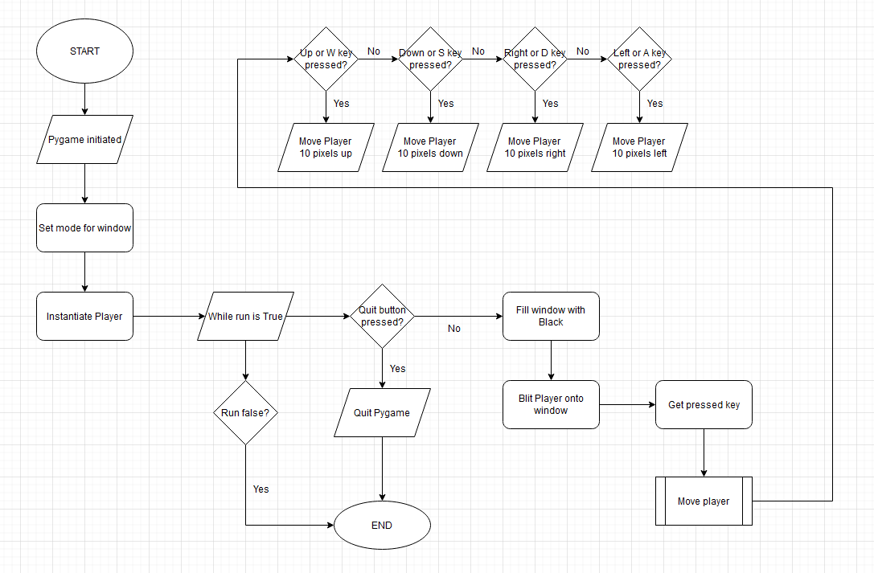

***NOTE: The syntax/format for any pseudocode can be found in Appendix B0***

After creating the Player class (pseudocode can be found in Appendix B1 [Page 264]) I am going to instantiate the player and set up a pygame loop in the main program which will just blit the player onto the pygame screen and allow the user to move the player sprite around. Below is the pseudocode for this.

IMPORT ***pygame***

from time IMPORT ***sleep***

from Player_class IMPORT Player

***pygame***.init()

win ← ***pygame***.display.set_mode((1900, 1000), pygame.FULLSCREEN)

***pygame***.display.set_caption("Maths Maze Navigator")

player ← new Player("Player.png")

run ← **True**

WHILE run = **True**

FOR event IN ***pygame***.event.get()

IF event.type = ***pygame***.QUIT THEN

run ← **False**

ENDIF

ENDFOR

win.*fill*((0,0,0))

win.*blit*(player.surf, player.rect)

***pygame***.display.update()

pressed_keys = ***pygame***.key.get_pressed()

player.move(pressed_keys)

ENDWHILE

IF run = **False** THEN

***sleep(2)***

***pygame***.quit()

ENDIF

After that, I am going to create my maze objects which will include cell sprites, wall sprites, an empty sprite for the entrance and exit of the maze and also a key sprite that the user can collect to end the game.

Maze Objects

The next thing I am going to do is create the Cell, Wall and Empty and Key classes.

These will be done in a subprogram called ‘Maze_objects’

Below is the class diagram for this subprogram:

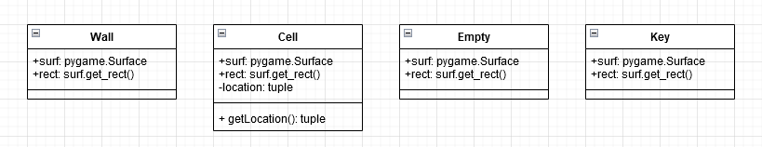

Below is the flowchart of the updated main program after the maze objects have been added:

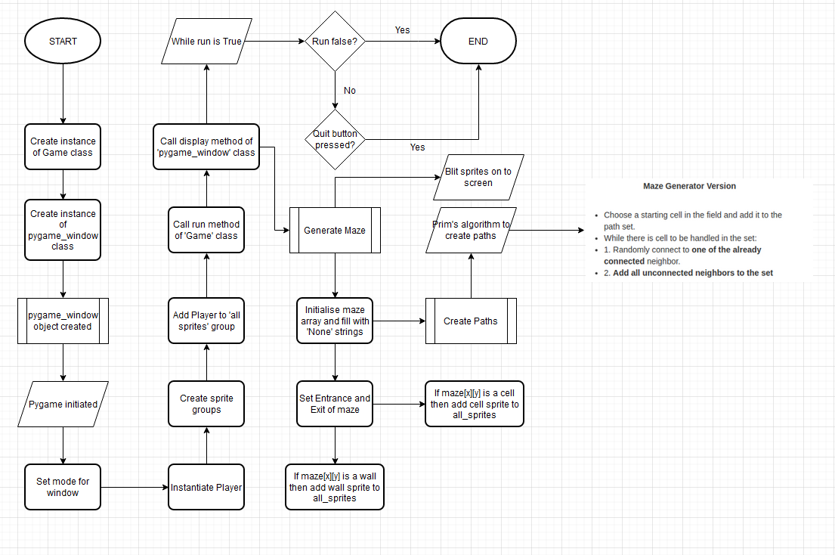

The pseudocode for the Maze_objects subprogram can be found in Appendix B2 [Page

On the next page, is the Pseudocode for the Main program after it has been updated

Prim’s algorithm implementation (in create_paths function) was found on github

<https://github.com/OrWestSide/python-scripts/blob/master/maze.py>

IMPORT ***pygame***

FROM time IMPORT ***sleep***

FROM random IMPORT ***randint***,***random***

FROM Player_class IMPORT Player

FROM Maze_objects IMPORT Wall, Cell, Empty

MAZE_HEIGHT ← 10

MAZE_WIDTH ← 10

maze ← []

FUNCTION surroundingCells(maze, rand_wall)

s_cells ← 0

IF (maze[rand_wall[0]-1][rand_wall[1]] = **True**) THEN

s_cells ← s_cells + 1

ENDIF

IF (maze[rand_wall[0]+1][rand_wall[1]] = **True**) THEN

s_cells ← s_cells + 1

ENDIF

IF (maze[rand_wall[0]][rand_wall[1]-1] = **True**) THEN

s_cells ← s_cells + 1

ENDIF

IF (maze[rand_wall[0]][rand_wall[1]+1] = **True**) THEN

s_cells ← s_cells + 1

ENDIF

RETURN s_cells

ENDFUNCTION

FUNCTION create_paths(maze, MAZE_HEIGHT, MAZE_WIDTH)

starting_height ← *Int*(***random()***\*MAZE_HEIGHT)

starting_width ← *Int*(***random()***\*MAZE_WIDTH)

IF (starting_height = 0) THEN

starting_height ← starting_height + 1

ENDIF

IF (starting_height = MAZE_HEIGHT-1) THEN

starting_height ← starting_height - 1

ENDIF

IF (starting_width = 0) THEN

starting_width ← starting_width + 1

ENDIF

IF (starting_width = MAZE_WIDTH-1) THEN

starting_width ← starting_width - 1

ENDIF

maze[starting_height][starting_width] ← **True**

wallCoords ← []

wallCoords.**Append**([starting_height - 1, starting_width])

wallCoords.**Append**([starting_height, starting_width - 1])

wallCoords.**Append**([starting_height, starting_width + 1])

wallCoords.**Append**([starting_height + 1, starting_width])

maze[starting_height-1][starting_width] ← **False**

maze[starting_height][starting_width - 1] ← **False**

maze[starting_height][starting_width + 1] ← **False**

maze[starting_height + 1][starting_width] ← **False**

WHILE (wallCoords)

rand_wall ← wallCoords[*Int*(***random()***\*wallCoords.*Length*)-1]

IF (rand_wall[1] <> 0) THEN

IF (maze[rand_wall[0]][rand_wall[1]-1] = "None" AND

maze[rand_wall[0]][rand_wall[1]+1] = **True**) THEN

s_cells = surroundingCells(maze, rand_wall)

IF s_cells < 2 THEN

maze[rand_wall[0]][rand_wall[1]] ← **True**

IF rand_wall[0] <> 0 THEN

IF (maze[rand_wall[0]-1][rand_wall[1]] <> **True**) THEN

maze[rand_wall[0]-1][rand_wall[1]] ← **False**

ENDIF

IF ([rand_wall[0]-1, rand_wall[1]] NOT IN wallCoords) THEN

wallCoords.**Append**([rand_wall[0]-1, rand_wall[1]])

ENDIF

ENDIF

IF rand_wall[0] <> MAZE_HEIGHT-1 THEN

IF (maze[rand_wall[0]+1][rand_wall[1]] <> **True**) THEN

maze[rand_wall[0]+1][rand_wall[1]] ← **False**

ENDIF

IF ([rand_wall[0]+1, rand_wall[1]] NOT IN wallCoords) THEN

wallCoords.**Append**([rand_wall[0]+1, rand_wall[1]])

ENDIF

ENDIF

IF (rand_wall[1] <> 0) THEN

IF (maze[rand_wall[0]][rand_wall[1]-1] <> **True**) THEN

maze[rand_wall[0]][rand_wall[1]-1] ← **False**

ENDIF

IF ([rand_wall[0], rand_wall[1]-1] NOT IN wallCoords) THEN

wallCoords.**Append**([rand_wall[0], rand_wall[1]-1])

ENDIF

ENDIF

ENDIF

FOR wall IN wallCoords

IF (wall[0] = rand_wall[0] AND wall[1] = rand_wall[1]) THEN

wallCoords.**Remove**(wall)

ENDIF

ENDFOR

ENDIF

CONTINUE

ENDIF

IF rand_wall[0] <> 0 THEN

IF (maze[rand_wall[0]-1][rand_wall[1]] = "None" AND

maze[rand_wall[0]+1][rand_wall[1]] = **True**) THEN

s_cells = surroundingCells(maze, rand_wall)

IF s_cells < 2 THEN

maze[rand_wall[0]][rand_wall[1]] ← **True**

IF rand_wall[0] <> 0 THEN

IF (maze[rand_wall[0]-1][rand_wall[1]] <> **True**) THEN

maze[rand_wall[0]-1][rand_wall[1]] ← **False**

ENDIF

IF ([rand_wall[0]-1, rand_wall[1]] NOT IN wallCoords) THEN

wallCoords.Append([rand_wall[0]-1, rand_wall[1]])

ENDIF

ENDIF

IF rand_wall[0] <> MAZE_HEIGHT-1 THEN

IF (maze[rand_wall[0]+1][rand_wall[1]] <> **True**) THEN

maze[rand_wall[0]+1][rand_wall[1]] ← **False**

ENDIF

IF ([rand_wall[0]+1, rand_wall[1]] NOT IN wallCoords) THEN

wallCoords.Append([rand_wall[0]+1, rand_wall[1]])

ENDIF

ENDIF

IF (rand_wall[1] <> 0) THEN

IF (maze[rand_wall[0]][rand_wall[1]-1] <> **True**) THEN

maze[rand_wall[0]][rand_wall[1]-1] ← **False**

ENDIF

IF ([rand_wall[0], rand_wall[1]-1] NOT IN wallCoords) THEN

wallCoords.Append([rand_wall[0], rand_wall[1]-1])

ENDIF

ENDIF

ENDIF

FOR wall IN wallCoords

IF (wall[0] = rand_wall[0] AND wall[1] = rand_wall[1]) THEN

wallCoords.**Remove**(wall)

ENDIF

ENDFOR

ENDIF

CONTINUE

ENDIF

IF rand_wall[0] <> MAZE_HEIGHT-1 THEN

IF (maze[rand_wall[0]+1][rand_wall[1]] = "None" AND

maze[rand_wall[0]-1][rand_wall[1]] = **True**) THEN

IF s_cells < 2 THEN

maze[rand_wall[0]][rand_wall[1]] ← **True**

IF rand_wall[0] <> 0 THEN

IF (maze[rand_wall[0]-1][rand_wall[1]] <> **True**) THEN

maze[rand_wall[0]-1][rand_wall[1]] ← **False**

ENDIF

IF ([rand_wall[0]-1, rand_wall[1]] NOT IN wallCoords) THEN

wallCoords.**Append**([rand_wall[0]-1, rand_wall[1]])

ENDIF

ENDIF

IF rand_wall[0] <> MAZE_HEIGHT-1 THEN

IF (maze[rand_wall[0]+1][rand_wall[1]] <> **True**) THEN

maze[rand_wall[0]+1][rand_wall[1]] ← **False**

ENDIF

IF ([rand_wall[0]+1, rand_wall[1]] NOT IN wallCoords) THEN

wallCoords.**Append**([rand_wall[0]+1, rand_wall[1]])

ENDIF

ENDIF

IF (rand_wall[1] <> 0) THEN

IF (maze[rand_wall[0]][rand_wall[1]-1] <> **True**) THEN

maze[rand_wall[0]][rand_wall[1]-1] ← **False**

ENDIF

IF ([rand_wall[0], rand_wall[1]-1] NOT IN wallCoords) THEN

wallCoords.**Append**([rand_wall[0], rand_wall[1]-1])

ENDIF

ENDIF

ENDIF

FOR wall IN wallCoords

IF (wall[0] = rand_wall[0] AND wall[1] = rand_wall[1]) THEN

wallCoords.**Remove**(wall)

ENDIF

ENDFOR

ENDIF

CONTINUE

ENDIF

IF rand_wall[1] <> MAZE_WIDTH-1 THEN

IF (maze[rand_wall[0]][rand_wall[1]+1] = "None" AND

maze[rand_wall[0]][rand_wall[1]-1] = **True**) THEN

IF s_cells < 2 THEN

maze[rand_wall[0]][rand_wall[1]] ← **True**

IF rand_wall[0] <> 0 THEN

IF (maze[rand_wall[0]-1][rand_wall[1]] <> **True**) THEN

maze[rand_wall[0]-1][rand_wall[1]] ← **False**

ENDIF

IF ([rand_wall[0]-1, rand_wall[1]] NOT IN wallCoords) THEN

wallCoords.Append([rand_wall[0]-1, rand_wall[1]])

ENDIF

ENDIF

IF rand_wall[0] <> MAZE_HEIGHT-1 THEN

IF (maze[rand_wall[0]+1][rand_wall[1]] <> **True**) THEN

maze[rand_wall[0]+1][rand_wall[1]] ← **False**

ENDIF

IF ([rand_wall[0]+1, rand_wall[1]] NOT IN wallCoords) THEN

wallCoords.Append([rand_wall[0]+1, rand_wall[1]])

ENDIF

ENDIF

IF (rand_wall[1] <> 0) THEN

IF (maze[rand_wall[0]][rand_wall[1]-1] <> **True**) THEN

maze[rand_wall[0]][rand_wall[1]-1] ← **False**

ENDIF

IF ([rand_wall[0], rand_wall[1]-1] NOT IN wallCoords) THEN

wallCoords.Append([rand_wall[0], rand_wall[1]-1])

ENDIF

ENDIF

ENDIF

FOR wall IN wallCoords

IF (wall[0] = rand_wall[0] AND wall[1] = rand_wall[1]) THEN

wallCoords.**Remove**(wall)

ENDIF

ENDFOR

ENDIF

CONTINUE

ENDIF

FOR wall IN wallCoords

IF (wall[0] = rand_wall[0] AND wall[1] = rand_wall[1]) THEN

wallCoords.**Remove**(wall)

ENDIF

ENDFOR

ENDWHILE

RETURN maze

ENDFUNCTION

PROCEDURE generate_maze(MAZE_HEIGHT, MAZE_WIDTH, maze, walls, cells, all_sprites)

FOR x = 0 TO MAZE_HEIGHT-1

mazeRow = []

FOR y = 0 TO MAZE_WIDTH - 1

mazeRow.**Append**("None")

ENDFOR

maze.**Append**(mazeRow)

ENDFOR

maze = create_paths(maze, MAZE_HEIGHT, MAZE_WIDTH)

FOR i = 0 TO MAZE_HEIGHT -1

FOR j = 0 TO MAZE_WIDTH -1

IF maze[i][j] = "None" THEN

maze[i][j] ← **False**

ENDIF

maze[0][1] ← "None"

maze[MAZE_HEIGHT-1][MAZE_WIDTH-2] ← "None"

FOR x = 0 TO MAZE_HEIGHT -1

FOR y = 0 TO MAZE_WIDTH -1

X ← (25*x)+500

Y ← (25*y)+100

IF maze[x][y] = **False**

wall ← new Wall([X,Y])

walls.**Add**(wall)

all_sprites.**Add**(wall)

ENDIF

ELSEIF maze[x][y] = **True**

cell ← new Cell([X,Y])

cells.**Add**(cell)

all_sprites.**Add**(cell)

ENDELSEIF

ELSE

empty ← new Empty([X,Y])

all_sprites.**Add**(empty)

ENDELSE

ENDFOR

ENDFOR

ENDPROCEDURE

CLASS pygame_window

PRIVATE maze_height

PRIVATE maze_width

PRIVATE maze

PRIVATE win

PRIVATE player

PRIVATE all_sprites

PRIVATE walls

PRIVATE cells

PUBLIC PROCEDURE new(MAZE_HEIGHT, MAZE_WIDTH, maze)

maze_height ← MAZE_HEIGHT

maze_width ← MAZE_WIDTH

maze ← maze

***pygame***.init()

win ← ***pygame***.display.set_mode((1200, 600))

***pygame***.display.set_caption("Maths Maze Navigator")

player ← new Player("Player.png",[500,100])

all_sprites ← ***pygame***.sprite.Group()

walls ← ***pygame***.sprite.Group()

cells ← ***pygame***.sprite.Group()

all_sprites.add(self.__player)

ENDPROCEDURE

PUBLIC METHOD display

generate_maze(maze_height, maze_width, maze, walls, cells, all_sprites)

run ← **True**

WHILE run

FOR event in ***pygame***.event.get()

IF event.type = ***pygame***.QUIT THEN

run ← **False**

ENDIF

ENDFOR

win.*fill*((0,0,0))

pressed_keys ← ***pygame***.key.get_pressed()

FOR sprite IN all_sprites

win.*blit*(sprite.surf, sprite.rect)

ENDFOR

***pygame***.display.update()

player.move(pressed_keys)

IF ***pygame***.sprite.spritecollideany(player, walls) THEN

player.*kill*()

run ← **False**

ENDIF

ENDWHILE

IF NOT run THEN

***sleep(2)***

***pygame***.quit()

ENDIF

ENDMETHOD

ENDCLASS

CLASS Game

PRIVATE display1

PUBLIC PROCEDURE new(MAZE_HEIGHT, MAZE_WIDTH, maze)

display1 ← new pygame_window(MAZE_HEIGHT, MAZE_WIDTH, maze)

ENDPROCEDURE

PUBLIC METHOD run

display1.display()

ENDMETHOD

ENDCLASS

IF __name__ = "__main__" THEN

game ← new Game(MAZE_HEIGHT, MAZE_WIDTH, maze)

game.run()

ENDIF

Information objects

The next thing I am going to do is create the scoreboard, lives counter, moves counter and timer. The respective classes for these will be called Scoreboard, LivesC, MovesC and Timer

These will be done in a subprogram called ‘‘Information_objects’

Below is the class diagram for this subprogram:

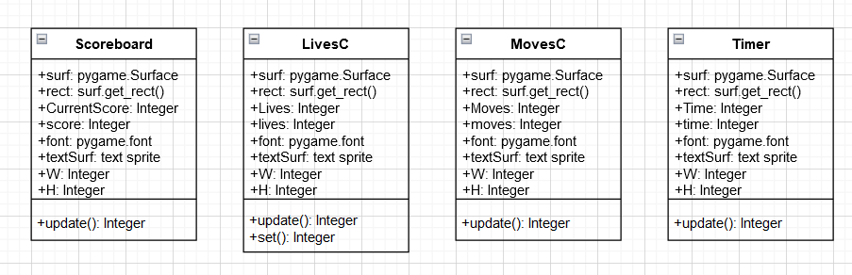

Below is the flowchart of the updated main program after the information objects have been added (only pygame_window class):

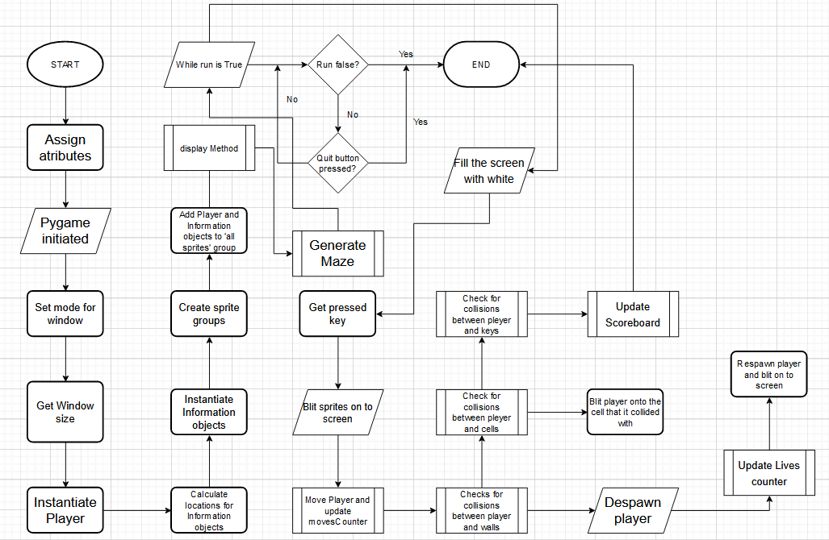

The pseudocode for the ‘Information_objects’ subprogram can be found in Appendix B3 [Page 266]

On the next page, is *part* of the Pseudocode for the Main program after it has been updated

CLASS pygame_window

PRIVATE maze_height

PRIVATE maze_width

PRIVATE maze

PRIVATE win

PRIVATE winXY

PRIVATE winX

PRIVATE winY

PRIVATE midX

PRIVATE midY

PRIVATE player

PRIVATE locX1

PRIVATE locX2

PRIVATE locX3

PRIVATE locX4

PRIVATE locY

PRIVATE scoreBoard

PRIVATE livesCounter

PRIVATE moveCounter

PRIVATE timer

PRIVATE CurrentScore

PRIVATE lives

PRIVATE moves

PRIVATE Time

PRIVATE all_sprites

PRIVATE walls

PRIVATE cells

PUBLIC PROCEDURE new(MAZE_HEIGHT, MAZE_WIDTH, maze)

maze_height = MAZE_HEIGHT

maze_width = MAZE_WIDTH

maze = maze

***pygame***.*init*()

win ← ***pygame***.display.set_mode((1200, 600), pygame.FULLSCREEN)

winXY ← ***pygame***.display.get_window_size()

***pygame***.display.set_caption("Maths Maze Navigator")

winX ← winXY[0]

winY ← winXY[1]

midX ← winX / 2

midY ← winY / 2

player ← new Player("Player.png",[600,300])

locX1 ← midX - 250

locX2 ← midX - 100

locX3 ← midX + 100

locX4 ← midX + 250

locY ← midY + (midY / 2)

scoreBoard ← new Scoreboard(15,"white",100,150,locX1,locY)

livesCounter ← new LivesC(15,"white",100,150,locX2,locY)

movesCounter ← new MovesC(15,"white",100,150,locX3,locY)

timer ← new Timer(15,"white",100,150,locX4,locY)

CurrentScore ← 0

lives ← 0

moves ← 0

Time ← 0

all_sprites ← ***pygame***.sprite.Group()

walls ← ***pygame***.sprite.Group()

cells ← ***pygame***.sprite.Group()

all_sprites.**Add**(player)

all_sprites.**Add**(scoreBoard)

all_sprites.**Add**(livesCounter)

all_sprites.**Add**(movesCounter)

all_sprites.**Add**(timer)

ENDPROCEDURE

PUBLIC METHOD display()

keys ← generate_maze(maze_height, maze_width, maze, walls, cells, all_sprites, midX, midY)

run ← **True**

WHILE run

FOR event IN ***pygame***.event.*get*()

IF event.type = ***pygame***.QUIT THEN

run ← **False**

ENDIF

IF event.type = ***pygame***.KEYDOWN THEN

IF event.key = ***pygame***.K_f THEN

***pygame***.display.toggle_fullscreen()

ENDIF

ENDIF

ENDFOR

win.*fill*((0,0,0))

pressed_keys ← ***pygame***.key.get_pressed()

FOR sprite IN all_sprites

win.*blit*(sprite.surf, sprite.rect)

***pygame***.display.*update*()

ENDFOR

moves ← player.move(pressed_keys, moves)

movesCounter.update(moves,15,"white",100,150)

IF ***pygame***.sprite.*spritecollideany*(player, walls) THEN

player.kill()

lives ← livesCounter.update(lives,15,"white",100,150)

player ← Player("Player.png",[600,300])

win.*blit*(player.surf, player.rect)

***pygame***.display.*update*()

ENDIF

thisCell ← pygame.sprite.*spritecollideany*(player, cells)

FOR cell IN cells

IF thisCell = cell THEN

player ← Player("Player.png",cell.getLocation())

win.*blit*(player.surf, player.rect)

pygame.display.*update*()

ENDIF

ENDFOR

IF pygame.sprite.*spritecollideany*(player, keys) THEN

CurrentScore ← 1000 - (25 * self.__moves)

scoreBoard.update(CurrentScore,15,"white",100,150)

***sleep(2)***

run ← **False**

ENDIF

ENDWHILE

IF NOT run THEN

***sleep(2)***

***pygame***.*quit*()

ENDIF

ENDMETHOD

ENDCLASS

Starting objects

The next thing I am going to do is create the buttons for the start screen. The respective classes for these will be called Title, Controls, Play, Instructions and Quit.

These will be done in a subprogram called ‘Starting_objects’.

Below is the class diagram for this subprogram:

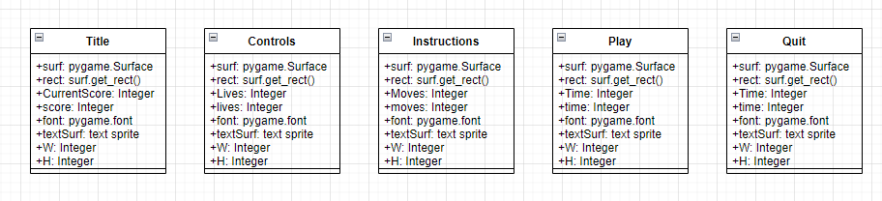

Below is the flowchart of the updated main program after the starting objects have been added (only Game class and ‘start_screen’ class with references to other classes):

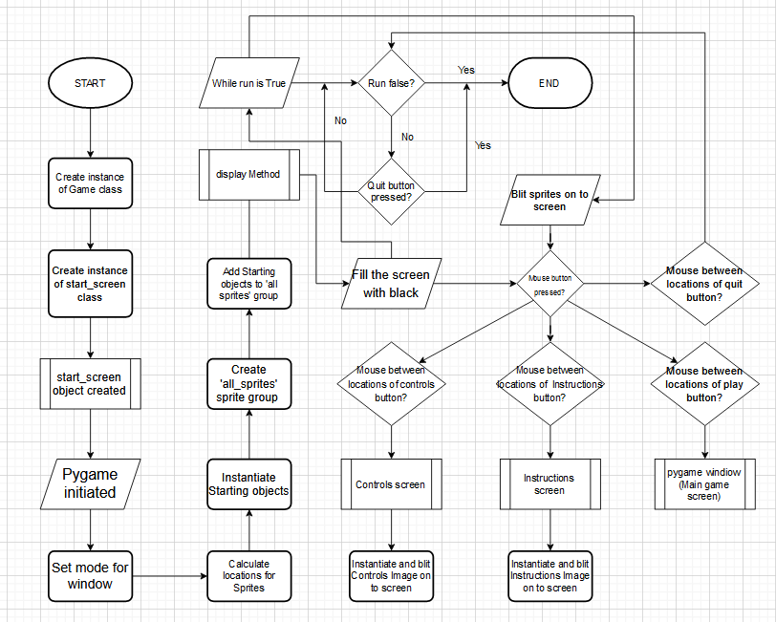

The pseudocode for the ‘Starting_objects’ subprogram can be found in Appendix B4 [Pg 270]

On the next page, is *part* of the Pseudocode for the Main program after it has been updated

CLASS controls_screen

PRIVATE win

PRIVATE winXY

PRIVATE controls_image

PRIVATE all_sprites

PUBLIC PROCEDURE new()

***pygame***.*init*()

win ← ***pygame***.display.set_mode((1900, 1000), ***pygame***.FULLSCREEN)

winXY ← ***pygame***.display.get_window_size()

***pygame***.display.set_caption("Maths Maze Navigator")

controls_image ← new controlsImage()

all_sprites ← ***pygame***.sprite.Group()

all_sprites.**Add**(controls_image)

ENDPROCEDURE

PUBLIC METHOD display()

run ← **True**

WHILE run

FOR event in ***pygame***.event.*get*()

IF event.type = ***pygame***.QUIT THEN

run ← **False**

ENDIF

IF event.type = ***pygame***.KEYDOWN THEN

IF event.key = ***pygame***.K_f

***pygame***.display.toggle_fullscreen()

ENDIF

ENDIF

ENDFOR

win.*fill*((0,0,0))

FOR sprite in all_sprites

win.*blit*(sprite.image, sprite.rect)

ENDFOR

***pygame***.display.*update*()

ENDWHILE

IF NOT run THEN

***sleep(2)***

***pygame***.*quit*()

ENDIF

ENDMETHOD

ENDCLASS

CLASS instructions_screen

PRIVATE win

PRIVATE winXY

PRIVATE controls_image

PRIVATE all_sprites

PUBLIC PROCEDURE new()

***pygame***.*init*()

win ← ***pygame***.display.set_mode((1900, 1000), ***pygame***.FULLSCREEN)

winXY ← ***pygame***.display.get_window_size()

***pygame***.display.set_caption("Maths Maze Navigator")

instructions_image ← new instructionsImage()

all_sprites ← ***pygame***.sprite.Group()

all_sprites.**Add**(instructions_image)

ENDPROCEDURE

PUBLIC METHOD display()

run ← **True**

WHILE run

FOR event in ***pygame***.event.*get*()

IF event.type = ***pygame***.QUIT THEN

run ← **False**

ENDIF

IF event.type = ***pygame***.KEYDOWN THEN

IF event.key = ***pygame***.K_f

***pygame***.display.toggle_fullscreen()

ENDIF

ENDIF

ENDFOR

win.*fill*((0,0,0))

FOR sprite in all_sprites

win.*blit*(sprite.image, sprite.rect)

ENDFOR

***pygame***.display.*update*()

ENDWHILE

IF NOT run THEN

***sleep(2)***

***pygame***.*quit*()

ENDIF

ENDMETHOD

ENDCLASS

CLASS start_screen

PRIVATE win

PRIVATE winXY

PRIVATE winX

PRIVATE winY

PRIVATE midX

PRIVATE midY

PRIVATE locX1

PRIVATE locX2

PRIVATE locX3

PRIVATE locX4

PRIVATE locX5

PRIVATE locY1

PRIVATE locY2

PRIVATE title

PRIVATE controls

PRIVATE play

PRIVATE instructions

PRIVATE quit

PRIVATE all_sprites

PUBLIC PROCEDURE new()

***pygame***.*init*()

win ← ***pygame***.display.set_mode((1900, 1000), ***pygame***.FULLSCREEN)

winXY ← ***pygame***.display.get_window_size()

***pygame***.display.set_caption("Maths Maze Navigator")

winX ← winXY[0]

winY ← winXY[1]

midX ← winX / 2

midY ← winY / 2

locX1 ← midX

locX2 ← 400

locX3 ← midX - 200

locX4 ← midX + 150

locX5 ← winX - 400

locY1 ← midY - (midY / 2)

locY2 ← midY + (midY / 2)

title ← Title((locX1, locY1),"Welcome to Maths Maze Navigator")

controls ← Controls((locX2, locY2),"Controls")

play ← Play((locX3, locY2),"Play game")

instructions ← Instructions((locX4, locY2),"How to play")

quit ← Quit((locX5, locY2),"Quit!")

all_sprites ← ***pygame***.sprite.Group()

all_sprites.**Add**(title)

all_sprites.**Add**(controls)

all_sprites.**Add**(play)

all_sprites.**Add**(instructions)

all_sprites.**Add**(quit)

PUBLIC METHOD display()

loc1 ← locX2 - 100

loc2 ← locX2 + 100

loc3 ← locY2 - 50

loc4 ← locY2 + 50

loc5 ← locX3 - 100

loc6 ← locX3 + 100

loc7 ← locX4 - 100

loc8 ← locX4 + 100

loc9 ← locX5 - 100

loc0 ← locX5 + 100

run ← **True**

WHILE run

FOR event IN ***pygame***.event.*get*():

IF event.type = ***pygame***.QUIT THEN

run ← **False**

ENDIF

IF event.type = ***pygame***.KEYDOWN THEN

IF event.key = pygame.K_f THEN

***pygame***.display.toggle_fullscreen()

ENDIF

ENDIF

IF event.type = ***pygame***.MOUSEBUTTONDOWN THEN

IF loc1 <= mouse[0] <= loc2 AND loc3 <= mouse[1] <= loc4 THEN

game.run_controls()

ENDIF

IF loc5 <= mouse[0] <= loc6 AND loc3 <= mouse[1] <= loc4 THEN

game.run_main()

ENDIF

IF loc7 <= mouse[0] <= loc8 AND loc3 <= mouse[1] <= loc4 THEN

game.run_instructions()

ENDIF

IF loc9 <= mouse[0] <= loc0 AND loc3 <= mouse[1] <= loc4 THEN

run ← **False**

ENDIF

ENDFOR

win.*fill*((0,0,0))

mouse ← ***pygame***.mouse.get_pos()

FOR sprite IN all_sprites

win.blit(sprite.surf, sprite.rect)

ENDFOR

***pygame***.display.*update*()

ENDWHILE

IF NOT run THEN

***sleep(2)***

***pygame***.*quit*()

ENDIF

ENDMETHOD

ENDCLASS

CLASS Game

PRIVATE display1

PRIVATE display2

PRIVATE display3

PRIVATE display4

PUBLIC PROCEDURE new(MAZE_HEIGHT, MAZE_WIDTH, maze)

display1 ← new start_screen()

display2 ← new pygame_window(MAZE_HEIGHT, MAZE_WIDTH, maze)

display3 ← new controls_screen()

display4 ← new instructions_screen()

ENDPROCEDURE

PUBLIC METHOD run_start()

display1.display()

ENDMETHOD

PUBLIC METHOD run_controls()

display3.display()

ENDMETHOD

PUBLIC METHOD run_instructions()

display4.display()

ENDMETHOD

PUBLIC METHOD run_main()

display2.display()

ENDMETHOD

ENDCLASS

Other objects

Also alongside the starting objects, a subprogram called ‘Other_objects’ is going to be made.

This will include the images that will be displayed on the controls screen and instructions screen as well as images for the win_screen and lose_screen

Below is the class diagram for this subprogram:

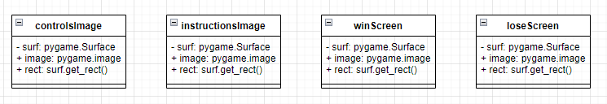

The pseudocode for the Main program after it has been updated with the win and lose screens can be found in Appendix B5 [Page 273]

The pseudocode for the ‘Other_objects’ subprogram is below:

IMPORT ***pygame***

CLASS controlsImage *inherits* Sprite

PRIVATE surf

PUBLIC image

PUBLIC rect

PUBLIC PROCEDURE new()

SUPER()

surf ← ***pygame***.Surface((1920,1080))

surf.*fill*((255,255,255))

image ← ***pygame***.image.load('Controls.png').*convert*()

rect ← surf.get_rect(center=(960,540))

ENDPROCEDURE

ENDCLASS

CLASS instructionsImage *inherits* Sprite

PRIVATE surf

PUBLIC image

PUBLIC rect

PUBLIC PROCEDURE new()

SUPER()

surf ← ***pygame***.Surface((1920,1080))

surf.*fill*((255,255,255))

image ← ***pygame***.image.load('Instructions.png').*convert*()

rect ← surf.get_rect(center=(960,540))

ENDPROCEDURE

ENDCLASS

CLASS winScreen *inherits* Sprite

PRIVATE surf

PUBLIC image

PUBLIC rect

PUBLIC PROCEDURE new()

SUPER()

surf ← ***pygame***.Surface((1920,1080))

surf.*fill*((255,255,255))

image ← ***pygame***.image.load('Win_Screen.png').*convert*()

rect ← surf.get_rect(center=(960,540))

ENDPROCEDURE

ENDCLASS

CLASS loseScreen *inherits* Sprite

PRIVATE surf

PUBLIC image

PUBLIC rect

PUBLIC PROCEDURE new()

SUPER()

surf ← ***pygame***.Surface((1920,1080))

surf.*fill*((255,255,255))

image ← ***pygame***.image.load('Lose_Screen.png').*convert*()

rect ← surf.get_rect(center=(960,540))

ENDPROCEDURE

ENDCLASS

Maths Quiz

This will be the subprogram with a few Tkinter classes for the maths side of the game. It will be able to be loaded up separately if the user wants to just play the maths questions. The maths questions used will be the ‘Ninson’s specials’ Qs.

Below is the class diagram for this subprogram:

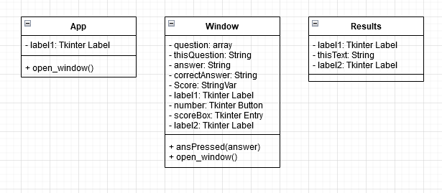

The pseudocode for this subprogram is below:

FROM ***tkinter*** IMPORT *

FROM ***random*** IMPORT *

FUNCTION get_questions()

questions ← []

file ← *open*("maths_qs.txt", "r")

FOR line IN file

newLine ← line.*strip*("\n").*split*(",")

questions.**Append**(newLine)

RETURN questions

CLASS Results *inherits* Toplevel

PRIVATE label1

PRIVATE thisText

PRIVATE label2

PUBLIC PROCEDURE new(parent, score)

SUPER.parent()

Toplevel.geometry('410x200')

Toplevel.title('Results')

Toplevel.configure(bg="#12AAE6")

label1 ← Label(Toplevel, text="The results are in", bg="#12AAE6")

label1.config(font=('Helvetica bold',40))

label1.grid(row=0, columnspan=2)

thisText ← f"You scored: {score} / 10"

label2 ← Label(self, text=thisText, bg="#12AAE6")

label2.config(font=('Helvetica bold',25))

label2.grid(row=1, columnspan=2)

ENDPROCEDURE

ENDCLASS

CLASS Window *inherits* Toplevel

PRIVATE question

PRIVATE thisQuestion

PRIVATE answer1

PRIVATE answer2

PRIVATE answer3

PRIVATE answer4

PRIVATE correctAnswer

PRIVATE Score

PRIVATE label1

PRIVATE number1

PRIVATE number2

PRIVATE number3

PRIVATE number4

PRIVATE scoreBox

PRIVATE label2

PUBLIC PROCEDURE new(parent, calls, questions)

SUPER.parent()

Toplevel.geometry('2000x500')

Toplevel.title('Questions')

Toplevel.configure(bg="#12AAE6")

question ← questions[0]

thisQuestion ← self.question[0]

answer1 ← question[1]

answer2 ← question[2]

answer3 ← question[3]

answer4 ← question[4]

correctAnswer ← answer1

Score ← StringVar()

label1 ← Label(Toplevel, text=thisQuestion, bg="#12AAE6")

label1.config(font=('Helvetica bold',20))

label1.grid(row=0,columnspan=2)

number1 ← Button(Toplevel, text=answer1, bg="#12AAE6",

command=lambda: Window.ansPressed(answer1, correctAnswer))

number1.grid(row=1, column=0)

number2 ← Button(Toplevel, text=answer2, bg="#12AAE6",

command=lambda: Window.ansPressed(answer2, correctAnswer))

number2.grid(row=1, column=1)

number3 ← Button(Toplevel, text=answer3, bg="#12AAE6",

command=lambda: Window.ansPressed(answer3, correctAnswer))

number3.grid(row=2, column=0)

number4 ← Button(Toplevel, text=answer4, bg="#12AAE6",

command=lambda: Window.ansPressed(answer4, correctAnswer))

number4.grid(row=2, column=1)

scoreBox ← Entry(Toplevel, bg="#12AAE6", textvariable=Score)

scoreBox.config(state= "disabled")

scoreBox.grid(row=3, column=1)

label2 ← Label(Toplevel, text="Score:", bg="#12AAE6")

label2.config(font=('Helvetica bold',10))

label2.grid(row=3, column=0)

Button(Toplevel,text="Next Question",bg="#12AAE6",

command=lambda: Window.open_window(score, questions)).

grid(row=4, column=0)

Button(Toplevel,text='Close',bg="#12AAE6",

command=*destroy*).grid(row=4, column=1)

ENDPROCEDURE

ENDCLASS

PUBLIC METHOD ansPressed(answer, correctAnswer)

GLOBAL score

IF answer = correctAnswer THEN

print("Correct!")

score ← score + 1

ENDIF

ELSE

print("Incorrect!")

score ← score - 1

ENDELSE

Score.**Set**(*Str*(score))

ENDMETHOD

PUBLIC METHOD open_window(score, questions)

GLOBAL calls

questions.**Remove**(question)

calls ← calls + 1

self.*destroy*()

IF calls < 10 THEN

window ← new Window(app, calls, questions)

window.grab_set()

ENDIF

ELSE

results ← new Results(app, score)

results.grab_set()

ENDELSE

ENDMETHOD

CLASS App *inherits* Tk

PUBLIC PROCEDURE new(score, calls)

SUPER()

Tk.geometry('825x500')

Tk.title('Maths Maze Navigator')

Tk.configure(bg="#12AAE6")

label1 ← Label(Tk, text="Welcome to Maths Maze Navigator",

bg="#12AAE6")

label1.config(font=('Helvetica bold',40))

label1.grid(row=0,columnspan=2)

Button(Tk,text='Open questions',bg="#12AAE6",

command=App.open_window).grid(row=1, column=0)

Button(Tk,text='Close',bg="#12AAE6",command=*destroy*).

grid(row=1, column=1)

PUBLIC METHOD open_window()

calls ← 0

questions ← get_questions()

window ← new Window(self, calls, questions)

window.grab_set()

IF __name__ = "__main__" THEN

score ← 0

calls ← 0

app ← new App(score, calls)

app.mainloop()

Further updates to Main program

**UPDATE 1:**

The Save Button and Load button will be added and then the game will be updated along with the *screens* interface - pseudocode for GameSave class is in Appendix B6 [Page 276]

The pseudocode for the new and changed elements of the *Main* program is below:

CLASS screens

PROTECTED win

PROTECTED winXY

PROTECTED all_sprites

PUBLIC PROCEDURE new()

win ← ***pygame***.display.set_mode((1900, 1000), ***pygame***.RESIZABLE)

winXY ← ***pygame***.display.get_window_size()

***pygame***.display.set_caption("Maths Maze Navigator")

all_sprites = ***pygame***.sprite.Group()

ENDPROCEURE

PUBLIC METHOD display()

PASS

ENDMETHOD

CLASS save_screen *inherits* screens

PRIVATE SaveScreen

PRIVATE gameSave

PUBLIC PROCEDURE new(maze, CurrentScore, lives, moves, Time)

SUPER()

***pygame***.*init*()

SaveScreen ← new SS_image()

all_sprites.**Add**(SaveScreen)

gameSave ← GameSave(maze, CurrentScore, lives, moves, Time)

PUBLIC METHOD save(coords)

file ← *Open*("mazeInfo.txt", 'w')

gameSave.writeToFile(file, coords)

file.*Close*()

ENDMETHOD

PUBLIC METHOD display()

run ← True

WHILE run

FOR event IN ***pygame***.event.*get*()

IF event.type = ***pygame***.QUIT THEN

run ← **False**

ENDIF

IF event.type = ***pygame***.KEYDOWN THEN

IF event.key = ***pygame***.K_f THEN

***pygame***.display.toggle_fullscreen()

ENDIF

ENDIF

IF event.type = ***pygame***.MOUSEBUTTONDOWN

game.run_main()

ENDIF

ENDFOR

win.*fill*((0,0,0))

FOR sprite IN all_sprites

win.*blit*(sprite.surf, sprite.rect)

ENDFOR

***pygame***.display.*update*()

ENDWHILE

IF NOT run THEN

***sleep(2)***

***pygame***.*quit*()

ENDIF

ENDMETHOD

ENDCLASS

CLASS load_screen *inherits* screens

PRIVATE savedMaze

PRIVATE CurrentScore

PRIVATE lives

PRIVATE moves

PRIVATE Time

PRIVATE playerPos

PRIVATE midX

PRIVATE midY

PRIVATE LoadScreen

PUBLIC PROCEDURE new(maze, CurrentScore, lives, moves, Time, playerPos, midX,

midY)

savedMaze ← maze

CurrentScore ← CurrentScore

lives ← lives

moves ← moves

Time ← Time

playerPos ← playerPos

midX ← midX

midY ← midY

SUPER()

***pygame***.*init*()

LoadScreen ← new LS_image()

all_sprites.**Add**(LoadScreen)

ENDPROCEDURE

PUBLIC METHOD display()

run ← True

WHILE run

FOR event IN ***pygame***.event.*get*()

IF event.type = ***pygame***.QUIT THEN

run ← **False**

ENDIF

IF event.type = ***pygame***.KEYDOWN THEN

IF event.key = ***pygame***.K_f THEN

***pygame***.display.toggle_fullscreen()

ENDIF

ENDIF

IF event.type = ***pygame***.MOUSEBUTTONDOWN

game.run_main()

ENDIF

ENDFOR

win.*fill*((0,0,0))

FOR sprite IN all_sprites

win.*blit*(sprite.surf, sprite.rect)

ENDFOR

***pygame***.display.*update*()

ENDWHILE

IF NOT run THEN

***sleep(2)***

***pygame***.*quit*()

ENDIF

ENDMETHOD

PUBLIC METHOD loadMaze(maze, midX, midY)

all_sprites ← ***pygame***.sprite.Group()

walls ← ***pygame***.sprite.Group()

cells ← ***pygame***.sprite.Group()

FOR x = 0 TO MAZE_HEIGHT - 1

FOR y = 0 TO MAZE_WIDTH - 1

X ← (25*x)+(midX-((25*MAZE_WIDTH) / 2))

Y ← (25*y)+(midY-(25*MAZE_HEIGHT))

IF maze[x][y] = **False** THEN

wall ← Wall([X,Y])

walls.**Add**(wall)

all_sprites.**Add**(wall)

ELSEIF maze[x][y] = **True** THEN

cell ← Cell([X,Y])

cells.**Add**(cell)

all_sprites.**Add**(cell)

ELSE

empty = Empty([X,Y])

all_sprites.**Add**(empty)

RETURN walls, cells, all_sprites

PUBLIC METHOD loadGame(all_sprites, MAZE_HEIGHT, MAZE_WIDTH)

new_sprites ← all_sprites

pixelX ← (25\**Int*(playerPos[1]))+(midX-((25*MAZE_WIDTH) / 2))

pixelY ← (25\**Int*(playerPos[4]))+(midY-(25*MAZE_HEIGHT))

player ← new Player("Player.png",[pixelX, pixelY])

locX1 ← midX - 250

locX2 ← midX - 100

locX3 ← midX + 100

locX4 ← midX + 250

locY ← midY + (midY / 2)

scoreBoard ← new Scoreboard(15,"white",100,150,locX1,locY)

livesCounter ← new LivesC(15,"white",100,150,locX2,ocY)

movesCounter ← new MovesC(15,"white",100,150,locX3,locY)

timer ← new Timer(15,"white",100,150,locX4,locY)

new_sprites.**Add**(player)

new_sprites.**Add**(scoreBoard)

new_sprites.**Add**(livesCounter)

new_sprites.**Add**(movesCounter)

new_sprites.**Add**(timer)

RETURN new_sprites, player, scoreBoard, ivesCounter, movesCounter, timer

ENDMETHOD

ENDCLASS

CLASS pygame_window *inherits* screens

...

PUBLIC METHOD display()

keys, visited ← generate_maze(maze_height, maze_width, maze, walls, cells,

all_sprites, midX, midY)

loc1 ← locX3 - 50

loc2 ← locX3 + 50

loc3 ← locX4 - 50

loc4 ← locX4 + 50

loc5 ← locY1 - 14

loc6 ← locY1 + 14

run ← **True**

WHILE run

FOR event IN ***pygame***.event.*get*()

IF event.type = ***pygame***.QUIT THEN

run ← **False**

ENDIF

IF event.type = ***pygame***.KEYDOWN THEN

IF event.key = ***pygame***.K_f THEN

***pygame***.display.toggle_fullscreen()

ENDIF

ENDIF

IF event.type = ***pygame***.MOUSEBUTTONUP THEN

***pygame***.time.set_timer(event, 1000)

Time ← Time + 1

ENDIF

IF event.type = ***pygame***.MOUSEBUTTONDOWN THEN

IF loc1 <= mouse[0] <= loc2 and loc5 <= mouse[1] <= loc6 THEN

SS ← new save_screen(maze, CurrentScore, lives, moves, Time)

SS.save(coords)

SS.display()

ENDIF

IF loc3 <= mouse[0] <= loc4 and loc5 <= mouse[1] <= loc6 THEN

file ← *Open*("mazeInfo.txt", 'r')

maze, CurrentScore, lives, moves, Time, playerPos ←

gameSave.loadMaze(file, maze_height, maze_width)

LS ← new load_screen(maze, CurrentScore, lives, moves, Time, playerPos,

midX, midY)

walls, cells, all_sprites ← LS.loadMaze(maze, midX, midY)

all_sprites, player, scoreBoard, livesCounter, movesCounter, timer ←

LS.loadGame(all_sprites, maze_height, maze_width)

LS.display()

ENDIF

ENDIF

ENDFOR

win.*fill*((0,0,0))

pressed_keys ← ***pygame***.key.get_pressed()

mouse ← ***pygame***.mouse.get_pos()

FOR sprite IN all_sprites

win.*blit*(sprite.surf, sprite.rect)

ENDFOR

win.*blit*(saveButton.image, saveButton.rect)

win.*blit*(loadButton.image, loadButton.rect)

***pygame***.display.*update*()

moves ← player.move(pressed_keys, moves)

movesCounter.update(moves,15,"white",100,150)

timer.update(Time,15,"white",100,150)

IF ***pygame***.sprite.*spritecollideany*(player, walls) THEN

player.*kill*()

lives ← livesCounter.update(lives,15,"white",100,150)

player ← Player("Player.png",[600,300])

win.*blit*(player.surf, player.rect)

***pygame***.display.*update*()

ENDIF

IF lives < 0 THEN

game.run_lose()

ENDIF

thisCell ← pygame.sprite.*spritecollideany*(player, cells)

FOR cell IN cells

IF thisCell = cell THEN

player ← Player("Player.png",cell.getLocation())

win.*blit*(player.surf, player.rect)

pygame.display.*update*()

ENDIF

ENDFOR

IF pygame.sprite.*spritecollideany*(player, keys) THEN

CurrentScore ← 1000 - (25 * moves)

scoreBoard.update(CurrentScore,15,"white",100,150)

***sleep(2)***

game.run_win()

ENDIF

ENDWHILE

IF NOT run THEN

***sleep(2)***

***pygame***.*quit*()

ENDIF

ENDMETHOD

ENDCLASS

**UPDATE 2:**

The scoring system will be added - pseudocode for HighScores class found in Appendix B6.

The pseudocode for the new and changed elements of the *Main* program is below:

CLASS high_scores_screen2 *inherits* Toplevel

PRIVATE high_scores

PRIVATE fileIn

PRIVATE scoreValid

PRIVATE sortedNames

PRIVATE fileOut

PRIVATE label1

PRIVATE textBox

PRIVATE nameScore

PRIVATE name

PRIVATE score

PRIVATE text

PUBLIC PROCEDURE new(parent, score, name)

SUPER.parent()

high_scores ← new HighScores()

scoreValid ← **Null**

fileIn ← *Open*('high_scores.txt', 'r')

high_scores.get_scores(fileIn)

fileIn.*Close*()

IF high_scores.check_score(score) THEN

scoreValid ← **True**

high_scores.add_score(name, score)

sortedNames ← high_scores.sortNames()

sortedNames ← sortedNames[::-1]

fileOut ← *Open*('high_scores.txt', 'w')

high_scores.saveScore(fileOut, sortedNames)

fileOut.*Close*()

ELSE

scoreValid ← False

Toplevel.geometry('1650x1000')

Toplevel.title('Maths Maze Navigator')

Toplevel.configure(bg="#12AAE6")

label1 ← Label(Toplevel, text="High Scores", bg="#12AAE6")

label1.config(font=('Helvetica bold',40))

label1.grid(row=0,columnspan=2)

textBox ← Text(Toplevel, bg="#12AAE6")

textBox.grid(row=1, columnspan=2)

IF scoreValid THEN

textBox.*delete*("1.0", END)

ELSE

sortedNames ← high_scores.sortNames()

textBox.*delete*("1.0", END)

FOR num = 1 TO sortedNames.*Length*

nameScore ← sortedNames[num-1]

name ← nameScore[0]

score ← nameScore[1]

text ← *Str*(num)+"."+name+": "+*Str*(score)+"\n"

textBox.*insert*(END, text)

ENDFOR

Button(Toplevel,text='Close',bg="#12AAE6",command=*destroy*).

grid(row=2, columnspan=2)

ENDPROCEDURE

CLASS high_scores_screen1 *inherits* Tk

PRIVATE text

PRIVATE label1

PRIVATE label2

PRIVATE entry1

PRIVATE textBox

PUBLIC PROCEDURE new(score)

SUPER()

Tk.geometry('1650x1000')

Tk.title('Maths Maze Navigator')

Tk.configure(bg="#12AAE6")

text ← f"Your score is: {score}"

label1 ← Label(Tk, text=text, bg="#12AAE6")

label1.config(font=('Helvetica bold',40))

label1.grid(row=0,columnspan=2)

label2 ← Label(Tk, text="Enter name here:", bg="#12AAE6")

label2.config(font=('Helvetica Bold',20))

label2.grid(row=1,column=0)

entry1 ← Entry(Tk, bg="#12AAE6")

entry1.grid(row=1, column=1)

textBox ← Text(Tk, bg="#12AAE6")

textBox.grid(row=2, columnspan=2)

Button(Tk,text='Submit score',bg="#12AAE6",command=lambda:

high_scores_screen1.open_window(score)).grid(row=3, column=0)

Button(Tk,text='Close',bg="#12AAE6",command=*destroy*).grid(row=3, column=1)

ENDPROCEDURE

PUBLIC METHOD open_window(score)

name ← entry1.*get*()

IF name.*Length* > 10 OR name.*Length* < 2 THEN

text ← "Error: Name has to be between 2 and 10 characters long!"

textBox.*delete*("1.0", END)

textBox.*insert*("1.0", text)

ENDIF

ELSE

hss2 ← new high_scores_screen2(score, name)

hss2.grab_set()

ENDELSE

ENDMETHOD

ENDCLASS

CLASS win_screen *inherits* screens

...

PUBLIC METHOD display(currentScore)

…

WHILE run

FOR event IN ***pygame***.event.*get*()

…

IF event.type = ***pygame***.MOUSEBUTTONDOWN THEN

hss1 ← new high_scores_screen1(currentScore)

hss1.mainloop()

ENDIF

…

ENDMETHOD

ENDCLASS

**UPDATE 3:**

The Question system will be added similar to *Maths_quiz* and also the Question Select screen - pseudocode for QS Objects found in appendix B7 [Page 280].

The pseudocode for the new and changed elements of the *Main* program is below:

CLASS QuestionWindow *inherits* Tk

PRIVATE question

PRIVATE thisQuestion

PRIVATE answer1

PRIVATE answer2

PRIVATE answer3

PRIVATE answer4

PRIVATE correctAnswer

PRIVATE Score

PRIVATE movesLeft

PRIVATE score

PRIVATE status

PRIVATE label1

PRIVATE number1

PRIVATE number2

PRIVATE number3

PRIVATE number4

PRIVATE scoreBox

PRIVATE label2

PUBLIC PROCEDURE new(questions, score)

SUPER()

Tk.geometry('2000x500')

Tk.title('Questions')

Tk.configure(bg="#12AAE6")

question ← questions[0]

thisQuestion ← self.question[0]

answer1 ← question[1]

answer2 ← question[2]

answer3 ← question[3]

answer4 ← question[4]

correctAnswer ← answer1

self.Score ← StringVar()

self.movesLeft ← 0

self.score ← score

self.status ← "Incorrect!"

label1 ← Label(Tk, text=thisQuestion, bg="#12AAE6")

label1.config(font=('Helvetica bold',20))

label1.grid(row=0,columnspan=2)

number1 ← Button(Tk, text=answer1, bg="#12AAE6",

command=lambda: self.ansPressed(answer1, correctAnswer))

number1.grid(row=1, column=0)

number2 ← Button(Tk, text=answer2, bg="#12AAE6",

command=lambda: self.ansPressed(answer2, correctAnswer))

number2.grid(row=1, column=1)

number3← Button(Tk, text=answer3, bg="#12AAE6",

command=lambda: self.ansPressed(answer3, correctAnswer))

number3.grid(row=2, column=0)

number4 ← Button(Tk, text=answer4, bg="#12AAE6",

command=lambda: self.ansPressed(answer4, correctAnswer))

number4.grid(row=2, column=1)

scoreBox ← Entry(Tk, bg="#12AAE6", textvariable=self.Score)

scoreBox.config(state= "disabled")

scoreBox.grid(row=3, column=1)

Score.**Set**(*Str*(score))

label2 ← Label(Tk, text="Score:", bg="#12AAE6")

label2.config(font=('Helvetica bold',10))

label2.grid(row=3, column=0)

ENDPROCEDURE

PUBLIC METHOD ansPressed(answer, correctAnswer)

IF answer = correctAnswer THEN

status ← "Correct!"

score ← score + 1

ENDIF

ELSE

status ← "Incorrect!"

score ← score - 1

Score.**Set**(*Str*(score))

Tk.destroy()

ENDELSE

ENDMETHOD

PUBLIC METHOD return_info()

currentScore ← score

IF status = "Correct!"

movesLeft ← 5

ENDIF

ELSE

movesLeft ← 1

ENDELSE

RETURN currentScore, movesLeft

ENDMETHOD

CLASS QuestionSelect_screen *inherits* screens

PRIVATE winX

PRIVATE winY

PRIVATE midX

PRIVATE midY

PRIVATE locX1

PRIVATE locY1

PRIVATE locY2

PRIVATE locY3

PRIVATE locY4

PRIVATE locY5

PRIVATE locY6

PRIVATE SyQD

PRIVATE GCSE

PRIVATE Easy

PRIVATE Medium

PRIVATE Hard

PRIVATE NS

PUBLIC PROCEDURE new()

SUPER()

***pygame***.*init*()

winX ← winXY[0]

winY ← winXY[1]

midX ← winX / 2

midY ← winY / 2

locX1 ← midX

locY1 ← 150

locY2 ← midY - 200

locY3 ← midY - 50

locY4 ← midY + 100

locY5 ← midY + 250

locY6 ← winY - 100

SyQD ← new Text1((locX1,locY1),"Select your Question Difficulty")

GCSE ← new Button1((locX1,locY2),"GCSE")

Easy ← new Button2((locX1,locY3),"Easy")

Medium ← new Button3((locX1,locY4),"Medium")

Hard ← new Button4((locX1,locY5),"Hard")

NS ← new Button5((locX1,locY6),"Ninson's specials")

all_sprites.**Add**(SyQD)

all_sprites.**Add**(GCSE)

all_sprites.**Add**(Easy)

all_sprites.**Add**(Medium)

all_sprites.**Add**(Hard)

all_sprites.**Add**(NS)

ENDPROCEDURE

PUBLIC METHOD display(qs_diff)

loc1 ← locX1 - 100

loc2 ← locX1 + 100

loc3 ← locY5 - 50

loc4 ← locY5 + 50

loc5 ← locY2 - 50

loc6 ← locY2 + 50

loc7 ← locY3 - 50

loc8 ←locY3 + 50

loc9 ← locY4 - 50

loc10 ← locY4 + 50

loc11 ← locY6 - 50

loc12 ← locY6 + 50

run ← True

WHILE run

FOR event IN ***pygame***.event.*get*()

IF event.type = ***pygame***.QUIT THEN

run ← **False**

ENDIF

IF event.type = ***pygame***.KEYDOWN THEN

IF event.key = ***pygame***.K_f THEN

***pygame***.display.toggle_fullscreen()

ENDIF

ENDIF

IF event.type = ***pygame***.MOUSEBUTTONDOWN THEN

IF loc1 <= mouse[0] <= loc2 AND loc5 <= mouse[1] <= loc6 THEN

qs_diff ← "GCSE"

game.run_main(qs_diff)

ENDIF

IF loc1 <= mouse[0] <= loc2 AND loc7 <= mouse[1] <= loc8 THEN

qs_diff ← "Easy"

game.run_main(qs_diff)

ENDIF

IF loc1 <= mouse[0] <= loc2 AND loc9 <= mouse[1] <= loc10 THEN

qs_diff ← "Medium"

game.run_main(qs_diff)

ENDIF

IF loc1 <= mouse[0] <= loc2 AND loc3 <= mouse[1] <= loc4 THEN

qs_diff ← "Hard"

game.run_main(qs_diff)

ENDIF

IF loc1 <= mouse[0] <= loc2 AND loc11 <= mouse[1] <= loc12 THEN

qs_diff ← "NS"

game.run_main(qs_diff)

ENDIF

ENDIF

ENDFOR

win.*fill*((0,0,0))

mouse ← ***pygame***.mouse.get_pos()

FOR sprite IN all_sprites

win.blit(sprite.surf, sprite.rect)

ENDFOR

pygame.display.update()

ENDWHILE

IF NOT run THEN

sleep(2)

pygame.quit()

ENDIF

ENDMETHOD

ENDCLASS

CLASS pygame_window *inherits* screens

…

PUBLIC METHOD display(qs_diff)

…

IF qs_diff = "GCSE" THEN

file ← *Open*("GCSE_qs.txt", mode='r')

ENDIF

ELSEIF qs_diff = "Easy" THEN

file ← *Open*("Easy_qs.txt", mode='r')

ENDELSEIF

ELSEIF qs_diff = "Medium" THEN

file ← *Open*("Medium_qs.txt", mode='r')

ENDELSEIF

ELSEIF qs_diff = "Hard" THEN

file ← *Open*("Hard_qs.txt", mode='r')

ENDELSEIF

ELSEIF qs_diff = "NS" THEN

file ← *Open*("NS_qs.txt", mode='r')

ENDELSEIF

ELSE

OUTPUT("An error has occurred!")

ENDELSE

…

score ← 0

questions ← get_questions(file)

calls ← 0

crashes ← 0

…

IF movesLeft <= 0 THEN

IF calls < 10

open_question(questions)

calls ← calls + 1

ENDIF

ELSE

movesLeft ← movesLeft + 100

ENDELSE

ENDIF

…

ENDMETHOD

PUBLIC METHOD open_question(questions)

window ← new QuestionWindow(questions, score)

window.mainloop()

question ← questions[0]

questions.**Remove**(question)

score, movesLeft ← window.return_info()

ENDMETHOD

**UPDATE 4:**

The undo moves feature will be added - MovesQueue class found in Appendix B8 [Page 283]

The pseudocode for the new and changed elements of the *Main* program is below:

CLASS pygame_window *inherits* screens

…

undoButton ← new UndoButton((locX2,locY1))

…

movesQueue ← new MovesQueue()

PUBLIC METHOD display(qs_diff)

…

moveNum ← 0

moveUndone ← **False**

…

IF loc7 <= mouse[0] <= loc8 AND loc5 <= mouse[1] <= loc6 THEN

moveUndone ← **True**

ENDIF

…

IF moveUndone THEN

moveUndone ← False

IF NOT movesQueue.isEmpty() THEN

lastMove ← pygame_window.undoMove()

player ← new Player("Player.png",lastMove)

win.*blit*(player.surf, player.rect)

***pygame***.display.*update*()

movesLeft ← movesLeft + 1

ENDIF

ELSE

OUTPUT("No move to undo")

ENDELSE

ENDIF

…

win.blit(undoButton.image, undoButton.rect)

…

FOR cell IN cells

IF thisCell = cell THEN

moveNum ← moveNum + 1

cellLoc ← cell.getLocation()

player ← new Player("Player.png",cellLoc)

IF movesQueue.isFull() THEN

movesQueue.replace(cellLoc)

ENDIF

ELSE

movesQueue.enQueue(cellLoc)

ENDELSE

coords ← gameSave.calcPlayerPos(

cellLoc,MAZE_HEIGHT,MAZE_WIDTH, midX, midY)

X ← coords[0]

Y ← coords[1]

visited[Y][X] ← **True**

win.*blit*(player.surf, player.rect)

***pygame***.display.*update*()

…

ENDMETHOD

…

PUBLIC METHOD undoMove()

lastMove ← movesQueue.deQueue()

OUTPUT("Move undone successfully")

RETURN lastMove

ENDMETHOD

ENDCLASS

**UPDATE 5:**

The final planned change that will be made to the main program is that the Hints system will be added

The pseudocode for the new and changed elements of the *Main* program is below:

FUNCTION recursiveSolve(x,y,width,height,visited,correctPath):

endX ← width-1

endY ← height-1

IF x = endX and y = endY THEN

RETURN correctPath

ENDIF

IF maze[x][y] = visited[x][y] THEN

RETURN correctPath

ENDIF

IF x <> 0 THEN

IF (recursiveSolve(x-1, y, width, height, visited, correctPath)) THEN

correctPath[x][y] ← **True**

RETURN correctPath

ENDIF

ENDIF

IF x <> width - 1 THEN

IF (recursiveSolve(x+1, y, width, height, visited, correctPath)) THEN

correctPath[x][y] ← **True**

RETURN correctPath

ENDIF

ENDIF

IF y <> 0 THEN

IF (recursiveSolve(x, y-1, width, height, visited, correctPath)) THEN

correctPath[x][y] ← **True**

RETURN correctPath

ENDIF

ENDIF

IF y <> height - 1 THEN

IF (recursiveSolve(x, y+1, width, height, visited, correctPath)) THEN

correctPath[x][y] ← **True**

RETURN correctPath

ENDIF

ENDIF

RETURN correctPath

ENDFUNCTION

…

FUNCTION create_paths(maze, MAZE_HEIGHT, MAZE_WIDTH)

…

correctPath ← [ ]

FOR x = 0 TO MAZE_HEIGHT - 1

correctPathRow ← [ ]

FOR y = 0 TO MAZE_WIDTH - 1

correctPathRow.**Append**(**False**)

ENDFOR

correctPath.**Append**(correctPathRow)

ENDFOR

maze ← create_paths(maze, MAZE_HEIGHT, MAZE_WIDTH)

correctPath ← recursiveSolve(0,0,MAZE_HEIGHT,MAZE_WIDTH,

visited,correctPath)

…

ENDFUNCTION

FUNCTION revealHint(visited, correctPath)

hint ← (0, 0)

FOR i = 0 TO correctPath.*Length* - 1

FOR j = 0 TO correctPath[0].*Length* - 1

IF visited[i][j] THEN

IF j < visited[0].*Length* - 1 AND NOT visited[i][j+1] AND correctPath[i][j+1] THEN

hint ← (i, j+1)

ENDIF

IF i < visited.*Length* - 1 AND NOT visited[i+1][j] AND correctPath[i+1][j] THEN

hint ← (i+1, j)

ENDIF

ENDIF

ENDFOR

ENDFOR

RETURN hint

ENDFUNCTION

CLASS pygame_window *inherits* screens

…

PUBLIC METHOD display(qs_diff)

…

IF hintRevealed THEN

hint ← revealHint(visited, correctPath)

hintX ← hint[0]

hintY ← hint[1]

hintX ← (MAZE_CONSTANT*hintX)+(midX-((MAZE_CONSTANT*maze_width) / 2))

hintY ← (MAZE_CONSTANT*hintY)+(midY-(MAZE_CONSTANT*maze_height))

player.*kill*()

player ← new Player("Player.png",[hintX,hintY])

win.blit(player.surf, player.rect)

CurrentScore ← CurrentScore - 10

scoreBoard.update(CurrentScore,15,"white",sWidth,sHeight)

hintRevealed ← **False**

ENDIF

…

ENDMETHOD

ENDCLASS

Sketches of the game

The first sketch will be of the Start screen window

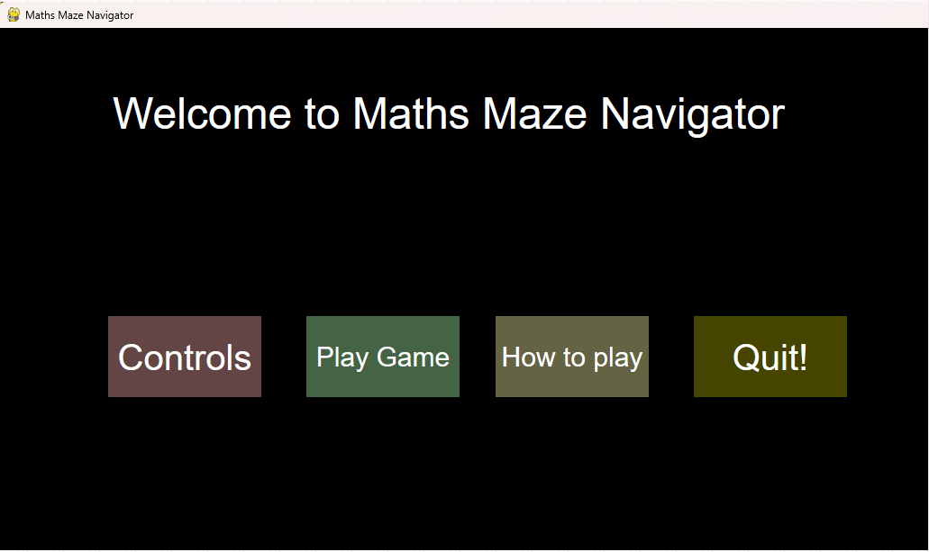

The colours used are the colours I will be using for the actual game (kind of random)

The next sketch will be of the ‘Controls’ screen

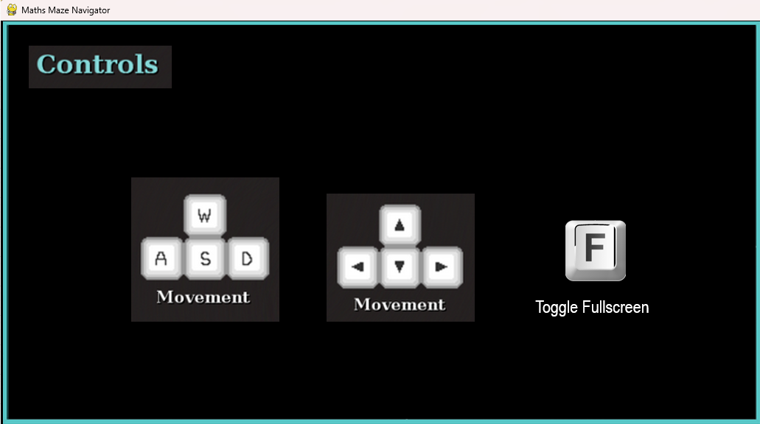

The user will be able to click anywhere on this screen to go back to the Start screen

The next sketch will be of the ‘Instructions’ screen

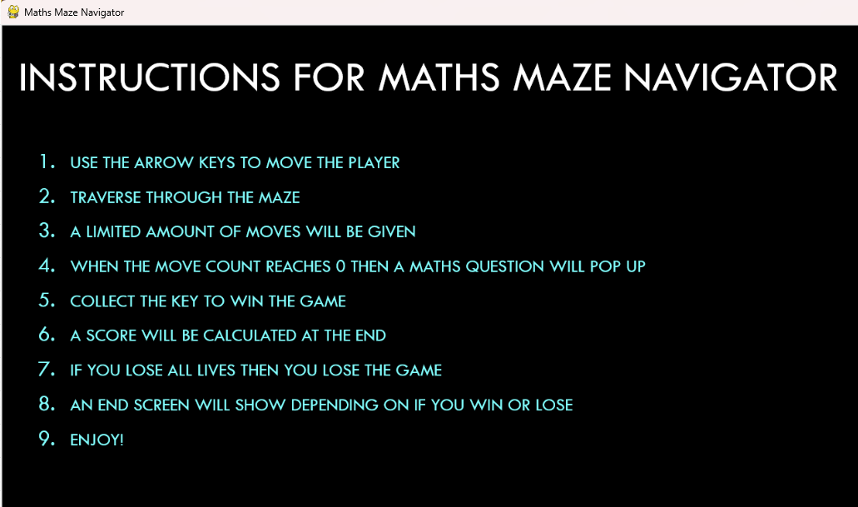

Again, the user will be able to click anywhere on this screen to go back to the Start screen

The next sketch will be of an example Question window - this will be a Tkinter window

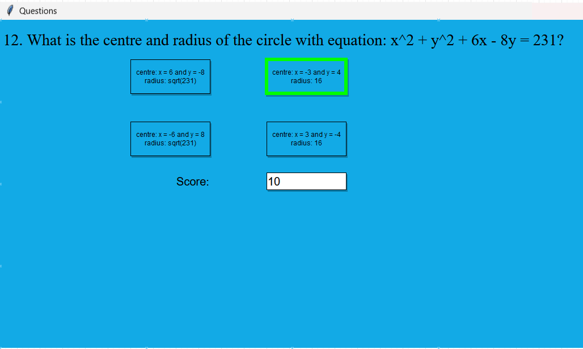

The user will be able to click on the 4 answer buttons - the correct answer is outlined with green in this sketch - however, it will not be in the actual game

The next sketch will be an animation of a character traversing through a maze

The google drive link to this animation is below:

<https://drive.google.com/file/d/1nY1k67gZWVVa84fEDGPvSQ5f-tIIi7dU/view?usp=share_link>



The maze will be white for the walls and blue for the cells - in the animation a red/black circle is shown, this is to make it clearer to see the player character

The next sketch will be of the Main game window after all the features have been added

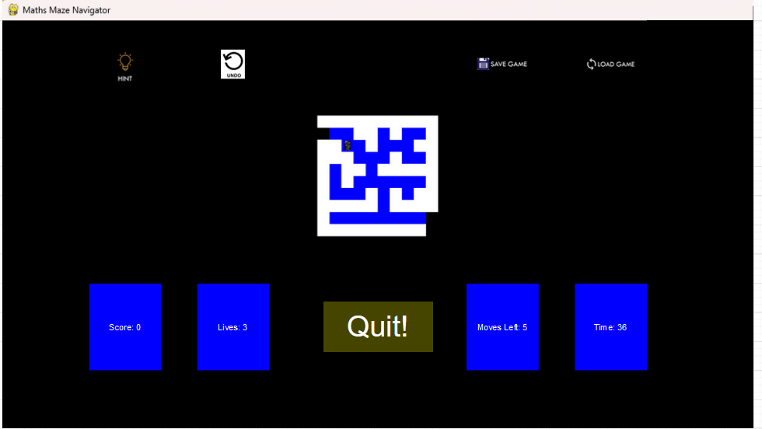

The top row shows the Hint button, Undo button, Save game button and Load game button. The middle row shows the Maze and the bottom row shows the Information Objects (which includes the Scoreboard, Lives counter, Moves counter and Timer) and Quit button. The colours and images used are the ones I will be using in the actual game.

The next sketch will be of the lose screen



The next sketch will be of the win screen



The next sketch will be of the save screen (screen shown after saving a game)

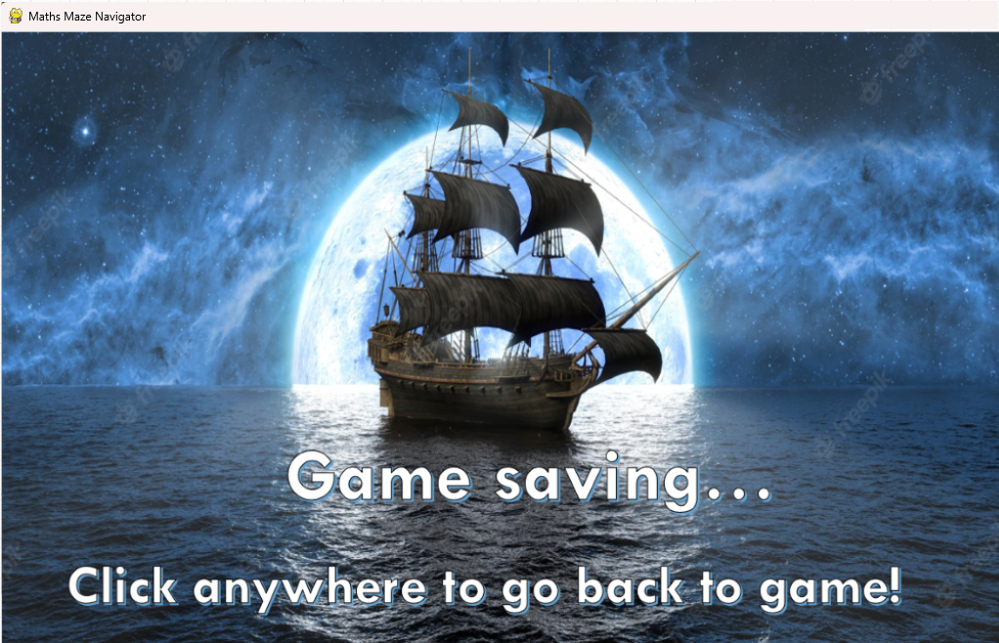

The next sketch will be of the load screen (screen shown after loading a saved game)

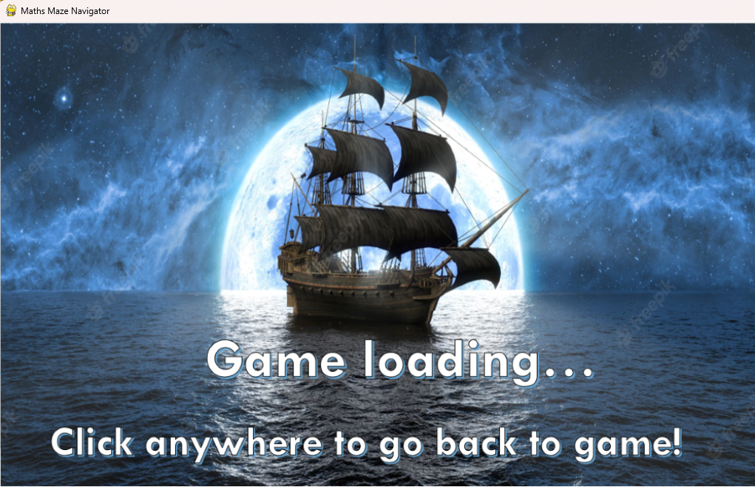

The next sketch will be of the first high scores screen

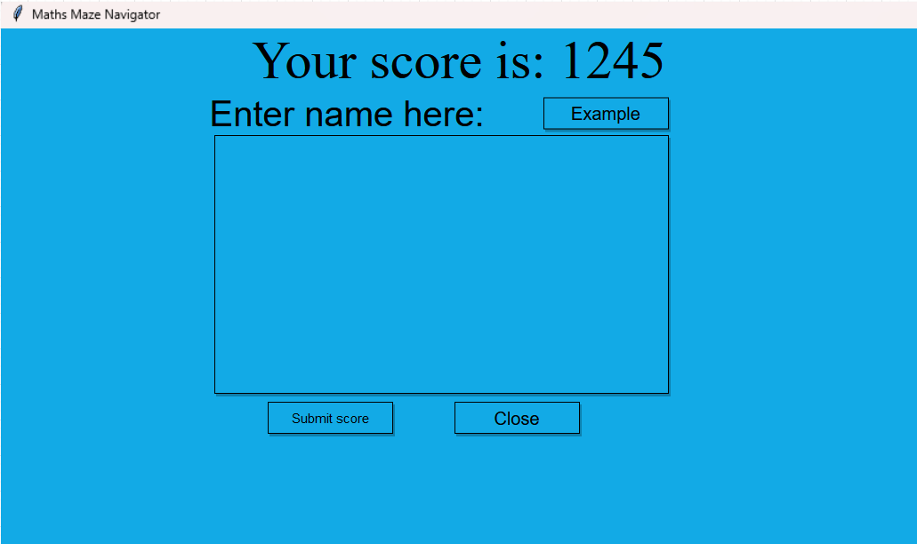

This screen will show the total score of the user, allow them to enter in a name and display a suitable error message if the name is not between 2 & 10 characters

The next sketch will be of the second high scores screen

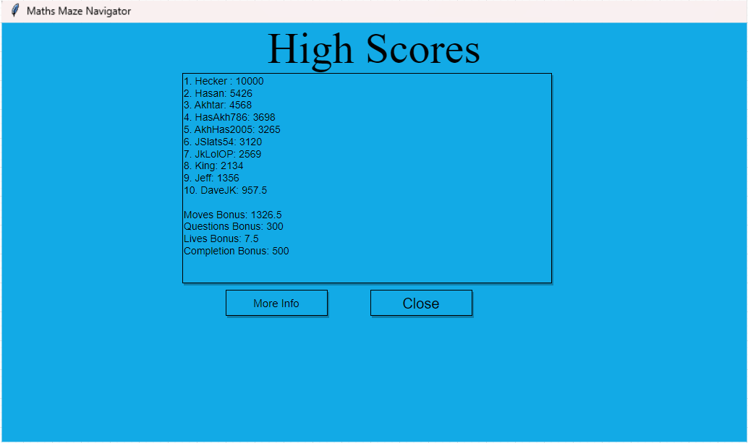

The last 4 lines in the text box will be revealed after the user clicks the ‘More Info’ button. The scores used are just example scores with example names.

The next and final sketch will be of the Question Select screen

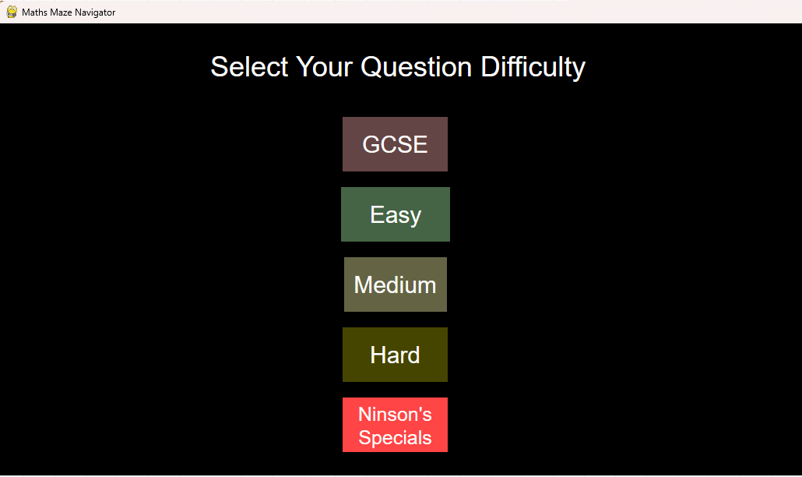

The user will be able to click one of the 5 buttons and then it will take them to the Main game

**Technical Solution**

**Overview:**

At the end of the technical solution a link to a video showcasing the full game (made by me) will be provided. The video will also be attached with my project.

There were a few modules that were used in the creation of this program:

Pygame - <https://www.pygame.org/wiki/about>

Tkinter - <https://docs.python.org/3/library/tkinter.html>

Random - <https://docs.python.org/3/library/random.html>

Time - <https://docs.python.org/3/library/time.html>

Also a few websites were used to aid with the development of this program. They are listed in the reference and include websites such as:

* <https://realpython.com/pygame-a-primer/> - initial tutorial for pygame basics
* <https://www.pygame.org/docs/> - check pygame features throughout project
* <https://realpython.com/python-gui-tkinter/> - initial tutorial for tkinter basics

A mini contents of this section is listed below:

* **PHASE 1:**
  + Player class [Player_class] (page 118)
  + Wall class [Maze_objects] (page 121)
  + Cell class [Maze_objects] (page 121)
  + Empty class [Maze_objects] (page 121)
  + pygame_window class [Main] (page 122)
  + Game class - version 1 [Main] (page 122)
  + generate_maze function [Main] (page 123)
  + create_paths function [Main] (page 123-125)
  + Key class [Maze_objects] (page 126)
* **PHASE 2:**
  + Scoreboard class [Information_objects] (page 129)
  + Lives class [Information_objects] (page 129)
  + Moves class [Information_objects] (page 130)
  + Timer class [Information_objects] (page 130)
  + Title class [Starting_objects] (page 132)
  + Controls class [Starting_objects] (page 133)
  + Play class [Starting_objects] (page 133)
  + Instructions class [Starting_objects] (page 133)
  + Quit class [Starting_objects] (page 133)
  + controlsImage and instructionsImage classes [Other_objects] (page 134)
  + start_screen class [Main] (page 134-135)
  + controls_screen class [Main] (page 135)
  + instructions_screen class [Main] (page 136)
  + Game class - version 2 [Main] (page 136)
  + winScreen and loseScreen classes (page 139)
  + Game class - version 3 [Main] (page 139)
  + win_screen class [Main] (page 140)
  + lose_screen class [Main] (page 140)
* **PHASE 3:**
  + App class [Maths_quiz] (page 142)
  + get_questions function [Maths_quiz] (page 142)
  + Window class [Maths_quiz] (page 143)
  + Results class [Maths_quiz] (page 144)
* **PHASE 4:**
  + screens class {interface} [Main] (page 148)
  + GameSave class [GameSave_class] (page 149)
  + SaveButton and LoadButton classes [Information_objects] (page 150)
  + SS_image and LS_image classes [Other_objects] (page 151)
  + save_screen class [Main] (page 152)
  + load_screen class [Main] (page 152-153)
  + HighScores class [HighScores_class] (page 157)
  + high_scores_screen1 class [Main] (page 158)
  + high_scores_screen2 class [Main] (page 159)
* **PHASE 5:**
  + Text1 class [QS_objects] (page 161)
  + Button1 - Button5 classes [QS_objects] (page 162-163)
  + QuestionSelect_screen class [Main] (page 163-164)
  + Game class - version 4 [Main] (page 166)
  + get_questions function [Main] (page 166)
  + QuestionWindow [Main] (page 168)
  + MovesStack [Stack_class] (page 174)
  + UndoButton [Information_objects] (page 175)
* **PHASE 6:**
  + recursiveSolve function [Main] (page 178)
  + revealHint function [Main] (page 178)
  + HintButton [Information_objects] (page 179)
* **PHASE 7:**
  + Text2 class [Other_objects] (page 183)
  + loading_screen class [Main] (page 183-184)

A list of key technical features, with directions as to where they are discussed in the document, can be seen below:

* OOP (Object Oriented Programming)
  + OOP used throughout e.g. many classes used such as the Player class, Title class, pygame_window class and many, many more [e.g page 118 & 119]
  + Inheritance used to inherit from screens (an interface) and also for sprites to inherit from general sprite class (in pygame module) [e.g. page 163]
  + Compositional association used to instantiate screens e.g. start_screen, controls_screen, win_screen, QS_screen etc within the Game class and also instantiate the sprites within the different screens e.g pygame_window, lose_screen, save_screen etc. [e.g. page 122]
  + Interface used (screens) - base class for 7+ subclasses [Page 148]
* Prim’s algorithm implementation [Page 123-125]
  + 2 dimensional array used to store maze (True for Cell, False for Wall)
  + Random module used to select wall from array
* Recursive solving implementation [Page 178]
  + 2 dimensional array used to store solved path (True for Cell, False for Wall)
  + Used as part of the hints system to reveal part of the maze path to the user
  + Depends on visited 2D array
* Merge sort [Page 157]
  + Used to sort out the high scores before re-writing the file
* File handling
  + Used to get Maths questions from file [Page 142 & 166]
  + Also used to get high scores from file [Page 157-159]
  + Used to re-write high scores with new score added [Page 157-159]
  + Also used to write game info to a file when saving the game [Page 149 & 152]
  + Used to load game info from a file when loading a previously saved game [Page 149 & 152-153]
* Save/Load game feature [Page 150-153]
  + This allows the user to save the game and so key details about the game are written to a file
  + It also allows the user to load in a previously saved game
* Undo game feature [174 & 175]
  + Queue data structure used to store previous moves that user has made
* Advanced programming style
  + OOP used for all code
  + Interface used as base class for a few classes
  + Subprograms used to group similar classes together
  + Methods and Objects encapsulated and localised, getter methods used to pass attributes to main part of program/other classes
  + Code laid out logically and classes confined to their function only - no class is handling bits of everything
  + Classes are kept separate and communicate together when required.

**Phase 1:**

The first thing I decided to do was to create my Player class. This was done as a subprogram and commented throughout.

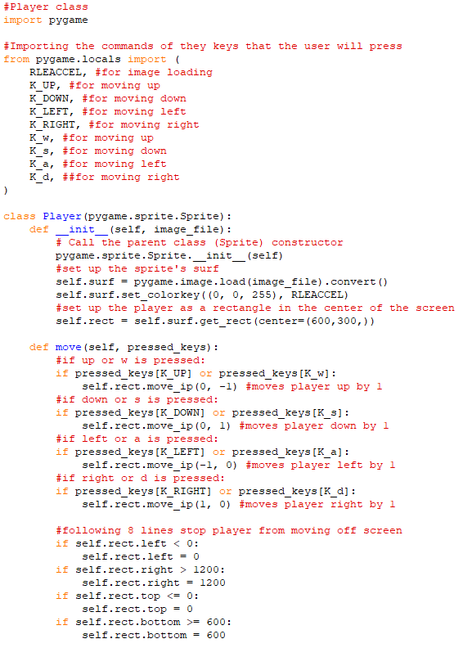

I then decided to test it by initialising pygame and creating an instance of Player.

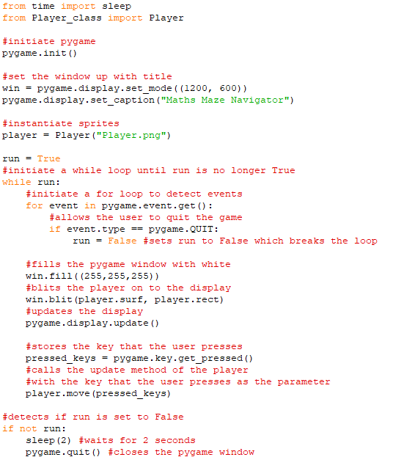 Here is the program running in pygame: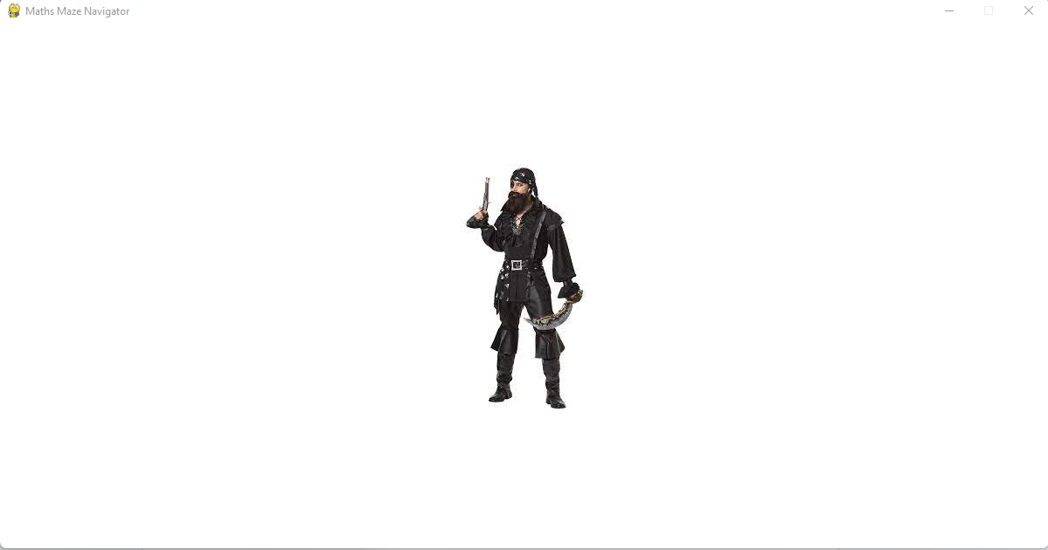

After pressing RIGHT once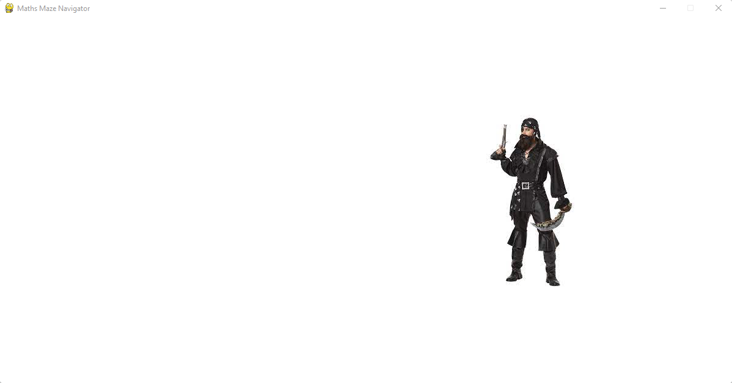

After pressing UP once:

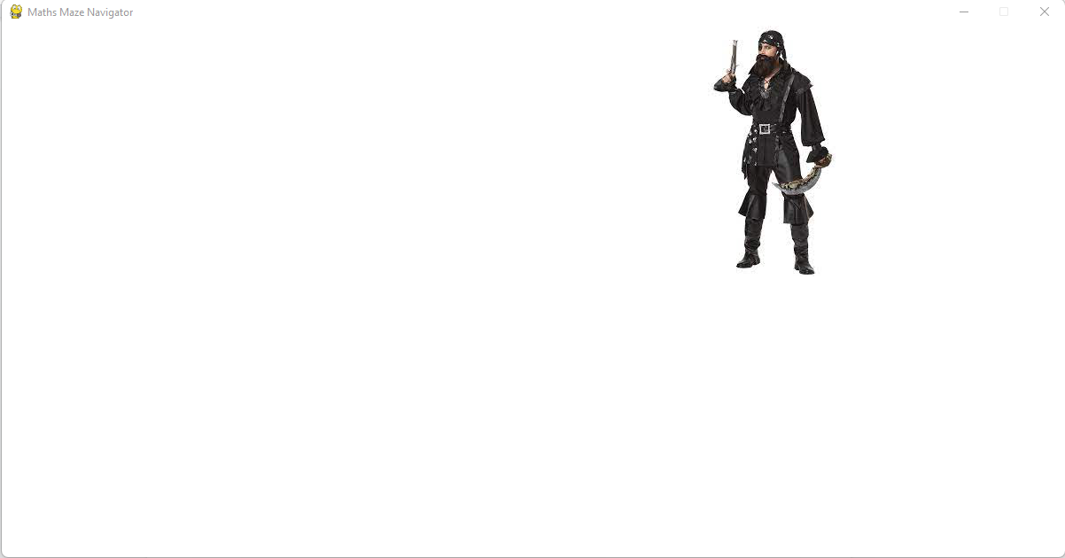

After pressing LEFT multiple times:

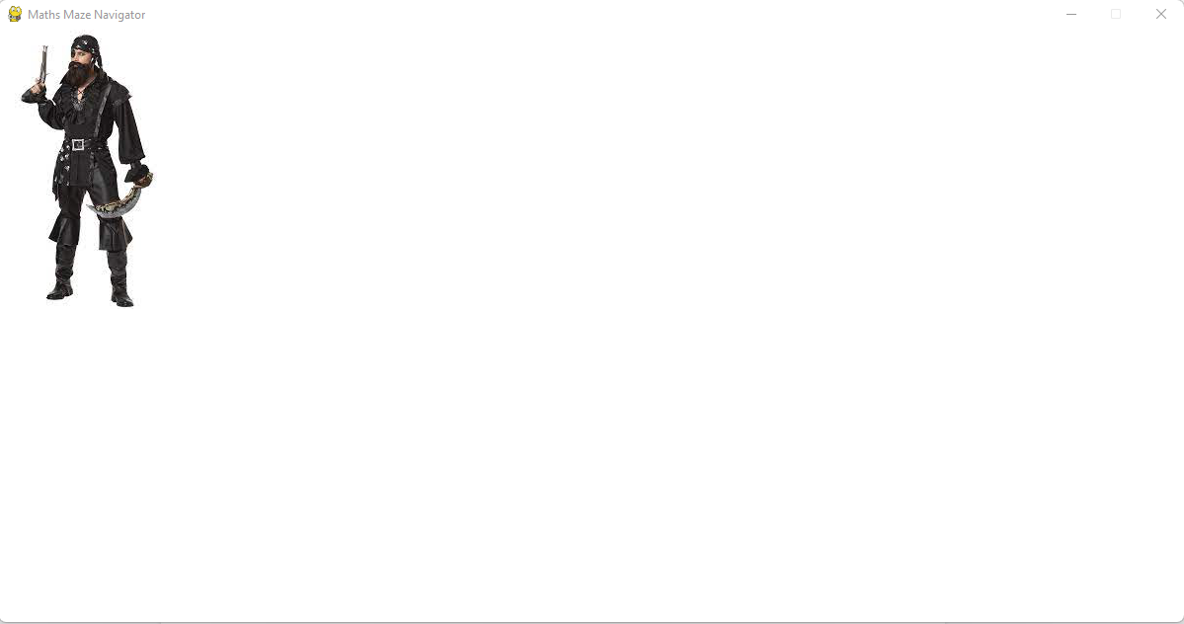

After pressing DOWN multiple times:

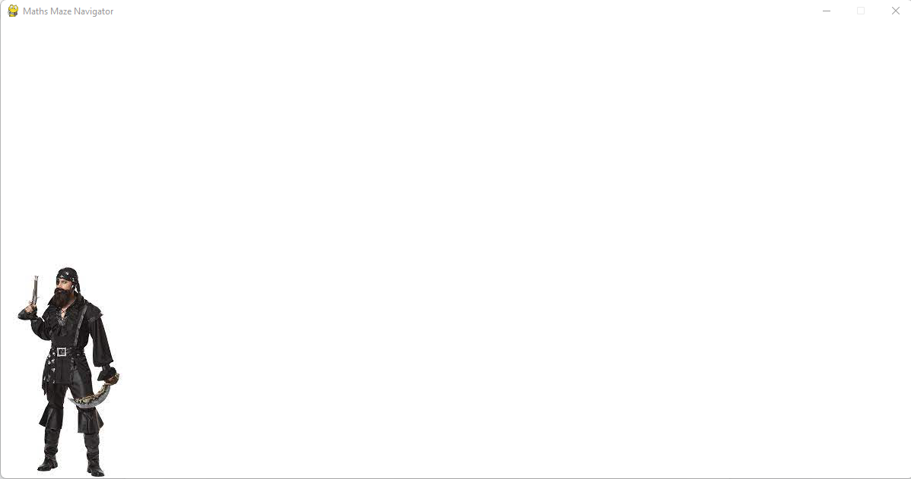

Next I decided to create the Cell, Wall and Empty classes. These were also done in a sub program and commented throughout.

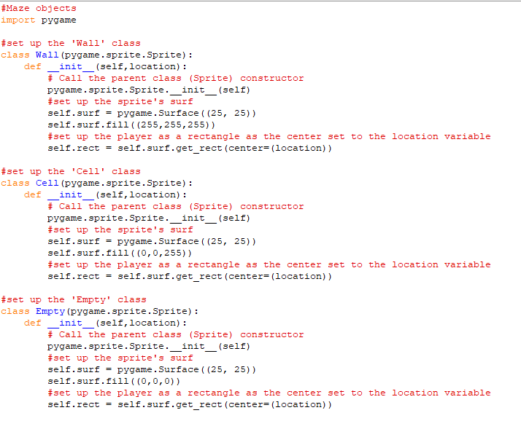

I then decided to make my ‘pygame_window’ class with a ‘display’ method

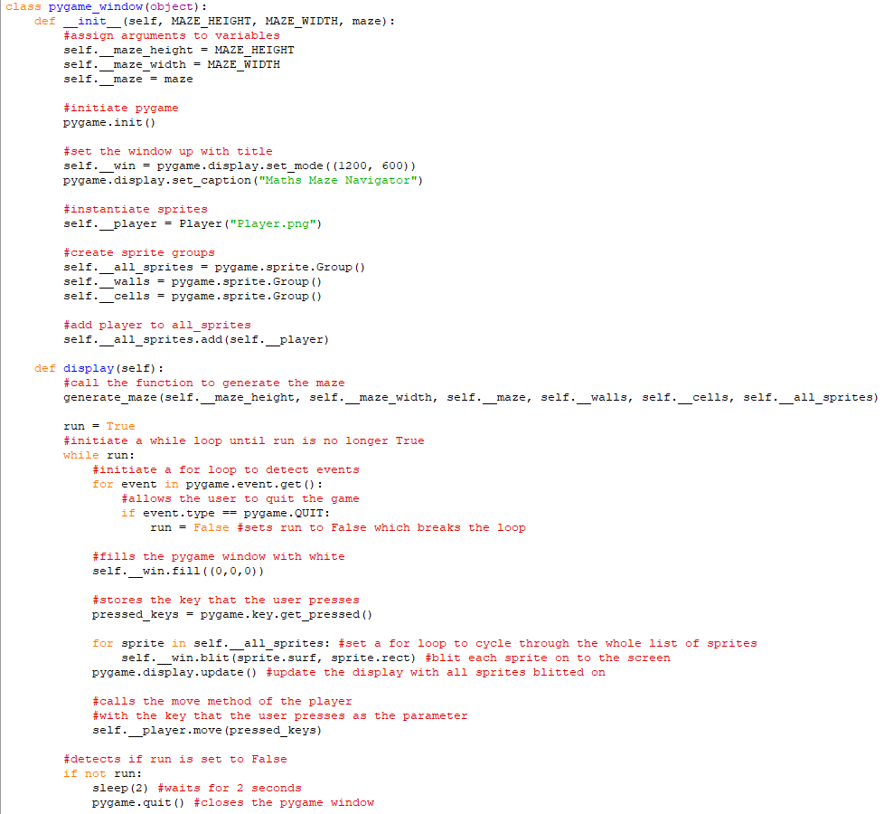

I then decided to use an object oriented approach to update my main program

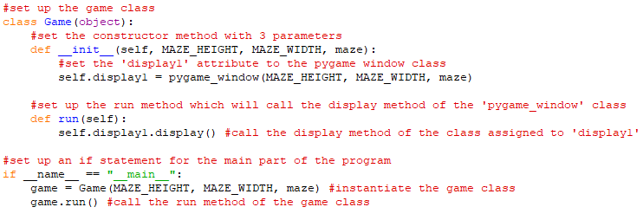

Next I worked on my ‘generate_maze’ procedure

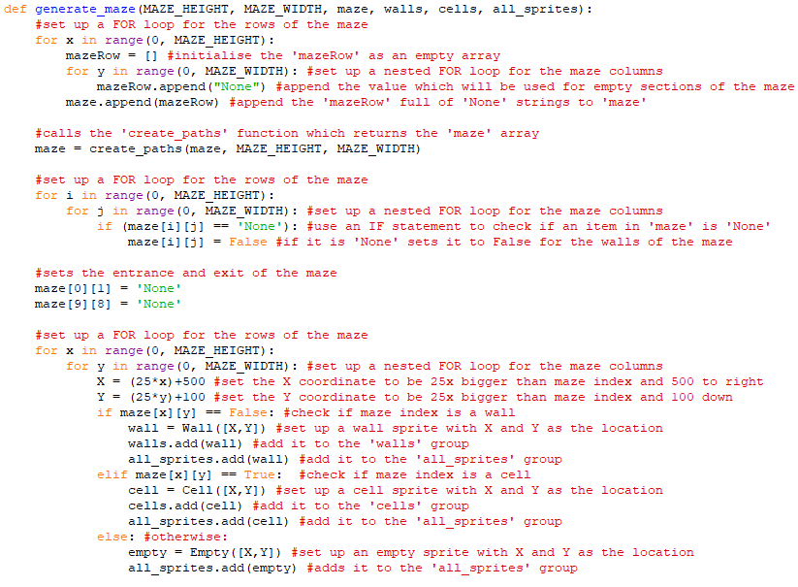

This includes the ‘create_paths’ function which will also return the maze array

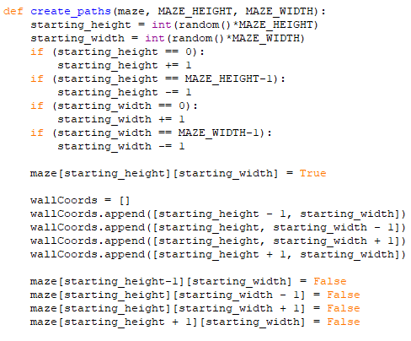

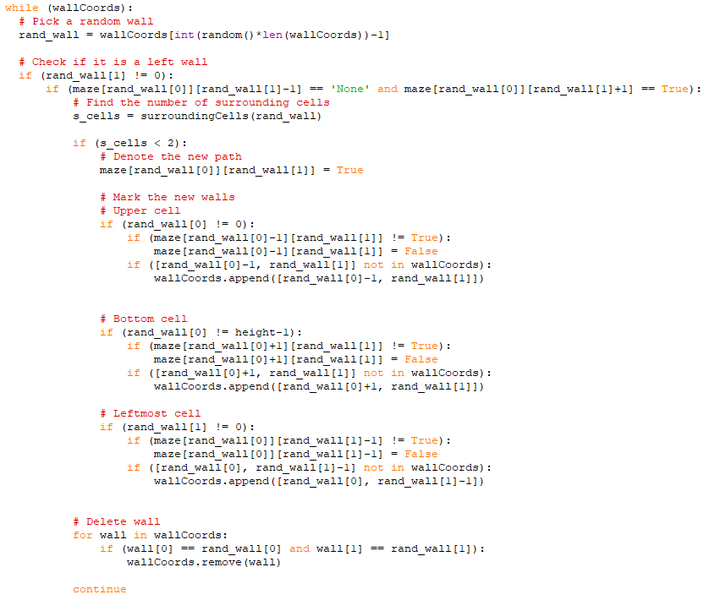

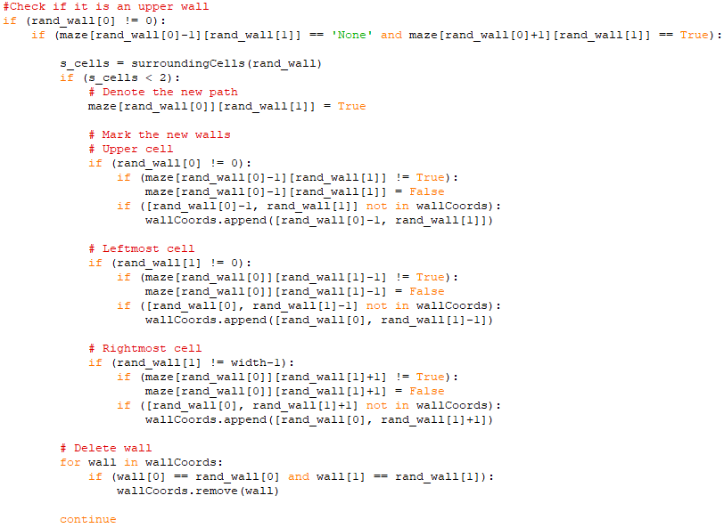

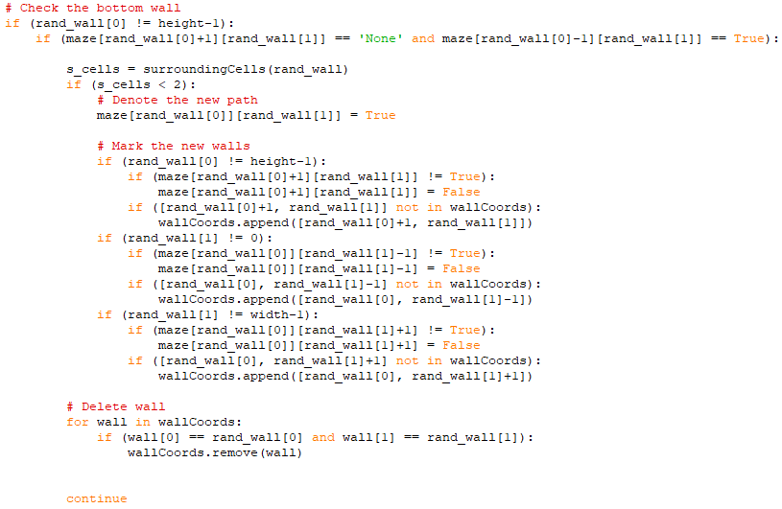

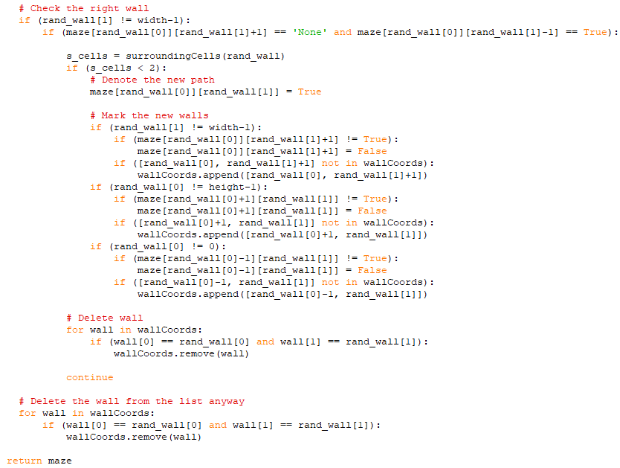

Above is the python implementation of Prim’s algorithm (the above 4 screenshots) which is used within the *create_paths* function. See documented design [page 62] for more info.

Then there were to be some more small little tweaks before it was ready for modular testing

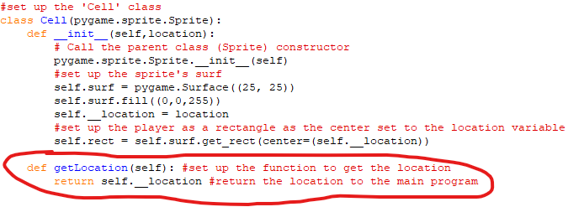

A getLocation method was added to the Cell class

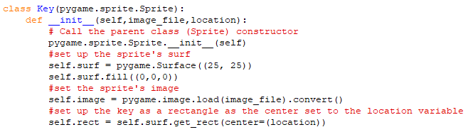

A Key class was added

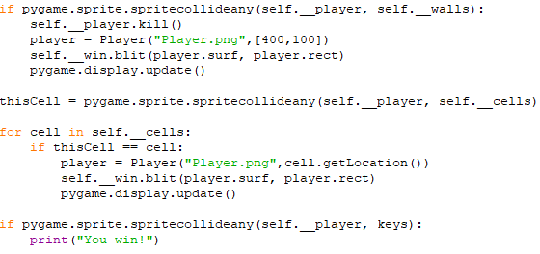

Collision detection with Walls, Cells and Keys was added

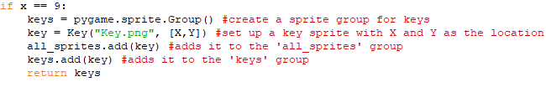

Initialising the key and adding it to 2 sprite groups was added

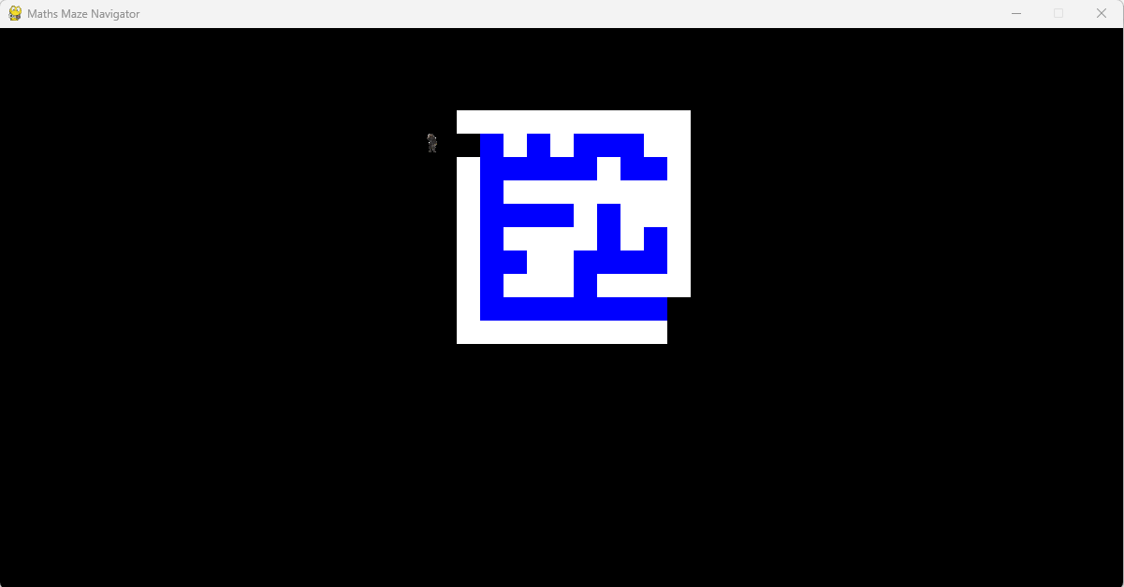

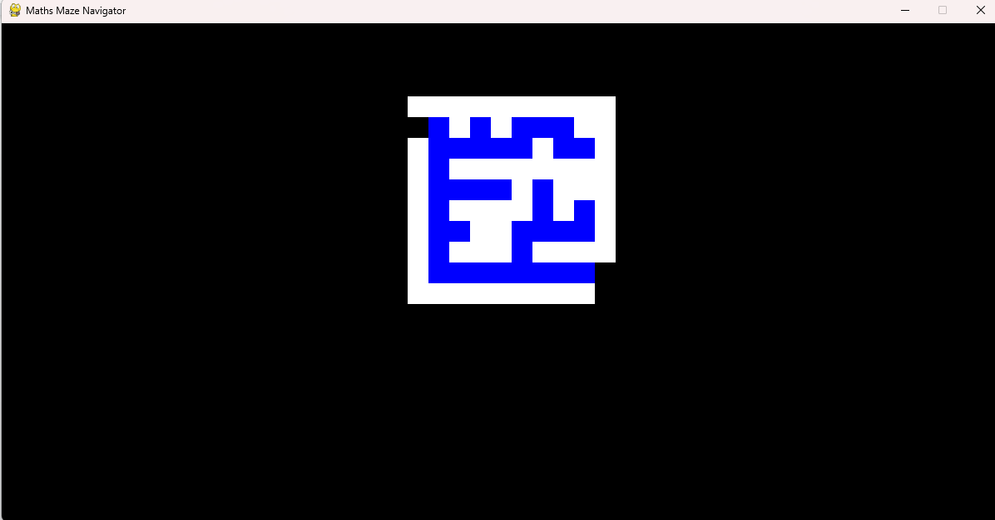

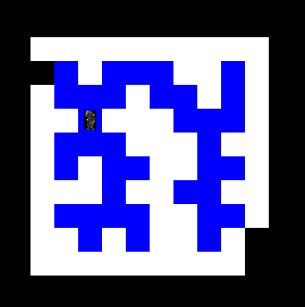

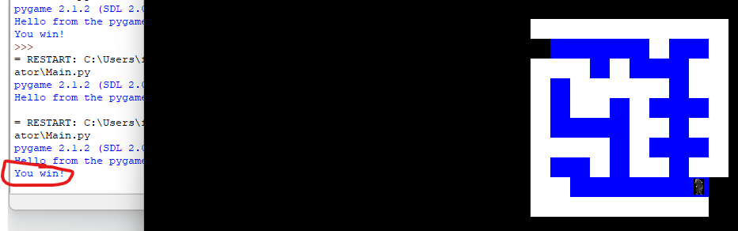

This was phase 1 of the testing and game development

**Phase 2:**

To begin with phase 2 introduced some ‘Information objects’ as part of the game. These include the scoreboard, lives counter, moves counter and timer. Also to be added were a start screen and 2 end screens - one for winning and one for losing.

Firstly I decided to create the Scoreboard class. This was done in a subprogram which also included the lives counter, moves counter and timer classes.

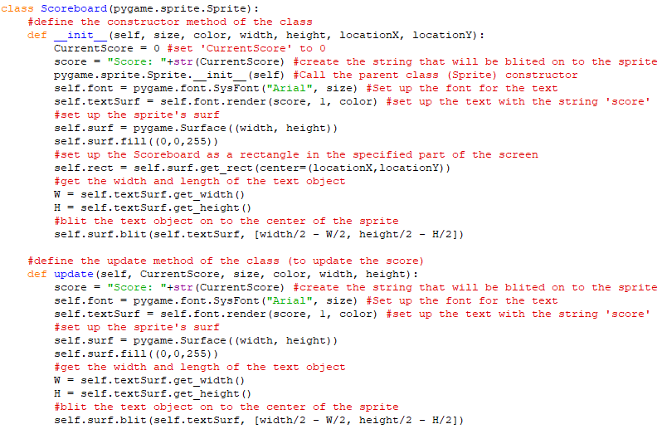

Next I created the Lives counter class - in the same subprogram.

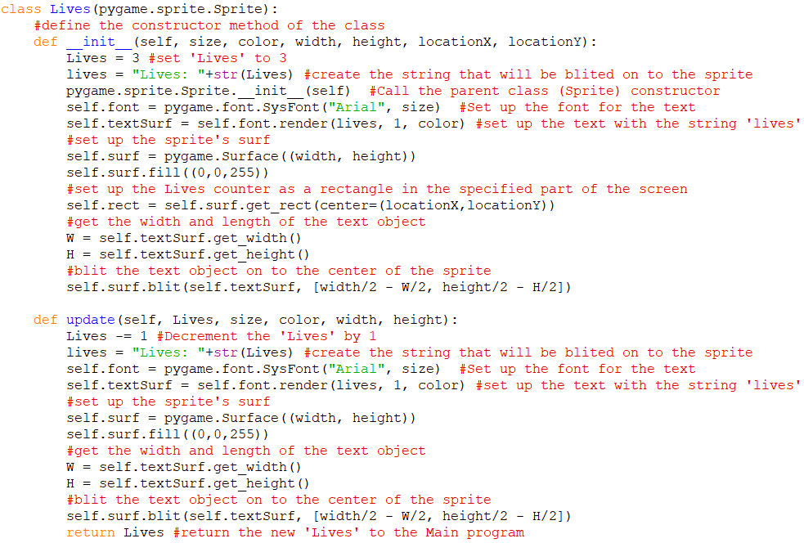

Then I created the Moves counter class - also in the same subprogram.

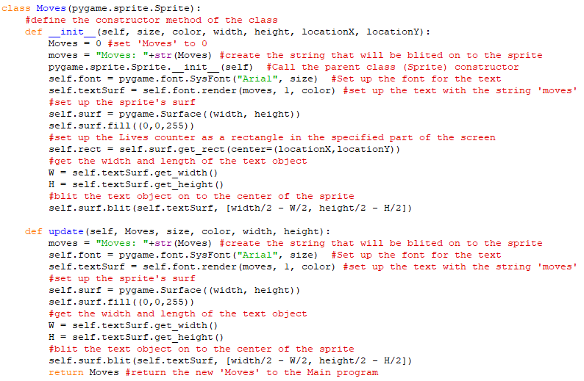

Finally, in the same subprogram, I created the timer class in the similar way to the previous three classes.

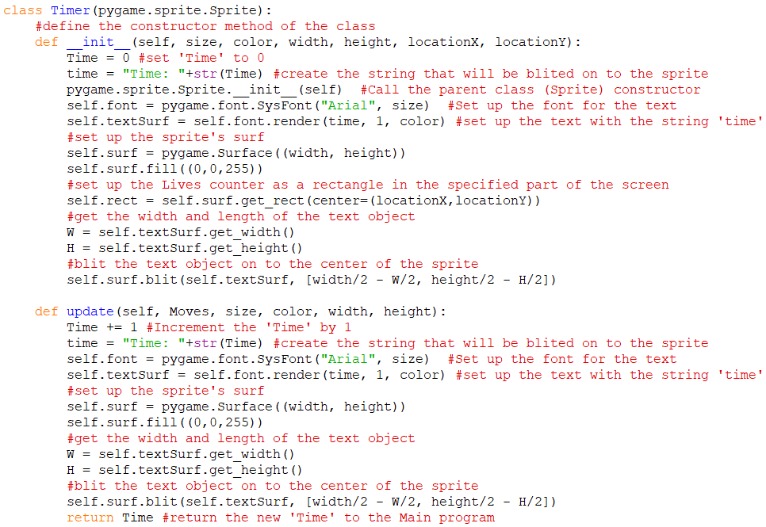

Next the ‘move’ method of the ‘Player’ class was updated

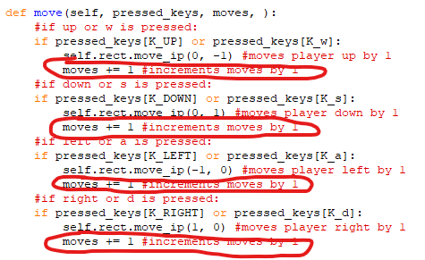

Then the constructor of the pygame window in the Main program was updated to include instantiation of the Scoreboard, Lives counter, Moves counter and Timer.

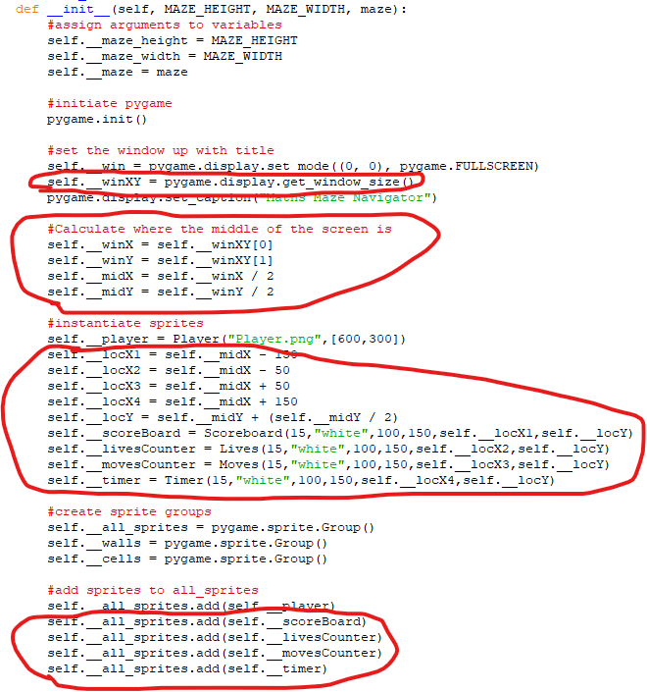

Next I had to include the update methods of the Information objects at appropriate times

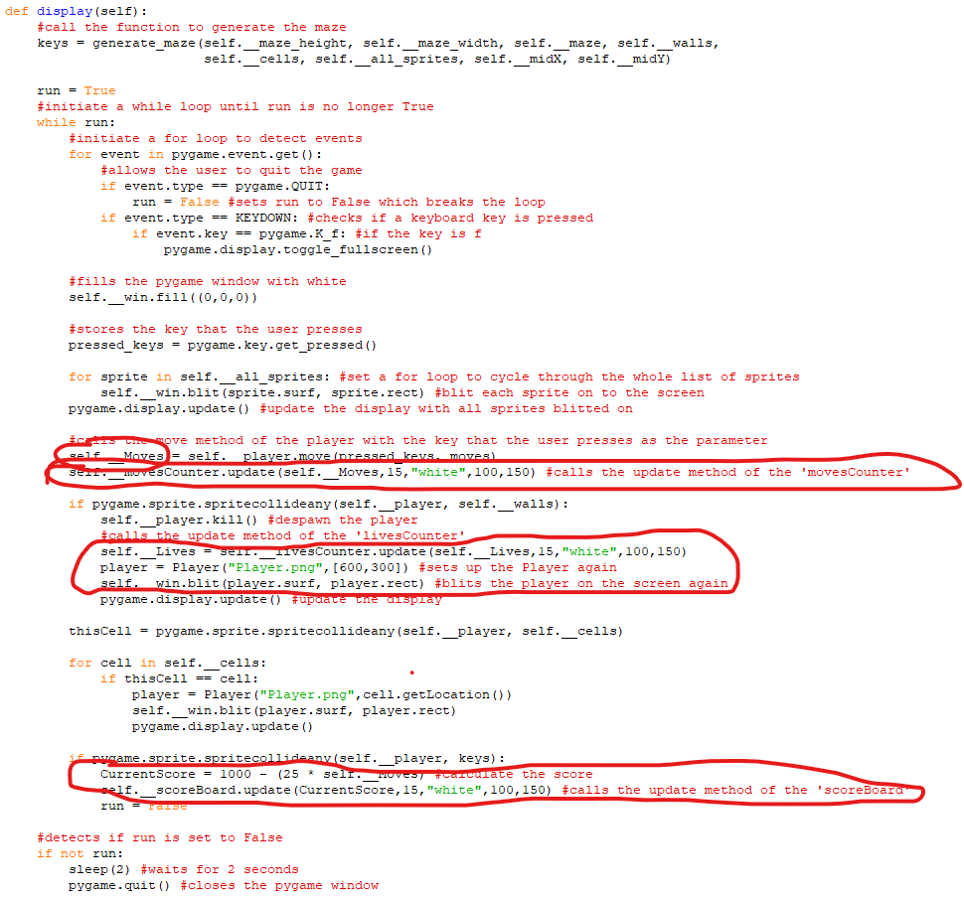

After this, the next stage was to make and call a start screen method to show the start screen. First the objects were made in a subprogram called ‘Starting_objects’

The first class that was made was the ‘Title’ object class

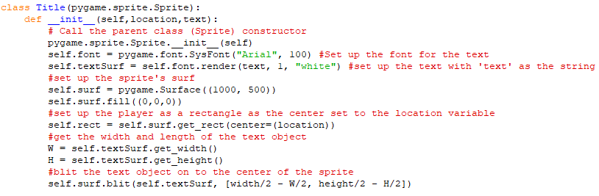

The next 2 classes were the ‘Controls’ and ‘Play’ button classes

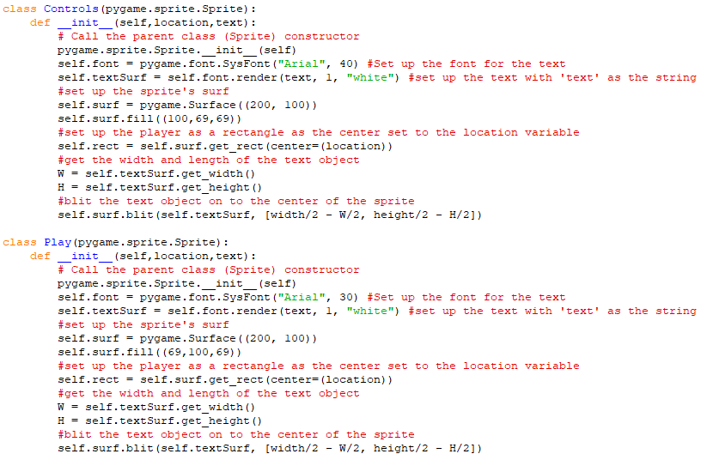

The final 2 classes in this subprogram were the ‘Instructions’ and ‘Quit’ button classes

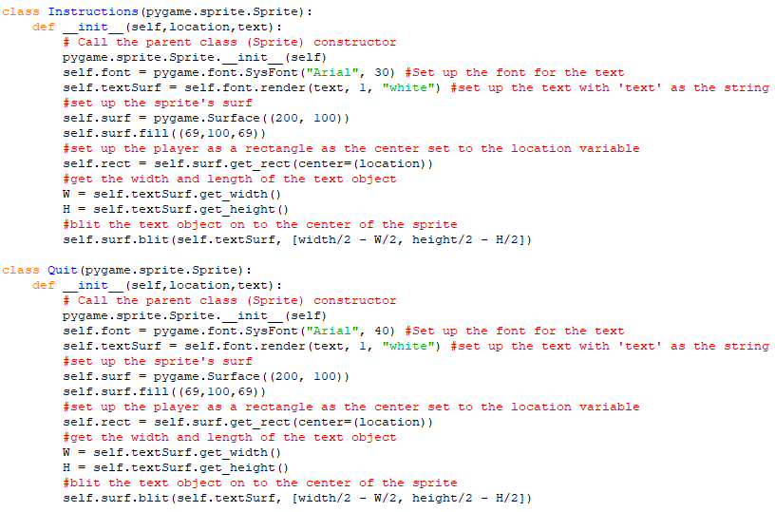

Then the classes for the image sprites for the controls and instructions were made

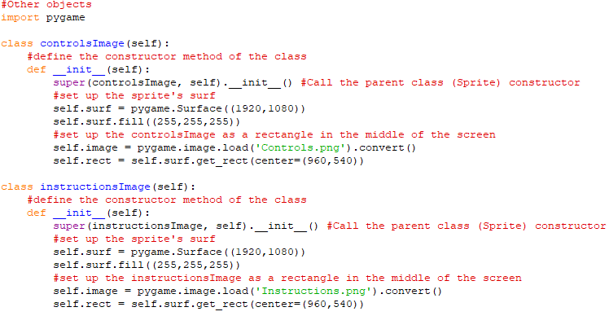

Then the ‘start_screen’ class was made with its constructor method

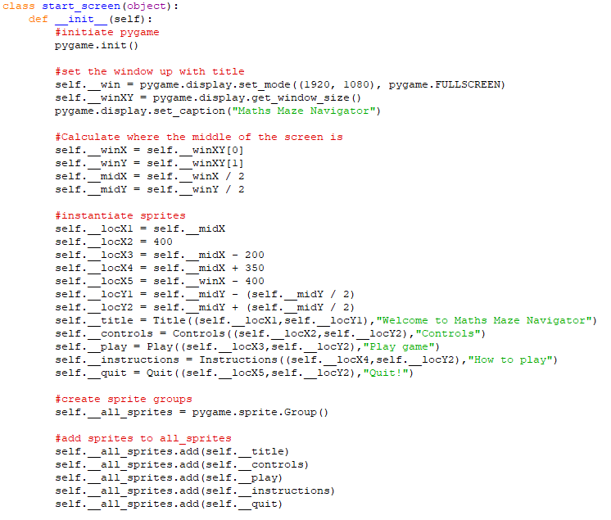

Its ‘display’ method was made

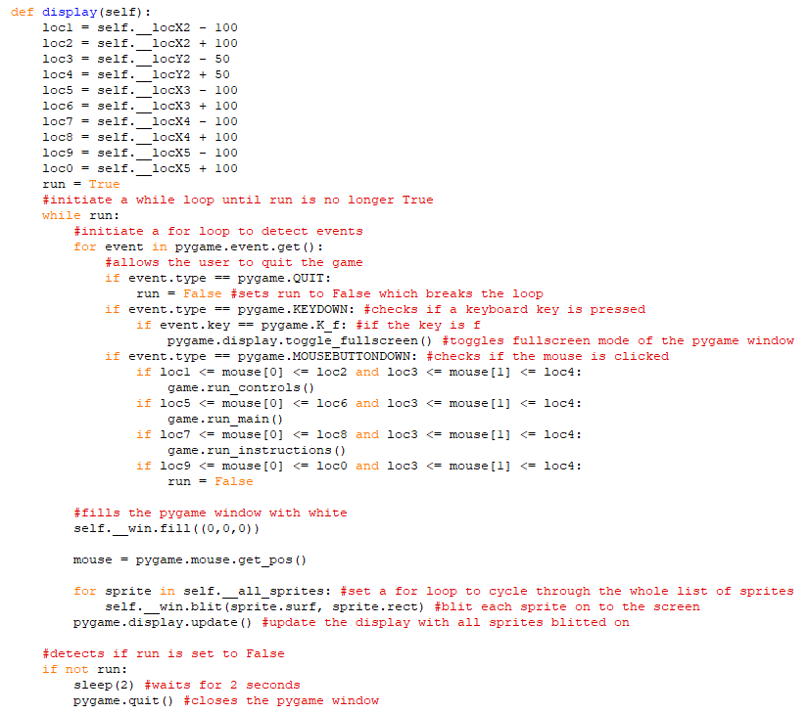

Next the ‘controls_screen’ class was created with its constructor and display methods

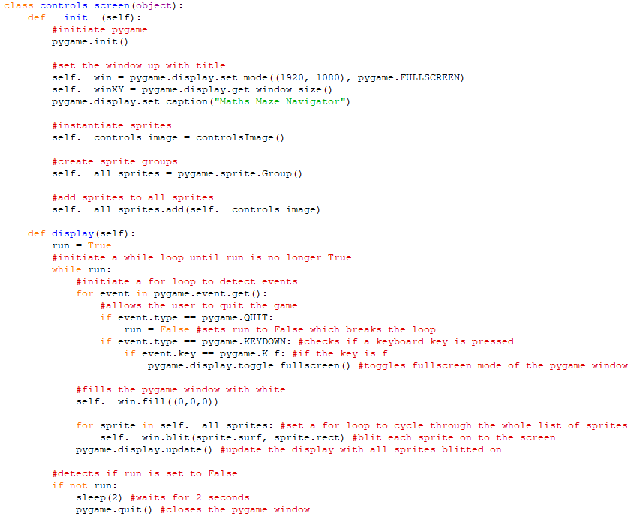

Next the ‘instructions_screen’ class was created with its constructor and display methods

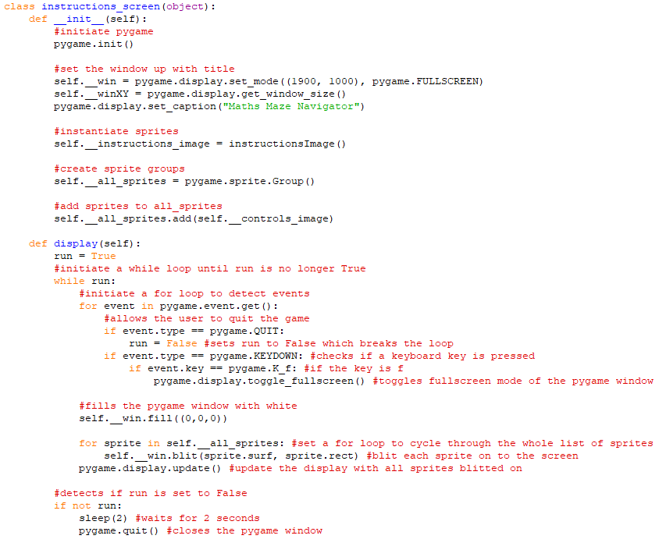

Finally for the start screen, the game class was updated

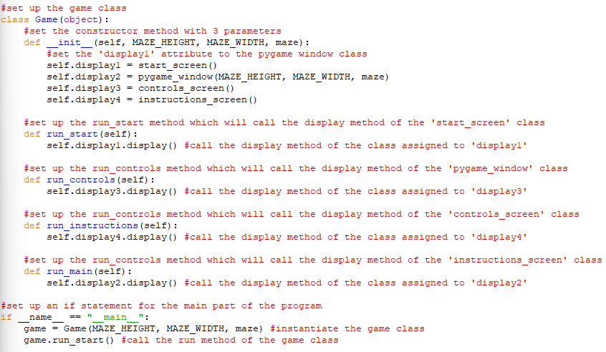

Here are a few screenshots of the program running at this point so far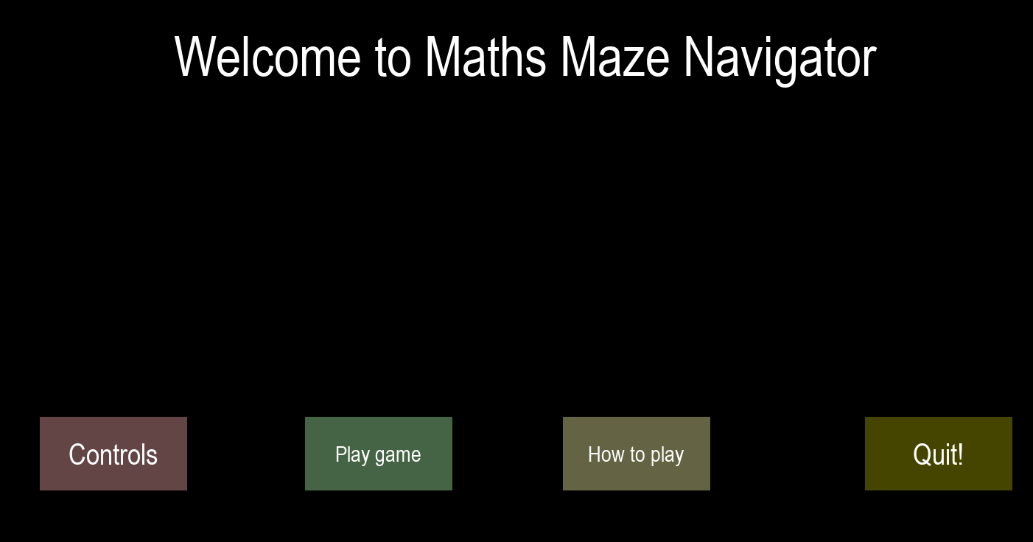

After clicking ‘Controls’: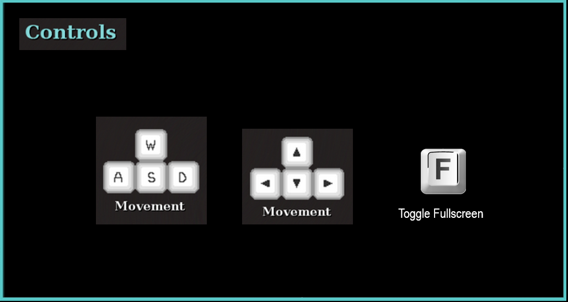

You can also click anywhere to go to the game from the ‘Controls’ or the ‘Instructions screen’

After clicking ‘Play game’:

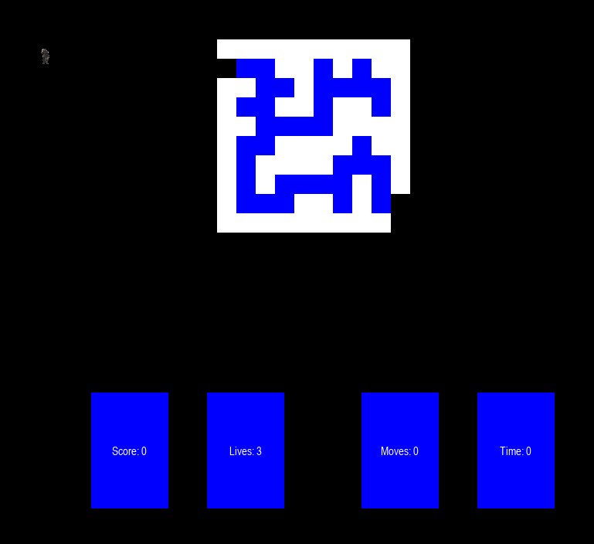After clicking ‘How to play’: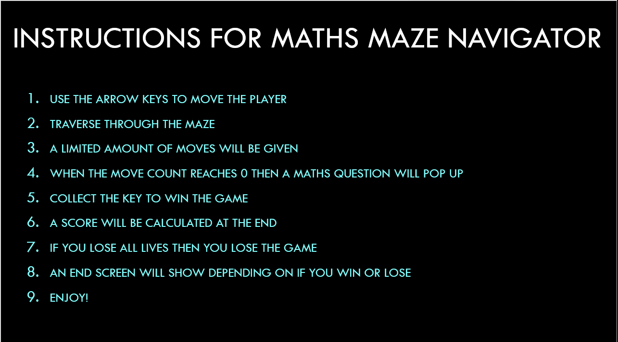

I then added the classes for the win screen and lose screen in the ‘other objects’ subprogram.

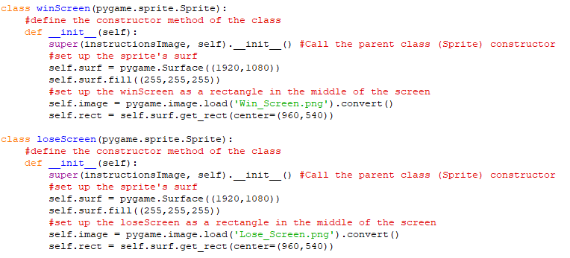

Next the ‘Game’ class was updated to include methods for the win screen and lose screens.

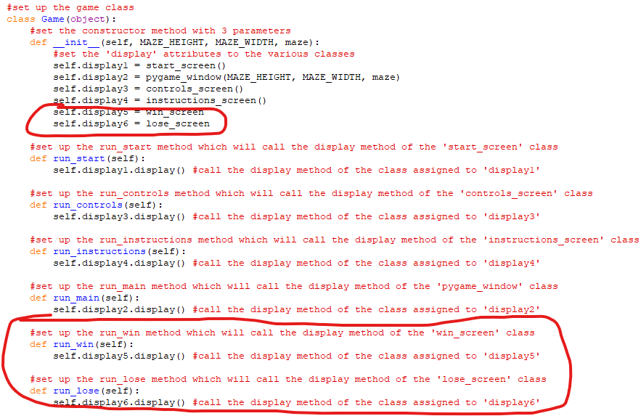

Finally for this phase, the ‘win_screen’ and ‘lose_screen’ classes were created.

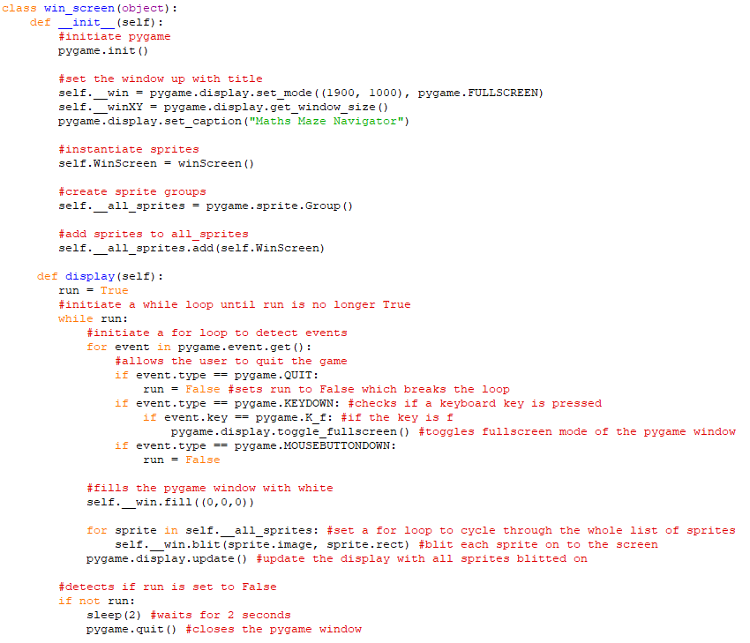

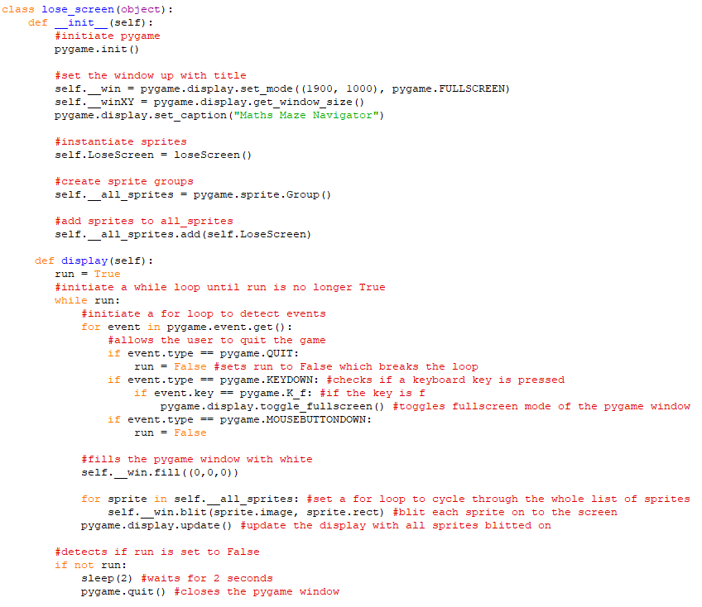

Also the calls of these methods was implemented into the ‘pygame_window’ class

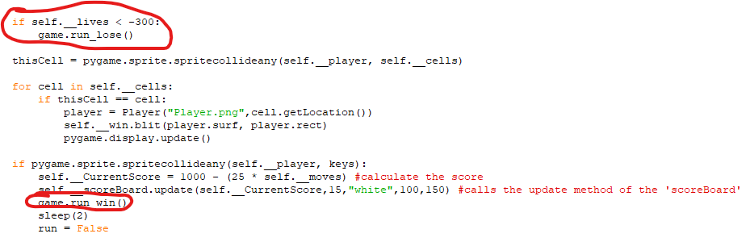



**Phase 3:**

In this phase I created the Maths side of the game using Tkinter and the questions from a file.

Firstly the app class and main part of the program was created

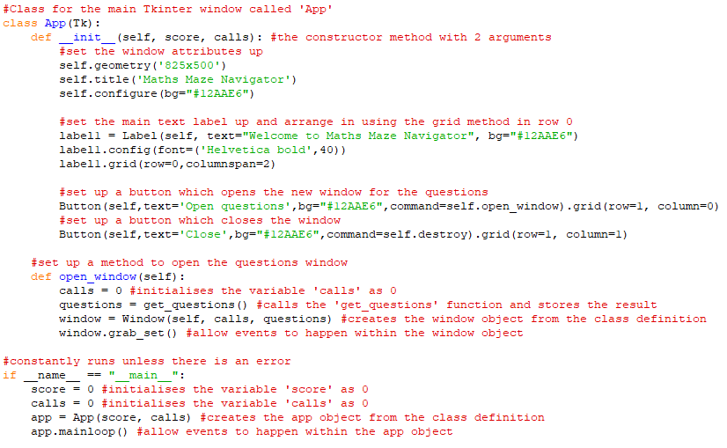

Then the ‘get_questions’ function was created which imports the questions from a file and returns them in a 2D array.

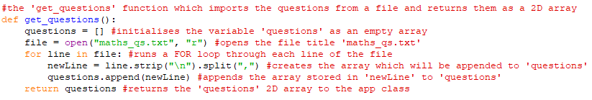

The output of questions can be shown below:

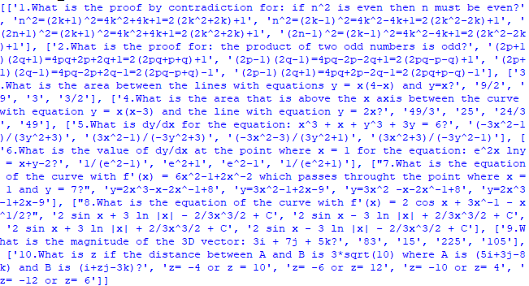

Next the ‘Window’ class was set up which would show the questions, 4 possible answers and allow the user to answer the question. It would also allow the user to go to the next question or close the window.

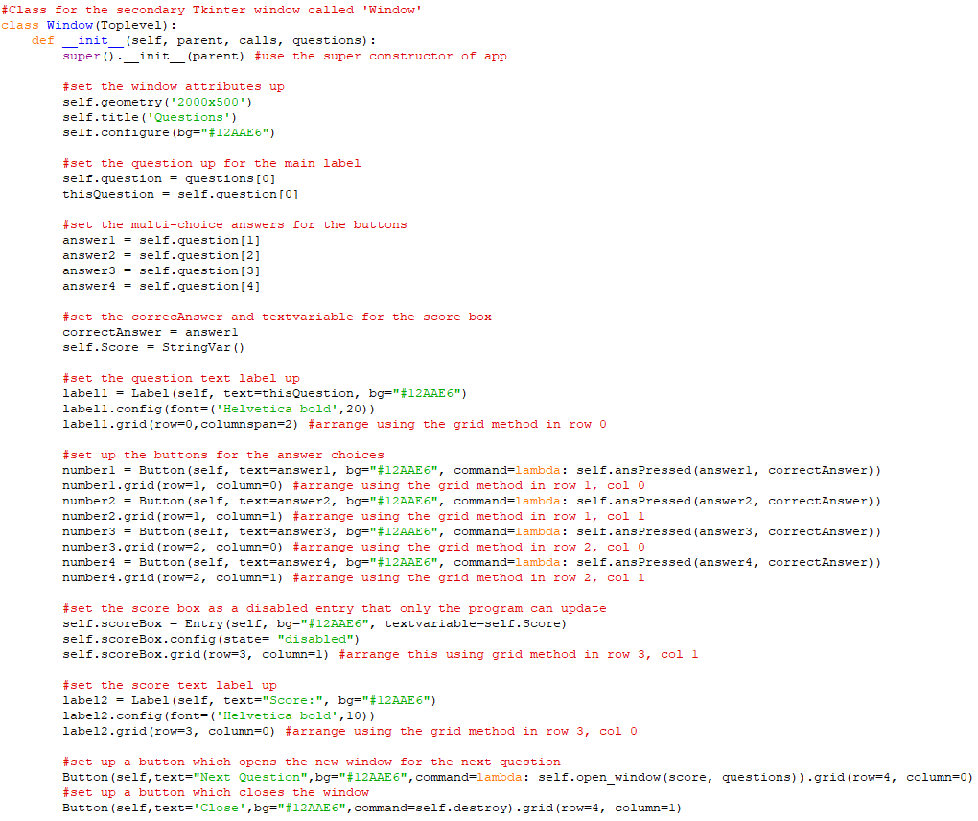

Its method for updating the score when a question was answered was also included.

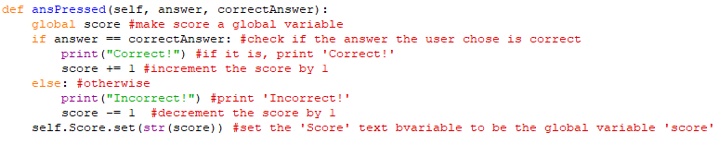

Also its method for opening the next question was included.

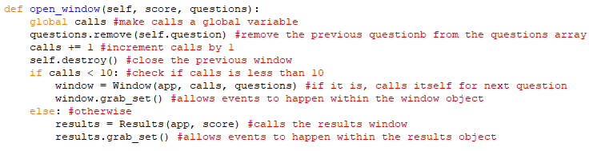

Finally for this phase, the ‘Results’ class was created to show the final results.

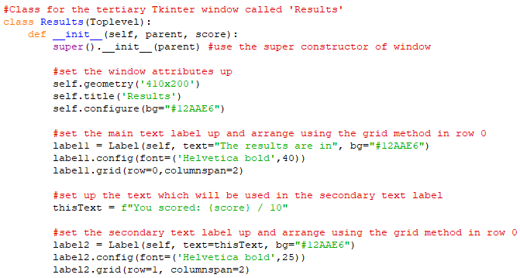

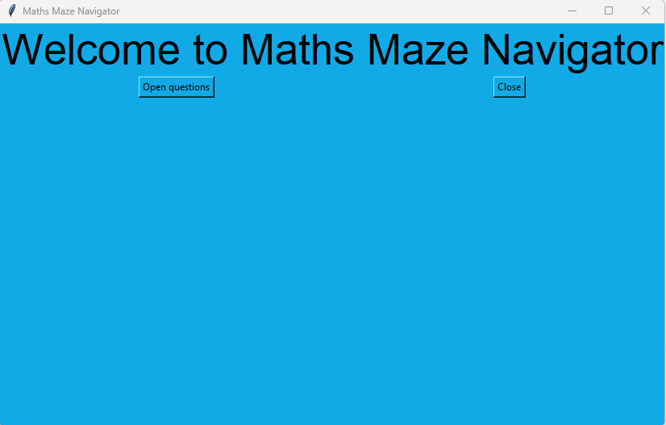

After clicking ‘Open questions’: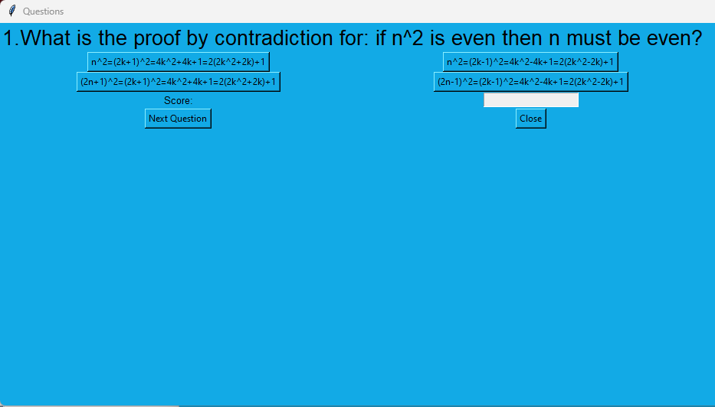

After clicking option 2: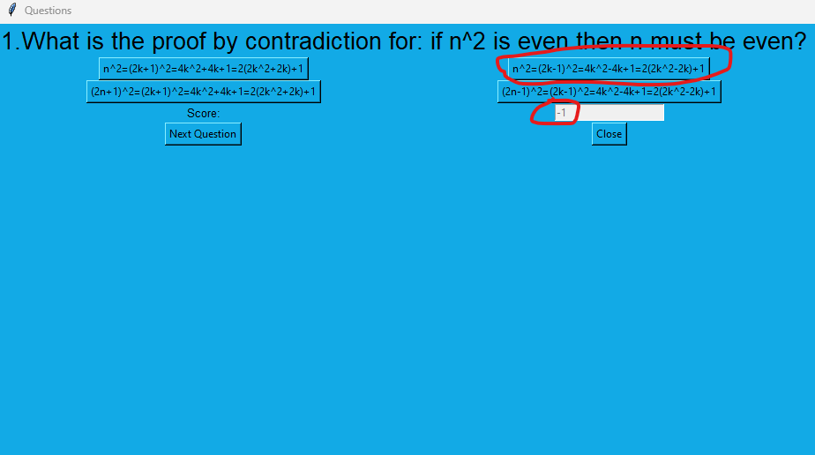

After clicking ‘Next Question’: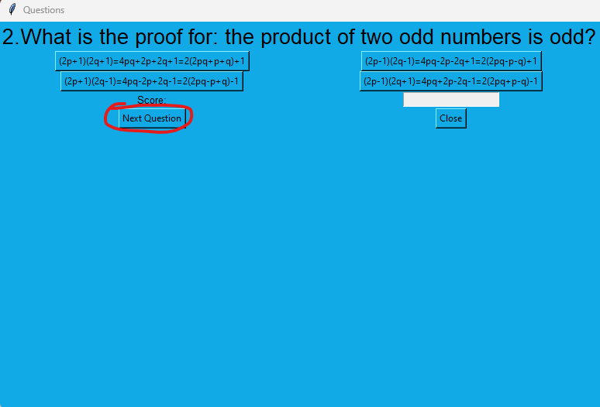

After clicking option 1: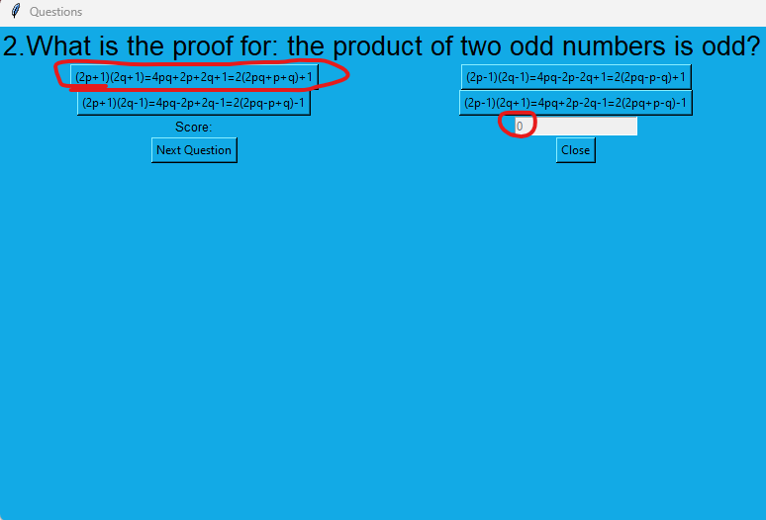

After clicking ‘Next Question’ then option 1:

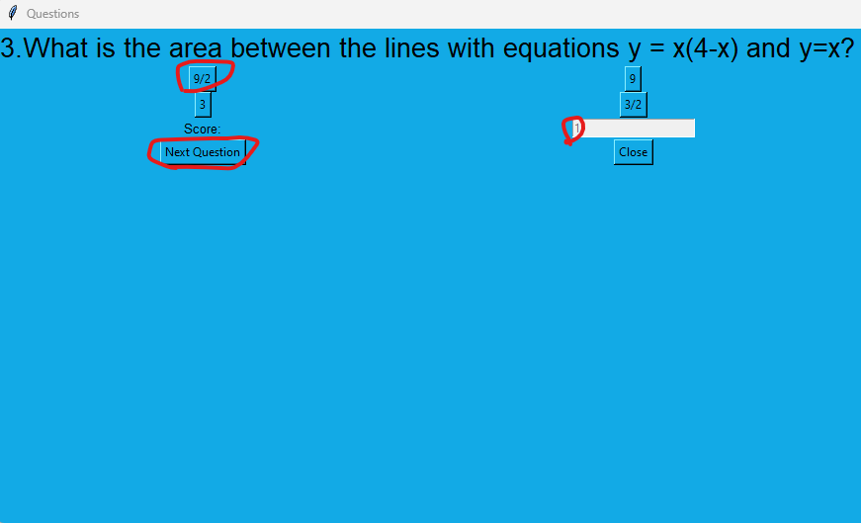

After further clicks of ‘Next Question’ and the correct option:

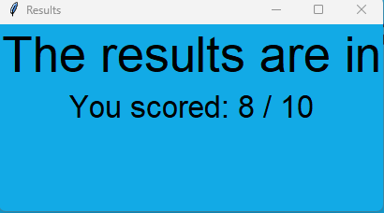

**Phase 4:**

This phase was about improving the code from Phase 2 to include a save and load game buttons and more features. It also introduced a high scores system.

Firstly, the timer class was implemented properly so the timer updates every second.

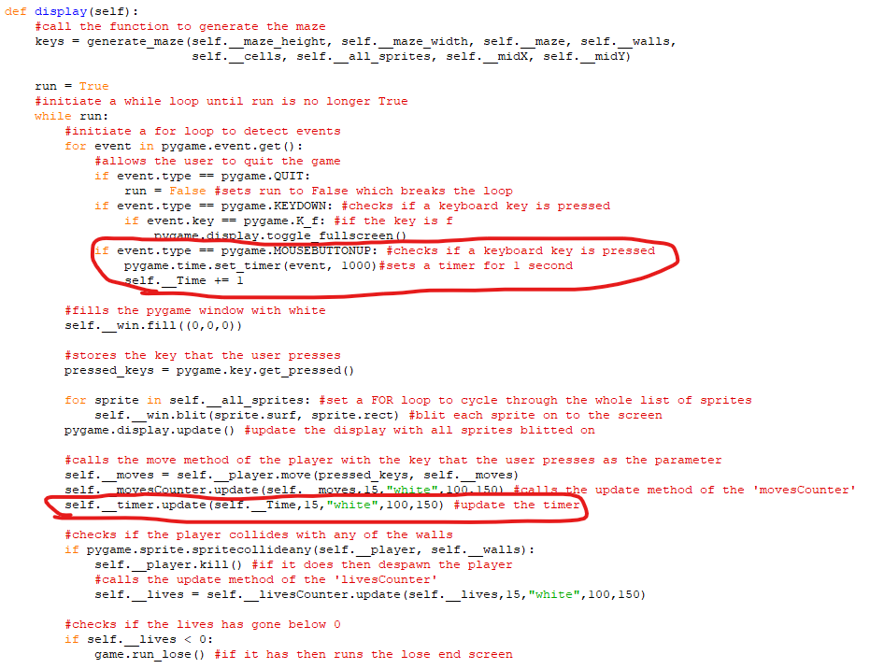

Next, the screens interface was added which was currently the base class for the 6 screen classes which were start_screen, pygame_window, controls_screen, instructions_screen win_screen(), lose_screen()

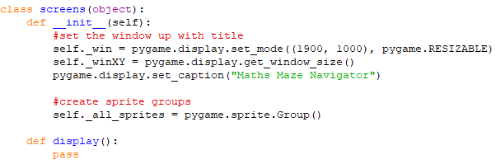

The next thing to do was to start making the save/load game feature.

Firstly, the ‘GameSave’ class was made in a new subprogram with 3 methods.

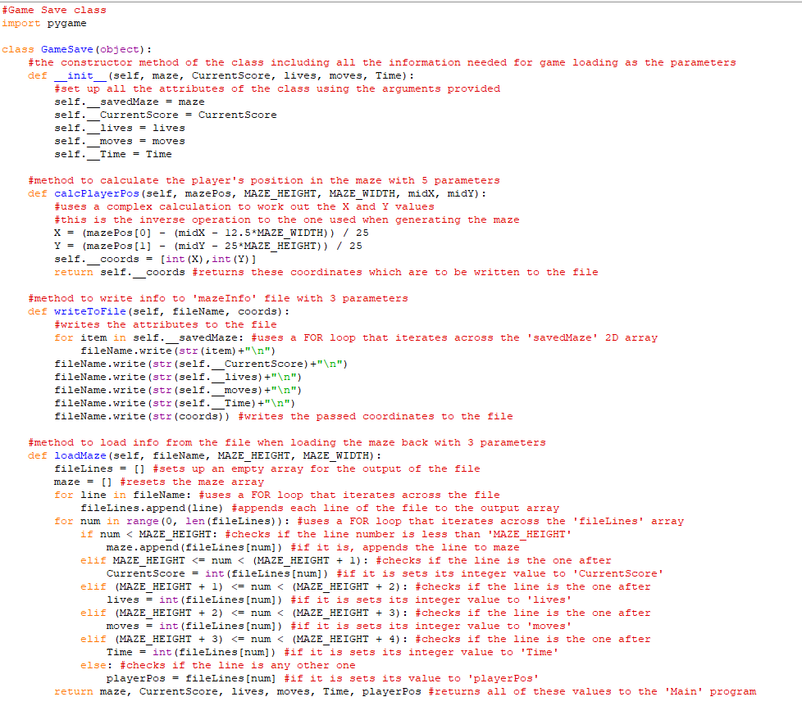

Also, a visited 2D array was added to show the squares in the maze that the player has visited.

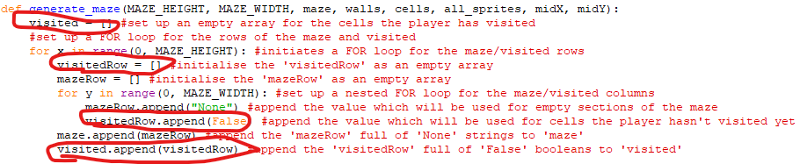

Next, a SaveButton and LoadButton classes were added in the ‘Information_objects’ subprogram.

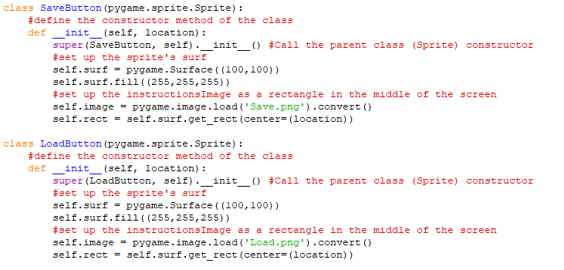

Here is the game with the Save Button and Load Button displayed.

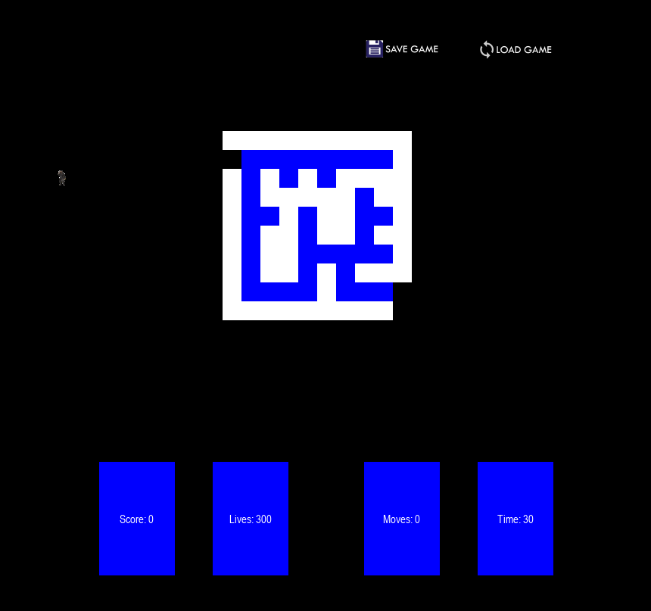

The sprites for the MoveButton and LoadButton were initialised and blitted on to the screen.

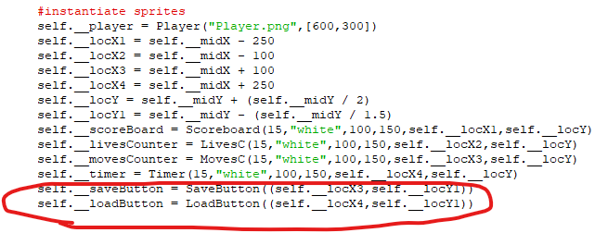

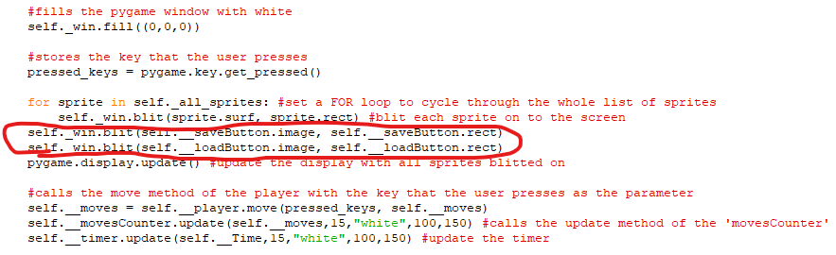

The ‘SS_image’ and ‘LS_image’ classes were set up in the ‘Other_objects’ subprogram.

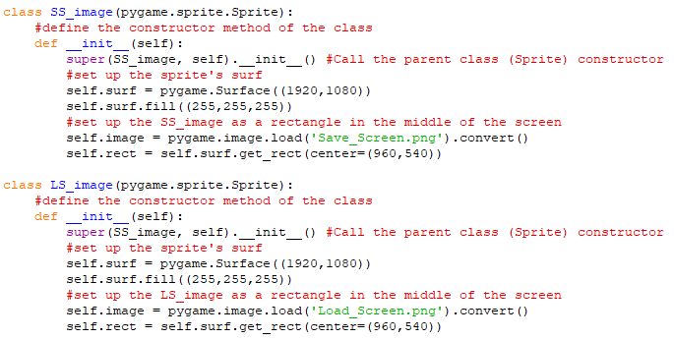

Then, in the ‘Main’ program a ‘save_screen’ class was created with ‘display’ and ‘save’ methods.

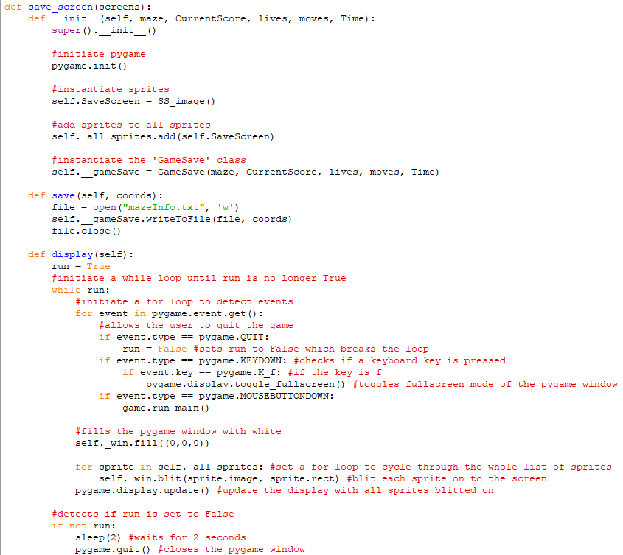

Also a ‘load_screen’ class was created with ‘display’, ‘load_maze‘ and ‘load_game’ methods.

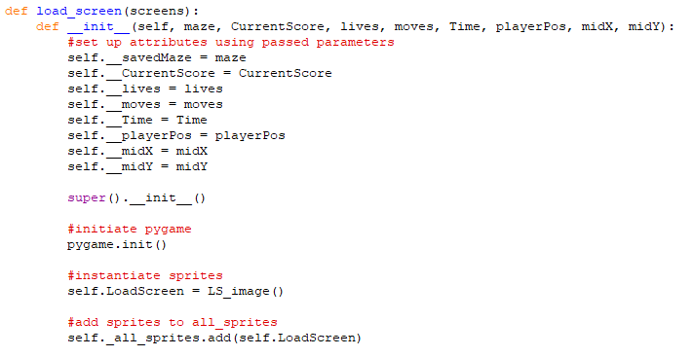

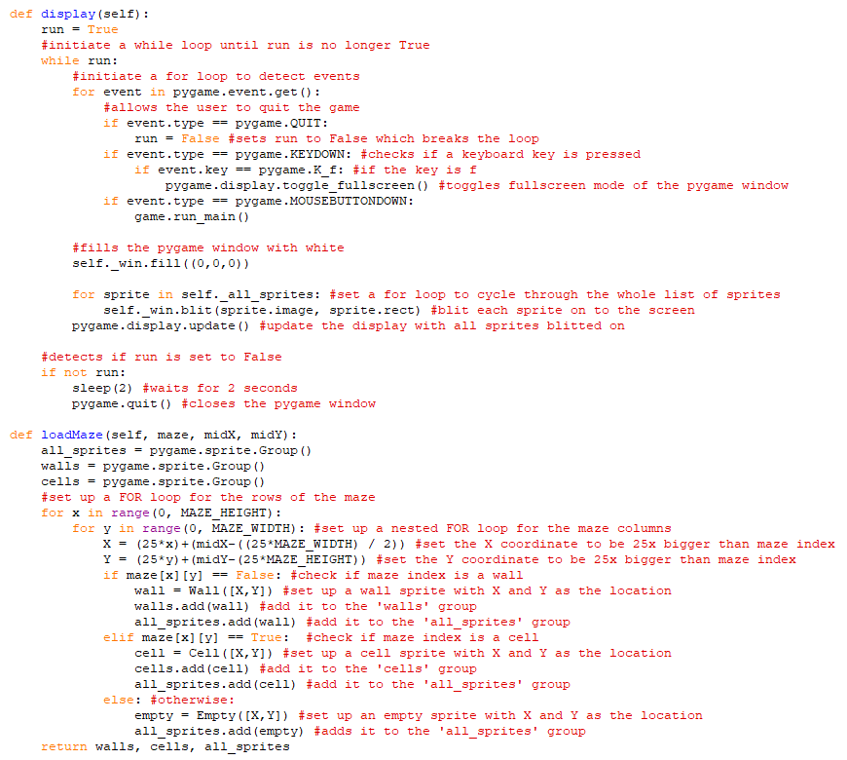

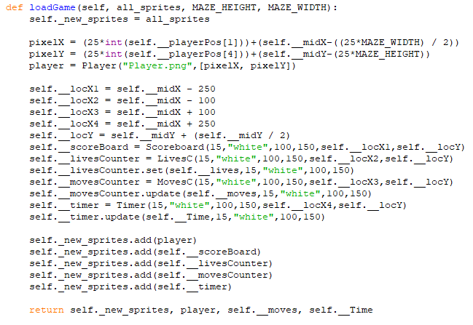

The ‘pygame_window’ class was updated

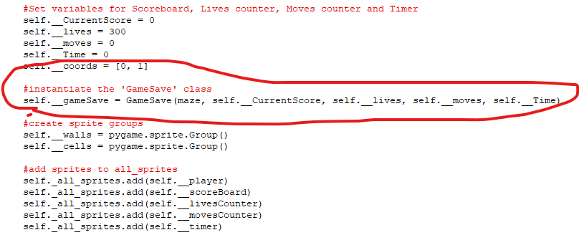

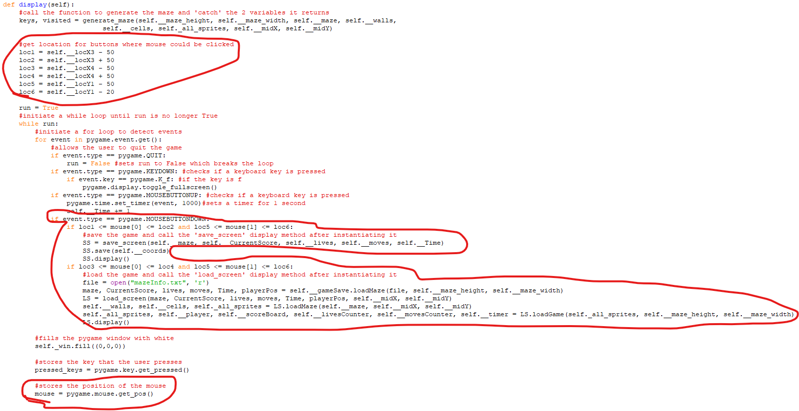

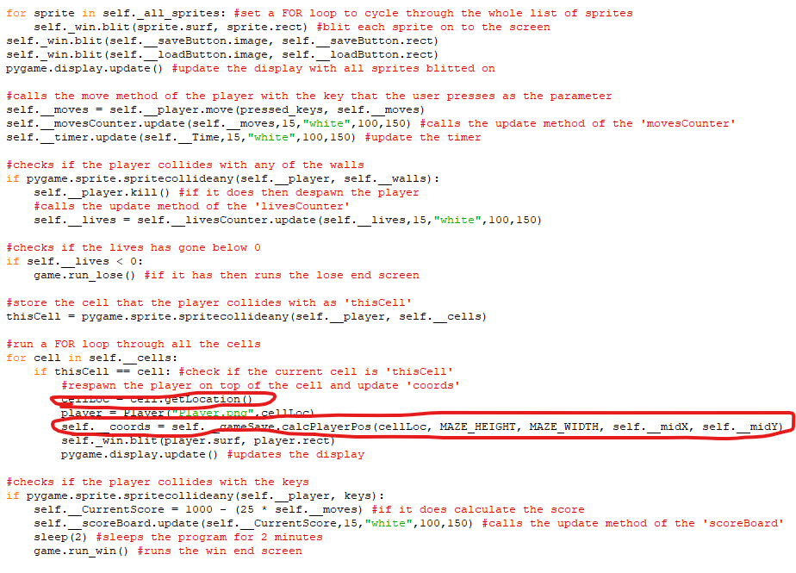

After clicking ‘Save Game’:



The contents of the ‘Maze_Info’ file:

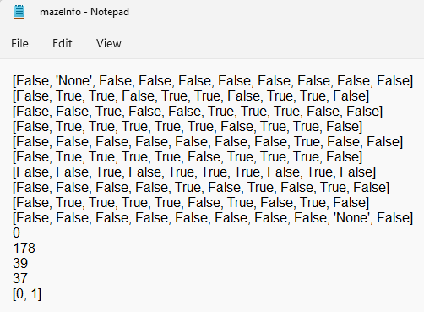

After clicking ‘Load Game’ (after running the game again):

The game after loading: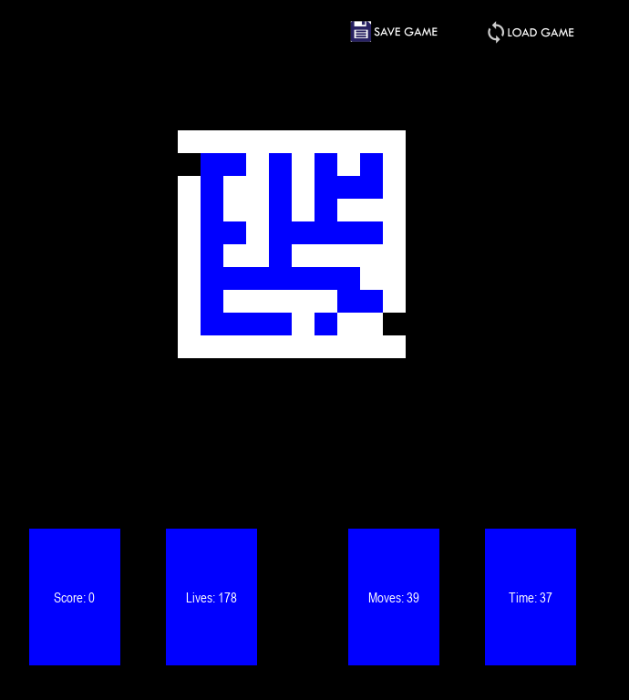

Next, for this phase of the program, the High scores system was implemented.

The ‘HighScores’ class was created in a new subprogram with 6 methods.

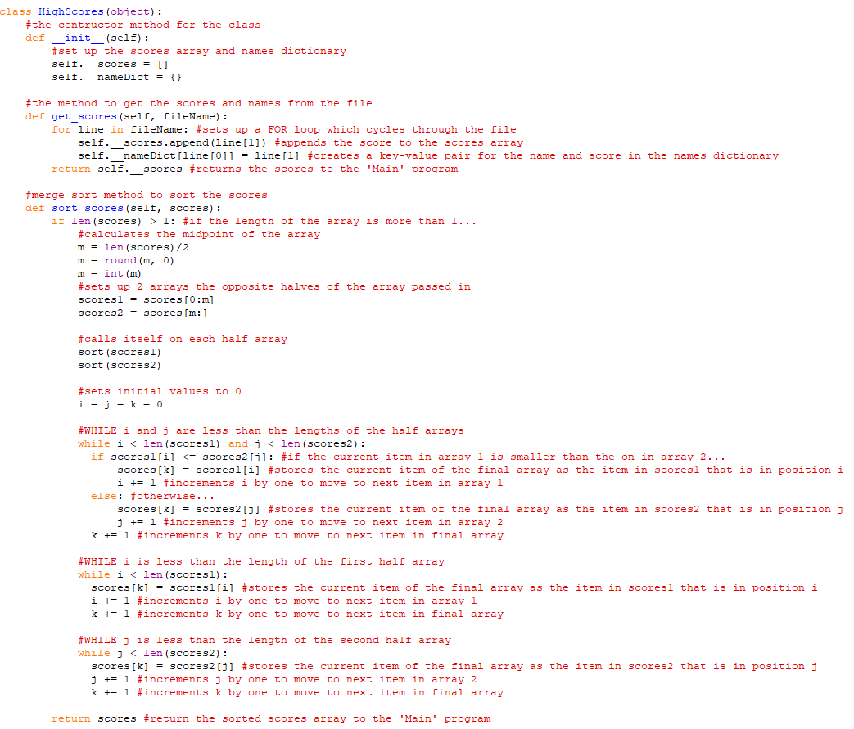

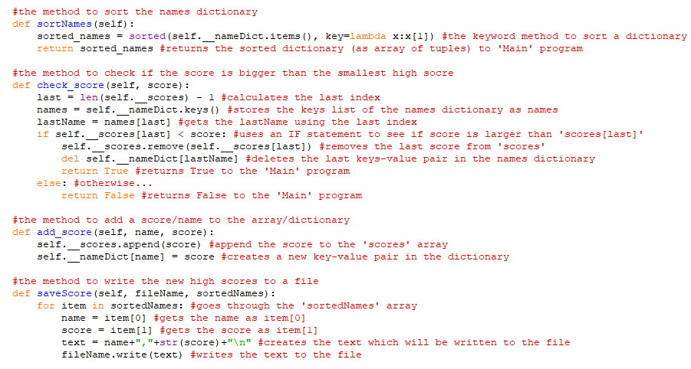

The display method of ‘win_screen’ was updated

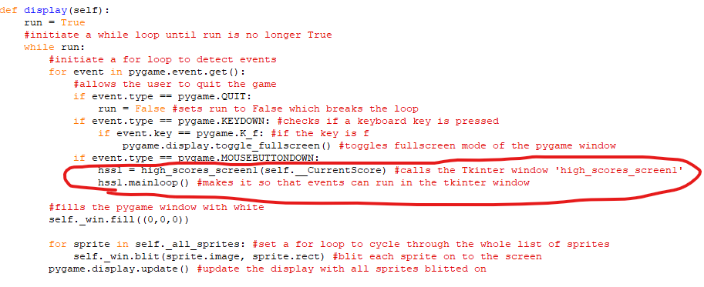

The ‘high_scores_screen’ classes were created

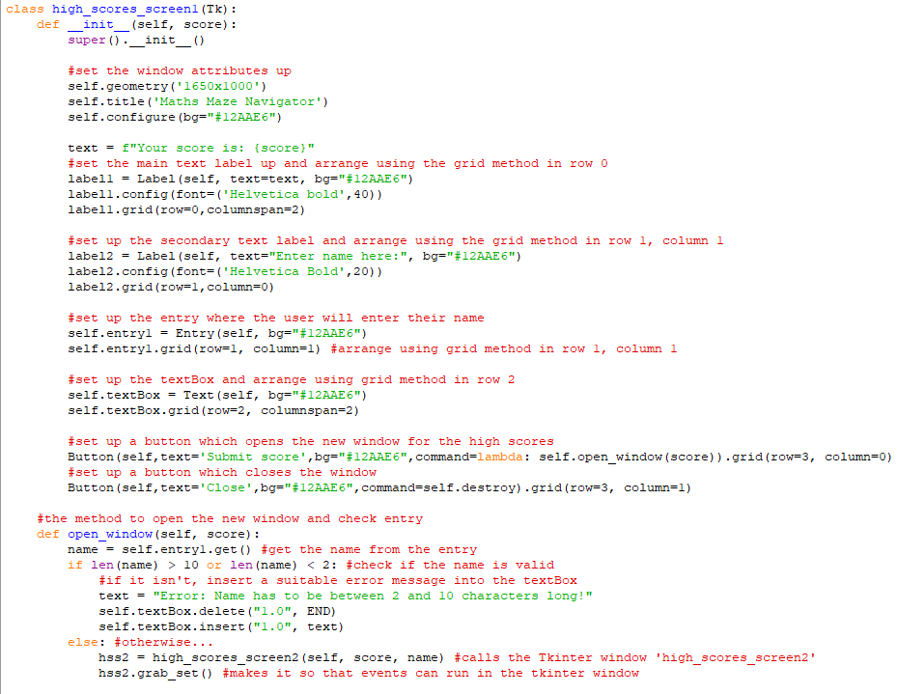

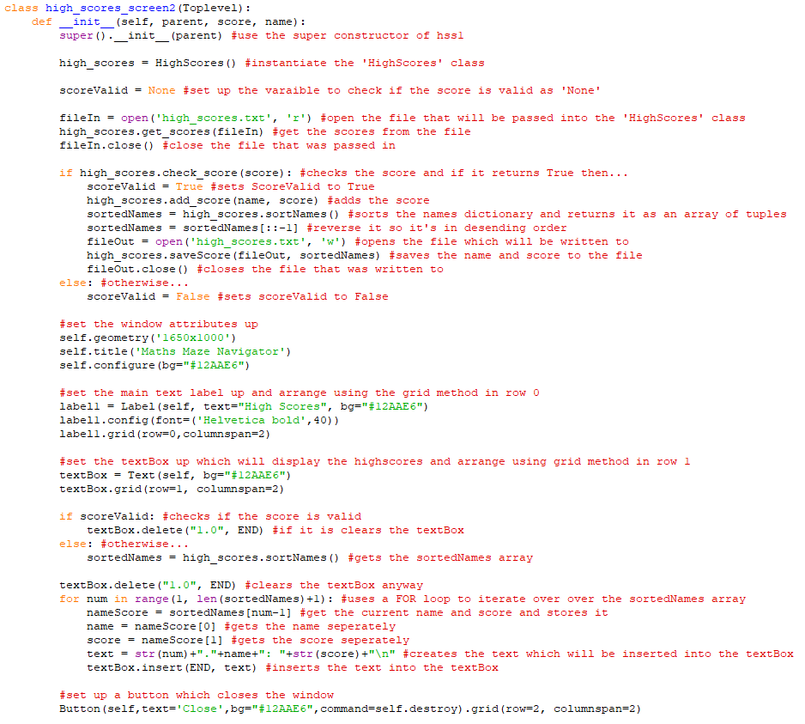

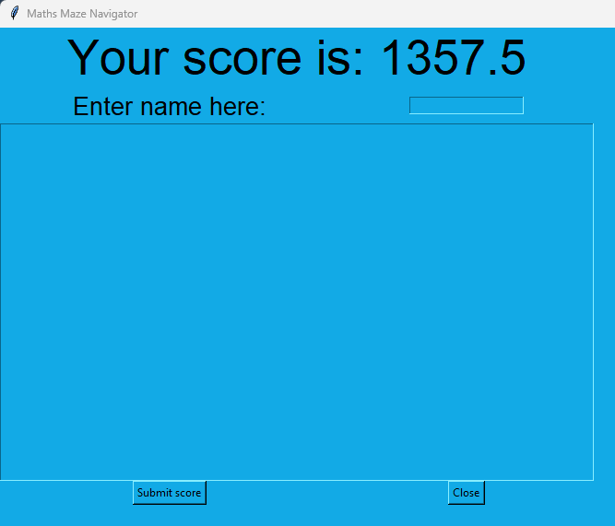

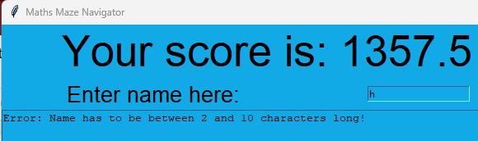

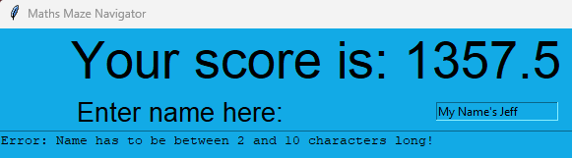

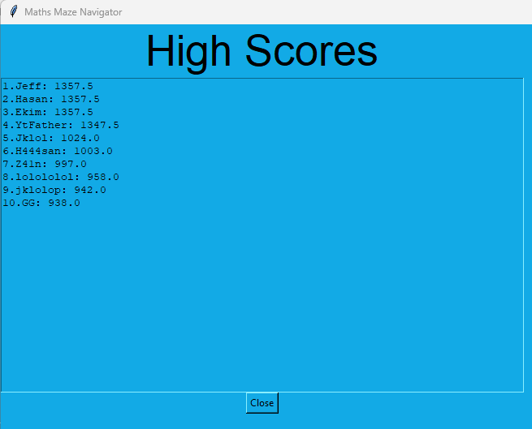

**Phase 5:**

This phase was all about bringing the Maths side of the program (developed in phase 3) and the Maze side of the program (developed in phase 1, 2 and 4) together to form somewhat of a finished product.

To begin with, the buttons for the questions selection screen were made in a new subprogram called ‘QS_objects’. These would decide the type of questions the user would get asked during the game.

Firstly, the ‘Text’ class and ‘Button1’ class were made in ‘QS_objects’

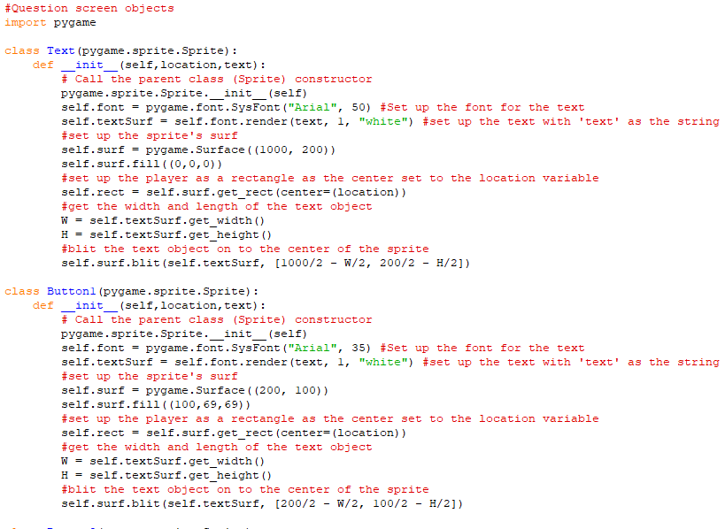

Then the following button classes were made from ‘Button2’ up to ‘Button5’

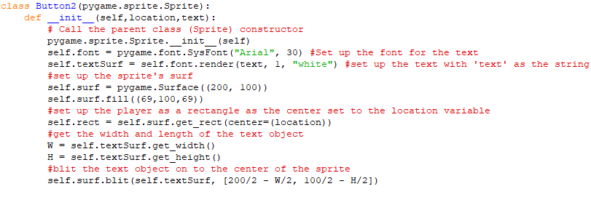

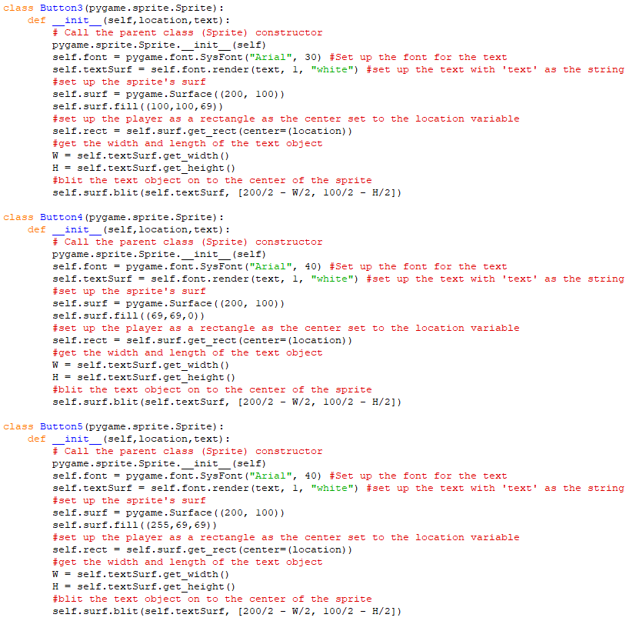

These were then to be instantiated in a new class called ‘QuestionSelect_screen’ which would also inherit from the ‘screens’ class and be part of the ‘Main’ program.

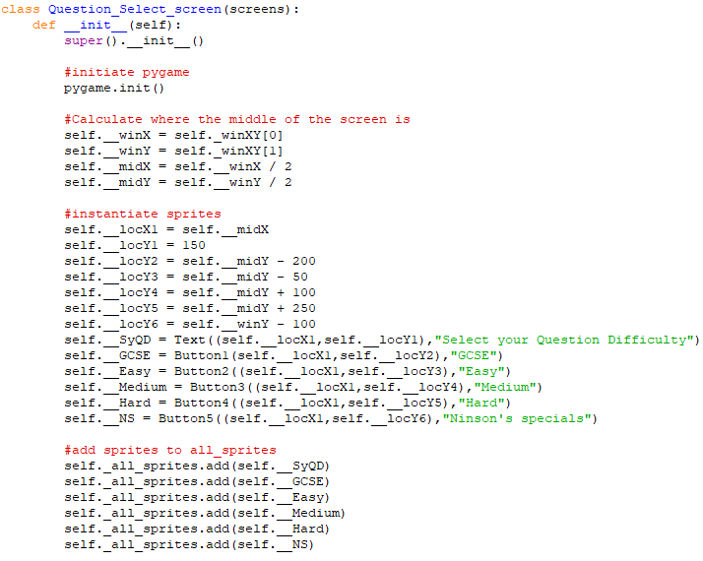

Its ‘display’ method was only included

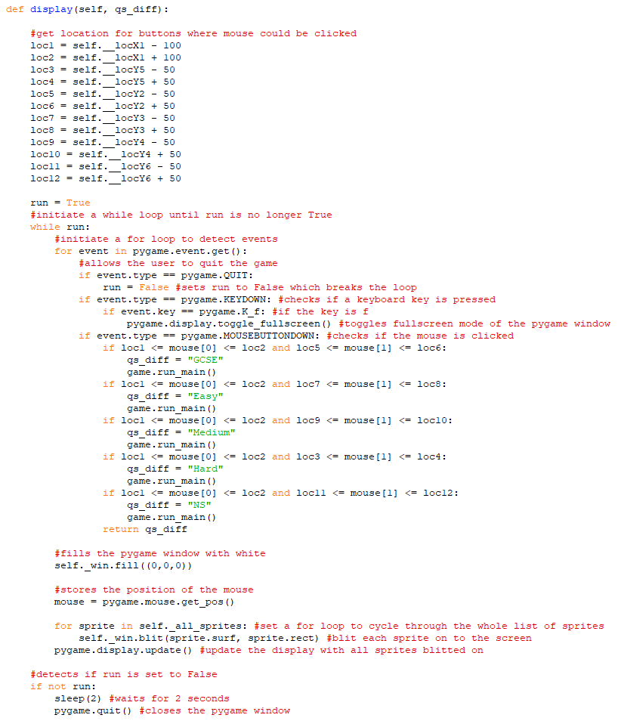

Next, a ‘run_qss’ method was made for it in ‘Game’





Also the ‘display’ method of ‘start_screen’ was updated

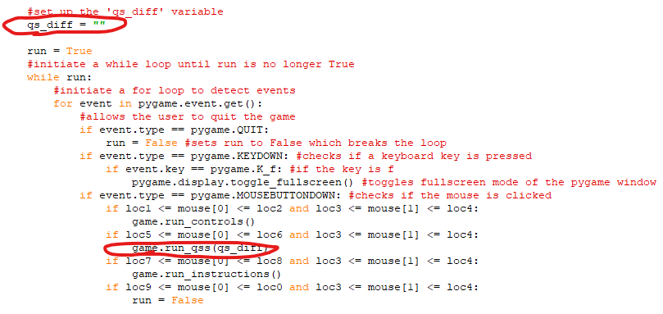

This produced the following screen after pressing ‘Play game’ on the start screen

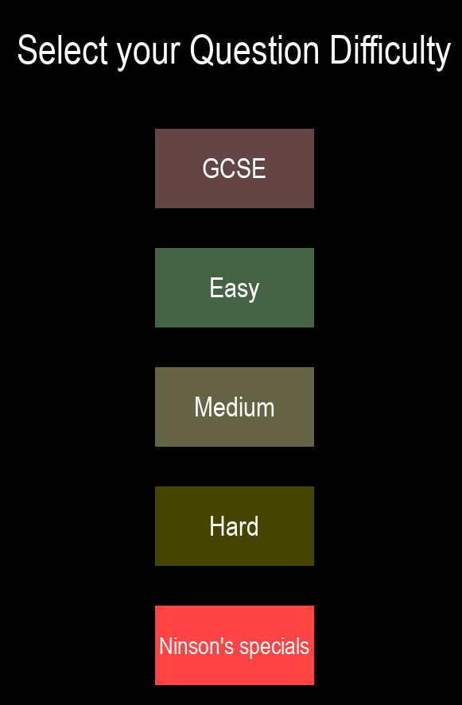

The next thing to do was to combine the ‘Maths_quiz’ and ‘Main’ programs

First the ‘Game’ class was updated

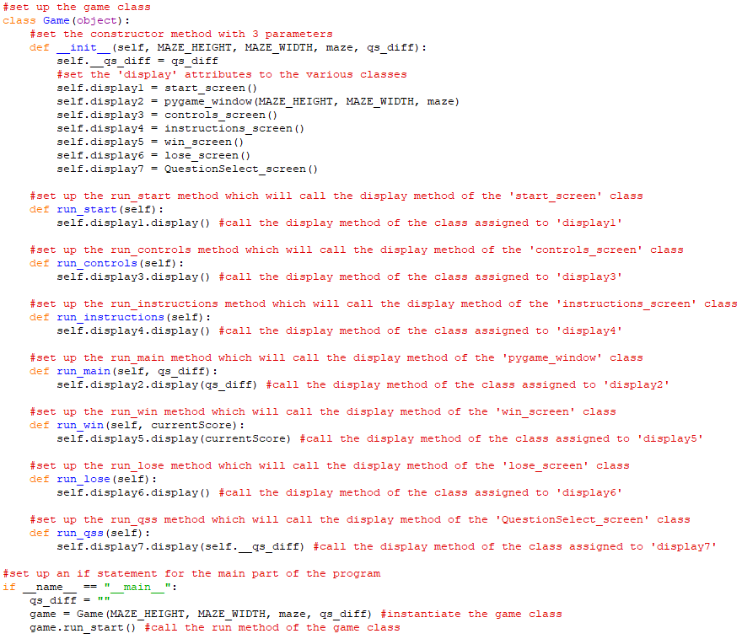

Then a ‘get_questions’ function was defined similar to the one in ‘Maths_quiz’

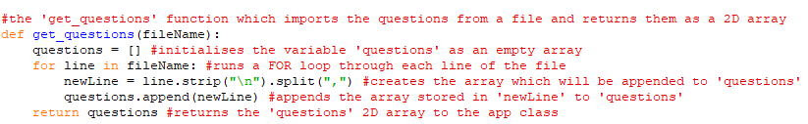

Also an ‘open_question’ method was defined in the ‘pygame_window’ class

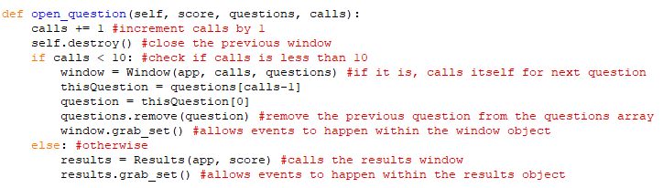

Then, the ‘display’ method of the ‘pygame_window’ was updated to include calling of this new method

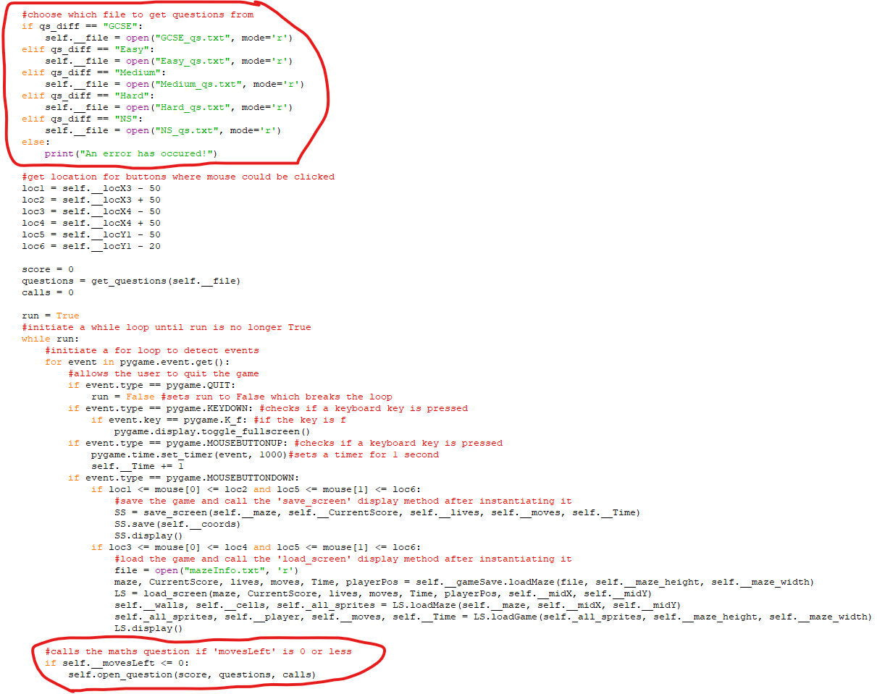

The ‘window’ class from ‘Maths_quiz’ was copied into ‘Main’ and updated as ‘QuestionWindow’

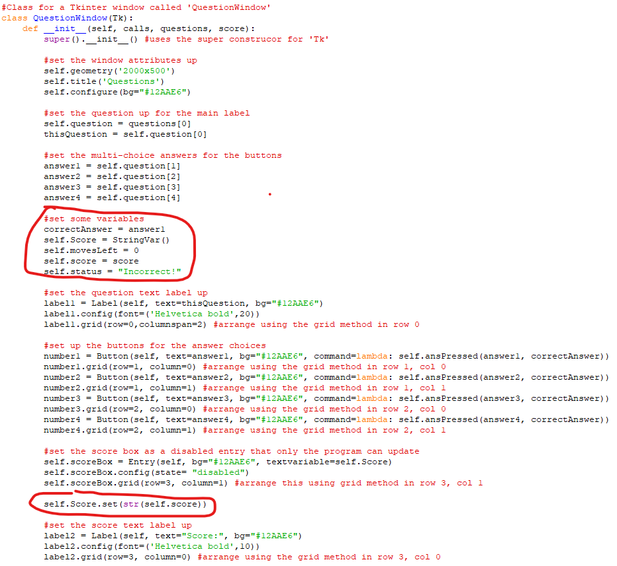

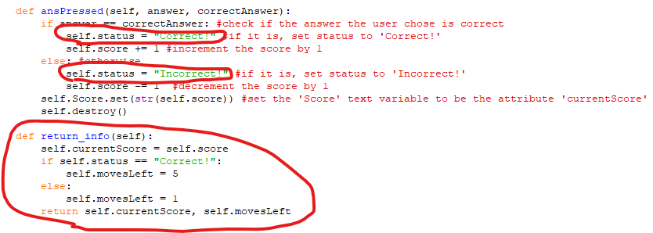

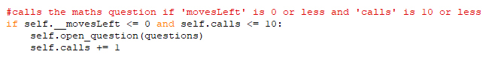

After clicking ‘More Info’ after ‘High Scores’ have opened

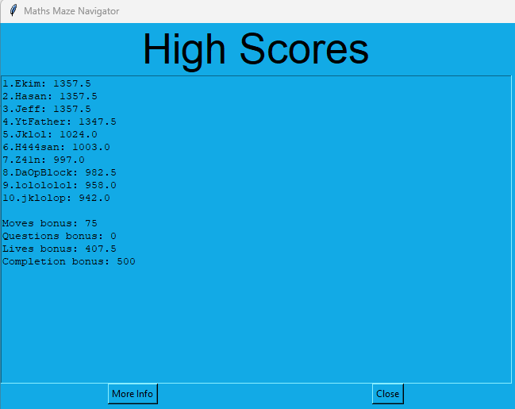

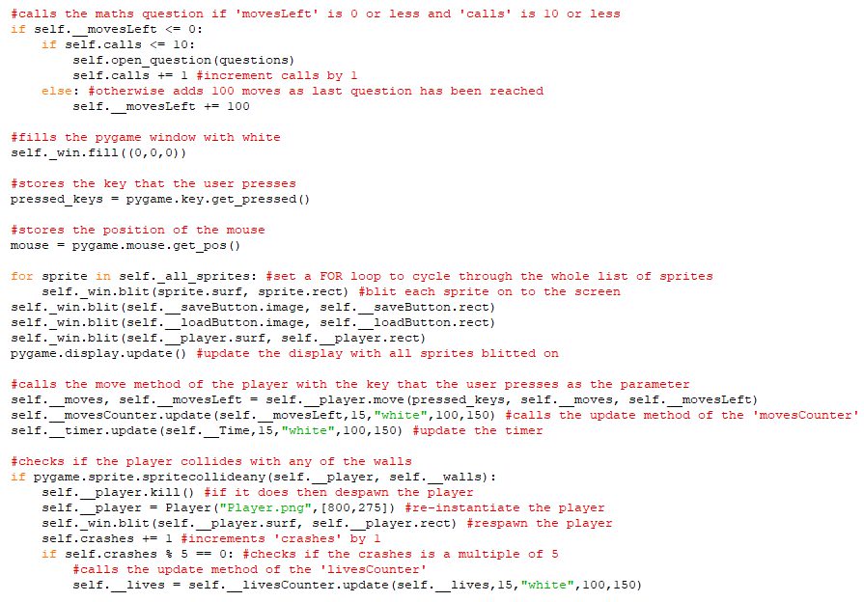

The game after the first question has been displayed

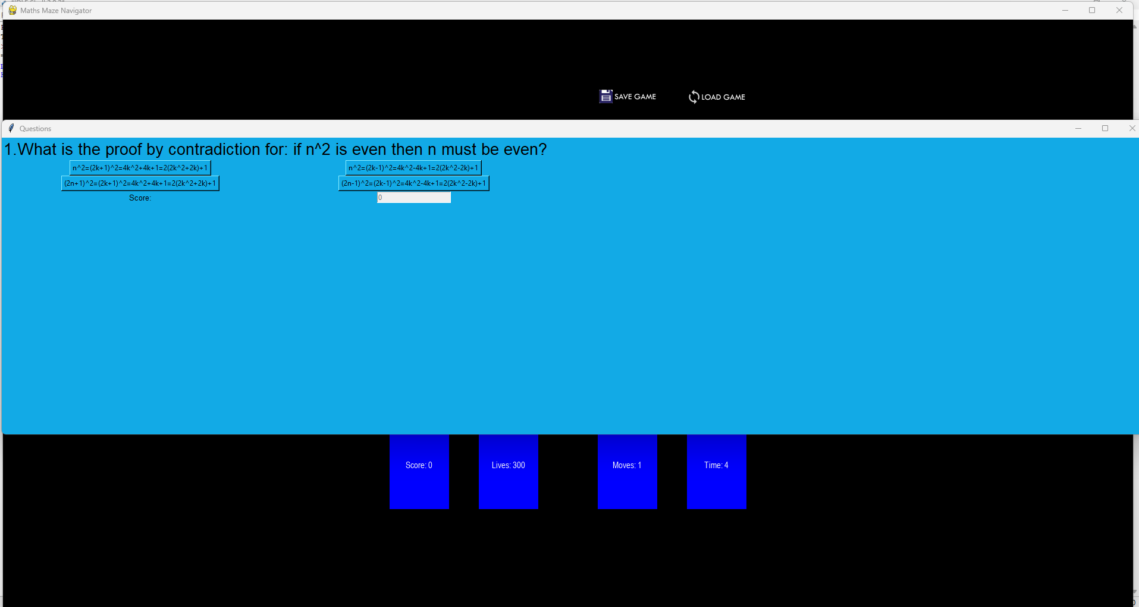

After answering first question correctly (closes automatically)

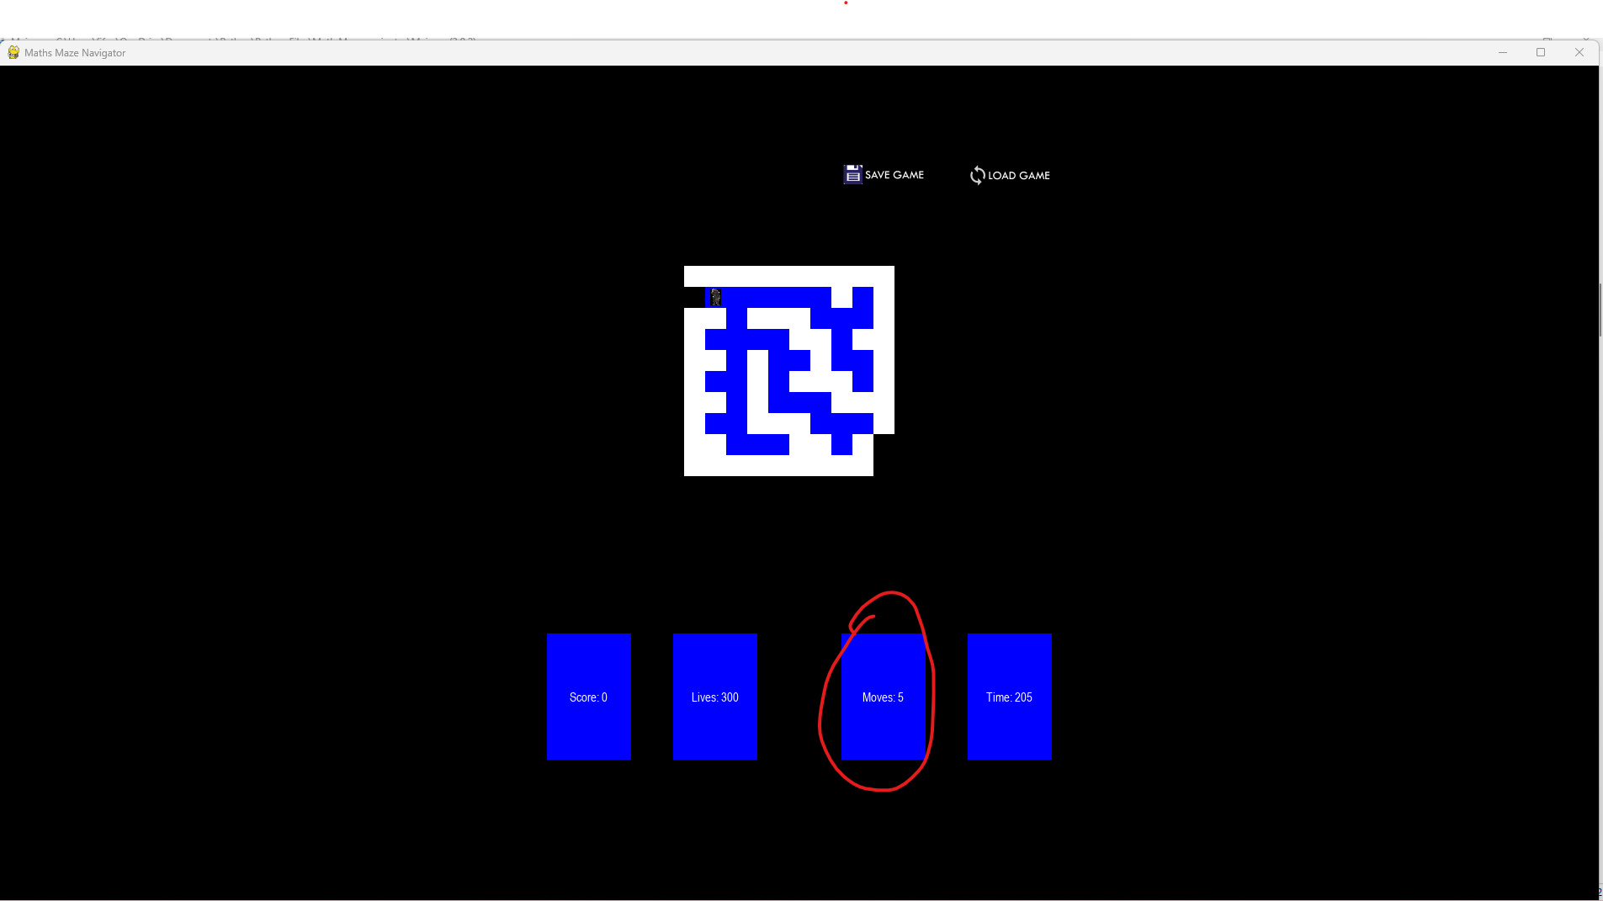

Halfway through the questions

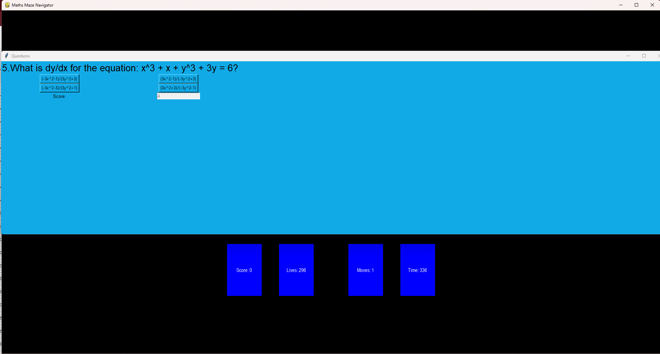

After losing all lives

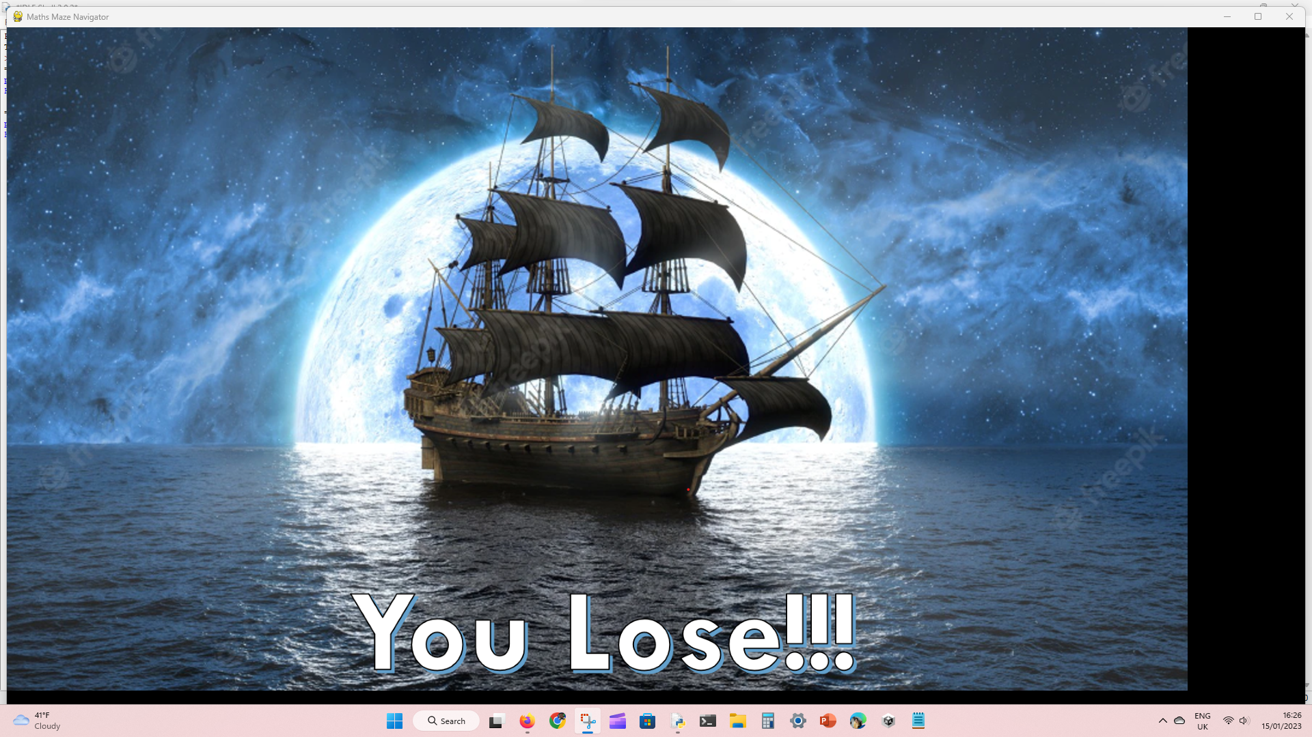

About to complete the maze

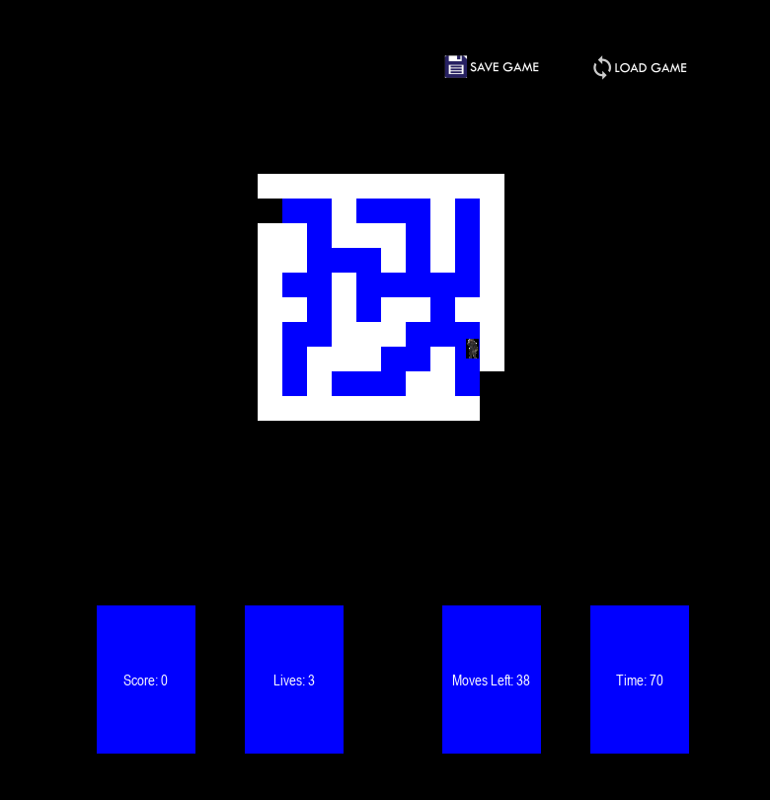

After completing the maze and clicking off the win screen

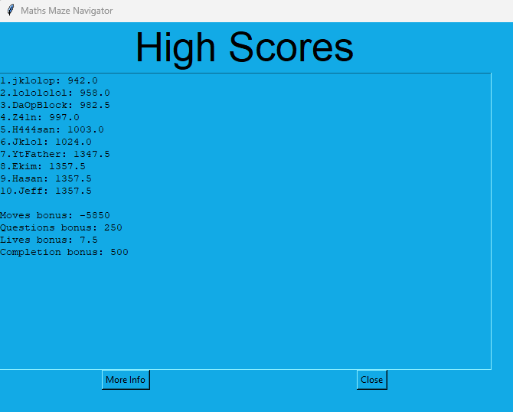

Final screenshot of ‘High Scores’

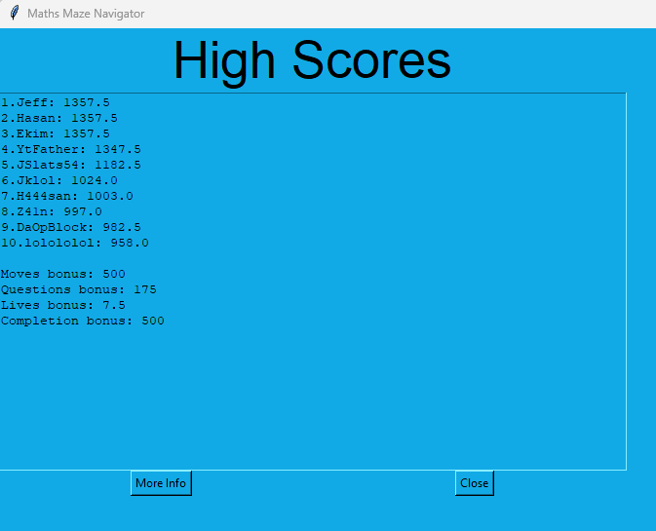

Next in this phase, an undo moves feature was to be added. This would allow the user to be able to undo up to 5 previous moves that they had made.

Firstly, a stack class was made to store the moves that the user makes

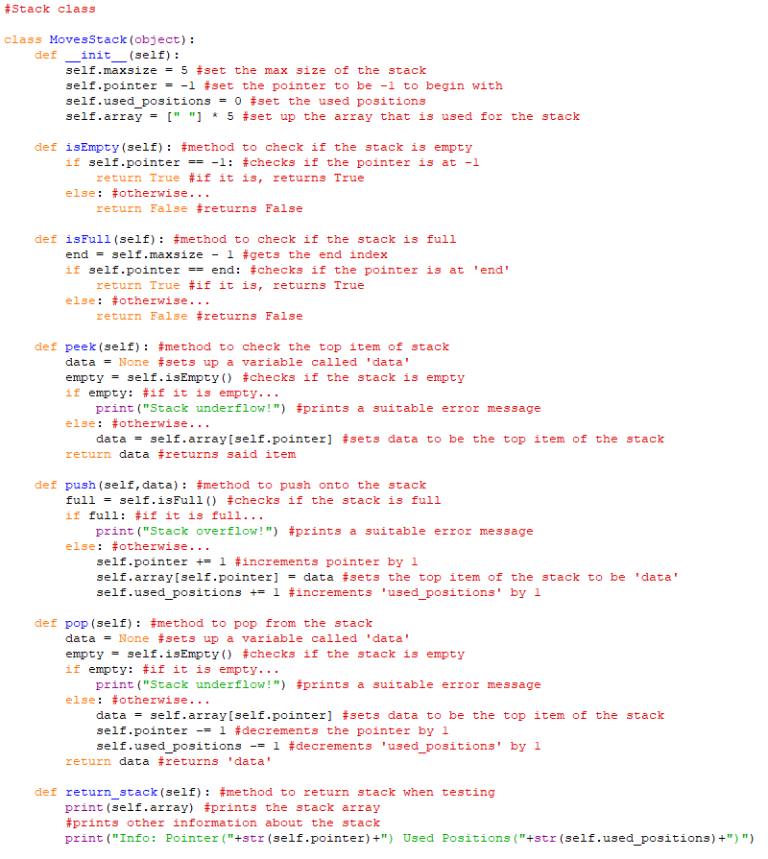

Also the ‘pygame_window’ class was updated to implement this

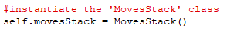

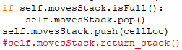

The output of the stack after the game has just started:

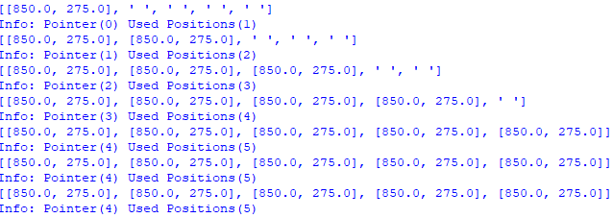

The Undo Button sprite was defined in the ‘Information_objects’ program

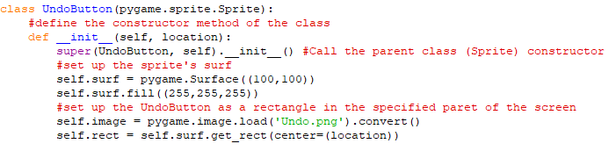

Next, it was instantiated in the ‘pygame_window’ class and blighted onto the screen

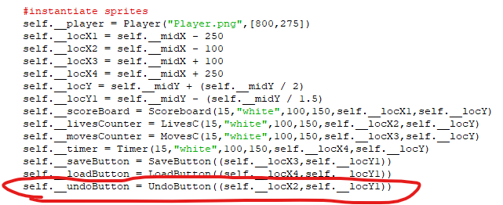

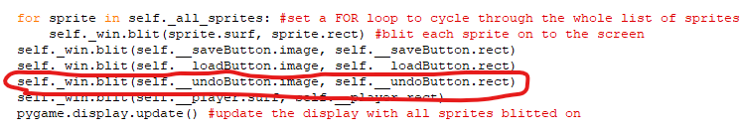

Here is the game with the undo button displayed

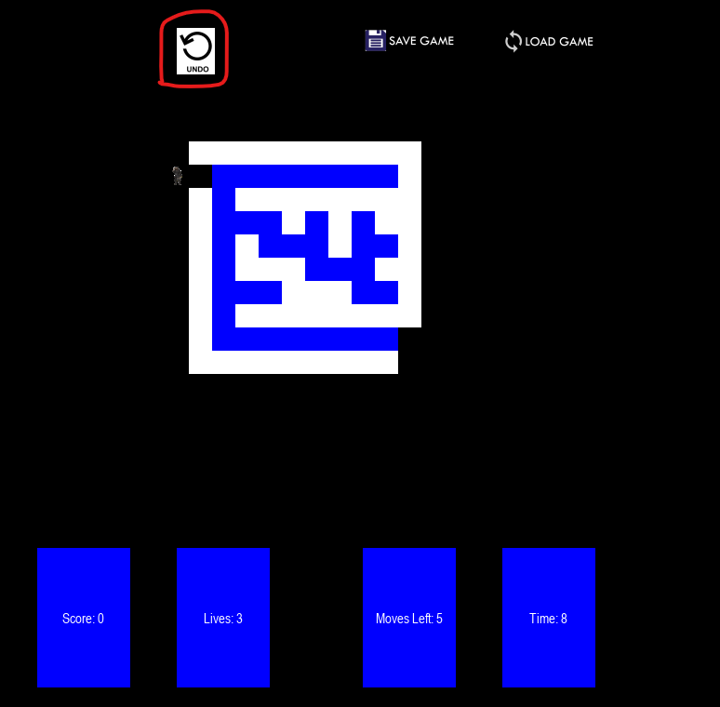

The next thing to do was to add the functionality of undoing moves

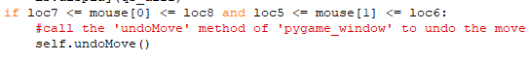

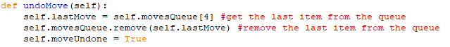

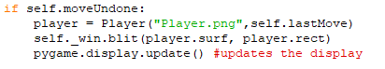

The game before clicking ‘Undo Move’:

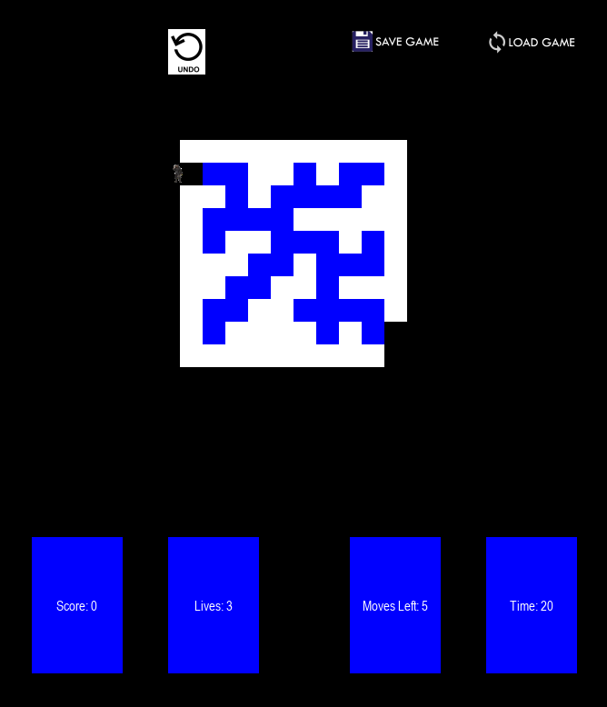

After clicking ‘Undo Move’:

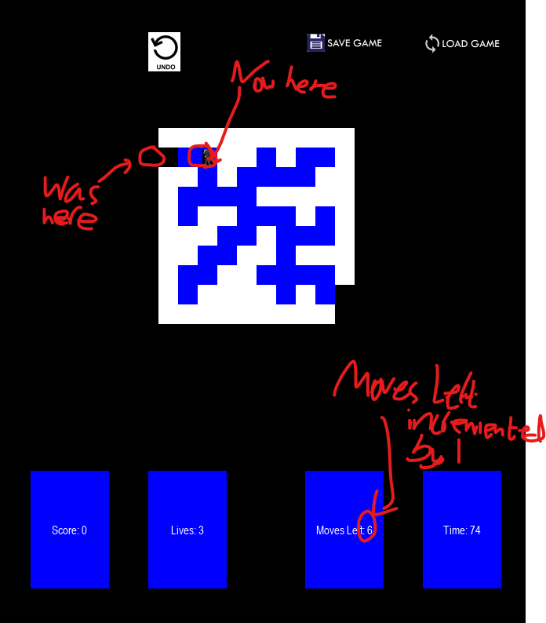

**Phase 6:**

In this Phase, a hints system will be created which will provide a hint in exchange for points off the score at the end. The hint will move the user to the nearest block that is on the correct path of the maze.

First, a ‘recursiveSolve’ function was defined that recursively calls itself

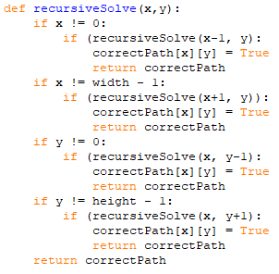

This was then called within the ‘generate_maze’ function

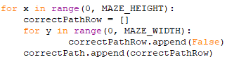

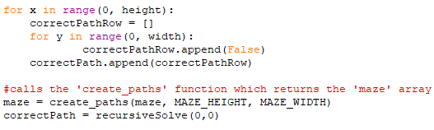

A function called ‘revealHint’ was defined

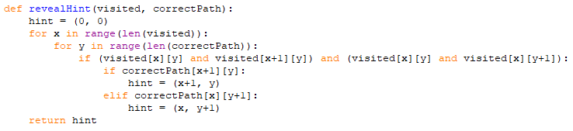

This was then called from ‘pygame_window’ and implemented

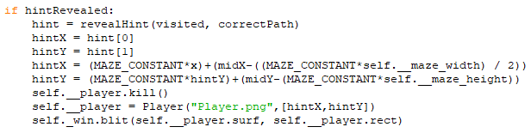

A ‘HintButton’ class was created in ‘Information_objects’

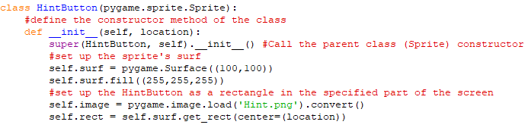

This was then instantiated and blitted onto the screen

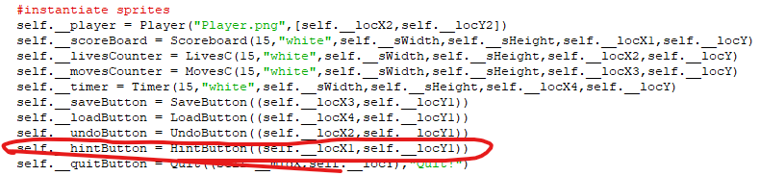

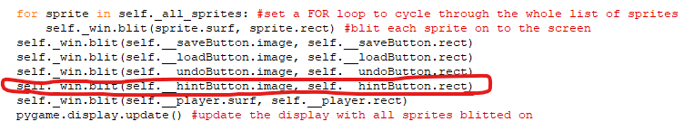

The ‘revealHint’ function was updated

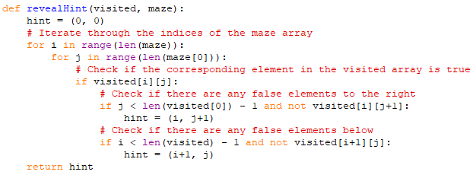

Before pressing ‘Hint’

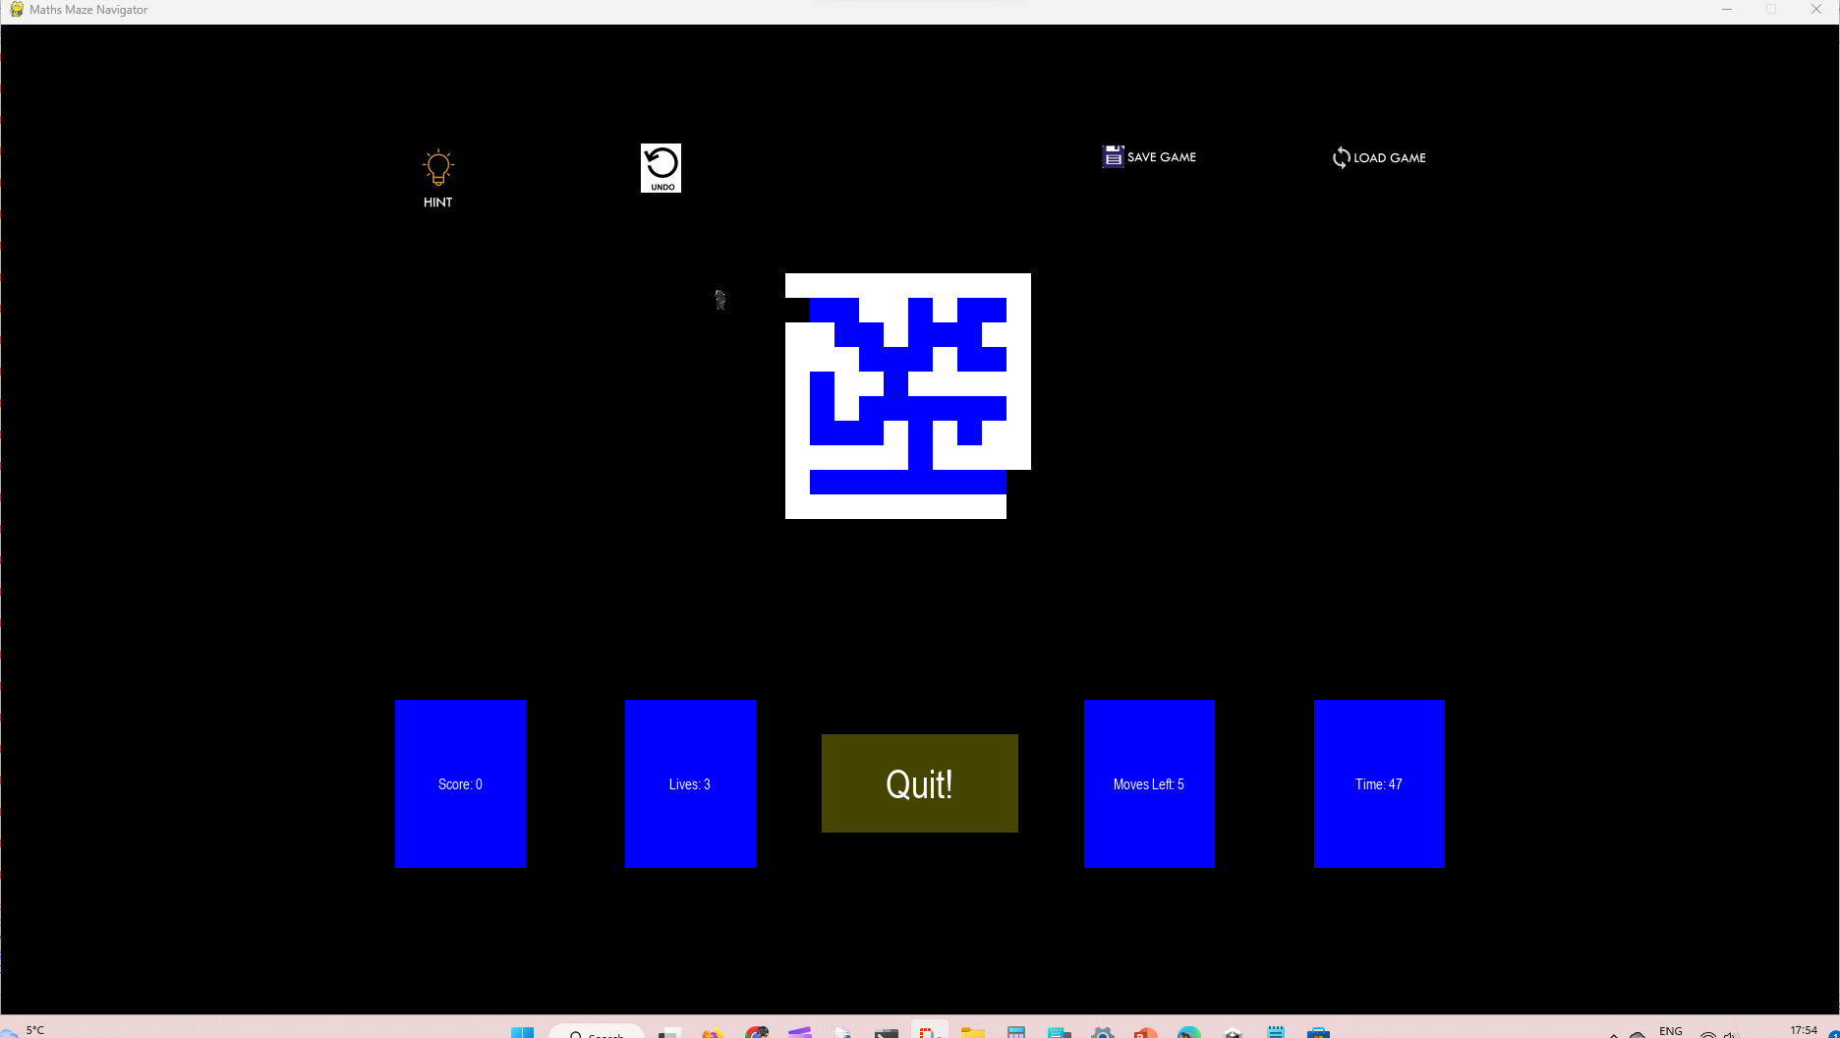

After pressing ‘Hint’

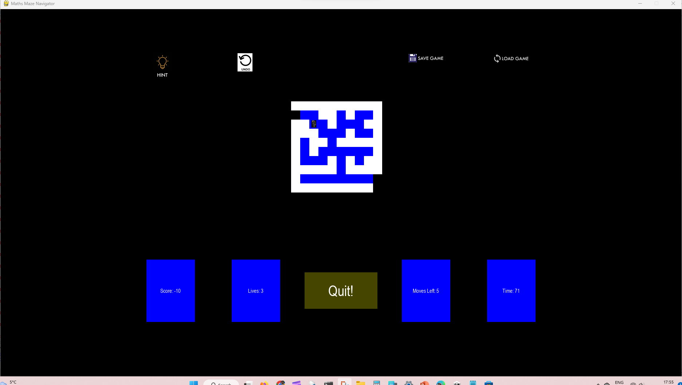

**Phase 7:**

In this Phase, the program will be finalised.

First, the question answers were shuffled using the shuffle method of the random module

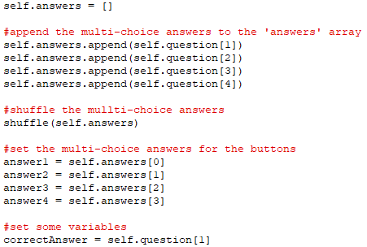

Here are the shuffled questions answers displayed

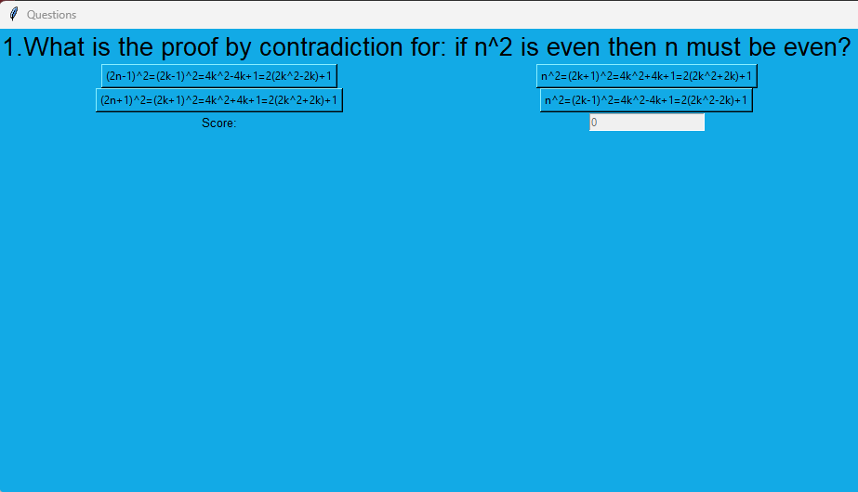

Just for reference (here it was before the shuffle)

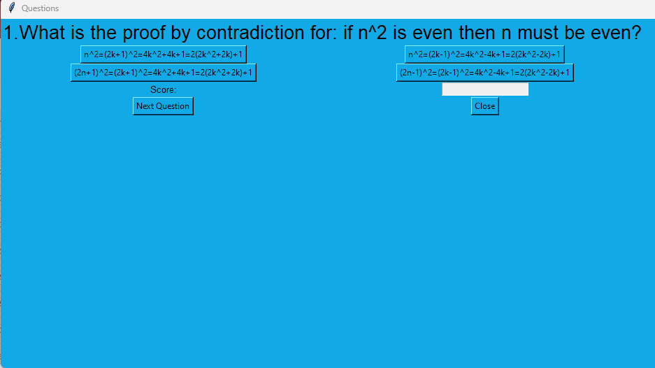

Next the loading of the game was updated via the ‘loadGame’ method of ‘load_screen’

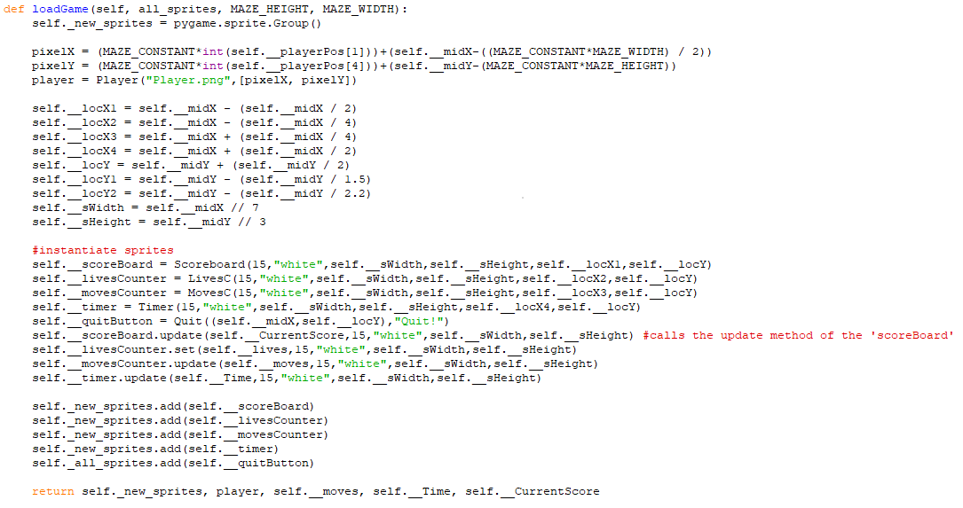

Next, a general text class called ‘Text2’ was made in ‘Other_objects’

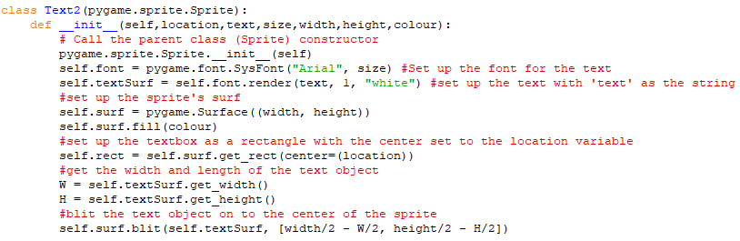

Its update method was made

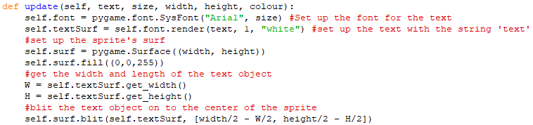

Then the ‘loading_screen’ class was added in ‘Main’ inheriting from ‘screens’

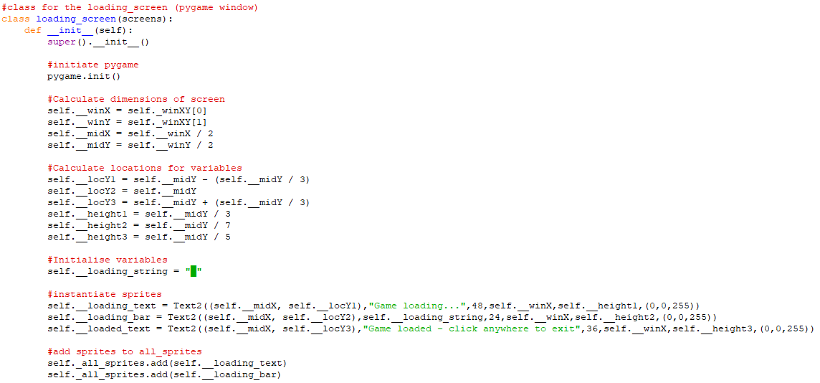

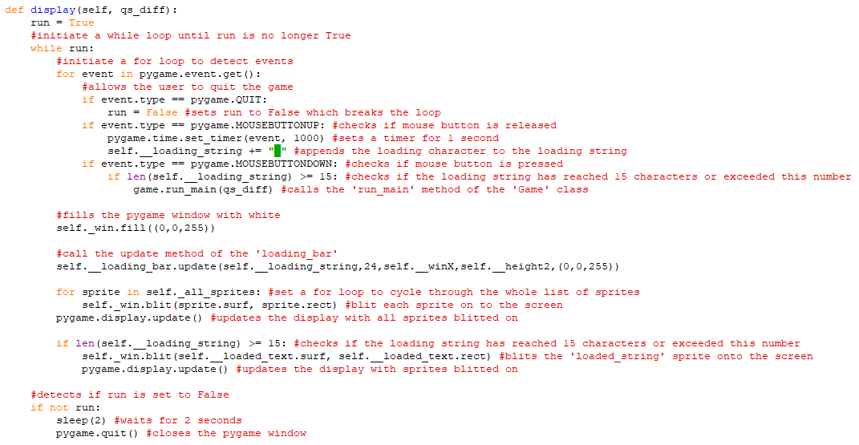

Here is the loading screen when it is first displayed

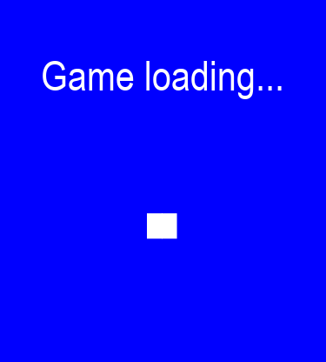

Here it is about half-way through loading

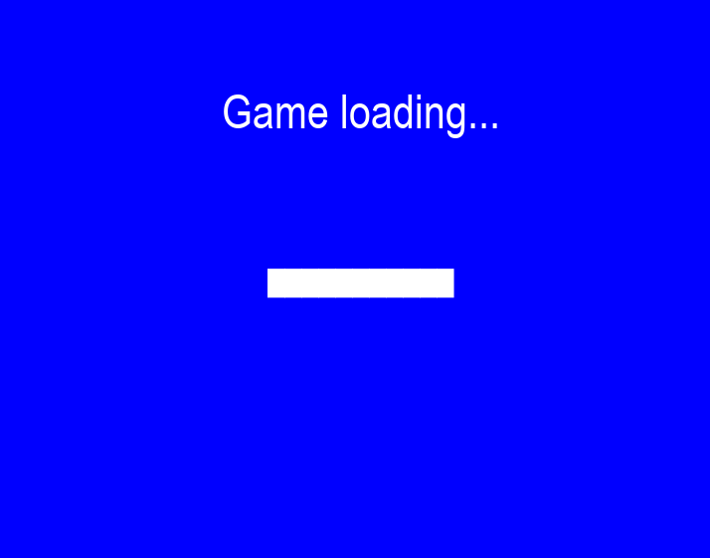

After it has fully loaded (and then some)

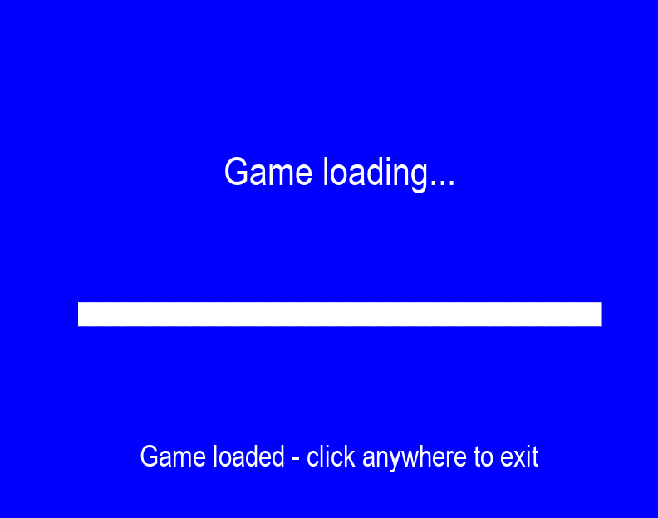

Then, the player position was updated so that the player spawns at the entrance of the maze



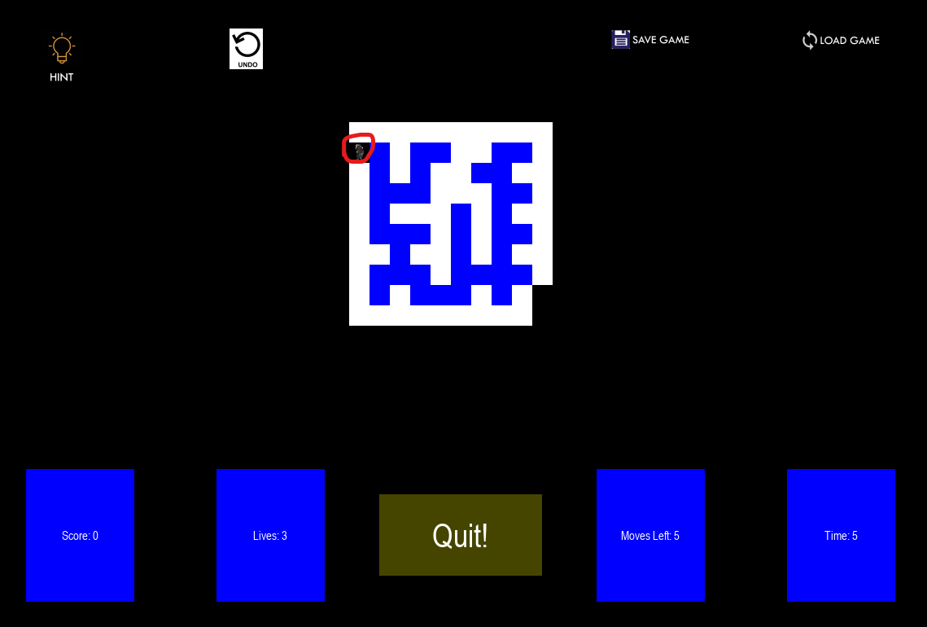

Also the ‘movesBonus’ attribute was updated in the ‘display’ method of ‘pygame_window’

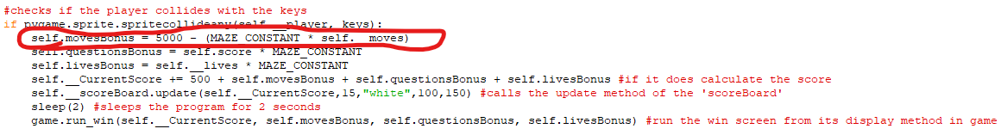

Then exception handling for files and a way around question files being corrupt or missing was to be devised.

Firstly, the ‘get_questions’ function was updated

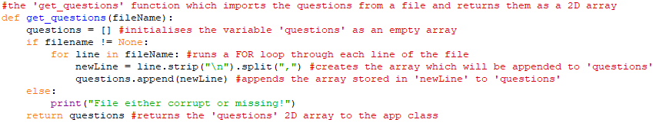

Then exception handling (try and except) was used in the ‘display’ method of the ‘pygame_window’ class when opening the files

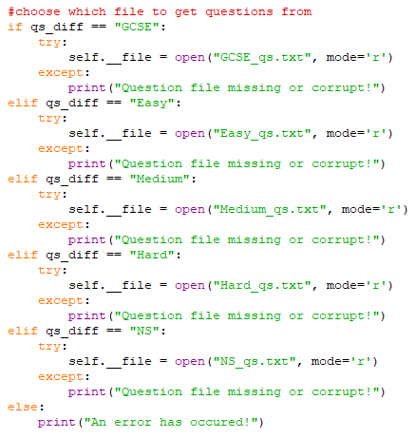

The python shell after clicking ‘Hard’ on the Question Select screen



Then 3 versions of the ‘Text2’ sprite were instantiated to be blitted on in different scenarios



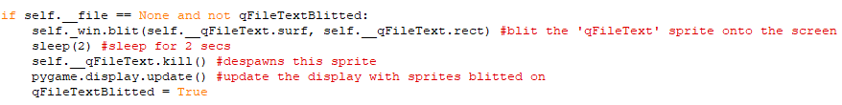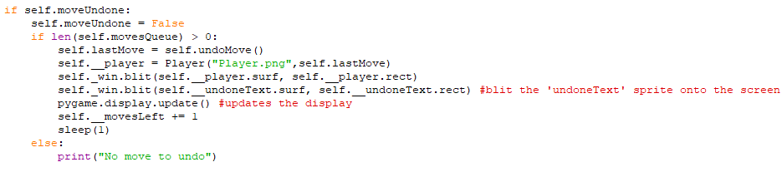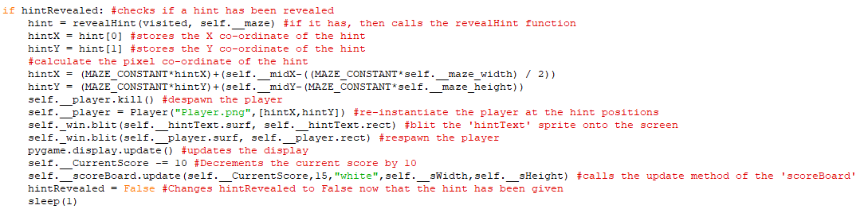

Last question after the text has been resized

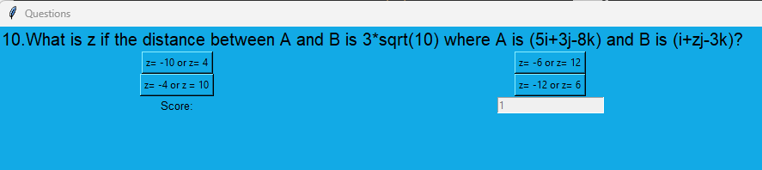

After winning the game for the final time

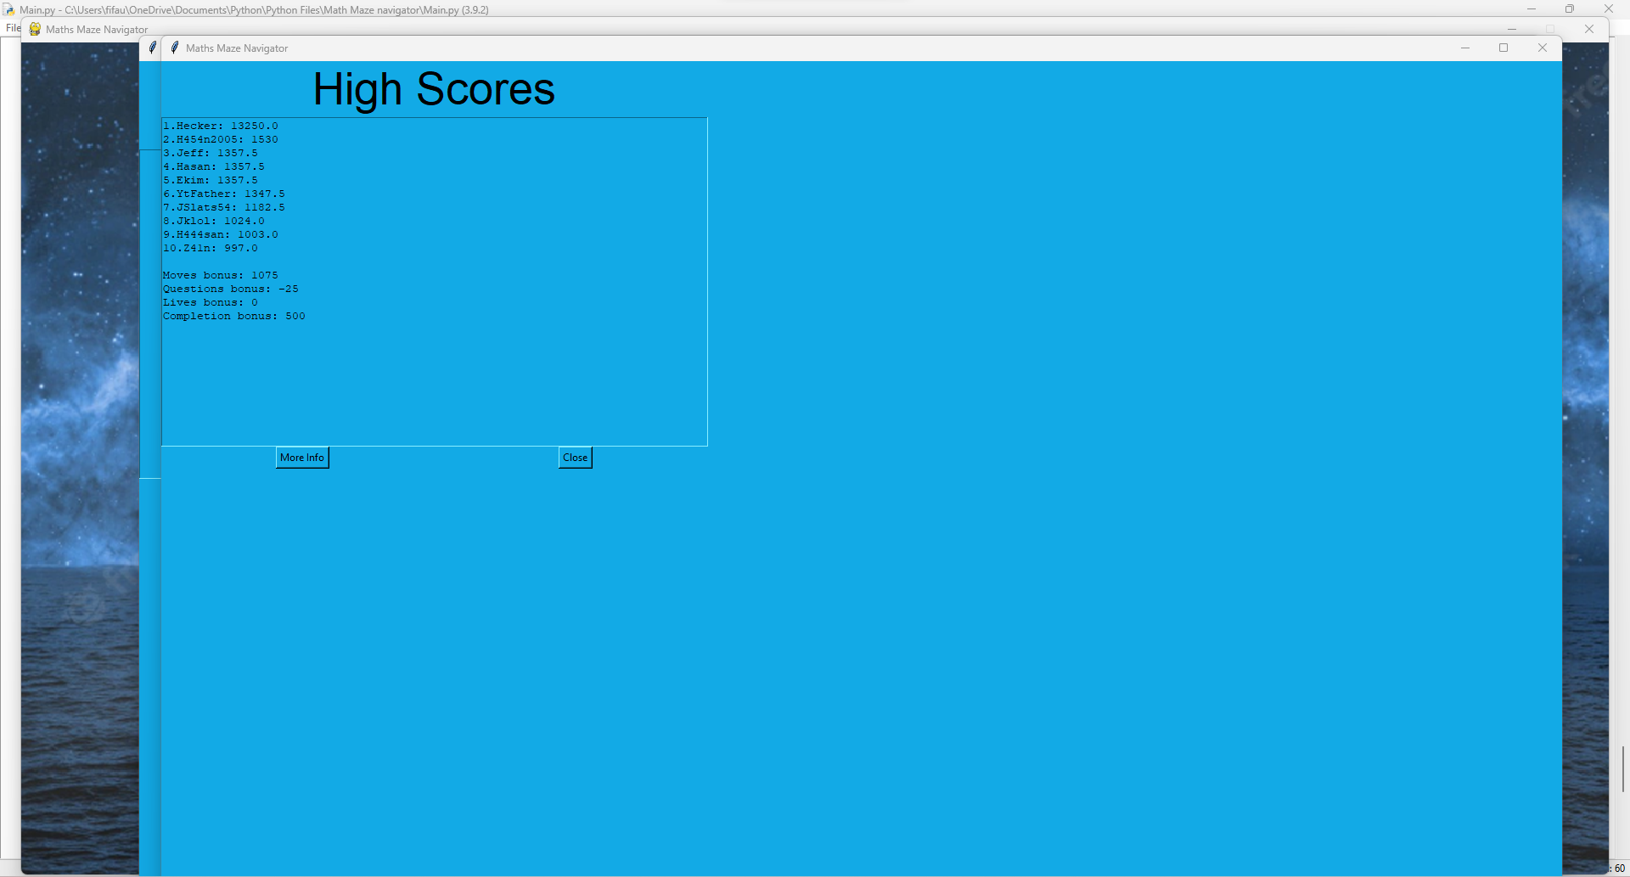

The link to the video: <https://youtu.be/7ZZU3XJEb_Y>

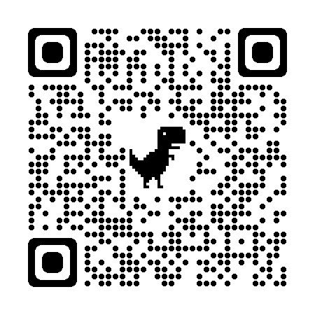

**Analysis by supervisor:**

This part of the document is a documentation of how each line of code of *Maths Maze Navigator* works written by the supervisor.

Each line that contains code will be explained. Each line will be documented and explained. Its purpose will be outlined and each line will be checked as to what function it serves and where it is used in the *Maths Maze Navigator*.

Comments are included as lines, but comments will not be explained.

**VERSION 1 (see Phase 1)**

Maths Maze Navigator v1 contains 3 python files - a Main program and 2 subprograms (called Player_class and Maze_objects) which can be summed up in 6 operations: (p = pixels)

* Runs the main game window
* Instantiates a Player that can be moved with either the arrow keys or WASD
* Generates a Maze using 25p x 25p sprites (Blue for Cells and White for Walls)
* Allows the Player to traverse through the maze
* Kills the player and respawns them if they hit a wall
* If the Player gets to the end, prints a message saying “You win!”

NOTE: This was an early version of the program so only basic functionality such as navigating the maze was added. Other functionality such as the score, lives, moves and questions were to be added later on in the project.

**Player class:**

This subprogram contains the Player class, which contains the character you can control, as well as its movement.

Line 2 is where pygame is imported. This is used throughout the entirety of the player class to make up the attributes of the player without typing out each attribute (due to inheritance), allowing less code to be reused.

Lines 5-15 is where variables that store events such as pressing the ‘w’ key on a keyboard. Pygame.locals stores these events which can be used to set movements within a game loop. There is also an event for loading an image loading for run length encoding (RLE encoding) which is inserted as a parameter to allow for faster and more efficient insertion of an image onto a pygame window.

Line 17 shows that the class Player inherits from a pygame superclass called ‘pygame.sprite.Sprite’.

Lines 18-25 define the constructor method of the class Player. The constructor method takes in 2 parameters which are ‘image_file’ and ‘location’. ‘Image_file’ consists of the name of the file, and the location is the location of where the player will be instantiated. Line 20 shows the constructor method of the parent class pygame.sprite.Sprite being called. Line 22 shows the player image being loaded and stored inside a variable named ‘self.surf’. Line 23 shows the colour of the image being set as blue.

Finally line 25 shows the coordinates of the image being stored in a separate variable known as ‘self.rect’.

Lines 27-49 show the definition of the method ‘move()’ which takes 1 parameter known as ‘pressed_keys’. It contains 4 if statements which all check if a certain key is pressed and then allow the character to move. The final 8 lines stop the player moving off screen by checking the position of the character, then moving the character if they hit the wall.

**Maze Objects:**

This file contains the objects that make up the maze the character must move through.

Line 2 is where pygame is imported. This is used throughout the entirety of Maths Maze Navigator v1 to create the maze.

All classes (listed below) inherit from pygame.sprite.Sprite.

Wall:

* This class defines the walls of the mazes, which the player cannot pass through while inside the maze.
* It contains 1 method (the constructor) which takes in 1 parameter of ‘location’, and sets the colour of each wall to be white with rgb values of 255,255,255

Cell:

* This class defines the squares within a maze that the player can traverse through which do not contain any items of significance.
* It contains 2 methods:

1. The constructor, which sets the colour of the cell to be blue with rgb values of 0,0,255.
2. getLocation(), which takes no parameters and returns the private attribute self.__location to the main program.

Empty:

* Defines an empty square, which is used for the entrance/exit of the maze.
* It contains 1 constructor method which sets the colour of each empty square to be black with rgb values of 0,0,0.

Key:

* Defines the square within the maze which contains the key to exit the maze and win the game.
* It contains 1 constructor method (2 parameters are required, that being image_file and location)
* The colour is set to the same as an empty square (black with rgb of 0,0,0) however the image_file (the image of the key) is loaded inside the class. (This allows for the image file to be changed while the program is running without changing which image is loaded when initialising a Key class)

**Main**

The main program is where the main game can be played. The player can move their character through a generated maze and find a key, which allows you to win the game of the maze.

Line 2 imports pygame.

Line 4 imports the sleep method of time

Line 5 imports the randint and random methods of random.

Line 7 imports the Player class from the file Player_class.

Line 8 imports the classes Wall, Cell, Empty, and Key from the file Main_objects.

Line 10 assigns the value 10 to the constant MAZE_HEIGHT

Line 11 assigns the value 10 to the constant MAZE_WIDTH

Line 13 assigns an empty array to the variable maze.

3 main program methods:

1. surroundingsCells

* Takes 2 parameters [maze, rand_wall]
* Checks for the number of surrounding cells of the current cell generated,
* Returns s_cells, which stores the number of surrounding cells.

1. create_paths

* Takes 3 parameters [maze, MAZE_HEIGHT, MAZE_WIDTH]
* Starts by creating a random starting_height and starting_width, then adjusting them according to if they are equal to certain values [0, MAZE_HEIGHT-1, MAZE_WIDTH-1]
* Assigns True to the position of the starting_width and starting_height of the maze array.
* Assigns an empty array to wallCoords, then appends 4 values to wallCoords [the starting height-1 and the starting width, the starting
* height and the starting width-1, the starting height and the starting width+1, the starting height+1 and the starting width]
* Assigns False to 4 positions in the array maze [the same 4 positions of wallCoords]
* A while loop is used to create the paths of the maze.
  + A random wall is picked and checked to see if it a left wall, an upper wall, a bottom wall, or a right wall, in which in either scenario a new path can be denoted and new walls can be created depending on if the value of rand_wall[0] is not equal to 0 or MAZE_HEIGHT-1. This only occurs if the number of surrounding cells are 2.
  + After the while loop, maze is returned to the main program.

1. generate_maze

* Takes 6 parameters (MAZE_HEIGHT, MAZE_WIDTH, maze, walls, cells, all_sprites)
* A nested for loop is set up which repeats a total of 100 times (10 times for each row in each column, with 10 columns)
* The create_paths() function is called to generate the maze array.
* A different nested for loop is used to check if each row and column of the maze array contains ‘None’, where it is set to False so as to ensure the maze is generated there.
* The entrance (maze[0][1]) and the exit (maze[9][8]) of the maze are assigned the value ‘None’.
* A new nested for loop is set for each row and column which is used to group each square of the maze into its corresponding group, stored in the variable all_sprites.
* On the 9th row, a new sprite group is created which results in the subroutine returning keys to the main program.

Classes:

1. pygame_window
   1. constructor

* 3 parameters (MAZE_HEIGHT, MAZE_WIDTH, maze)
* Is used to initialise the pygame window, where pygame, and sprites are instantiated inside the class, with attributes being assigned their values.
  1. display
* generate_maze is called and the returned value is stored in a variable called keys.
* A game loop is set up, where unless the user closes the window the pygame window is constantly running. On each loop, the following occurs in descending order:
  + The pygame window screen is set to black
  + The previous key the user pressed is stored in pressed_keys
  + Another for loop is set which places each sprite in the variable all_sprites onto the pygame window.
  + The pygame window is updated.
  + The player is moved depending on the key they pressed
  + The current sprite is checked to see if it has collided with any walls sprites (any walls of the maze). If it has, the player is killed and respawned in the same position as if they had started the game again.
  + A variable (thisCell) stores the function used in the previous if statement but it stores the result of if the player collided into a cell instead.
  + A for loop is initiated where the location of the cell is returned to the main program if the player moves and collides with a cell [note this cell must not contain a key]
  + The player is checked if they collided with the key. If they do, the statement ‘You win’ is printed and the program is closed.

1. Game
   1. Constructor

* 3 parameters (MAZE_HEIGHT, MAZE_WIDTH, mase)
* Uses composition using an instance of the class pygame_window to initialise the main game window.
  1. run
* Calls the display method from pygame_window to display the pygame window.

FINAL IF STATEMENT:

* Initialises an instance of the class Game, then calls the run method of the class Game if before running the python file it detects that the __name__ of the program is equal to “__main__” which is always True unless the program is imported into another program i.e it is a subprogram.

**VERSION 2 (see Phase 2)**

Maths Maze Navigator v2 contains 3 additional python files which can be summed up in 3 operations:

* Introduces a start screen and 2 new screens that can be reached from the start screen (a how to play screen and controls screen)
* Adds information objects such as the scoreboard to the main game screen
* Adds a win and lose screen for when the game finishes

**Player class:**

The player class has had some changes to movement with a new variable “moves” being introduced.

* Instead of importing specific functions and variables from pygame.locals, the entirety of pygame.locals is imported to allow for more functions to be implemented in the future and to reduce the number of lines of code the python file is.
* The move() function now takes in a new parameter known as “moves”, which is there to track the number of moves the player has made. With each move that is made, the variable “moves” increases by 1. “Moves” is returned to the main program.
* When moving, a player moves in a direction by 10 instead of by 1. Another change is that the boundaries in place to prevent the player moving off the screen have changed, with players now being able to move further to the right and further below to match the new screen size.

**Starting_Objects program:**

This class is used to store the class blueprints for the objects used at the start of the game. This includes a Title and 4 buttons.

Every class listed below inherits from pygame.sprite.Sprite (the sprite class).

Class Title:

* Takes 2 parameters in constructor method (location, text)
* This class stores the title text on the title screen that runs once you load up the main program.
* It sets up the font of the text, the surface of the text, the rectangle coordinates, places the text onto a black rectangle, and then blits the Title screen onto the pygame window.

Class Controls:

* Takes 2 parameters in constructor method (location, text)
* This class stores the text for the button that says “controls” on the title screen. This button when clicked shows the controls for how to play the game.
* It sets the font of the text, the surface of the text, the rectangle coordinates and places the text onto a red rectangle.

Class Play:

* Takes 2 parameters (location, text)
* This class stores the text for the button that says “Play Game” on the title screen.
* It sets the font of the text, the surface of the text, the rectangle coordinates and places the text onto a green rectangle.

Class Instructions:

* Takes 2 parameters (location, text)
* This class stores the text for the button that says “instructions” on the title screen. This button when clicked shows the numbered list of instructions that explain how to play the game in words.
* It sets the font of the text, the surface of the text, the rectangle coordinates and places the text onto a light green rectangle.

Class Quit:

* Takes 2 parameters (location, text)
* This class stores the text for the “Quit” button on the title screen. This button when clicked closes the pygame window and quits the program.
* It sets the font of the text, the surface of the text, places the text onto a black rectangle, the rectangle coordinates, and then blits the text of the “Quit button” onto the pygame window

**Other_objects program:**

This program stores 4 classes which are used to store the class blueprints for 4 images.

Every class inherits from pygame.sprite.Sprite.

Class controlsImage:

* Loads the image known as “controls” which is displayed below the control text from Starting_Objects.
* It also sets up a surface for the image to be loaded onto.

Class instructionsImage:

* Loads the image known as “Instructions” which shows the instructions of the game.
* Also sets up a surface for the image to be loaded onto.

Class winScreen:

* Loads the win screen onto a surface created inside the class.
* Is loaded when the user obtains the key inside the maze.

Class loseScreen:

* Loads the lose screen onto a surface created inside the class.
* Is loaded when the user’s number of lives decreases to 0.

**Information_objects:**

This stores the 4 pieces of information that the player can see while playing through the maze.

All classes inherit from pygame.sprite.Sprite and all 4 classes take the following parameters:

1. size (used to store the size of the font)
2. color (used to store the colour of the text)
3. width (stores the width of the surface the text is stored on)
4. height (stores the height of the surface the text is stored on)
5. locationX (stores the x coordinate of the rectangle shown to the player)
6. locationY (stores y coordinate of the rectangle shown to player)

Class Scoreboard:

1. Constructor method:

* Sets the current score to 0
* Calls pygame.sprite.Sprite constructor method (subclass calling base class)
* Sets the font of the score text and forces text upon the surface.

1. Update:

* Similar to the constructor method, except the score string uses the parameter CurrentScore for the score

Class LivesC:

1. Constructor method:

* Sets Lives to 3
* Creates the string showing the player how many lives they have.
* Calls pygame.sprite.Sprite constructor method (subclass calling base class)
* Sets the font of the lives text and forces text upon the surface.

1. update:

* Similar to the constructor method, except that everytime the method is called, “Lives” is decreased by 1

Class MovesC:

1. Constructor method:

* Sets Moves to 0.
* Creates a string which outputs how many moves the player has made.
* Calls pygame.sprite.Sprite.
* Sets the font of the moves text and forces text upon the surface.

1. Update:

* Similar to the constructor method, except the score string uses the parameter Moves for the moves.

Class Timer:

1. Constructor method:

* Sets Time to 0.
* Creates the string that shows the time that has passed.
* Initialises pygame.sprite.Sprite.
* Creates the surface on which the timer will be shown on.

1. Update:

* Increments time by 1.
* Recreates the string that shows how much time has passed.
* Returns Time to the main program.

**Main program:**

The changes made to the main program (since Version 1) will be listed in this section.

Importing:

* The classes Scoreboard, LivesC, MovesC, and Timer are imported from Information_objects
* The classes Title, Controls, Play, Instructions, and Quit are imported from Starting_objects
* The classes controlsImage, instructionsImage, winScreen, and loseScreen are imported from Other_objects.

Generate_maze:

* Instead of X being equal to (25*x) + 500, X is now equal to (25*x) + (midX-((25*MAZE_WIDTH)/2))

Instead of Y being equal to (25*y) + 100 is now equal to (25*y) + (midY-(25*MAZE_HEIGHT)).

These changes are made to allow the program to be resizable and able to be able to change size without breaking.

Class win_screen:

1. Constructor:

* Sets up the display of the win screen.
* Calls the winScreen() class and assigns it to a variable “self.WinScreen”
* Adds the sprite to the sprite group “self.__all_sprites”

1. Display:

* Defines a game loop, where:
  + If the ‘f’ key is pressed, the fullscreen is displayed.
  + If a mouse button is pressed, the game loop ends.
  + The window is filled with white, then every sprite in “self.__all_sprites” is displayed 1 by 1 in a FOR loop.
* Checks whether the game loop is not running (whether “run” is set to "FALSE"). If the game is not running, the entire game pauses for 2 seconds, then quits.

Class lose_screen:

1. Constructor:

* Sets up the display of the lose screen.
* Calls the loseScreen() class and assigns it to a variable “self.LoseScreen”
* Adds the sprite to the sprite group “self.__all_sprites”

1. Display:

* Defines a game loop, where:
  + If the ‘f’ key is pressed, the fullscreen is displayed.
  + If a mouse button is pressed, the game loop ends.
  + The window is filled with white, then every sprite in “self.__all_sprites” is displayed 1 by 1 in a FOR loop.
* Checks whether the game loop is not running (whether “run” is set to “FALSE”. If the game is not running, the entire game pauses for 2 seconds, then quits.

Class controls_screen:

1. Constructor:

* Sets up the display of the controls screen.
* Calls the controlsImage() class and assigns it to a variable “self.__controls_image”
* Adds the sprite to the sprite group “self.__all_sprites”

1. Display:

* Defines a game loop, where:
  + If the ‘f’ key is pressed, the fullscreen is displayed.
  + If a mouse button is pressed, the class game method run_main() is called (is defined later)
  + The window is filled with white, then every sprite in “self.__all_sprites” is displayed 1 by 1 in a FOR loop.
* Checks whether the game loop is not running (whether “run” is set to “FALSE”. If the game is not running, the entire game pauses for 2 seconds, then quits.

Class Instructions_screen:

1. Constructor:

* Sets up the display of the instructions image.
* Calls the instructionsImage() class and assigns it to a variable “self.__instructions_image”
* Adds the sprite to the sprite group “self.__all_sprites”

1. Display:

* Defines a game loop, where:
  + If the ‘f’ key is pressed, the fullscreen is displayed.
  + If a mouse button is pressed, the class game method run_main() is called (is defined later)
  + The window is filled with white, then every sprite in “self.__all_sprites” is displayed 1 by 1 in a FOR loop.
* Checks whether the game loop is not running (whether “run” is set to “FALSE”. If the game is not running, the entire game pauses for 2 seconds, then quits.

Class start_screen:

1. Constructor:

* Creates the window for the start_screen, then assigns the window size of the screen to a variable “self.__winXY”
* The middle of the screen is calculated using the variable “self.__winXY”, where the X value is calculated using the first index of the tuple, and the Y value is calculated using the second index of the tuple. From this, the “self.__midX” value is calculated using the X value / 2, and the “self.__midY” value is calculated using the Y value / 2.
* Sprites are instantiated:

1. The first X location (locX1) stores the “self.__midX” value.
2. The second X location (locX2) stores the integer 400.
3. The third X location (locX3) stores the value “self.__midX” - 200.
4. The fourth X location (locX4) stores the value “self.__midX” + 200
5. The fifth X location (locX5) stores the value “self.__winX” - 400
6. The first Y location (locY1) stores the value “self.__midY” - (“self.__midY”/2)
7. The second Y location (locY2) stores the value “self.__midY” + (“self.__midY”/2)
8. The variable “self.__title” stores an instance of the Title class, with variables locX1 and locY1 passed as arguments.
9. The variable “self.__controls” stores an instance of the Controls class with variables locX2 and locY2 passed as arguments.
10. The variable “self.__play” stores an instance of the Play class with variables locX3 and locY2 passed as arguments.
11. The variable “self.__instructions” stores an instance of the Instructions class with variables locX4 and locY2 passed as arguments.
12. The variable “self.__quit” stores an instance of the Quit class with variables locX5 and locY2 passed as arguments.

* The sprites “self.__title”, “self.__controls”, “self.__play”, “self.__instructions”, and “self.__quit” are added to the __all_sprites sprite_group.

1. Display:

* If statements are set up in a game loop which check for the mouse position (listed below)
* 10 location variables are set up (bruh):

1. loc1 is used as a lower_bound check for where the mouse X position is when loading the controls screen.
2. loc2 is used as an upper_bound check for where the X mouse position is when loading the controls screen.
3. loc3 is used as a lower_bound check for where the mouse Y position is in all if statements.
4. loc4 is used as an upper_bound check for where the mouse Y position is in all if statements.
5. loc5 is used as a lower_bound check for where the mouse X position is when loading the main window.
6. loc6 is used as an upper_bound check for where the mouse X position is when loading the main window.
7. loc7 is used as a lower_bound check for where the mouse X position is when loading the instructions screen.
8. loc8 is used as an upper_bound check for where the mouse X position is when loading the instructions screen.
9. loc9 is used as a lower_bound check for where the mouse X position is when checking whether the game loop should end or not.
10. loc0 is used as an upper_bound check for where the mouse X position is when checking whether the game loop should end or not.

* Every sprite is blitted to the screen 1 at a time in a for loop.
* An if statement checks if the game loop is running. If it isn’t the game pauses for 2 seconds then ceases to exist any longer.

Class pygame_window:

1. Constructor:

* The maze height, maze width, and maze array are all assigned to separate variables.
* pygame.init() is called, which initialises pygame.
* The pygame window is set up.
* The middle of the screen is calculated using the variable “self.__winXY”, where the X value is calculated using the first index of the tuple, and the Y value is calculated using the second index of the tuple. From this, the “self.__midX” value is calculated using the X value / 2, and the “self.__midY” value is calculated using the Y value / 2.
* Sprites are initialised:

1. Player class initialised, with location 600 X and 300 Y
2. locX1 assigned midX-250
3. locX2 assigned midX-100
4. locX3 assigned midX+100
5. locX4 assigned midX+250
6. locY assigned “self.__midY” + (“self.__midY”/2)
7. ScoreBoard class initialised, with initial score at 15, colour as white, text sizes at 100, then 150, then locations as locX1 and locY
8. LivesC class initialised, with initial lives at 15, colour as white, text sizes at 100, then 150, then locations as locX2 and locY
9. MovesC class initialised, with initial moves at 15, colour as white, text sizes at 100, then 150, then locations as locX3 and locY
10. Timer class initialised, with initial time at 15, colour as white, text sizes at 100, then 150, then locations as locX4 and locY.

* CurrentScore, lives, moves, and Time are all set to 0
* Sprite groups all_sprites, walls, and cells created.
* Sprites for the Player, ScoreBoard, LivesC, MovesC, and Timer class are all added to the all_sprites group.

1. Display:

* generate_maze() is called, which generates the maze
* Initialises the game loop:

1. If a keyboard key is pressed in the event loop, a timer is set for 1 second and the timer sprite is updated by 1 second.
2. If the ‘f’ key is pressed in the event loop, the fullscreen mode is toggled.
3. The window is filled with white.
4. All keys that the user presses are stored.
5. All sprites are blitted onto the screen.
6. Calls the player.move method, allowing the user to move if they pressed the correct keys.
7. The movesCounter sprite is updated.
8. Sprite collision is checked, where if the player collides with any walls, the player is killed and the livesCounter decreases.
9. Checks if lives is less than 300. If it is, the loseScreen is shown to the player.
10. Stores the cell the player collides with in the maze as “thisCell’
11. Runs through each cell and checks if the player collided with ‘thisCell’. I the player did, the player location is checked for, and the display is updated
12. Another for loop is used to check if the player collided with the key to the exit of the maze. If the player did collide with the key, the Current Score is calculated by taking the integer 1000 and taking away the number of moves the player made multiplied by 25. (1000 - (25 * self.__moves). The scoreboard sprite is updated, then the game pauses for 2 seconds, then loads the winning screen
13. The “if not run” if statement is checked to see if the game loop has stopped running. If it has, the game sleeps for 2 seconds then quits.

Class Game:

1. Constructor:

6 display variables are set up:

1. self.display1 stores the start_screen() class.
2. self.display2 stores the main pygame window.
3. self.display3 stores the controls_screen() class
4. self.display4 stores the instructions_screen() class
5. self.display5 stores the win_screen() class
6. self.display6 stores the lose_screen() class.
7. run_start:

* Displays start_screen() class

1. run_controls:

* Displays controls_screen() class

1. run_instructions:

* Displays instructions_screen() class

1. run_main:

* Displays the pygame main window.

1. run_win:

* Displays win_screen() class

1. run_lose:

* Displays lose_screen() class

FINAL IF STATEMENT:

* The final if statement is used to allow the code inside the entire python file to be run only when the code is directly invoked (i.e. when the user runs the module directly)
* If this if statement is true, it initialises the game class, then calls upon the run_start() method to allow the game to start.

**VERSION 3 (see Phase 3)**

Maths Maze Navigator v3 contains a 100 line python file (called Maths_quiz) which can be summed up in 2 operations:

* Opens a Tkinter window which Welcomes the user to the Maths Maze Navigator.
* Allows the user to interact with the program using Tkinter buttons

The program imports everything from both the Tkinter and random modules.

get_questions()

Opens the maths.qs text file (this file stores the questions used in the program).

It stores the questions in an array “questions”.

Results (class)

Constructor method:

* Inherits from a parameter known as parent (App class), and uses Toplevel to allow the results to be managed by the main program
* Constructs the geometry of the results screen, which shows the player’s score from answering the questions presented to them

Window (class):

Constructor method:

* Inherits from parameter parent (App class)
* Creates widgets which store the 4 choices for each question in the array, and displays these choices as possible answers to the question displayed.
* Sets the correct answer to the 1st answer in the array.

ansPressed:

* Requires the parameters, answer, and correctAnswer.
* Checks if the answer given is equal to the correct answer given. If this is True, then “Correct!” is printed to the main program and the score is incremented by 1.
* If not True, then the opposite occurs, where “Incorrect!” is printed to the program and the score decreases by 1 (note, this means your score can go below 0)

open_window:

* Requires the parameters: score, and questions.
* Used to destroy the previous window and open a new window when a question is answered.
* Sets a variable calls to a global variable.
* Removes a question from the questions array
* Increments calls by 1, then destroys the window.
* Checks if calls are less than 10, where if they are, a new Window class is instantiated. If calls are equal to 10 (or greater than 10 somehow), a Results class is instantiated.

App (class):

Constructor method:

* Inherits from Tk
* Creates the window for the start of the program.
* Creates the label which states "Welcome to Maths Maze Navigator”
* Creates 2 buttons, which when pressed, perform different actions (1 button opens the questions for the user to answer, the other button closes the program)

open_window:

* Defines calls as 0 (to be passed to Window class)
* Stores the questions in an array generated by the get_questions() main program function.
* Initialises a Window object with the parameters calls (0) and the question array (questions)
* Calls window.grab_set(). This means that the widget grabs all events for the application. In this program it also prevents multiple instances of the ‘Window’ class opening at once.

FINAL IF STATEMENT:

* Sets up a variable called score as an integer (to be passed into App class)
* Sets up a variable called calls as an integer (to be passed into App class)
* Instantiates the App class which is a Tkinter window (Tk)
* Does app.mainloop() which allows events to happen within the ‘App’ class
* Only runs if before running the python file it detects that the __name__ of the program is equal to “__main__” which is always True unless the program is imported into another program i.e it is a subprogram.

**VERSION 4 (see Phase 4)**

This version has a few changes compared to version 2 and therefore adds a few new features:

* A save game feature
* A load game feature
* A store score feature and add it to high scores if it is ‘high’ enough
* A feature that shows the high scores in descending order

**GameSave_class:**

This class is designed to save games you wish to continue playing later and load games you wish to resume playing.

1. Constructor method:

* 5 variables are set to be equal to their corresponding parameters (the maze array as self.__savedMaze, the current score as self__CurrentScore, the current number of lives as self.__lives, the current number of moves as self.__moves, and the current time passed as self.__Time)

1. calcPlayerPos:

* Takes parameters mazePos (maze position), MAZE_HEIGHT, MAZE_WIDTH, midX, midY
* Calculates X through taking the x position of the mazePos variable, and takes away the following from it: midX - 12.5*MAZE_WIDTH. This whole sum above is divided by 25.
* Calculates Y through taking the y position of the mazePos variable, and takes away the following from it: midY - 25*MAZE_HEIGHT. This whole sum above is divided by 25.
* Returns the variable self.__coords, which is defined as a tuple with 2 variables X and Y.

1. writeToFile:

* Takes parameters fileName and coords (self.__coords from calcPlayerPos).
* A for loop is used where each ‘item’ (row) in self.__savedMaze is written to the file.
* The current score, the lives remaining, the number of moves, the time passed, and the coords are written to the last 5 lines of the file.

1. loadMaze:

* Takes parameters fileName, MAZE_HEIGHT and MAZE_WIDTH.
* 2 variables (fileLines and maze) are assigned empty arrays.
* Each line in fileName is appended to fileLines.
* This entire file just scans through the file, and adds whatever is into the file into variables within the code.
* Variables returned are: maze, CurrentScore, lives, moves, Time, and playerPos
* A for loop iterates across the array ‘fileLines’

1. Line number is checked to see if it is less than maze height. If it is, the current fileLine is appended to maze.
2. Num is checked to see if it is greater than or equal to MAZE_HEIGHT and num is checked to see if it is lesser than (MAZE_HEIGHT+1). If it is, current score is changed to equal the current fileLine.
3. Num is checked to see if it is greater than or equal to (MAZE_HEIGHT+1) and num is checked to see if it is lesser than (MAZE_HEIGHT+2). If it is, lives is changed to equal the current fileLine.
4. Num is checked to see if it is greater than or equal to (MAZE_HEIGHT+2)and num is checked to see if it is lesser than (MAZE_HEIGHT+3). If it is, moves is changed to equal the current fileLine.
5. Num is checked to see if it is greater than or equal to (MAZE_HEIGHT+3) and num is checked to see if it is lesser than (MAZE_HEIGHT+4) . If it is, Time is changed to equal the current fileLine.
6. If none of these conditions are met then playerpos is changed to equal the current fileline.

**HighScores_class:**

This class contains, maintains, and changes the high scores as well as anything relating to it.

1. Constructor:

* Takes 0 parameters (shocking!)
* Sets self.__scores (scores array) as an empty array and self.__namesDict (name dictionary) as an empty dictionary

1. get_scores:

* Takes 1 parameter fileName
* Uses a for loop to cycle through the file, split the file, and add the scores to the score array. A key value pair is also created to pair the name with the score.
* self.__scores is returned to the main program.

1. sort_scores:

* Takes 1 parameter scores.
* The length of the parameter scores (an array) is checked. If it is greater than 1, the rest of this function plays out. If not, the array scores is returned to the main program (note: scores is always returned no matter whether length of scores is greater than 1. I’m not saying scores is not returned if the length of scores is greater than 1)
* m is assigned 3 values (m = length of scores divided by 2, then m = m rounded to a whole number, then m = integer of itself)
* 2 scores variables are set (scores1 = the 1st half of the scores array, scores2 = the 2nd half of the scores array)
* Recursion is used, where 1st scores1 is passed as a parameter, then scores2 is passed as a parameter on the line below it.
* 3 values (i,j,k) are all set to 0.
* The first while loop operates where the while loop continues as long as i is less than the length of scores1 and j is less than the length of scores2. It checks if the current value of scores1 is less than or equal to the current value of scores2. If it is, the current value of scores1 is assigned to the current item of scores, and i is incremented by 1. If it is not, the current item of scores is assigned the current value of scores2 and j is incremented by 1. At the end of the 1st while loop, k is incremented by 1.
* The 2nd while loop operates only as long as i is less than the length of scores1. It assigns the current item of scores to the value of the current item of scores1, then increments i by 1 and k by 1.
* The third while loop operates only as long as j is less than the length of scores2. It assigns the current item of scores to the value of the current item of scores2, then increments j by 1 and k by 1.
* Scores is returned at the end (scores is returned immediately upon calling the method if the length of scores is less than or equal to 1.

1. sortNames:

* Takes no parameters.
* Assigns the variable ‘sorted_names’ to the value of the sorted list of items in self.__nameDict, where the key used is a lambda function where x is paired with x[1].
* Returns ‘sorted_names’ to the main program.

1. check_score:

* Takes 1 parameter score.
* 3 variables (last, names, lastName) are all assigned separate values (last = length of scores array - 1, names = the key list of the name dictionary, lastName = the last name).
* An if statement is used to check if the floating point value of the last value in the scores array is less than the parameter score. If it is, the last value of the scores array is removed, and the last name in the name dictionary is deleted. True is also returned. If it is not, False is returned.

1. add_score:

* Takes 2 parameters, name and score.
* Adds the parameter score onto the end of the scores array.
* Creates a new key-value pair between the new parameter name as the key and the new parameter score as the value.
* The scores array is returned.

1. save_score:

* Takes 2 parameters fileName and sortedNames.
* Uses a for loop to assign a piece of text to the variable text, where the variable name = name in row of sortedNames and variable score = score in row of sorted names. It then writes this piece of text onto the fileName.

1. get_score:

* Returns scores array (self.__scores) and names dictionary (self.__nameDict)

**Information_objects:**

Some additions have been made to the information_objects file.

LivesC:

LivesC now has a new method known as set.

* Set:
  + Takes the same parameters as LivesC.update (Lives, size, color, width height)
  + Follows the same procedure as update, however the difference is that Lives itself does not decrease by 1 every time you call the method.
  + Lives is instead solely passed as a parameter, and Lives is not returned to the main program when this method is called.

SaveButton:

SaveButton is a new class in Information_objects which is used to store a class blueprint of the save button sprite (uses an image to display it).

It inherits from pygame.sprite.Sprite

1. Constructor method:

* Takes 1 parameter location.
* Inherits attributes and methods of pygame.sprite.Sprite.
* Sets up the surface of the sprite, then the image, then the rectangle used to track its location.

LoadButton:

LoadButton is a new class in Information_objects which is used to store a class blueprint of the load button sprite (uses an image to display it).

It inherits from pygame.sprite.Sprite

1. Constructor method:

* Takes 1 parameter location.
* Inherits attributes and methods of pygame.sprite.Sprite.
* Sets up the surface of the sprite, then the image, then the rectangle used to track its location.

**Other_objects:**

There have been some additions to the Other_objects file.

SS_image:

* Holds the blueprint to the Save_Screen image.
* It inherits from pygame.sprite.Sprite, and calls upon the parent class by calling upon it inside the constructor.
* It sets up the surface (same as the others), then loads the image, then loads the rectangle to track its location.

LS_image:

* Holds the blueprint to the Load_Screen image.
* It inherits from pygame.sprite.Sprite, and calls upon the parent class by calling upon it inside the constructor.
* It sets up the surface (same as the others), then loads the image, then loads the rectangle to track its location.

**Main:**

The main program has changed a small bit. Most changes have been made to the details of the main program. No extreme changes have been made.

Importing:

* Everything from tkinter has been imported.
* New SaveButton and LoadButton classes have been imported from Information_objects.
* New SS_image and LS_image have been imported from Other_objects.
* The GameSave class has been imported from GameSave_class, and the HighScores class has been imported from HighScores_class.

Changes to old classes/method/functions:

Some previous classes/methods/functions have been altered. This section tries to detail every alteration.

1. generate_maze:

* In the first for loop, 2 empty arrays are created, which are assigned to visited and visitedRow. visitedRow is defined as empty inside the outer loop of the first nested for loop. visitedRow is filled with False keywords in the inner loop, then visited is filled with the current visitedRow. Explicitly, the visited array is used to store which cells the player has ‘visited’ by assigning them to True after the player ‘visits’ them. Implicitly, I have been informed that it will be used for the hints system which is coming in version 6.
* Instead of maze[9][8] being assigned as ‘None’, maze[MAZE_WIDTH-1][MAZE_WIDTH-2] is assigned as ‘None’. This is done to ensure the exit of the maze is consistent with any size changes to the maze.
* The last IF statement now checks if x is equal to the value of MAZE_WIDTH-1 instead of checking if it was equal to 9. This is to ensure the maze can handle size changes to the pygame window. The visited array is also returned along with the keys array if this IF statement turns out to be true.

1. win_screen:

* Inherits from parent class screens.
* In the occurrence that the player presses their mousebutton, instead of run being assigned False, an instance of high_scores_screen1 with the argument currentScore is instantiated, and the mainloop() method is called to allow events to run in the newly created tkinter window.

1. lose_screen:

* Inherits from parent class screens.

1. controls_screen:

* Inherits from parent class screens.

1. instructions_screen:

* Inherits from parent class screens.

1. start_screen:

* Inherits from parent class screens.

1. pygame_window:
2. Constructor:

* Inherits from parent class screens.
* Contains new variable locY1, which is equal to self.__midY - (self.__midY/1.5).
* 2 new sprites are instantiated (self.__saveButton which uses locX3 and locY1, and self.__loadButton, which uses locX4 and locY1)
* self__lives is now assigned 300 instead of 0, and a new variable self.__coords is assigned an array with 0 at index 0, and 1 at index 1.
* The GameSave class is instantiated.

1. display:

* 6 location variables are created (to help with mouse tracking):

1. loc1 = self.__locX3 - 50
2. loc2 = self.__locX3 + 50
3. loc3 = self.__locX4 - 50
4. loc4 = self.__locX4 + 50
5. loc5 = self.__locY1 - 50
6. loc6 = self.__locY1 - 20

* A game loop is run. In the event loop, if the key pressed == f, the player can toggle fullscreen. If the player releases their finger from their mouse, a timer is set for 1 second and self.__Time is incremented by 1. If the player presses their mouse button, a series of if statements are checked.
  + If the mouse x coordinate is in between positions loc1 and loc2 and mouse y coordinate is in between positions loc5 and loc6, the save_screen method is called, with variables catched in SS. SS.save is then called, and SS.display() is called afterwards.
  + If the mouse y coordinate is in between positions loc3 and loc4 and mouse y coordinate is in between positions loc5 and loc6, the file ‘mazeInfo.txt” is opened in read mode, and self__gameSave.loadMaze is called. Then, load_screen is called and stored as LS. Then, LS.loadMaze is called so as to update self.__walls, self.__cells, and self.__all_sprites. Then, LS.loadGame is called to update self.__all_sprites, self.__player, self.__moves, and self.__Time. Finally, LS.display() is called.
* The mouse position is stored along with the most recent key pressed.
* All sprites are blitted to the screen, then the save button and load button images are blitted to the screen.
* game.run_lose() now only runs when lives are less than 0, not when they are less than -300.
* Instead of only updating the player position, the cell location itself is used in self.__gameSave.calcPlayerPos (value assigned to self.__coords) to calculate the player position.
* The X and Y position are calculated, and the x and y position in the visited array are updated to equal True (to store last visited position).

1. Game:

* Running .run_main requires the currentScore variable as a parameter. This is because the display method of the win_screen() requires currentScore.

Final if statement:

* screens() is instantiated and assigned to screen.

New classes:

A number of new classes have been introduced.

1. screens:

* Is an interface, takes no parameters.
* Constructor method only serves to set the main window up and create the self._all_sprites sprite group.

1. high_scores_screen2:

* Inherits from Toplevel, which is a tkinter module which helps with configuring the attributes of a tkinter window.
* Takes 3 parameters (parent, score, name).
* Initialises the constructor method of the Toplevel widget inside the python file with the parent parameter passed as an argument.
* An instance of the HighScores() class is assigned to the container high_scores.
* A file ‘high_scores.txt’ is opened in read mode, and the method .get_scores() is used to get all of the scores in that file. The file is then closed.
* high_scores.check_score(score) is run. If it returns False, then ScoreValid is assigned False.
* If it returns true, then the following occurs.

1. ScoreValid is assigned True.
2. The score is added to the high_scores variable, with the name and score being passed as arguments.
3. sortedNames is assigned the sorted names in the high_scores container using high_scores.sortNames().
4. The file ‘high_scores.txt’ is opened in write mode, and (using the .saveScore method) scores are saved into the file ‘high_score.txt’, then the file is closed.

* The geometry of the window is set up, where methods from the parent class Toplevel are used.
* The main label is set up with the text ’High Scores’ being used.
* The textbox is set up. This textbox displays the highscores.
* An if statement is used to check if scoreValid is True. If it isn’t sortedNames is reassigned high_scores.sortNames(). If it is, the textbox is cleared.
* The textbox is cleared, then a for loop is used to create the text for the textbox and store it in the textbox for each score and name.
* A button is set up with the command to destroy itself if clicked. It is used to close the window.

1. high_score_screen1:
   1. Constructor:

* Inherits from parent class Tk (standard interface).
* Takes 1 parameter score.
* First, window attributes are set up (size, title of window, background colour)
* Then, a string of text is assigned to the variable ‘text’.
* Next 2 labels are created. Both are placed into different positions in the grid so that they are separate from each other when loading up.
* The entry text box is set up so the user can enter their name.
* A textbox is created and arranged such that it is below every label and textbox entry box so far on the grid.
* 2 buttons are set up (1 is used to submit score and show that score with the other scores, the other is used to close the window)
  1. open_window:
* Takes 1 parameter score.
* Assigns the value in the entry box to the value ‘name’.
* An if statement is used to check the length of name. If name is greater than 10 or less than 2, text is reassigned to resemble an error message, the textbox is cleared, and the text is then placed into the textbox. If name is not greater than 10 or not less than 2 (if the name is valid), then an instance of high_score_screen2 is instantiated and stored in a container called ‘hss2’. A method known as hss2.grab_set() is used to ensure that the events that take place in high_score_screen2 all take place in high_score_screen1.

1. save_screen:

* Inherits from parent class screens

1. Constructor:

* Initialises the parent class inside the save_screen class.
* Initialises pygame.
* Instantiates 1 sprite SS_image and assigns it to self.SaveScreen.
* Adds sprite to self.__all_sprites sprite group.
* Instantiates GameSave class and assigns it to self.__gameSave.

1. save

* Opens file ‘mazeInfo.txt’ in write mode.
* Writes gameSave data into file through gameSave.writeToFile method.
* Closes file.

1. display:

* A pygame game loop is set up, where if the player presses the f key, a fullscreen display is shown, and where if the player presses the screen with their mouse, the main game is run (game.run_main() is called) Also contains an if statement in case the loop closes, in which pygame quits.

1. load_screen:

* Inherits from parent class screens.

1. Constructor:

* Takes 8 parameters (maze array, current score, lives left, number of moves made, time passed, player position, midX, and midY)
* 8 attributes are set up, where the parameters passed into the class are now assigned as attributes of the load_screen class.
* The parent class is initialised inside of the load_screen class through super().__init__().
* Pygame is initialised.
* LS_image is initialised as a sprite and is assigned to self.LoadScreen, which is then added to the self.__all_sprites sprite group.

1. display:

* A pygame game loop is set up, where if the player presses the f key, a fullscreen display is shown, and where if the player presses the screen with their mouse, the main game is run (game.run_main() is

called). A separate for loop from the event loop is used to blit all sprites in self.__all_sprites to the display.

* Also contains an if statement in case the loop closes, in which pygame quits.

1. loadMaze:

* Takes 3 parameters (maze array, midX, midY)
* all_sprites, walls and cells are all initialised as separate sprite groups (these are returned after the for loop scans through each row of the maze)
* A for loop is set up in which the following occurs:

1. 2 variables are set. X is equal to midX - the value of (25*MAZE_WIDTH)/2) and Y is equal to midY - the value of (25*MAZE_HEIGHT).
2. An if statement is used to check if the X and Y position of the maze array is equal to False.

* If it is, then a wall sprite is set up and added to the walls sprite group and the all_sprites group.
* If it is not (if it is equal to True, separate elif statement), then a cell sprite is set up and added to the cells sprite group and the all_sprites group.
* If anything else, then an empty sprite is set up and added to the all_sprites group.

1. loadGame:

* Takes 3 parameters (all_sprites, MAZE_HEIGHT, MAZE_WIDTH)
* Variable ‘self._new_sprites’ is assigned parameter all_sprites
* 2 pixel variables are set, where pixelX is equal to 25 times the playerpos[1] + (the midX - (25*MAZE_WIDTH)/2), and pixelY is equal to 25 times the playerpos[4] + (the midY - (25*MAZE_WIDTH)
* The player sprite is set up, where the position is equal to pixelX and pixelY.
* 5 location variables are set, where:

1. locX1 = midX - 250
2. locX2 = midX - 100
3. locX3 = midX + 100
4. locX4 = midX + 250
5. locY = midY + (midY/2)

* 4 sprites are set up, where Scoreboard uses locX1 and locY, LivesC uses locX2 and locY, MovesC uses locX3 and locY, and Timer uses locX4 and locY. livesCounter is also set, and movescounter and timer are both updated separately.
* The player, scoreboard, livescounter, movescounter, and timer sprites are all added to the new_sprites sprite group.
* Self._new_sprites, player, self.__moves, and self.__Time.

**VERSION 5 (see Phase 5)**

This version introduces the Question system that was seen in Version 3 implemented into the Main game. It also introduces a screen where you can select what difficulty maths questions you want to do. The final feature that has been added since version 4 is an undo moves feature which utilises a MovesQueue class and uses queue data structure principles.

**Player_Class**

The player class has undergone some small changes, which are listed here.

1. Constructor change:

* Instead of directly passing the parameter ‘location’ into the self.surf.get_rect method as the location of the centre, the parameter location is assigned to the attribute self.location. This attribute is passed into the self.surf.get_rect method.

1. move() change:

* A new parameter ‘movesLeft’ is required.
* The parameter movesLeft is decremented (decreased) by 1 every time the player makes a move.
* movesLeft is returned when the method Move() is called, along with the parameter moves.

1. getCoords():

* Takes no parameters when called.
* Returns the attribute ‘self.location’

**Information_Objects**

Multiple classes within the file have undergone change.

Some changes are small, some changes are large, but all are listed here.

Changes:

LivesC:

1. Lives has now been assigned 3 instead of 300. (300 was only for testing purposes)

MovesC:

1. Moves has now been assigned 5 instead of 0.
2. moves has been changed to say “Moves Left” instead of “Moves”. [This change has occurred in both the constructor method and the update() method)

Addition:

UndoButton:

1. Constructor (Takes parameter location. Used in rectangle):
   1. Calls parent class of pygame.sprite.Sprite.
   2. Sets a surface which is 100 pixels in width and height.
   3. Sets the surface colour to be white.
   4. Sets up the undobutton as a rectangle in a specific part of the screen
   5. Uses the image ‘Undo.png’ to set up its image - this is what’s blitted onto the screen

**QS_Objects**

This is a new file that has not been seen before in previous versions.

All classes take the following parameters:

1. Location (Used to define where the button will be placed on the screen)
2. Text (Used to store the text that will be displayed on the button)

Every class (listed below) contains very similar code, which does the following:

1. Instantiate the parent class pygame.sprite.Sprite.
2. Sets up the font size and colour of the font for the text of each button, and renders the text, with the parameter Text storing the actual text being displayed.
3. Sets up the surface of the button and the colour of that surface.
4. Sets up the sprite as a rectangle with the Location parameter being used as the centre coordinates of the button.
5. Gets the width and the height of the text that has been rendered.
6. Blits the rendered text onto the surface created in step 3.

Listed below are the unique features/differences between each class:

Text1:

* Uses a font size of 50 instead of 35.
* The pygame surface for this button is 1000 pixels in width and 200 pixels in height instead of 200 pixels in width and 100 pixels in length.
* The colour of the surface is black (0,0,0 means black)
* When blitted to the screen, the width is minused from 500 and the height is minused from 100 instead of the width being minused from 100 and the height being minused from 50.

Button1:

* The colour of the surface is this colour here: 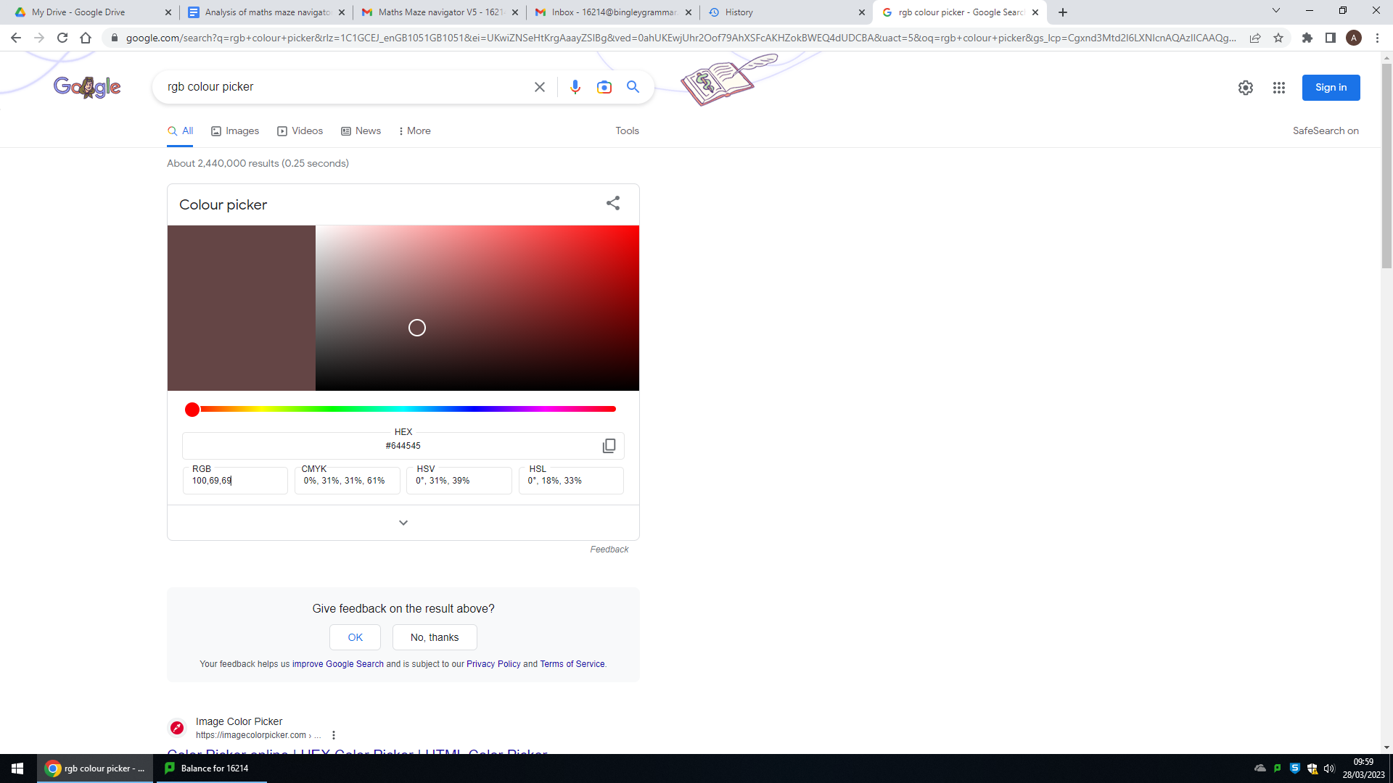 (Dark Brown/Maroon)

Button2:

* The colour of the surface is this colour here: 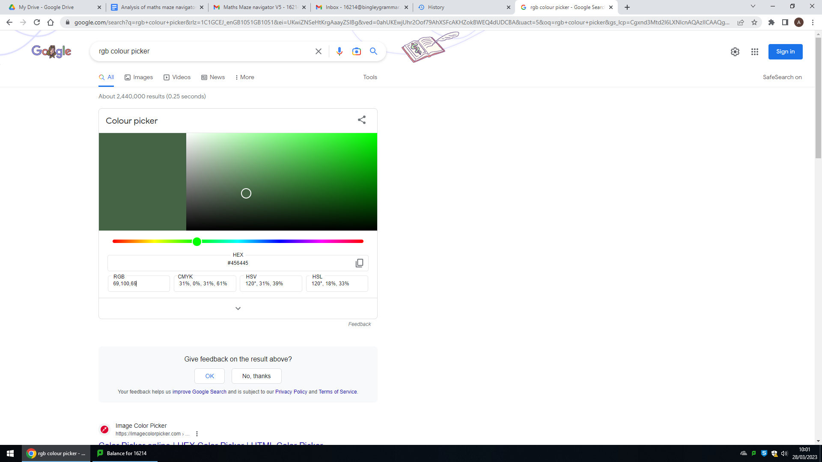 (Dark Green)

Button3:

* The colour of the surface is this colour here: 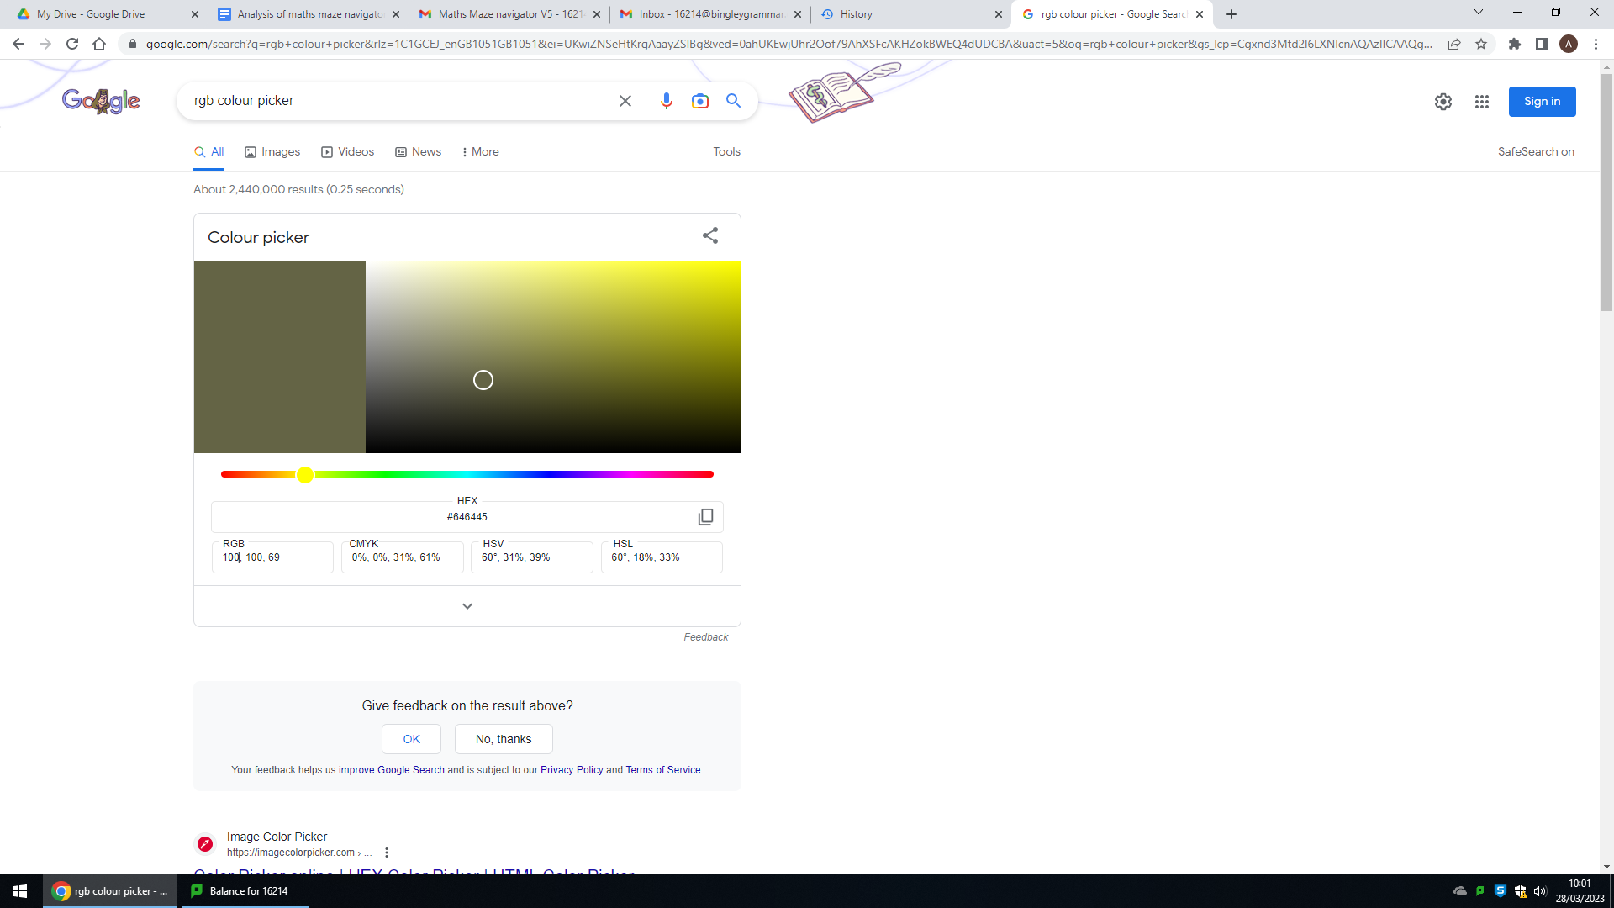 (Mud yellow/ A darker shade of the yellow colour of wet sand)

Button4:

* The colour of the surface is this colour here: 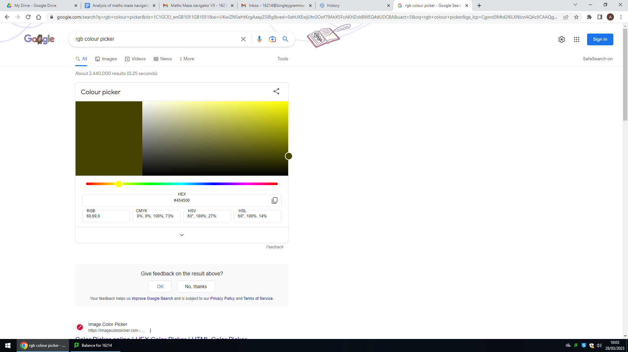 (Swamp green)

Button5:

* The colour of the surface is this colour here: 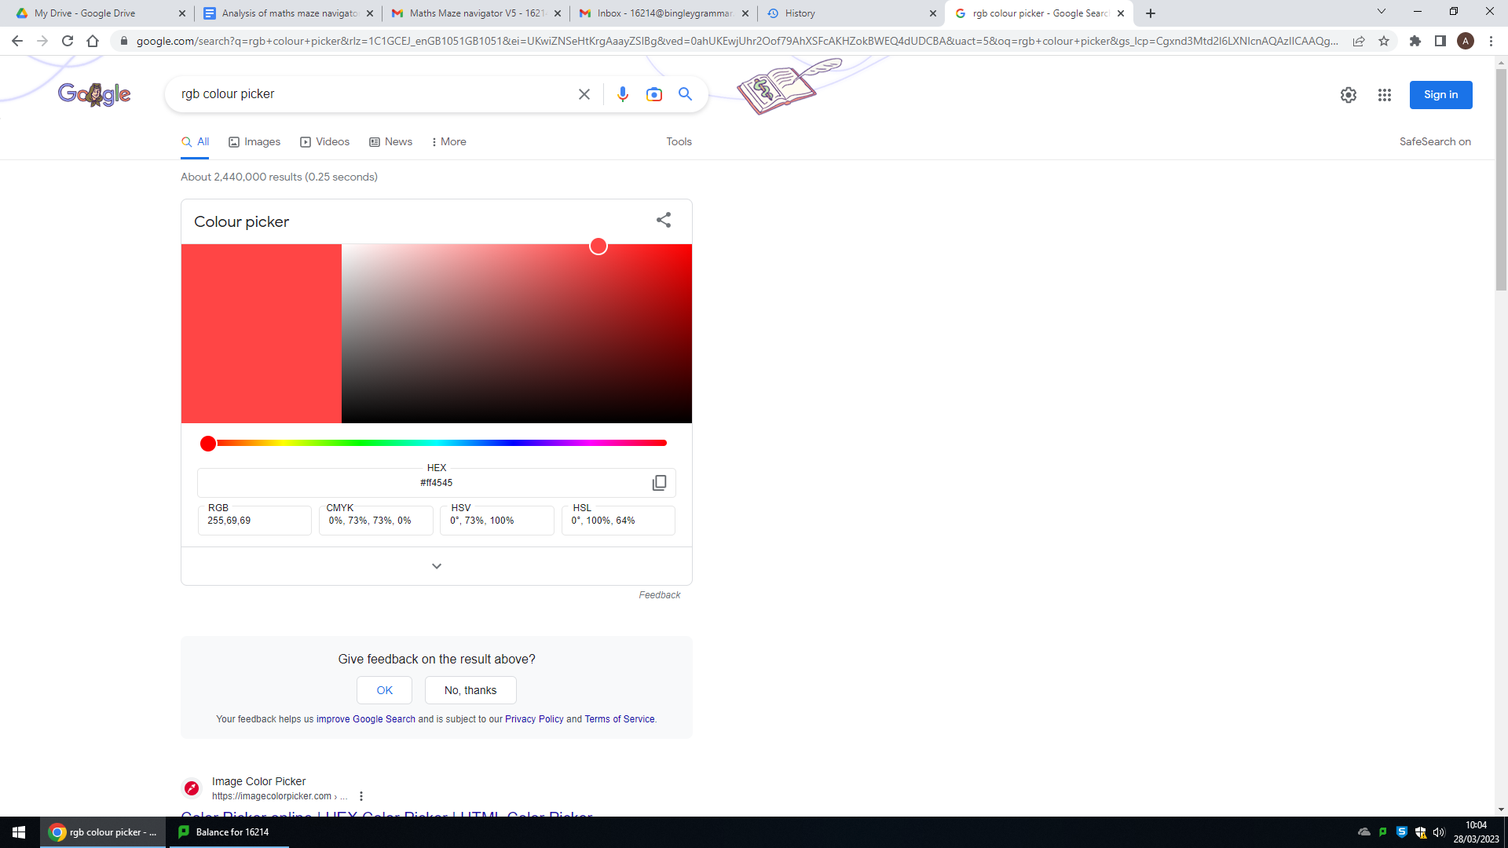 (Light red)
* The font size is 30 instead of 35.

**Main.py:**

This is the main program, where the game itself is run.

Listed below is every single difference between Main.py of V5 and Main.py of V4:

* New variable MAZE_CONSTANT assigned value 25.
* New function get_questions():

1. Takes parameter fileName.
2. Initialises an empty array “questions”
3. A FOR loop is initialised, where for each line in the file, a line is split of its commas, is stripped off its new line character, and is stored in a variable called newline. The variable newline is appended to the questions array.

* Generate maze in the nested FOR loop; X and Y are now calculated using the MAZE-CONSTANT instead of only the x and y values of the for loop itself.
* New class QuestionWindow (shown below):

1. Constructor (takes the questions array and the score as parameters):
   1. Inherits from parent class Tk.
   2. The window size, title, and background of the question window itself are set up.
   3. The first question in the file is assigned to be equal to the first line of the questions array, where self.question is assigned the contents of the first index of the questions array, and where thisQuestion is assigned self.question.
   4. 4 answers are set up where the following occurs:
      1. answer1 = questions[1]
      2. answer2 = questions[2]
      3. answer3 = questions[3]
      4. answer4 = questions[4]
   5. The correct answer is assigned answer1
   6. self.Score is assigned StringVar() (a tkinter function used to allow entry of values)
   7. self.movesLeft is assigned 0
   8. self.score is assigned the parameter score.
   9. self.status is assigned “Incorrect”
   10. A question text label is set up and used, with the text being the attribute thisQuestion, with the font size being 20 and with the font being Helvetica bold.
   11. 4 answer buttons are set up, with each button containing the corresponding answer and with each button calling upon the corresponding ansPressed method of the QuestionWindow text when the button is pressed.
   12. A scorebox is enabled which is only able to be updated by the program.
   13. A score text label is set up, with text assigned “Score:”, with the font being 10, and with the font being Helvetica bold.
2. ansPressed(Takes answer and correctAnswer as parameters)
   1. An if statement is used to check whether the answer given as a parameter is equal to the correct answer given for that question. If it is, self.status is assigned “Correct!” and self.score is incremented by 1. If the answer is not correct, self.status is assigned “Incorrect!” and self.score is decremented (decreased) by 1.
   2. After the if statements are checked, the self.Score text is set to self.score.
3. return_info():
   1. Assigns self.currentScore to self.score.
   2. Checks if self.status is equal to “Correct!”. If it is, then self.movesLeft is assigned 5. If not, then self.movesLeft is assigned 1.
   3. self.currentScore and self.movesLeft are returned to the main program.

* New class QuestionSelect_screen(screens) shown below:

1. Constructor (takes no parameters):
   1. Inherits from parent class screens
   2. Initialises pygame.
   3. 4 attributes are assigned, with 2 of them being used to calculate the middle of the screen.
   4. 6 location attributes are assigned and are used as location parameters for 1 text sprite and 5 separate button sprites.
   5. All sprites are added to the all_sprites group.
2. display (takes 1 parameter qs_diff)
   1. 12 location variables are assigned different values using the location attributes assigned in the constructor method.
   2. A game loop (while loop) is set up with a sentry variable run which is assigned True.
      1. An event loop is set up:
         1. The event is checked to see if it is equal to pygame.QUIT (if the user presses the red X in the top right corner). If it is, then run is assigned to false and the game loop is terminated.
         2. The event is checked to see if the user has pressed a key. If the user has pressed the f key, fullscreen is toggled.
         3. The event is checked to see if the mouse is pressed. If it has, depending on the location, the parameter qs_diff is assigned a different value and game.run_main is called with the parameter qs_diff passed through.
      2. Pygame window filled with black.
      3. The current mouse position is assigned to the variable mouse.
      4. A for loop is set up for each sprite in the all_sprites group, where each sprite is blitted to the screen.
      5. The pygame screen is updated.
   3. An if statement is used to check whether run is equal to False. If it is, the entire program is paused for 2 seconds, then pygame.quit is called.

high_score_screen2(TopLevel) changes:

* 3 new parameters movesBonus, questionsBonus, livesBonus in place.
* sortedNames is now equal to itself but in descending order (using [::-1] which reverses a list)
* A new button with the text “More Info” is set up, which calls self.displayInfo(movesBonus, questionsBonus, livesBonus) when pressed.
* New function displayInfo:
  + Takes 3 parameters movesBonus, questionsBonus, livesBonus.
  + Assigns 4 separate text variables to 4 separate lines of text and inserts them all into the textbox.

high_score_screens1(Toplevel) changes:

* Constructor takes 3 new parameters (movesBonus, questionsBonus, livesBonus)
* The ‘Submit Score’ button takes in 3 new parameters (movesBonus, questionsBonus, livesBonus)

save_screen(screens) changes:

* display method takes new parameter qs_diff which is passed as an argument into game.run_main()

load_screen(screens) changes:

* display method takes new parameter qs_diff which is passed as an argument into game.run_main()
* loadMaze and loadGame method both use the constant MAZE_CONSTANT instead of the value 25.

wins_screen(screens) changes:

* display method takes 3 new parameters (movesBonus, questionsBonus, livesBonus)

start_screen(screens) changes:

* In the display method, instead of running game.run_main() after the x and y mouse coordinates are within the loc5, loc6, loc3, and loc4 bounds, game.run_qss() is run.

pygame_window(screens) changes:

* New attributes assigned in the constructor (self.__lives is assigned 3 instead of 300, self.__movesLeft is assigned 5, self.__file is assigned None)
* An empty array is assigned to an attribute self.movesQueue.
* display method changes:
  + New parameter qs_diff
  + 6 comparisons are made with the value of the parameter qs_diff. These comparisons are used to open specific question files through assigning that file to the attribute self.__file)
  + 5 variables are set up (self.score = 0, questions = the array returned from get_questions(self.__file), self.calls = 0, self.crashes = 0, self.moveUndone = False)
  + A new if statement checks whether the undo button is pressed.
  + A question is opened if the player has at least 0 moves left and if the player has answered less than 10 questions.
  + If a player presses the undo move button and has undone a move, self.moveUndone is assigned False. If the queue contains moves, the player’s most recent move is undone.
  + The undo button is placed (blitted) onto the screen, where self.movesLeft is incremented after 1.
  + The player is blitted onto the screen after the undo button.
  + The player coordinates are updated.
  + Instead of the player only being killed, the player is killed then re-instantiated and respawned, then self.crashes is incremented by 1. If self.crashes is a multiple of 5, the livesCounter is updated.
  + If the queue length is equal to 5, the first item is removed and the new player coords are added to the queue.
  + self.__CurrentScore is now equal to 500 + self.movesBonus + self.questionsBonus + self.livesBonus (self.movesBonus = 1500 - (MAZE_CONSTANT * self.__moves), self.questionsBonus = self.score * MAZE_CONSTANT, self.livesBonus = self.__lives * MAZE_CONSTANT)
  + 3 new functions:
    - open_window(opens a question window by taking 1 parameter: questions)
    - undoMove(Removes the last item from the queue)
    - checkQueue(Takes 1 parameter: cellLoc, and checks if a move is safe by scanning through the queue - done to prevent duplicate moves in queue)

Game class changes:

* New parameter qs_diff
* New display QuestionSelect_screen() assigned to self.display7
* New method run_qss, which calls the display method of self.display7

Main game changes:

* screens() is no longer instantiated (it never needed to be)
* Variable qs_diff is assigned: “” (empty string)
* Variable qs_diff is passed as an argument into the Game class.

**Testing**

**Testing the Objectives:**

For this section, I have made a video showcasing the game - this is the same video as is detailed at the end of *Technical Solution* (page 189)

The link to the video: <https://youtu.be/7ZZU3XJEb_Y>



| **Objective** | **Met/Partially met/Not met** | **Comments** |
| --- | --- | --- |
| An algorithm to generate the maze | Met | A maze has been generated using Prim’s algorithm which is originally a shortest paths algorithm but can be used for maze generation  <https://youtu.be/7ZZU3XJEb_Y?t=53> - 0:53 (Code)  <https://youtu.be/7ZZU3XJEb_Y?t=298> - 4:58 (Game) |
| Maths questions that can be stored in an array | Met | 5 categories of questions loaded in from different files - based on topics the end-users wanted  <https://drive.google.com/file/d/15iDl5hVBddnYJR_DYk6vT_Fyddjorp7U/view?usp=sharing> - Files  <https://youtu.be/7ZZU3XJEb_Y?t=318> - 5:18 (Medium)  <https://youtu.be/7ZZU3XJEb_Y?t=557> - 9:17 (Easy)  <https://youtu.be/7ZZU3XJEb_Y?t=716> - 11:56 (Hard) |
| Ability to move character around using keyboard | Met | The character can move around using either the arrow keys or WASD  <https://youtu.be/7ZZU3XJEb_Y?t=308> - 5:08 (shows the character moving for first time) |
| Can select answers to maths questions | Met | The user can click on 1 answer on each Maths Question window  <https://youtu.be/7ZZU3XJEb_Y?t=320> - 5:20 (shows user clicking on answer of maths question for first time) |
| Interactive GUI | Met | Both Pygame and Tkinter have been used  Pygame has been used for various windows from the Start screen to the win/lose screens  Tkinter has been used for the questions and also high scores screen  <https://youtu.be/7ZZU3XJEb_Y?t=253> - 4:13 (Start screen - Pygame window)  <https://youtu.be/7ZZU3XJEb_Y?t=290> - 4:50 (Loading screen - Pygame window)  <https://youtu.be/7ZZU3XJEb_Y?t=298> - 4:58 (Main game - Pygame window [1st time])  <https://youtu.be/7ZZU3XJEb_Y?t=333> - 5:33 (Question 3 [Medium] - Tkinter window)  <https://youtu.be/7ZZU3XJEb_Y?t=1006> - 16:46 (High Scores 1 - Tkinter window)  <https://youtu.be/7ZZU3XJEb_Y?t=1047> - 17:27 (High Scores 2 - Tkinter window) |
| Scoring system | Met | Merge sort used to sort high scores in order and 4 variables added together to calculate final score  <https://youtu.be/7ZZU3XJEb_Y?t=142> - 2:22 (Code)  <https://youtu.be/7ZZU3XJEb_Y?t=1006> - 16:46 (High Scores 1 - Game)  <https://youtu.be/7ZZU3XJEb_Y?t=1047> - 17:27 (High Scores 2 - Game) |
| File handling to store high scores | Met | File used to store high scores of players who have beaten the game before and new scores can be appended to end of file  <https://drive.google.com/file/d/1QcnKWeX_IbWUEnRaHvQFQKPAivc2v6gC/view?usp=sharing> - High scores File  <https://youtu.be/7ZZU3XJEb_Y?t=1047> - 17:27 (High Scores 2 - Game) |
| Limited number of moves | Met | Start off with 5 moves at start of game and moves gained for answering questions and used when moving player with keyboard  <https://youtu.be/7ZZU3XJEb_Y?t=309> - 5:09 (First time moves left decrease to 0) |
| Moves given after answering question correct | Met | One move given if question not answered correctly and five moves given if question answered correctly  <https://youtu.be/7ZZU3XJEb_Y?t=322> - 5:22 (First time question answered right)  <https://youtu.be/7ZZU3XJEb_Y?t=330> - 5:30 (First time question answered wrong) |
| Set amount of lives | Met | 3 lives given at start and lives lost if crash into wall every 5 times  <https://youtu.be/7ZZU3XJEb_Y?t=300> - 5:00 (Start of game showing 3 lives)  <https://youtu.be/7ZZU3XJEb_Y?t=464> - 7:44 (Life lost for the first time - from 3 to 2) |
| Ability to undo moves | Met | Queue used to store up to 5 previous moves that user has done  Undo button can be clicked to go back a move  Coordinates of move are stored and player moves to those coordinates  Coordinates are taken every time the user moves  <https://youtu.be/7ZZU3XJEb_Y?t=484> - 8:04 (Move undone for first time) |
| Ability to save and load games | Met | User able to close game and pick back up from where they left off  Load screen and save screen displayed when user clicks button to load and save game  <https://youtu.be/7ZZU3XJEb_Y?t=622> - 10:22 (Saving the game for the first time)  <https://youtu.be/7ZZU3XJEb_Y?t=646> - 10:46 (Loading the game for the first time) |
| Able to select difficulty of maths questions | Met | Menu choice at start of game and allows user to choose how hard they want maths questions to be  <https://youtu.be/7ZZU3XJEb_Y?t=120> - 2:00 (Code)  <https://youtu.be/7ZZU3XJEb_Y?t=282> - 4:42 (Question select screen displayed for first time in game) |
| Hints given with correct solution | Met | User has option to buy hint - costs 10 points off the score  Scoreboard updated with -10 value from before  Hint respawns player at nearest spot on correct path to where they last visited  Recursive solving used to find correct path and store in array  <https://youtu.be/7ZZU3XJEb_Y?t=996> - 16:36 (Hint) |
| Advanced Objectives | N/A | These objectives were mostly not met due to time constraints |
| Aesthetics of maze and player | Partially met | Image for character was used but for maze no image was used  <https://drive.google.com/file/d/1hV_4p371VwGI7gJMBZYy2vnIFIUGhmNG/view?usp=sharing> - Player image  <https://youtu.be/7ZZU3XJEb_Y?t=296> - 4:56 (Player shown for first time) |
| Background image | Not met | Having a background would have appealed nicely to aesthetics of game but was decided against as may be harder to see maze and player and also may have been ‘over the top’ |
| A loading screen | Met | Includes a loading bar and text that says “Game Loading…”  Also includes text that says “Game loaded - click anywhere to exit” which is displayed after few seconds  Can click off loading screen when this text appears  <https://youtu.be/7ZZU3XJEb_Y?t=290> - 4:50 (Loading screen displayed for first time) |
| Multiple levels increasing in difficulty | Not met | There wasn’t time, so multiple levels were not considered with the size of the maze increasing with difficulty of each level |
| Theme of levels | Not met | Each level could’ve had its own slightly different theme |
| Personalised settings | Not met | These could have been accessibility settings and other options which would’ve allowed user to customise their game experience |
| Different game modes | Not met | There could have been time trial mode where instead of having a limited amount of moves, user has limited amount of time in which to complete maze and answering questions correctly gives user more time to complete maze  There could have also been mode that only focused on answering questions (an arcade mode) and didn’t give bonus points for completing maze in small amount of moves |

**End-User Testing:**

For this section, there were 2 videos made by the end-users - Mr Ninson made both videos

Both videos were at different stages of development of the game/program.

Video 1: Mr Ninson End user testing | MMN V3 - <https://www.youtube.com/watch?v=T6QJxXW1zjg>

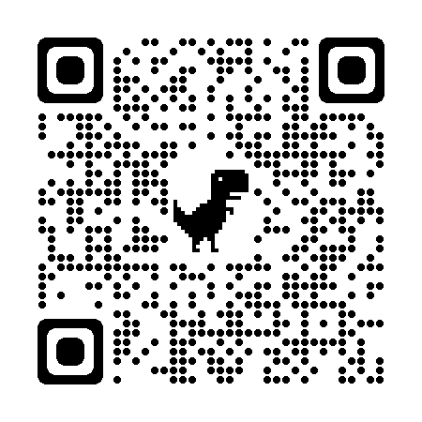

Video 2: Mr Ninson End user testing | MMN V6 - <https://www.youtube.com/watch?v=QJB7YmHfPHs>

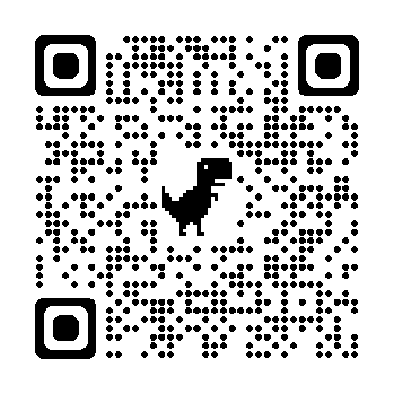

| **Feature** | **Working/Not Working** | **Comments** |
| --- | --- | --- |
| Welcome screen for maths questions | Working | This was only in version 3, in version 6 the welcome screen used was the start screen for the full game  <https://youtu.be/T6QJxXW1zjg?t=1> - 0:01, Quiz |
| Multiple choice maths questions | Working | There were 4 answers given for each maths question and the user can select one.  In version 3 the user can select ‘Next question’ to go to the next one while in version 6, the question closes automatically.  There were 5 categories of questions on version 6.  <https://youtu.be/T6QJxXW1zjg?t=12> - 0:12, q3 v3  <https://youtu.be/QJB7YmHfPHs?t=121> - 2:01, Easy q1 v6 |
| Results screen | Working | This was only shown in version 3 - in version 6 there was a high scores screen at the end for the full game  <https://youtu.be/T6QJxXW1zjg?t=40> - 0:40, Quiz |
| Character can traverse maze (with keyboard) | Working | There was a small character in version 6 which can be moved around using WASD or arrow keys  <https://youtu.be/QJB7YmHfPHs?t=24> - 0:24, Character moving for the first time |
| Undo moves | Working | The user can and did (in the video) undo multiple moves (at different times)  <https://youtu.be/QJB7YmHfPHs?t=238> - 3:58, Undoing a move for the first time |
| High Scores system | Working | The user was able to enter their name in for the high score and then the top 10 scores showed up.  Also a breakdown of the user’s total score was able to be seen as well  <https://youtu.be/QJB7YmHfPHs?t=300> - 5:00, High scores system {start} |
| Save game | Working | The game has an ability to be saved and the end-user did this (in the video)  <https://youtu.be/QJB7YmHfPHs?t=101> - 1:41, Saving |
| Load Game | Not Working | This feature was patched before the final product was released but was not working properly in version 6  <https://youtu.be/QJB7YmHfPHs?t=105> - 1:45, Loading |
| Hints system | Working | The user was able to press the hint button and then the player got teleported closer to the maze exit  <https://youtu.be/QJB7YmHfPHs?t=284> - 4:44, Hint |

**Validation Testing:**

For this section the same video was used as *Testing the Objectives*

The link to the video is here: <https://youtu.be/7ZZU3XJEb_Y>

Also a separate video was made for validation testing purposes: <https://youtu.be/_3WJ-a7ZXy8>

***File Handling validation***

Some code was implemented to deal with the event that a file is missing or corrupt.

This also worked in the event that a user somehow got around the file picking system and went straight to the game without choosing a question difficulty.

Below is a screenshot of this code and also the link to the part of the video that shows it

<https://youtu.be/7ZZU3XJEb_Y?t=205> - 3:25 (Code for File handling validation)

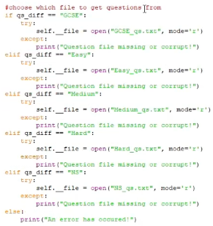

<https://youtu.be/_3WJ-a7ZXy8?t=14> - 0:14 (Medium Qs missing)

<https://youtu.be/_3WJ-a7ZXy8?t=40> - 0:40 (Character can move freely - no questions shown)

***High Scores validation***

Validation was put in place to ensure that a user’s ‘name’ when entering their score is between 2 and 10 characters long

Below is a screenshot of this code and also the link to the part of the video that shows it

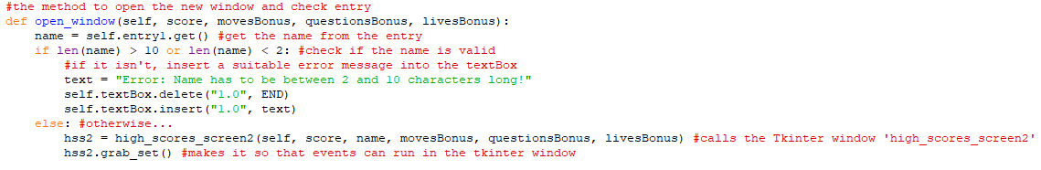

<https://youtu.be/_3WJ-a7ZXy8?t=60> - 1:00 (Validation testing for when entering user score)

**Evaluation**

**Evaluating objectives:**

To assess this project’s success, each objective laid out in the Analysis [Pages 10-12] will be considered and discussed.

*Core Objectives*

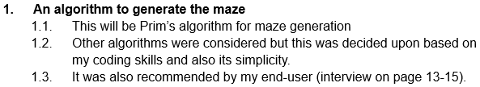

**Figure 8.1** above shows the first core objective

This objective outlines that Prim’s algorithm will be used to generate the maze which is a shortest path algorithm that can be used to generate mazes. This is the most important objective and has been met. This can be evidenced from Technical solution [Pages 123-125] and also from the showcase video in the testing section [Page 223]. Next time, a different algorithm such as Depth First Search could be used to generate the maze.

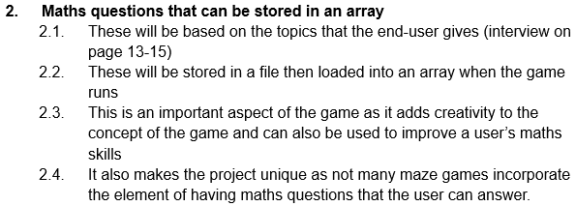

**Figure 8.2** above shows the second core objective

This objective outlines that Maths questions will be used and stored in a file. From the file, these will then be loaded in upon running the game, after starting a new game. The Maths questions used were all based on existing Maths questions from Dr Frost Maths. This objective has also been met. This can be evidenced from Technical Solution [Pages 143-148 & 169-172] and also from the showcase video in the testing section [Page 223]. Next time, different topics could be used for the Maths questions or maybe from a different website.

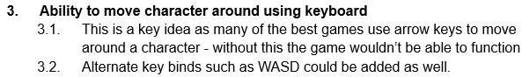

**Figure 8.3** above shows the next core objective

This objective outlines that the user will be able to move the character around using the arrow keys or WASD keys. This is one of the most important objectives and has also been met. This can be evidenced from Technical Solution [Page 118] and also from the showcase video in the testing section [Page 224]. Next time, customisation for the user to choose their own keybinds could be added.

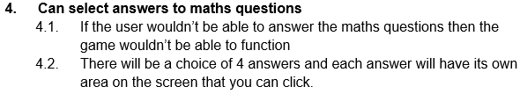

**Figure 8.4** above shows the next core objective

This objective outlines that the user will be able to select from a choice of 4 possible answers for the Maths questions (Multiple choice). This objective has also been met. This can be evidenced from Technical Solution [Pages 143-148 & 169-172] and also from the showcase video in the testing section [Page 224]. Next time, some questions could be left open-ended and some questions could still be multiple choice but provide more or less possible answers.

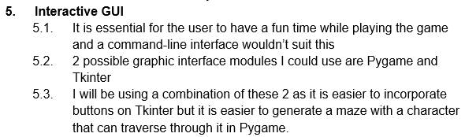

**Figure 8.5** above shows the fifth core objective

This objective outlines that the user will be able to play the game on both the tkinter & pygame GUI windows. This objective has also been met. This can be evidenced from Technical Solution [Pages 119-121, 127-128, 137-138, 144-147, 150, 156-157, 159-160, 169-173, 176-177, 180-182, 184-186, 189] and also from the showcase video in the testing section [Page 224]. Next time, a different module could be used where a combination of all features could be implemented.

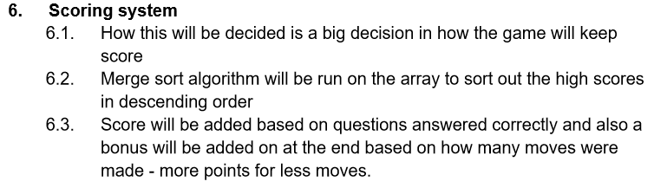

**Figure 8.6** above shows the sixth core objective

This objective outlines that there will be a scoring system with Merge sort being used to sort out the high scores. This objective has also been met. In the end, the score for a user if they won the game was calculated from 4 values - the completion bonus, moves bonus, question bonus and lives bonus. The details for this can be revealed on the ‘High Scores’ window which is a Tkinter window. Also, the user can enter in their name after clicking off the win screen which has to be between 2 & 10 characters then the high scores are shown (top 10) in descending order. This can all be evidenced from Technical Solution [Pages 158-161 & 170 & 174] and also from the showcase video in the testing section [Page 224]. Next time, different values could be used for the scoring system or it could be made simpler. Another improvement could be to have different scoring systems for different game modes.

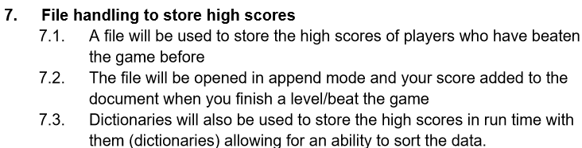

**Figure 8.7** above showing the next core objective

This objective outlines that a file will be used to store the high scores from different games. The new score is appended to the end of the file and replaces a score if it falls within the top 10 scores. This objective has also been met. This can be evidenced from Technical Solution [Pages 158-160] and also from the showcase video in the testing section [Page 225]. Next time, the high scores could be stored in a database with SQL commands being used to access them.

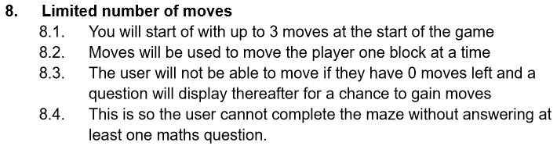

**Figure 8.8** above showing the next core objective

This objective outlines that the user will be given a limited amount of moves and when the user has no moves left a Maths question will display for a chance to gain moves. This was changed slightly so that the user started off with 5 moves at the start of the game instead of 3 and so that a move moved the user 10 pixels. This objective has also been met. This can be evidenced from Technical Solution [Pages 118 & 168] and also from the showcase video in the testing section [Page 225]. Next time, a different amount of moves could be given depending on the question difficulty.

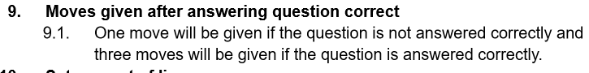

**Figure 8.9** above showing the next core objective

This objective outlines that the user will be given moves after answering a question. This was changed slightly so that the user got 5 moves after answering a question correctly in all question difficulties and 1 move for answering a question incorrectly. This objective has also been met. This can be evidenced from Technical Solution [Pages 168-169] and also from the showcase video in the testing section [Page 225]. Next time, a different amount of moves could be given after answering a question correctly depending on the question difficulty.

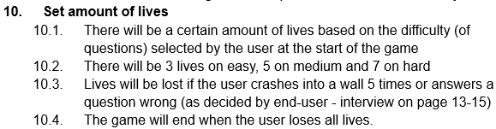

**Figure 8.10** above shows the tenth core objective

This objective outlines that a user will have a certain amount of lives depending on the question difficulty and also outlines how lives will be lost. It also mentions that the game will end when the user loses all lives. This objective has also been met. However, on all difficulties the lives counter was set to 3 to begin with as there wasn’t time to implement a different amount of lives on each question difficulty. This can be evidenced from Technical Solution [Pages 129 & 169] and also from the showcase video in the testing section [Page 225]. Next time, a different amount of lives on each question difficulty could be implemented.

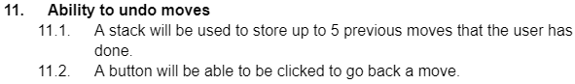

**Figure 8.11** above shows the eleventh core objective

This objective outlines that up to 5 previous moves that the user has done in the game will be stored and the user will be able to undo moves. This objective has also been met. However, a Stack could not be implemented due to some complications so instead a Queue data structure was used. This can be evidenced from Technical Solution [Pages 174-177] and also from the showcase video in the testing section [Page 225]. Next time, a stack could be used to store the moves and a redo button could also be implemented.

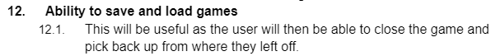

**Figure 8.12** above shows the next core objective

This objective outlines that the user will be able to save and load the game that has previously been saved. This objective has also been met. A text file was used to store the saved game and the details for the game retrieved from this file upon loading. This can be evidenced from Technical Solution [Pages 149-156] and also from the showcase video in the testing section [Page 226]. Next time, the loading of the game could be improved as some elements didn’t load properly.

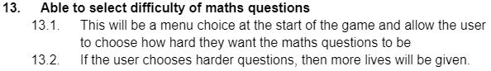

**Figure 8.13** above shows the thirteenth core objective

This objective outlines that there will be a screen where the user can choose which set of questions they want to answer in the game. This objective has also been met. This can be

evidenced from Technical Solution [Pages 161-166] and also from the showcase video in the testing section [Page 226]. Next time, the system of more lives being given for a harder question difficulty could be implemented.

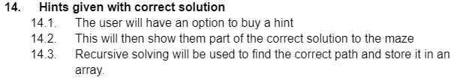

**Figure 8.14** above shows the next core objective

This objective outlines that there will be a hints system where the user can reveal part of the correct path. This objective has also been met. The user was able to get a hint for 10 points off their final score and the scoreboard was updated with this -10 score. The player was respawned at the hint position which was one block away from their last visited position on the maze and was on the correct path. This can be evidenced from Technical Solution [Pages 178-180] and also from the showcase video in the testing section [Page 226]. Next time, the user could choose where to respawn the player from 3 available hints, each with different prices.

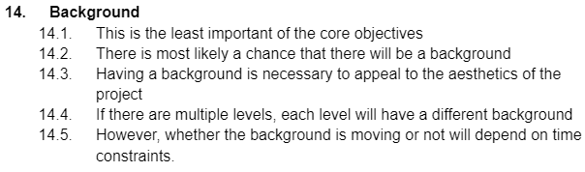

**Figure 8.15** above shows the final core objective

This objective outlines that there will be a background in the game. This objective has not been met. This is because it was deemed to be unnecessary and so therefore was moved into advanced objectives.

*Advanced Objectives*

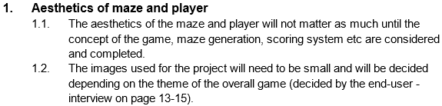

**Figure 9.1** above shows the first advanced objective

This objective outlines that some images will be used for the aesthetics of the project depending on the overall theme of the game. This objective has partially been met. An image was used for the player character but for the maze no image was used - instead it was plain white blocks but there was enough going on for it to not be detrimental to the aesthetics. This can be evidenced from Technical solution [Pages 119-121] and also from the showcase video in the testing section [Page 226]. Next time, an image for the maze could be used..

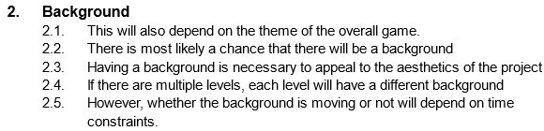

**Figure 9.2** above shows the second advanced objective

This objective outlines that there will be a background that could be moving and the images used will depend on the overall theme of the game. This objective has not been met. Having a background would have appealed nicely to aesthetics of the game but was decided against as it may be harder to see maze and player and also may have been ‘over the top’. Next time, a background could be used and this could move depending on where the player went on the screen (pan across effect).

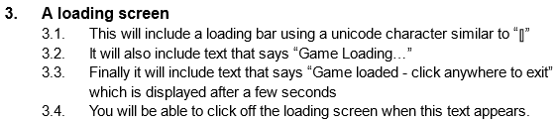

**Figure 9.3** above shows the next advanced objective

This objective outlines that there will be a loading screen that will display for some time before the user can advance. This objective has been met and was originally not part of the advanced objectives - it was added in later. This can be evidenced from Technical Solution [Page 183-186] and also from the showcase video in the testing section [Page 227]. Next time, the loading screen could be displayed for a shorter or customisable amount of time.

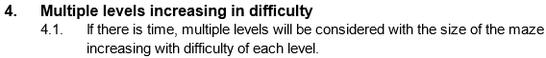

**Figure 9.4** above shows the next advanced objective

This objective outlines that there will be multiple levels with the size of the maze increasing with each level making it harder for the user as the levels increase. This objective has not been met. There wasn’t time, so multiple levels were not considered with the size of the maze increasing with difficulty of each level. Next time, multiple levels could be considered using the maze sizes suggested by end-user Jacob.

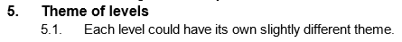

**Figure 9.5** above shows the fifth advanced objective

This objective outlines that if there are multiple levels, each level will have its own slightly different theme that will all fit into the overall theme of the game. This objective has not been met. Each level could’ve had its own slightly different theme if there was time to make multiple levels. Next time, multiple levels could be made with slightly different themes.

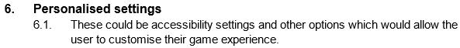

**Figure 9.6** above shows the sixth advanced objective

This objective outlines that there could be a settings section on the main menu where the user can customise their game experience e.g. colours, screen resolution, volume controls, key binds etc. This objective has not been met. There wasn’t time, so accessibility settings and other options which would’ve allowed the user to customise their game experience couldn’t be implemented. Next time, this settings menu could be implemented

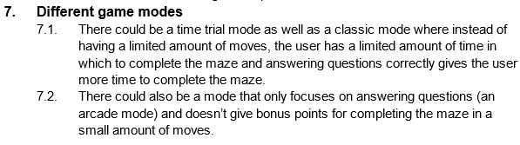

**Figure 9.7** above showing the final advanced objective

This objective outlines that there could be extra game modes created such as an arcade and time trial mode. This objective has not been met. If there was time, a time trial and arcade mode could have been implemented with the user being able to choose which game mode they wanted to play from the start menu. Next time, these game modes could be implemented to give the user a more varied experience when playing the game.

**Criticisms and Praises:**

Overall, the program functions well. There are no syntax errors and all core objectives have been met. There are also no notable logic errors. From the *Evaluating objectives* section [Page 232] it can be seen that the core objectives have been met but most of the advanced objectives have not been met and this is backed by the videos from the *Testing the Objectives* section [Page 223] and also the *End-User Testing* section [Page 228]. Validation for the relatively small amount of user inputs is also backed by the *Validation Testing* section [Page 230].

However, due to time constraints, the lack of completion of advanced objectives could be considered a weakness to do with the program. Advanced objectives such as the aesthetics of the game, having a moving background, having multiple levels all with a unique setting for the same theme and also different game modes such as a time trial mode and an arcade mode could be implemented if there was more time or if I was to do this again in the future.

Other than this, the code is all using the Object-oriented paradigm which is a high-level computer science programming paradigm and also it has been organised into a Main program and subprograms. The Main program can be run directly whereas the subprograms just contain classes that are imported into the Main program.

Another weakness to do with the program is that I wasn’t able to implement a stack data structure properly. If this was implemented properly, it would’ve been more suitable for undoing moves. Also a redo button feature could’ve been added that worked with a second stack.

**Feedback:**

Feedback was collected from the end-users (shown below)

End-user Mr Ninson (*after Phase 3*) said:

“The Maths questions are quite useful and challenging. Also the design of the game is quite good in that you have 4 possible answers that you can select and then you can click ‘Next Question’ which will open the next question. It also shows the results at the end which is useful to see how well you did.”

End-user Jacob (*after Phase 2*) said:

“About the controls, a good feature is that you can move with either WASD or the arrow keys which is useful. There is a toggle fullscreen feature but this does not always work properly. The graphics are quite good and the overall game experience is superb. However, when you crash into the wall, lives are lost at a tremendous rate and the player can still pass through the walls. If there is a way around this, it should be implemented.”

End-user Mr Ninson (*after Phase 6*) said:

“The game overall is a great revision source as I thought it would be. Hasan has done a really good job collecting these questions and fashioning this maze game. However, there are a few issues that will hopefully be resolved when the project is completed. A couple of these are that for some questions the font is too big so the question is not displayed fully. Also, the question answers are not shuffled, so a player can just select the first answer for each question and get them right.”

End-user Jacob (*after Phase 4*) said:

“The save game and load game feature is really good as you can load in a game you previously saved even after you have rebooted the game or started a new game, a previous game can still be loaded. Furthermore, the high scores are displayed in order at the end of the game if you win and how to play/instructions and control sections are very clear.”

End-user Mr Ninson (*after Phase 7 i.e at the end*) said:

“All issues I had before have been fully resolved and the game is complete now. I am proud of my student for building this great game.”

End-user Jacob (*after Phase 7 i.e at the end*) said:

“Easy to use interface complemented by easy to use controls and inputs. There are no notable issues which haven’t been fixed by this point. Overall good project and fine game. As far as I know, all the objectives have been met providing a useful final product which could be distributed and help students with their revision. Also, the aesthetics of the game are somewhat pleasing to a user. Furthermore, my suggestions were mostly taken into consideration and implemented into the game which I am pleased about.”

I also collected feedback of the code from the supervisor

Supervisor said:

“Pros/benefits/good things about the code:

- Code is all class based, using a mixture of composition and inheritance to construct each class.

- Code is very well organised into files, allowing for the code to be easily understood.

- High level algorithm (prim's algorithm) is used to generate a maze, showing deep algorithmic understanding.

- High level data structure (queue) is used to allow moves to be undone throughout the maze, which shows a high understanding of data structures.

- A range of maths questions were used for different levels of understanding, showing high enough levels of intelligence to understand and implement A level maths questions, but also showing deep understanding of his potential end users.

- Games are able to be saved and loaded.

- A robust scoring system and leaderboard are both implemented into the game.

Cons/drawbacks/bad things about the code:

- A queue was used instead of a stack to undo moves. A stack would have been much more appropriate for storing the player's movements.

Overall, this code is a masterpiece. It implements multiple A level features (algorithm, data structure) with ease, and provides sufficient end user interaction. The only drawback is that a stack should've been implemented instead of a queue to allow the end user to undo moves. Other than that, this is a masterpiece of an A level project.”

Reflecting on this feedback, I can say that it aligns itself with what improvements and achievements I as a developer thought I did myself and mentioned in the *Criticisms and Praises* section. The main summary is that, the features that I implemented were implemented well and one of the main purposes that I wanted to fulfil (making a game that could be used for Maths revision) was accomplished. Also, the main improvement, on the coding side of things, was that I should’ve implemented a stack instead of a queue for undoing moves. Furthermore, a greater range of features could’ve been added and that would’ve made the game even better. To conclude, both end-users were pleased with the final product and the supervisor thought highly of my code which was over 2000 lines in length including all the subprograms.

**References**

**Image References:**

***Figure 1 (page 4)***

Page title: *Mazes*

Website: www.mathsisfun.com

URL: <https://www.mathsisfun.com/games/mazes.html>

***Figure 2 (page 5)***

Article title: *Maze generations: Algorithms and Visualizations*

Author: Hybesis - H.urna (<https://medium.com/@urna.hybesis>)

Website: medium.com

URL: <https://medium.com/analytics-vidhya/maze-generations-algorithms-and-visualizations-9f5e88a3ae37>

***Figure 3 (page 7)***

Article title: *Maze generations: Algorithms and Visualizations*

Author: Hybesis - H.urna (<https://medium.com/@urna.hybesis>)

Website: medium.com

URL: <https://medium.com/analytics-vidhya/maze-generations-algorithms-and-visualizations-9f5e88a3ae37>

***Figure 4 (page 8)***

Page title: *Merge Sort Algorithm*

Website: www.geeksforgeeks.org

URL: <https://www.geeksforgeeks.org/merge-sort/>

***Figure 5 (page 16)***

Page title: *Weighted Graph Clustering for Community Detection of Large Social Networks*

Authors: Ruifang Liu, Shan Feng, Ruisheng Shi, Wenbin Guo

Website: www.semanticscholar.org (redirect to www.sciencedirect.com)

URL: <https://www.sciencedirect.com/science/article/pii/S1877050914004256?via%3Dihub>

***Figure 6 (page 17)***

Page title: *Applying Prim’s Algorithm to Identify Isolated Areas for Natural Disaster Prevention and Protection - Scientific Figure on ResearchGate*

Authors: Wang, Wen-Ching, Hsieh, Ming-Che

Website: www.researchgate.net

URL: <https://www.researchgate.net/figure/The-flow-chart-of-Prims-Algorithm-to-Identify-Isolated-Areas_fig4_326322550>

***Figure 7.1 (page 24)***

Page title: *Python Math: Create a simple math quiz*

Website: www.w3resource.com

URL: <https://www.w3resource.com/python-exercises/math/python-math-exercise-63.php>

***Figure 7.2 (page 25)***

Page title: *Python Math: Create a simple math quiz*

Website: www.w3resource.com

URL: <https://www.w3resource.com/python-exercises/math/python-math-exercise-63.php>

***Figure 7.3 (page 25)***

Page title: *Python Math: Create a simple math quiz*

Website: www.w3resource.com

URL: <https://www.w3resource.com/python-exercises/math/python-math-exercise-63.php>

***Figure 7.4 (page 26)***

Page title: *Python Math: Create a simple math quiz*

Website: www.w3resource.com

URL: <https://www.w3resource.com/python-exercises/math/python-math-exercise-63.php>

**Code References:**

These are the websites that were used to help build my program:

<https://realpython.com/pygame-a-primer/> - Initial tutorial for pygame basics

<https://www.pygame.org/docs/> - Check pygame features throughout project

<https://realpython.com/python-gui-tkinter/> - Initial tutorial for tkinter basics

<https://www.geeksforgeeks.org/merge-sort/> - Merge sort algorithm

<https://github.com/OrWestSide/python-scripts/blob/master/maze.py> - Prim’s Algorithm

<https://www.freecodecamp.org/news/sort-dictionary-by-value-in-python/> - Sort Dictionary

Also a host of my old python files were used to help with the making of this program:

[Maze generator V2](https://drive.google.com/file/d/1ftK_SQraiH3ZvU0bmUkCjTEBmxQUW3kq/view) (to help generate maze)

[Snake in python](https://drive.google.com/file/d/1NBYzjAjm5U5Hty-YFNrg9Ixhgq9ItorA/view) (to help with setting up sprites and general pygame workings)

[Football Pong](https://drive.google.com/file/d/1eL28aV3cYFeh-AuRHWk9ISlLN1m-Uq1t/view) (to help with setting up sprites and general pygame workings)

[Pygame Windows Practice](https://drive.google.com/file/d/196MZIALyrR4EV_kVtH1sLcgjSgny0aqn/view) (to help with setting up different types of windows)

[Pygame buttons](https://drive.google.com/file/d/1HBC3rzhbBO311LX1GcVvYhg7BkUqOlU6/view) (to help setting up button sprites)

[Pygame Timer Practice](https://drive.google.com/file/d/1236dtdPvOwdI7QR7U5OB2ksyz0C3-So_/view) (to help setting up Timer class)

[Larger GUI project](https://drive.google.com/file/d/1O84uVX1C7h_UA5fUlF_UGfg3tk1U8TFS/view) (to help with Tkinter workings)

[Critters vs Aliens](https://drive.google.com/file/d/15jbXIllIo7duJci0xHitkqxW-N-ka74V/view?usp=share_link) (to help with class inheritance)

[Python Stack Practice](https://drive.google.com/file/d/1PGZ-Rh_UHDDE-6k9Dn4ObxJbixZLJ1Tr/view?usp=sharing) (to help with setting up MovesStack class)

[Python Queues Practice](https://drive.google.com/file/d/1_YHV0pnUbuQnsa48r_zeQcwUfUN4l-lj/view?usp=share_link) (to help with setting up MovesQueue class)

**Other References:**

***Video on Prim’s algorithm (page 5)***

Video title: *Maze Generation - Prim's with flooding*

Website: www.youtube.com

Video Publisher: Hybesis Urna (<https://www.youtube.com/@hybesisurna8616>)

Video Source: https://hurna.io/academy/algorithms/maze_generator/prim_s.html

URL: <https://www.mathsisfun.com/games/mazes.html>

***Demonstration of Prim’s algorithm (page 6)***

Page title: *Maze Generation: Prim's Algorithm*

Website: weblog.jamisbuck.org

URL: <https://weblog.jamisbuck.org/2011/1/10/maze-generation-prim-s-algorithm.html>

***Python Maths program (page 20 - 26)***

Page title: *Python Math: Create a simple math quiz*

Website: www.w3resource.com

URL: <https://www.w3resource.com/python-exercises/math/python-math-exercise-63.php>

***Python Maze program (page 26 - 29)***

Page title: *Python maze game*

Website: pythonspot.com

URL: <https://pythonspot.com/maze-in-pygame/>

***Pseudocode syntax [for Documented Design] (page 30 - 113)***

Page title: *Pseudocode*

<https://isaaccomputerscience.org/concepts/prog_pas_pseudocode?examBoard=all&stage=all>

Page title: *Pseudocode conventions*

<https://isaaccomputerscience.org/concepts/isaac_pseudocode?examBoard=all&stage=all>

Page title: *Notes and guidance: Pseudo-code - AQA*

<https://filestore.aqa.org.uk/resources/computing/AQA-8525-NG-PC.PDF>

**Appendix**

Appendix A (from Analysis section [page 3 - 29])

A1 - Trace table of merge sort [page 9]:

array = [2,4,6,5,3,1,7]

| **m** | **i** | **j** | **k** | **array1** | **array2** | **array** |
| --- | --- | --- | --- | --- | --- | --- |
| 4 | 0 | 0 | 0 | [2,4,6,5] | [3,1,7] |  |
|  | 1 | 0 | 1 |  |  | [2] |
|  | 1 | 1 | 2 |  |  | [2,3] |
|  | 1 | 2 | 3 |  |  | [1,2,3] |
|  | 2 | 2 | 4 |  |  | [1,2,3,4] |
|  | 3 | 2 | 5 |  |  | [1,2,3,4,6] |
|  |  |  | 6 |  |  | [1,2,3,4,5,6] |
|  |  |  | 7 |  |  | [1,2,3,4,5,6,7] |

A2 - Final version of core objectives [page 15]:

1. **An algorithm to generate the maze**
   1. This is Prim’s algorithm for maze generation.
   2. Other algorithms were considered but this was decided upon based on my coding skills and also its simplicity.
   3. It was also approved by my end-user (interview on page 10-11).
2. **Maths questions that can be stored in an array**
   1. There are 5 categories of questions - GCSE, Easy, Medium, Hard and Ninson’s Specials.
   2. These are based on the topics that the end-user gave.
   3. These are stored in a file (one for each category) then loaded into an array when the game runs.
   4. This is an important aspect of the game as it adds creativity to the concept of the game and can also be used to improve a user’s maths skills.
   5. It also makes the project unique as not many maze games incorporate the element of having maths questions that the user can answer.
3. **Ability to move character around using keyboard**
   1. This is a key idea as many of the best games use arrow keys to move around a character - without this the game wouldn’t be able to function.
   2. Alternate key binds such as WASD are used as well.
4. **Can select answers to maths questions**
   1. If the user isn’t able to answer the maths questions then the game won’t be able to function.
   2. There is a choice of 4 answers and each answer has its own area on the screen that you can click.
5. **Interactive GUI**
   1. It is essential for the user to have a fun time while playing the game and a command-line interface wouldn’t suit this.
   2. 2 possible graphic interface modules I did use are Pygame and Tkinter.
   3. I did use a combination of these 2 as it is easier to incorporate buttons on Tkinter but it is easier to generate a maze with a character that can traverse through it in Pygame.
6. **Scoring system**
   1. Merge sort algorithm has been run on the array to sort out the high scores in descending order.
   2. The score is decided based on 4 scores added together (MAZE_CONSTANT is 25).
   3. The first of these is a completion bonus which is always 500.
   4. The second of these is a moves bonus which is calculated by “5000 - (MAZE_CONSTANT * moves)”.
   5. The third of these is a lives bonus which is calculated by “lives * MAZE_CONSTANT”.
   6. The final of these is a question bonus which is calculated by “QuestionScore * MAZE_CONSTANT”.
   7. The details for this can be revealed on the ‘High Scores’ window which is a Tkinter window.
7. **File handling to store high scores**
   1. A file is used to store the high scores of players who have beaten the game before.
   2. The file is opened in append mode and the user score added to the document when the user beats the game and scores a score that is high enough for the top 10.
   3. A high scores dictionary and high scores array are used to store the scores with the dictionary also storing the name with the score.
8. **Limited number of moves**
   1. You start off with 5 moves at the start of the game.
   2. Moves are used to move the player one block (10 pixels) at a time.
   3. The user isn’t able to move if they have 0 moves left and a question displays thereafter for a chance to gain moves.
   4. This is so the user cannot complete the maze without answering at least one maths question.
9. **Moves given after answering question correct**
   1. One move is given if the question is not answered correctly and five moves are given if the question is answered correctly.
10. **Set amount of lives**
    1. There are 3 lives
    2. Lives are lost if the user crashes into a wall 5 times and the user is reset every time they crash.
    3. The game will end when the user loses all lives.
    4. A lose screen displays if this happens.
11. **Ability to undo moves**
    1. A queue is used to store up to 5 previous moves that the user has done.
    2. A button can be clicked to go back a move.
    3. The coordinates of the move are stored and the player moves to those coordinates.
    4. Coordinates are taken every time the user moves.
12. **Ability to save and load games**
    1. This is useful as the user is able to close the game and pick back up from where they left off.
    2. A load screen and save screen are displayed when the user clicks the button to load and save the game.
13. **Able to select difficulty of maths questions**
    1. This is a menu choice at the start of the game and allows the user to choose how hard they want the maths questions to be.
14. **Hints given with correct solution**
    1. The user has an option to buy a hint - it costs 10 points off the score
    2. The scoreboard is updated with this -10 value from what it was before
    3. This hint respawns the player at the nearest spot on the correct path to where they last visited
    4. Recursive solving is used to find the correct path and store it in an array.

A3 - Final version of advanced objectives [page 15]:

NOTE: The advanced objectives have not been completed because of time constraints

1. **Aesthetics of maze and player**
   1. The aesthetics of the maze and player do not matter as much until the concept of the game, maze generation, scoring system etc have been considered and completed.
   2. The images used for the project are small and have been decided depending on the theme of the overall game which was pirates. The image for the character was used but for the maze no image was used.
2. **Background image**
   1. This also depends on the theme of the overall game.
   2. There was a background image but it wasn’t used
   3. Having a background would have appealed nicely to the aesthetics of the game but it was decided against as it may be harder to see the maze and player and also it may have been ‘over the top’
   4. If there were multiple levels, each level would’ve had a different background
   5. The background could have been moving but due to time constraints wasn’t.
3. **A loading screen**
   1. This includes a loading bar using a unicode character similar to “⫿”
   2. It also includes text that says “Game Loading…”
   3. Finally it includes text that says “Game loaded - click anywhere to exit” which is displayed after a few seconds
   4. You can click off the loading screen when this text appears
4. **Multiple levels increasing in difficulty**
   1. There wasn’t time, so multiple levels were not considered with the size of the maze increasing with difficulty of each level.
5. **Theme of levels**
   1. Each level could’ve had its own slightly different theme.
6. **Personalised settings**
   1. These could be accessibility settings and other options which allow the user to customise their game experience.
7. **Different game modes**
   1. There could have been a time trial mode where instead of having a limited amount of moves, the user has a limited amount of time in which to complete the maze and answering questions correctly gives the user more time to complete the maze.
   2. There could have also been a mode that only focused on answering questions (an arcade mode) and didn’t give bonus points for completing the maze in a small amount of moves.

A4 - Question examples (from [Dr Frost Maths](https://www.drfrostmaths.com/)) [page 15]:

**GCSE:**

Angles and right-angled triangles

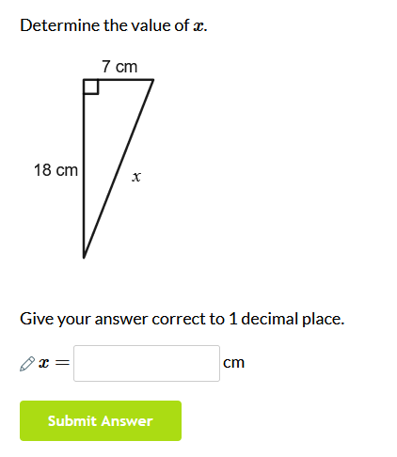

Probability

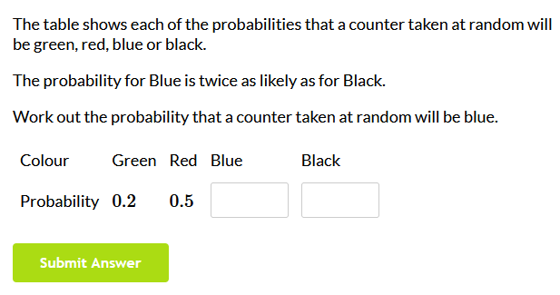

Graphs

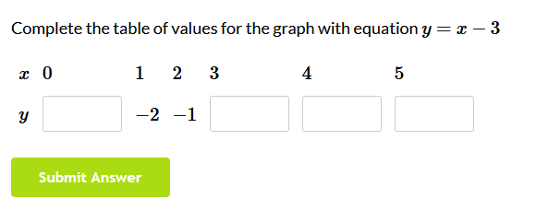

Sine and cosine rules

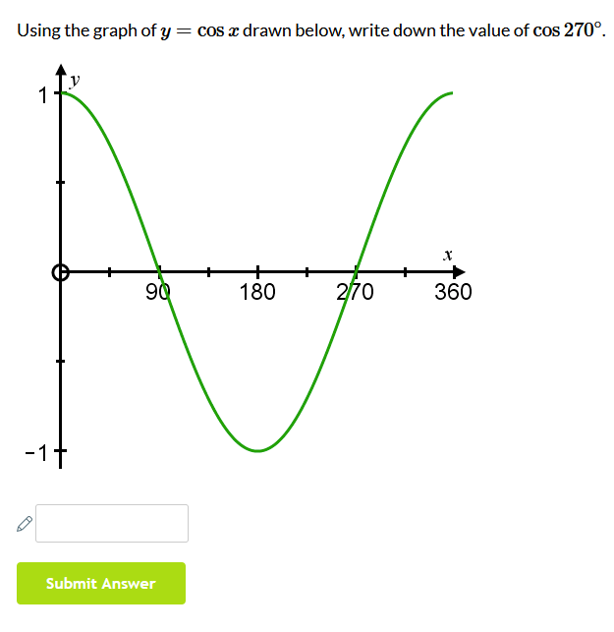

Proportion

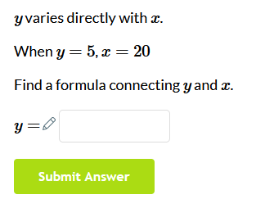

**Easy:**

Binomial expansion

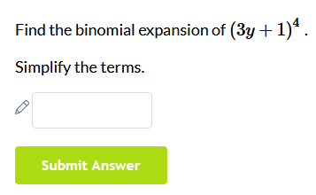

Algebra

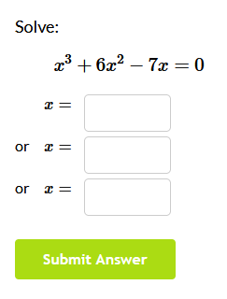

Vectors

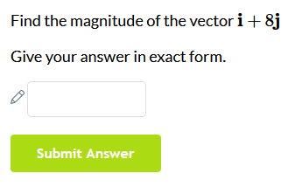

Quadratics

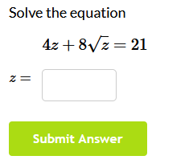

**Medium:**

Graphs and transformations

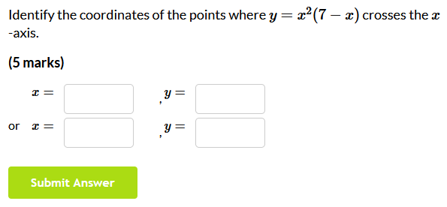

Differentiation

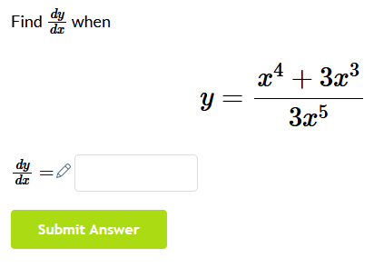

Integration

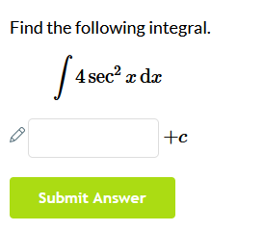

**Hard:**

Logarithms

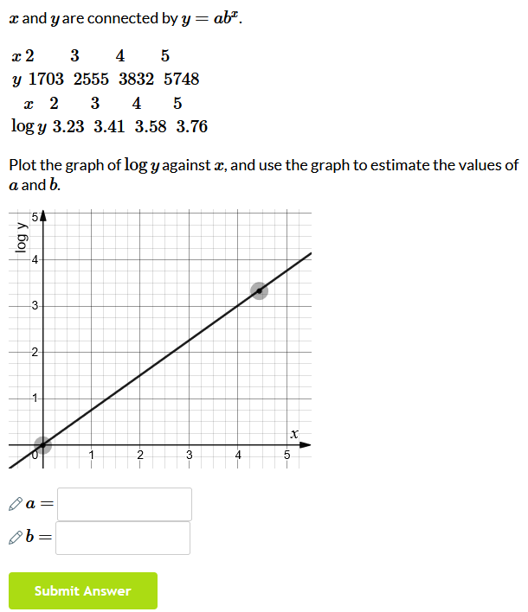

Trigonometry

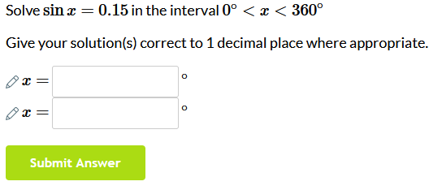

Circles

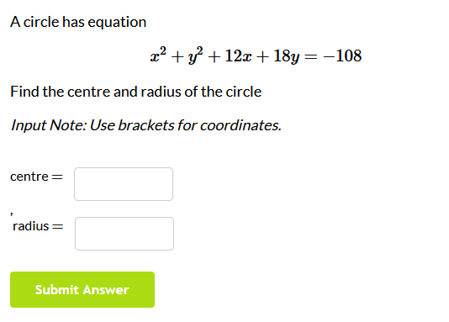

**Ninson’s specials:**

Mathematical proofs

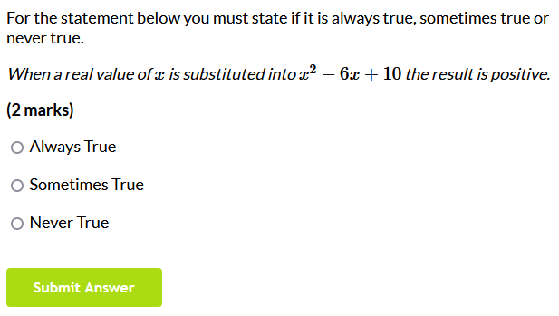

Problems involving areas between curves and lines

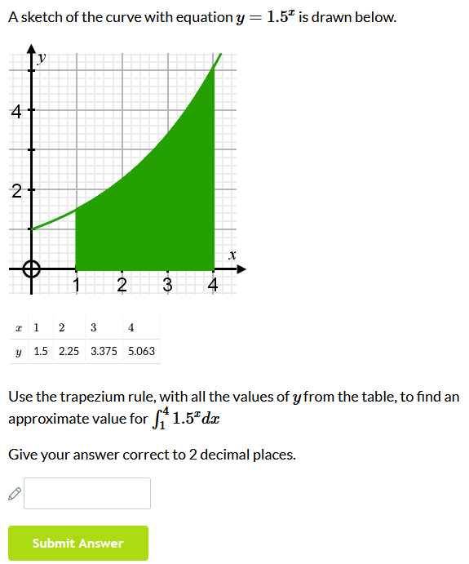

Implicit differentiation

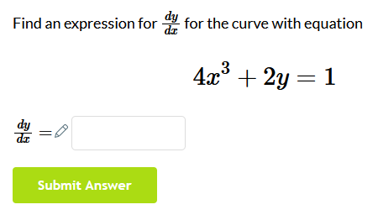

Integration

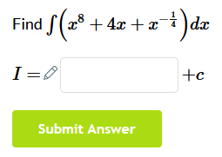

Vectors in 3D problems

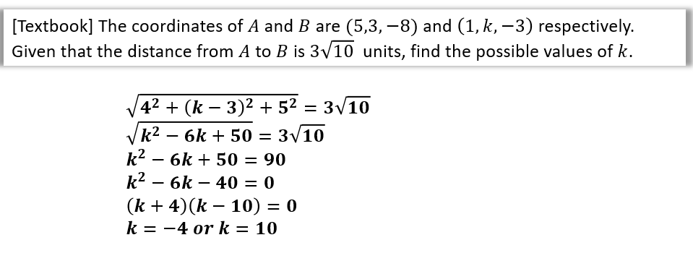

A5 - Trace table for Prim’s algorithm on example graph [page 16]:

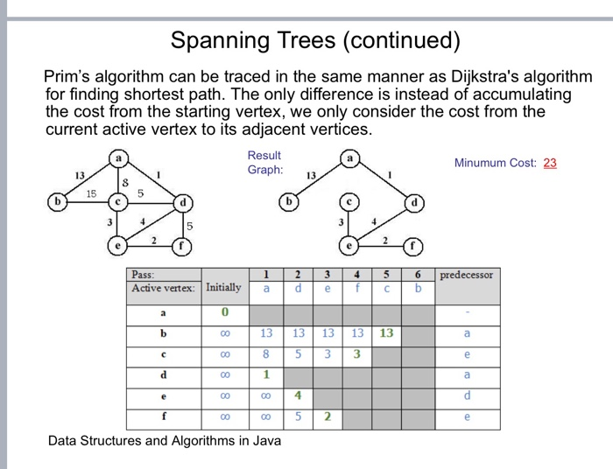

The GRAPH:



|  | Node | | | | | | | | | | | | |
| --- | --- | --- | --- | --- | --- | --- | --- | --- | --- | --- | --- | --- | --- |
| Vertex | 1 | 2 | 3 | 4 | 5 | 6 | 7 | 8 | 9 | 10 | 11 | 12 | 13 |
| 1 | 0 |  |  |  |  |  |  |  |  |  |  |  |  |
| 2 | **5** |  | 5 | 5 | 5 | 5 | 5 | 5 | 5 | 5 | 5 | 5 | 5 |
| 5 | 16 | ∞ | 22 | **66** |  | ∞ | ∞ | ∞ | ∞ | **8** |  |  |  |
| 6 | 45 | 43 | 38 | 69 | ∞ |  | ∞ | ∞ | ∞ | ∞ | ∞ | 18 |  |
| 3 | ∞ | **12** |  | ∞ | 43 | 38 | ∞ | ∞ | ∞ | ∞ | ∞ | **8** |  |
| 4 | ∞ | 44 | ∞ |  | 66 | 69 |  |  |  |  |  |  |  |
| 10 | ∞ | ∞ | ∞ | ∞ | **8** | ∞ | 41 | ∞ | ∞ |  | **9** | ∞ | 45 |
| 12 | ∞ | ∞ | **8** | ∞ | ∞ | **18** | 58 | ∞ | 35 | ∞ | ∞ |  | 68 |
| 11 | ∞ | ∞ | ∞ | ∞ | ∞ | ∞ | ∞ | ∞ | ∞ | 9 |  |  |  |
| 7 | ∞ | ∞ | ∞ | ∞ | ∞ | ∞ |  | **16** | ∞ | 41 | ∞ | 58 | 64 |
| 8 | ∞ | ∞ | ∞ | ∞ | ∞ | ∞ | **16** |  | **23** | ∞ | ∞ | ∞ | **37** |
| 9 | ∞ | ∞ | ∞ | ∞ | ∞ | ∞ | ∞ | 23 |  | ∞ | ∞ | 35 | 48 |
| 13 | ∞ | ∞ | ∞ | ∞ | ∞ | ∞ | 64 | 37 | 48 | 45 | ∞ | 68 |  |

A6 - More info on Recursive solving algorithm [page 17]:

Pusedocode was converted from Java which was found on wikipedia

<https://en.wikipedia.org/wiki/Maze-solving_algorithm>

A **maze-solving algorithm** is an [automated method](https://en.wikipedia.org/wiki/Algorithm) for solving a [maze](https://en.wikipedia.org/wiki/Maze). The random mouse, wall follower, Pledge, and Trémaux's [algorithms](https://en.wikipedia.org/wiki/Algorithm) are designed to be used inside the maze by a traveller with no prior knowledge of the maze, whereas the [dead-end](https://en.wikipedia.org/wiki/Cul-de-sac) filling and [shortest path algorithms](https://en.wikipedia.org/wiki/Shortest_path_algorithm) are designed to be used by a person or computer program that can see the whole maze at once.

Mazes containing no loops are known as "simply connected", or "perfect" mazes, and are equivalent to a [*tree*](https://en.wikipedia.org/wiki/Tree_(graph_theory)) in graph theory. Maze-solving algorithms are closely related to [graph theory](https://en.wikipedia.org/wiki/Graph_theory). Intuitively, if one pulled and stretched out the paths in the maze in the proper way, the result could be made to resemble a tree.

If given an omniscient view of the maze, a simple recursive algorithm can tell one how to get to the end. The algorithm will be given a starting X and Y value. If the X and Y values are not on a wall, the method will call itself with all adjacent X and Y values, making sure that it did not already use those X and Y values before. If the X and Y values are those of the end location, it will save all the previous instances of the method as the correct path.

This is in effect a depth-first search expressed in terms of grid points. The omniscient view prevents entering loops by memorization.

Appendix B (from Documented Design section [page 30 - 113])

B0 - Pseudocode syntax/format [page 60]:

KEYWORDS (Highlighted in Yellow in python) are written in CAPITALS, e.g. FOR, IF, AND





FOR, IF, AND, NOT, WHILE, OR, FUNCTION, ELIF, ELSE

Module (library) names (and when used) are written in **Bold** and *Italics* e.g. ***sleep()***

Booleans and some operations are written in **Bold** e.g. **True**, **False**, **Append**, **Add**

Other *keywords* (Highlighted in Purple in python) are written in *Italics* e.g *Int*, *Str*, *Float, Print*

**



*Int*, *Str*, *Float*

The main syntax of the pseudocode is AQA standard and the following websites have been used to refer to it throughout the code (also mentioned in References section)

[Pseudocode — Isaac Computer Science](https://isaaccomputerscience.org/concepts/prog_pas_pseudocode?examBoard=all&stage=all)

[Notes and guidance: Pseudo-code (AQA)](https://filestore.aqa.org.uk/resources/computing/AQA-8525-NG-PC.PDF)

[Pseudocode conventions — Isaac Computer Science](https://isaaccomputerscience.org/concepts/isaac_pseudocode?examBoard=all&stage=all)

B1 - Pseudocode for the Player class [page 61]:

IMPORT ***pygame***

from ***pygame***.locals IMPORT *

CLASS Player inherits sprite

PRIVATE surf

PRIVATE rect

PUBLIC PROCEDURE new(image_file, location)

super.Sprite()

surf ← ***pygame***.image.load(image_file).*convert*()

surf.set_colorkey ((0,0,255), RLEACCEL)

rect ← surf.get_rect(center=(location))

ENDPROCEDURE

PUBLIC PROCEDURE move(pressed_keys)

IF pressed_keys[K_UP] OR pressed_keys[K_w] THEN

Player.rect.move_ip(0, -10)

ENDIF

IF pressed_keys[K_DOWN] OR pressed_keys[K_s] THEN

Player.rect.move_ip(0, 10)

ENDIF

IF pressed_keys[K_LEFT] OR pressed_keys[K_a] THEN

Player.rect.move_ip(-10, 0)

ENDIF

IF pressed_keys[K_RIGHT] OR pressed_keys[K_d] THEN

Player.rect.move_ip(10, 0)

ENDIF

IF Player.rect.left < 0 THEN

Player.rect.left ← 0

ENDIF

IF Player.rect.right > 1900 THEN

Player.rect.right ← 1900

ENDIF

IF Player.rect.top <= 0 THEN

Player.rect.top ← 0

ENDIF

IF Player.rect.bottom. >= 1000 THEN

Player.rect.bottom ← 1000

ENDIF

ENDPROCEDURE

ENDCLASS

B2 - Pseudocode for the Maze_objects [page 62]:

IMPORT ***pygame***

CLASS Wall *inherits* sprite

PUBLIC surf

PUBLIC rect

PUBLIC PROCEDURE new(location)

super.Sprite()

surf ← ***pygame***.Surface((25, 25))

surf.*fill*((255,255,255))

rect ← surf.get_rect(center=(location))

ENDPROCEDURE

ENDCLASS

CLASS Cell *inherits* sprite

PUBLIC surf

PUBLIC rect

PRIVATE rectLocation

PUBLIC PROCEDURE new(location)

SUPER.Sprite()

surf ← ***pygame***.Surface((25, 25))

surf.*fill*((0,0,255))

rectLocation ← location

rect ← surf.get_rect(center=(rectLocation))

ENDPROCEDURE

PUBLIC METHOD getLocation

RETURN rectLocation

ENDMETHOD

ENDCLASS

CLASS Empty *inherits* sprite

PUBLIC surf

PUBLIC rect

PUBLIC PROCEDURE new(location)

SUPER.Sprite()

surf ← ***pygame***.Surface((25, 25))

surf.*fill*((0,0,0))

rect ← surf.get_rect(center=(location))

ENDPROCEDURE

ENDCLASS

CLASS Key *inherits* sprite

PUBLIC surf

PUBLIC rect

PUBLIC PROCEDURE new(location)

SUPER.Sprite()

surf ← ***pygame***.Surface((25, 25))

surf.*fill*((0,0,0))

rect ← surf.get_rect(center=(location))

ENDPROCEDURE

ENDCLASS

B3 - Pseudocode for the Information_objects [page 70]:

IMPORT ***pygame***

CLASS Scoreboard *inherits* sprite

PUBLIC CurrentScore

PUBLIC score

PUBLIC font

PUBLIC textSurf

PUBLIC surf

PUBLIC rect

PUBLIC W

PUBLIC H

PUBLIC PROCEDURE new(size, color, width, height, locationX, locationY)

CurrentScore ← 0

score ← "Score: "+*Str*(CurrentScore)

SUPER.Sprite()

font ← ***pygame***.font.SysFont("Arial", size)

textSurf ← self.font.*Render*(score, 1, color)

surf ← ***pygame***.Surface((width, height))

surf.*fill*((0,0,255))

rect ← surf.get_rect(center=(locationX,locationY))

W ← textSurf.get_width()

H ← textSurf.get_height()

surf.*blit*(textSurf, [width/2 - W/2, height/2 - H/2])

ENDPROCEDURE

PUBLIC METHOD update(CurrentScore, size, color, width, height)

score ← "Score: "+*Str*(CurrentScore)

font ← ***pygame***.font.SysFont("Arial", size)

textSurf ← self.font.*Render*(score, 1, color)

surf ← ***pygame***.Surface((width, height))

surf.fill((0,0,255))

W ← textSurf.get_width()

H ← textSurf.get_height()

surf.*blit*(textSurf, [width/2 - W/2, height/2 - H/2])

ENDMETHOD

ENDCLASS

CLASS LivesC *inherits* sprite

PUBLIC Lives

PUBLIC lives

PUBLIC font

PUBLIC textSurf

PUBLIC surf

PUBLIC rect

PUBLIC W

PUBLIC H

PUBLIC PROCEDURE new(size, color, width, height, locationX, locationY)

Lives ← 3

lives ← "Lives: "+*Str*(Lives)

SUPER.Sprite()

font ← ***pygame***.font.SysFont("Arial", size)

textSurf ← self.font.*Render*(lives, 1, color)

surf ← ***pygame***.Surface((width, height))

surf.*fill*((0,0,255))

rect ← surf.get_rect(center=(locationX,locationY))

W ← textSurf.get_width()

H ← textSurf.get_height()

surf.*blit*(textSurf, [width/2 - W/2, height/2 - H/2])

ENDPROCEDURE

PUBLIC METHOD update(Lives, size, color, width, height)

Lives ← Lives - 1

lives ← "Lives: "+*Str*(Lives)

font ← ***pygame***.font.SysFont("Arial", size)

textSurf ← self.font.*Render*(lives, 1, color)

surf ← ***pygame***.Surface((width, height))

surf.fill((0,0,255))

W ← textSurf.get_width()

H ← textSurf.get_height()

surf.*blit*(textSurf, [width/2 - W/2, height/2 - H/2])

RETURN Lives

ENDMETHOD

PUBLIC METHOD set(Lives, size, color, width, height)

lives ← "Lives: "+*Str*(Lives)

font ← ***pygame***.font.SysFont("Arial", size)

textSurf ← self.font.*Render*(lives, 1, color)

surf ← ***pygame***.Surface((width, height))

surf.fill((0,0,255))

W ← textSurf.get_width()

H ← textSurf.get_height()

surf.*blit*(textSurf, [width/2 - W/2, height/2 - H/2])

ENDMETHOD

CLASS MovesC *inherits* sprite

PUBLIC Moves

PUBLIC moves

PUBLIC font

PUBLIC textSurf

PUBLIC surf

PUBLIC rect

PUBLIC W

PUBLIC H

PUBLIC PROCEDURE new(size, color, width, height, locationX, locationY)

Moves ← 5

moves ← "Moves Left: "+*Str*(Moves)

SUPER.Sprite()

font ← ***pygame***.font.SysFont("Arial", size)

textSurf ← self.font.*Render*(moves, 1, color)

surf ← ***pygame***.Surface((width, height))

surf.*fill*((0,0,255))

rect ← surf.get_rect(center=(locationX,locationY))

W ← textSurf.get_width()

H ← textSurf.get_height()

surf.*blit*(textSurf, [width/2 - W/2, height/2 - H/2])

ENDPROCEDURE

PUBLIC METHOD update(Moves, size, color, width, height)

moves ← "Moves Left: "+*Str*(Moves)

font ← ***pygame***.font.SysFont("Arial", size)

textSurf ← self.font.*Render*(moves, 1, color)

surf ← ***pygame***.Surface((width, height))

surf.fill((0,0,255))

W ← textSurf.get_width()

H ← textSurf.get_height()

surf.*blit*(textSurf, [width/2 - W/2, height/2 - H/2])

ENDMETHOD

ENDCLASS

CLASS Timer *inherits* sprite

PUBLIC Time

PUBLIC time

PUBLIC font

PUBLIC textSurf

PUBLIC surf

PUBLIC rect

PUBLIC W

PUBLIC H

PUBLIC PROCEDURE new(size, color, width, height, locationX, locationY)

Time ← 0

time ← "Time: "+*Str*(Time)

SUPER.Sprite()

font ← ***pygame***.font.SysFont("Arial", size)

textSurf ← self.font.*Render*(time, 1, color)

surf ← ***pygame***.Surface((width, height))

surf.*fill*((0,0,255))

rect ← surf.get_rect(center=(locationX,locationY))

W ← textSurf.get_width()

H ← textSurf.get_height()

surf.*blit*(textSurf, [width/2 - W/2, height/2 - H/2])

ENDPROCEDURE

PUBLIC METHOD update(Time, size, color, width, height)

time ← "Time: "+*Str*(Time)

font ← ***pygame***.font.SysFont("Arial", size)

textSurf ← self.font.*Render*(time, 1, color)

surf ← ***pygame***.Surface((width, height))

surf.fill((0,0,255))

W ← textSurf.get_width()

H ← textSurf.get_height()

surf.*blit*(textSurf, [width/2 - W/2, height/2 - H/2])

RETURN Time

ENDMETHOD

ENDCLASS

B4 - Pseudocode for the Starting_objects [page 74]:

IMPORT ***pygame***

CLASS Title *inherits* sprite

PUBLIC font

PUBLIC textSurf

PUBLIC surf

PUBLIC rect

PUBLIC W

PUBLIC H

PUBLIC PROCEDURE new(location,text)

SUPER.Sprite()

font ← ***pygame***.font.SysFont("Arial", 75)

textSurf ← self.font.*Render*(text, 1, “white”)

surf ← ***pygame***.Surface((1000, 500))

surf.*fill*((0,0,0))

rect ← surf.get_rect(center=(location))

W ← textSurf.get_width()

H ← textSurf.get_height()

surf.*blit*(textSurf, [1000/2 - W/2, 500/2 - H/2])

ENDPROCEDURE

ENDCLASS

CLASS Controls *inherits* sprite

PUBLIC font

PUBLIC textSurf

PUBLIC surf

PUBLIC rect

PUBLIC W

PUBLIC H

PUBLIC PROCEDURE new(location,text)

SUPER.Sprite()

font ← ***pygame***.font.SysFont("Arial", 40)

textSurf ← self.font.*Render*(text, 1, “white”)

surf ← ***pygame***.Surface((200, 100))

surf.*fill*((100,69,69))

rect ← surf.get_rect(center=(location))

W ← textSurf.get_width()

H ← textSurf.get_height()

surf.*blit*(textSurf, [200/2 - W/2, 100/2 - H/2])

ENDPROCEDURE

ENDCLASS

CLASS Play *inherits* sprite

PUBLIC font

PUBLIC textSurf

PUBLIC surf

PUBLIC rect

PUBLIC W

PUBLIC H

PUBLIC PROCEDURE new(location,text)

SUPER.Sprite()

font ← ***pygame***.font.SysFont("Arial", 30)

textSurf ← self.font.*Render*(text, 1, “white”)

surf ← ***pygame***.Surface((200, 100))

surf.*fill*((69,100,69))

rect ← surf.get_rect(center=(location))

W ← textSurf.get_width()

H ← textSurf.get_height()

surf.*blit*(textSurf, [200/2 - W/2, 100/2 - H/2])

ENDPROCEDURE

ENDCLASS

CLASS Instructions *inherits* sprite

PUBLIC font

PUBLIC textSurf

PUBLIC surf

PUBLIC rect

PUBLIC W

PUBLIC H

PUBLIC PROCEDURE new(location,text)

SUPER.Sprite()

font ← ***pygame***.font.SysFont("Arial", 30)

textSurf ← self.font.*Render*(text, 1, “white”)

surf ← ***pygame***.Surface((200, 100))

surf.*fill*((100,100,69))

rect ← surf.get_rect(center=(location))

W ← textSurf.get_width()

H ← textSurf.get_height()

surf.*blit*(textSurf, [200/2 - W/2, 100/2 - H/2])

ENDPROCEDURE

ENDCLASS

CLASS Quit *inherits* sprite

PUBLIC font

PUBLIC textSurf

PUBLIC surf

PUBLIC rect

PUBLIC W

PUBLIC H

PUBLIC PROCEDURE new(location,text)

SUPER.Sprite()

font ← ***pygame***.font.SysFont("Arial", 40)

textSurf ← self.font.*Render*(text, 1, “white”)

surf ← ***pygame***.Surface((200, 100))

surf.*fill*((69,69,0))

rect ← surf.get_rect(center=(location))

W ← textSurf.get_width()

H ← textSurf.get_height()

surf.*blit*(textSurf, [200/2 - W/2, 100/2 - H/2])

ENDPROCEDURE

ENDCLASS

B5 - Pseudocode for the Main program after Other Objects [page 80]:

CLASS win_screen

PRIVATE win

PRIVATE winXY

PRIVATE WinScreen

PRIVATE all_sprites

PUBLIC PROCEDURE new()

***pygame***.*init*()

win ← ***pygame***.display.set_mode((1900, 1000), ***pygame***.RESIZABLE)

winXY ← ***pygame***.display.get_window_size()

***pygame***.display.set_caption("Maths Maze Navigator")

WinScreen ← new winScreen()

all_sprites ← ***pygame***.sprite.Group()

all_sprites.**Add**(WinScreen)

ENDPROCEDURE

PUBLIC METHOD display()

run ← **True**

WHILE run

FOR event in ***pygame***.event.*get*()

IF event.type = ***pygame***.QUIT THEN

run ← **False**

ENDIF

IF event.type = ***pygame***.KEYDOWN THEN

IF event.key = ***pygame***.K_f

***pygame***.display.toggle_fullscreen()

ENDIF

ENDIF

IF event.type = ***pygame***.MOUSEBUTTONDOWN THEN

run ← **False**

ENDIF

ENDFOR

win.*fill*((0,0,0))

FOR sprite in all_sprites

win.*blit*(sprite.image, sprite.rect)

ENDFOR

***pygame***.display.*update*()

ENDWHILE

IF NOT run THEN

***sleep(2)***

***pygame***.*quit*()

ENDIF

ENDMETHOD

ENDCLASS

CLASS lose_screen

PRIVATE win

PRIVATE winXY

PRIVATE LoseScreen

PRIVATE all_sprites

PUBLIC PROCEDURE new()

***pygame***.*init*()

win ← ***pygame***.display.set_mode((1900, 1000), ***pygame***.RESIZABLE)

winXY ← ***pygame***.display.get_window_size()

***pygame***.display.set_caption("Maths Maze Navigator")

LoseScreen ← new loseScreen()

all_sprites ← ***pygame***.sprite.Group()

all_sprites.**Add**(LoseScreen)

ENDPROCEDURE

PUBLIC METHOD display()

run ← **True**

WHILE run

FOR event in ***pygame***.event.*get*()

IF event.type = ***pygame***.QUIT THEN

run ← **False**

ENDIF

IF event.type = ***pygame***.KEYDOWN THEN

IF event.key = ***pygame***.K_f

***pygame***.display.toggle_fullscreen()

ENDIF

ENDIF

IF event.type = ***pygame***.MOUSEBUTTONDOWN THEN

run ← **False**

ENDIF

ENDFOR

win.*fill*((0,0,0))

FOR sprite in all_sprites

win.*blit*(sprite.image, sprite.rect)

ENDFOR

***pygame***.display.*update*()

ENDWHILE

IF NOT run THEN

***sleep(2)***

***pygame***.*quit*()

ENDIF

ENDMETHOD

ENDCLASS

CLASS Game

PRIVATE display1

PRIVATE display2

PRIVATE display3

PRIVATE display4

PUBLIC PROCEDURE new(MAZE_HEIGHT, MAZE_WIDTH, maze)

display1 ← new start_screen()

display2 ← new pygame_window(MAZE_HEIGHT, MAZE_WIDTH, maze)

display3 ← new controls_screen()

display4 ← new instructions_screen()

display5 ← new win_screen()

display6 ← new lose_screen()

ENDPROCEDURE

PUBLIC METHOD run_start()

display1.display()

ENDMETHOD

PUBLIC METHOD run_controls()

display3.display()

ENDMETHOD

PUBLIC METHOD run_instructions()

display4.display()

ENDMETHOD

PUBLIC METHOD run_main()

display2.display()

ENDMETHOD

PUBLIC METHOD run_win()

display5.display()

ENDMETHOD

PUBLIC METHOD run_lose()

display6.display()

ENDMETHOD

ENDCLASS

B6 - Pseudocode for GameSave_class and HighScores_class [page 86]:

CLASS GameSave

PRIVATE savedMaze

PRIVATE CurrentScore

PRIVATE lives

PRIVATE moves

PRIVATE Time

PUBLIC PROCEDURE new(maze, CurrentScore, lives, moves, Time)

savedMaze ← maze

CurrentScore ← CurrentScore

lives ← lives

moves ← moves

Time ← Time

ENDPROCEDURE

PUBLIC METHOD calcPlayerPos(mazePos, MAZE_HEIGHT, MAZE_WIDTH, midX,

midY)

X ← (mazePos[0] - (midX - 12.5*MAZE_WIDTH)) / 25

Y ← (mazePos[1] - (midY - 25*MAZE_HEIGHT)) / 25

coords ← [*Int*(X),*Int*(Y)]

RETURN coords

ENDMETHOD

PUBLIC METHOD writeToFile(fileName, coords)

FOR item IN savedMaze

fileName.**Write**(*Str*(item)+"\n")

fileName.**Write**(*Str*(CurrentScore)+"\n")

fileName.**Write**(*Str*(lives)+"\n")

fileName.**Write**(*Str*(moves)+"\n")

fileName.**Write**(*Str*(Time)+"\n")

fileName.**Write**(*Str*(coords))

ENDMETHOD

PUBLIC METHOD loadMaze(fileName, MAZE_HEIGHT, MAZE_WIDTH)

fileLines ← [ ]

maze ← [ ]

FOR line IN fileName

fileLines.**Append**(line)

ENDFOR

FOR num = 0 TO (fileLines.*Length* - 1)

IF num < MAZE_HEIGHT THEN

maze.**Append**(fileLines[num])

ENDELSEIF

ELSEIF MAZE_HEIGHT <= num < (MAZE_HEIGHT + 1) THEN

CurrentScore ← *Int*(fileLines[num])

ENDELSEIF

ELSEIF (MAZE_HEIGHT + 1) <= num < (MAZE_HEIGHT + 2) THEN

lives ← *Int*(fileLines[num])

ENDELSEIF

ELSEIF (MAZE_HEIGHT + 2) <= num < (MAZE_HEIGHT + 3) THEN

moves ← *Int*(fileLines[num])

ENDELSEIF

ELSEIF (MAZE_HEIGHT + 3) <= num < (MAZE_HEIGHT + 4) THEN

Time ← *Int*(fileLines[num])

ENDELSEIF

ELSE

playerPos ← fileLines[num]

ENDELSE

ENDFOR

RETURN maze, CurrentScore, lives, moves, Time, playerPos

ENDMETHOD

ENDCLASS

CLASS HighScores

PRIVATE scoreS

PRIVATE nameDict

PUBLIC PROCEDURE new()

scores ← []

nameDict ← {}

ENDPROCEDURE

PUBLIC METHOD get_scores(fileName)

FOR line IN fileName

line ← line.strip().split(",")

scores.**Append**(line[1])

nameDict[line[0]] ← *Float*(line[1])

ENDFOR

RETURN scores

ENDMETHOD

PUBLIC METHOD sort_scores(scores)

IF scores.length > 1 THEN

m ← (scores.length+1) DIV 2

scores1 ← scores(0,m)

scores2 ← scores(m,m)

HighScores.sort_scores(scores1)

HighScores.sort_scores(scores2)

i ← 0

j ← 0

k ← 0

WHILE i < scores1.length AND j < scores2.length

IF scores1[i] <= scores2[j] THEN

scores[k] ← scores1[i]

i ← i + 1

ENDIF

ELSE

scores[k] ← scores2[j]

j ← j + 1

ENDELSE

k ← k + 1

ENDWHILE

WHILE i < scores1.length

scores[k] ← scores1[i]

i ← i + 1

k ← k + 1

ENDWHILE

WHILE j < scores2.length

scores[k] ← scores2[j]

j ← j + 1

k ← k + 1

ENDWHILE

ENDIF

RETURN scores

ENDMETHOD

PUBLIC METHOD sortNames()

sorted_names ← *Sorted*(nameDict.items(), key=lambda x:x[1])

RETURN sorted_names

ENDMETHOD

PUBLIC METHOD check_score(score)

last ← scores.*Length* - 1

names ← [*nameDict]

lastName ← names[last]

IF *Float*(scores[last]) < score THEN

scores.**Remove**(scores[last])

*del* nameDict[lastName]

RETURN **True**

ENDIF

ELSE

RETURN **False**

ENDELSE

ENDMETHOD

PUBLIC METHOD add_score(self, name, score):

scores.**Append**(score)

nameDict[name] ← score

RETURN scores

ENDMETHOD

PUBLIC METHOD saveScore(fileName, sortedNames)

FOR item IN sortedNames

name ← item[0]

score ← item[1]

text ← name+","+*Str*(score)+"\n"

fileName.write(text)

ENDFOR

ENDMETHOD

PUBLIC METHOD get_score()

RETURN scores, nameDict

ENDMETHOD

ENDCLASS

B7 - Pseudocode for QS objects [page 95]

IMPORT ***pygame***

CLASS Text1 *inherits* sprite

PUBLIC font

PUBLIC textSurf

PUBLIC surf

PUBLIC rect

PUBLIC W

PUBLIC H

PUBLIC PROCEDURE new(location,text)

SUPER.Sprite()

font ← ***pygame***.font.SysFont("Arial", 50)

textSurf ← self.font.*Render*(text, 1, “white”)

surf ← ***pygame***.Surface((1000, 200))

surf.*fill*((0,0,0))

rect ← surf.get_rect(center=(location))

W ← textSurf.get_width()

H ← textSurf.get_height()

surf.*blit*(textSurf, [1000/2 - W/2, 200/2 - H/2])

ENDPROCEDURE

ENDCLASS

CLASS Button1 *inherits* sprite

PUBLIC font

PUBLIC textSurf

PUBLIC surf

PUBLIC rect

PUBLIC W

PUBLIC H

PUBLIC PROCEDURE new(location,text)

SUPER.Sprite()

font ← ***pygame***.font.SysFont("Arial", 35)

textSurf ← self.font.*Render*(text, 1, “white”)

surf ← ***pygame***.Surface((200, 100))

surf.*fill*((100,69,69))

rect ← surf.get_rect(center=(location))

W ← textSurf.get_width()

H ← textSurf.get_height()

surf.*blit*(textSurf, [200/2 - W/2, 100/2 - H/2])

ENDPROCEDURE

ENDCLASS

CLASS Button2 *inherits* sprite

PUBLIC font

PUBLIC textSurf

PUBLIC surf

PUBLIC rect

PUBLIC W

PUBLIC H

PUBLIC PROCEDURE new(location,text)

SUPER.Sprite()

font ← ***pygame***.font.SysFont("Arial", 35)

textSurf ← self.font.*Render*(text, 1, “white”)

surf ← ***pygame***.Surface((200, 100))

surf.*fill*((69,100,69))

rect ← surf.get_rect(center=(location))

W ← textSurf.get_width()

H ← textSurf.get_height()

surf.*blit*(textSurf, [200/2 - W/2, 100/2 - H/2])

ENDPROCEDURE

ENDCLASS

CLASS Button3 *inherits* sprite

PUBLIC font

PUBLIC textSurf

PUBLIC surf

PUBLIC rect

PUBLIC W

PUBLIC H

PUBLIC PROCEDURE new(location,text)

SUPER.Sprite()

font ← ***pygame***.font.SysFont("Arial", 35)

textSurf ← self.font.*Render*(text, 1, “white”)

surf ← ***pygame***.Surface((200, 100))

surf.*fill*((100,100,69))

rect ← surf.get_rect(center=(location))

W ← textSurf.get_width()

H ← textSurf.get_height()

surf.*blit*(textSurf, [200/2 - W/2, 100/2 - H/2])

ENDPROCEDURE

ENDCLASS

CLASS Button4 *inherits* sprite

PUBLIC font

PUBLIC textSurf

PUBLIC surf

PUBLIC rect

PUBLIC W

PUBLIC H

PUBLIC PROCEDURE new(location,text)

SUPER.Sprite()

font ← ***pygame***.font.SysFont("Arial", 35)

textSurf ← self.font.*Render*(text, 1, “white”)

surf ← ***pygame***.Surface((200, 100))

surf.*fill*((69,69,0))

rect ← surf.get_rect(center=(location))

W ← textSurf.get_width()

H ← textSurf.get_height()

surf.*blit*(textSurf, [200/2 - W/2, 100/2 - H/2])

ENDPROCEDURE

ENDCLASS

CLASS Button5 *inherits* sprite

PUBLIC font

PUBLIC textSurf

PUBLIC surf

PUBLIC rect

PUBLIC W

PUBLIC H

PUBLIC PROCEDURE new(location,text)

SUPER.Sprite()

font ← ***pygame***.font.SysFont("Arial", 30)

textSurf ← self.font.*Render*(text, 1, “white”)

surf ← ***pygame***.Surface((200, 100))

surf.*fill*((255,69,69))

rect ← surf.get_rect(center=(location))

W ← textSurf.get_width()

H ← textSurf.get_height()

surf.*blit*(textSurf, [200/2 - W/2, 100/2 - H/2])

ENDPROCEDURE

ENDCLASS

B8 - Pseudocode for MovesStack class and MovesQueue class [pg 101]

CLASS MovesStack

PRIVATE maxsize

PRIVATE pointer

PRIVATE used_positions

PRIVATE array

PUBLIC PROCEDURE new()

maxsize ← 5

pointer ← -1

used_positions ← 0

array ← [" "] * 5

ENDPROCEDURE

PUBLIC METHOD isEmpty()

IF self.pointer = -1 THEN

RETURN **True**

ENDIF

ELSE

RETURN **False**

ENDELSE

ENDMETHOD

PUBLIC METHOD isFull()

end ← maxsize - 1

IF pointer = end THEN

RETURN **True**

ENDIF

ELSE

RETURN **False**

ENDELSE

ENDMETHOD

PUBLIC METHOD peek()

data ← None

empty ← MovesStack.isEmpty()

IF empty THEN

print("Stack underflow!")

ENDIF

ELSE

data ← array[pointer]

ENDELSE

RETURN data

ENDMETHOD

PUBLIC METHOD push(data)

full = MovesStack.isFull()

IF full THEN

OUTPUT("Stack overflow!")

ENDIF

ELSE

pointer ← pointer + 1

array[pointer] ← data

used_positions ← used_positions + 1

ENDELSE

ENDMETHOD

PUBLIC METHOD pop()

data ← **Null**

empty ← MovesStack.isEmpty()

IF empty THEN

OUTPUT("Stack underflow!")

ENDIF

ELSE

data ← array[pointer]

pointer ← pointer - 1

used_positions ← used_positions - 1

RETURN data

ENDMETHOD

PUBLIC METHOD return_stack()

OUTPUT(array)

OUTPUT("Info: Pointer("+*Str*(pointer)+") Used Positions("+*Str*(used_positions)+")")

ENDMETHOD

ENDCLASS

CLASS MovesQueue

PRIVATE array

PRIVATE maxsize

PRIVATE front

PRIVATE rear

PRIVATE used_positions

PUBLIC PROCEDURE new()

array ← [""] * 5

maxsize ← 5

front ← 0

rear ← -1

used_positions ← 0

PUBLIC METHOD isEmpty()

IF used_positions = 0 THEN

RETURN **True**

ENDIF

ELSE

RETURN **False**

ENDELSE

ENDMETHOD

PUBLIC METHOD isFull()

IF used_positions = maxsize THEN

RETURN **True**

ENDIF

ELSE

RETURN **False**

ENDELSE

ENDMETHOD

PUBLIC METHOD enQueue(item)

full ← MovesQueue.isFull()

IF full THEN

OUTPUT("Queue is full!")

ENDIF

ELSE

IF rear = maxsize - 1 THEN

rear ← 0

ENDIF

ELSE

rear ← rear + 1

ENDELSE

array[rear] ← item

used_positions ← used_positions + 1

ENDELSE

ENDMETHOD

PUBLIC METHOD deQueue()

item ← **Null**

empty ← MovesQueue.isEmpty()

IF empty THEN

OUTPUT("Queue is empty!")

ENDIF

ELSE

item ← array[front]

used_positions ← used_positions - 1

IF front = maxsize - 1 THEN

front ← 0

ENDIF

ELSE

front ← front + 1

ENDELSE

ENDELSE

RETURN item

ENDMETHOD

PUBLIC METHOD replace(item)

array.**Pop**()

array.**Append**(item)

ENDMETHOD

PUBLIC METHOD return_queue()

OUTPUT(array)

OUTPUT("Info: Front("+*Str*(front)+"),Rear("+*Str*(rear)+"),

Used Positions("+*Str*(used_positions)+")")

ENDMETHOD

ENDCLASS

B9 - Final Pseudocode for Subprograms

Below is the updated parts of the pseudocode for the subprograms from the versions detailed above to the final versions, starting with *Informations Objects* from Appendix B3

**Information objects [Page 69 & 267]:**

CLASS SaveButton *inherits* sprite

PRIVATE surf

PUBLIC image

PUBLIC rect

PUBLIC PROCEDURE new(location)

super.Sprite()

surf ← ***pygame***.Surface((100, 100))

surf.*fill*((255,255,255))

image ← ***pygame***.image.load('Save.png').*convert*()

rect ← surf.get_rect(center=(location))

ENDPROCEDURE

ENDCLASS

CLASS LoadButton *inherits* sprite

PRIVATE surf

PUBLIC image

PUBLIC rect

PUBLIC PROCEDURE new(location)

super.Sprite()

surf ← ***pygame***.Surface((100, 100))

surf.*fill*((255,255,255))

image ← ***pygame***.image.load('Load.png').*convert*()

rect ← surf.get_rect(center=(location))

ENDPROCEDURE

ENDCLASS

CLASS UndoButton *inherits* sprite

PRIVATE surf

PUBLIC image

PUBLIC rect

PUBLIC PROCEDURE new(location)

super.Sprite()

surf ← ***pygame***.Surface((100, 100))

surf.*fill*((255,255,255))

image ← ***pygame***.image.load('Undo.png').*convert*()

rect ← surf.get_rect(center=(location))

ENDPROCEDURE

ENDCLASS

CLASS HintButton *inherits* sprite

PRIVATE surf

PUBLIC image

PUBLIC rect

PUBLIC PROCEDURE new(location)

super.Sprite()

surf ← ***pygame***.Surface((100, 100))

surf.*fill*((255,255,255))

image ← ***pygame***.image.load('Hint.png').*convert*()

rect ← surf.get_rect(center=(location))

ENDPROCEDURE

ENDCLASS

**Other objects [Page 79]:**

CLASS SS_image *inherits* Sprite

PRIVATE surf

PUBLIC image

PUBLIC rect

PUBLIC PROCEDURE new(width, height)

SUPER()

surf ← ***pygame***.Surface((1920,1080))

surf.*fill*((255,255,255))

image ← ***pygame***.image.load(‘Save_Screen.png').*convert*()

image ← ***pygame***.transform.scale(image, (width, height))

rect ← surf.get_rect(center=(960,540))

ENDPROCEDURE

ENDCLASS

CLASS LS_image *inherits* Sprite

PRIVATE surf

PUBLIC image

PUBLIC rect

PUBLIC PROCEDURE new(width, height)

SUPER()

surf ← ***pygame***.Surface((1920,1080))

surf.*fill*((255,255,255))

image ← ***pygame***.image.load(‘Load_Screen.png').*convert*()

image ← ***pygame***.transform.scale(image, (width, height))

rect ← surf.get_rect(center=(960,540))

ENDPROCEDURE

ENDCLASS

CLASS Text2

PUBLIC font

PUBLIC textSurf

PUBLIC surf

PUBLIC rect

PUBLIC W

PUBLIC H

PUBLIC PROCEDURE new(location,text,size,width,height,colour)

SUPER.Sprite()

font ← ***pygame***.font.SysFont("Arial", size)

textSurf ← self.font.*Render*(text, 1, color)

surf ← ***pygame***.Surface((width, height))

surf.*fill*(colour)

rect ← surf.get_rect(center=(locationX,locationY))

W ← textSurf.get_width()

H ← textSurf.get_height()

surf.*blit*(textSurf, [width/2 - W/2, height/2 - H/2])

ENDPROCEDURE

PUBLIC METHOD update(text, size, width, height, colour)

font ← ***pygame***.font.SysFont("Arial", size)

textSurf ← self.font.*Render*(text, 1, color)

surf ← ***pygame***.Surface((width, height))

surf.fill(colour)

W ← textSurf.get_width()

H ← textSurf.get_height()

surf.*blit*(textSurf, [width/2 - W/2, height/2 - H/2])

ENDMETHOD

ENDCLASS

B10 - Calculations from Documented Design:

Below is an example of the calculation used to reverse the calculation used to place cells/walls in their positions when generating the maze to get the player position in the maze.

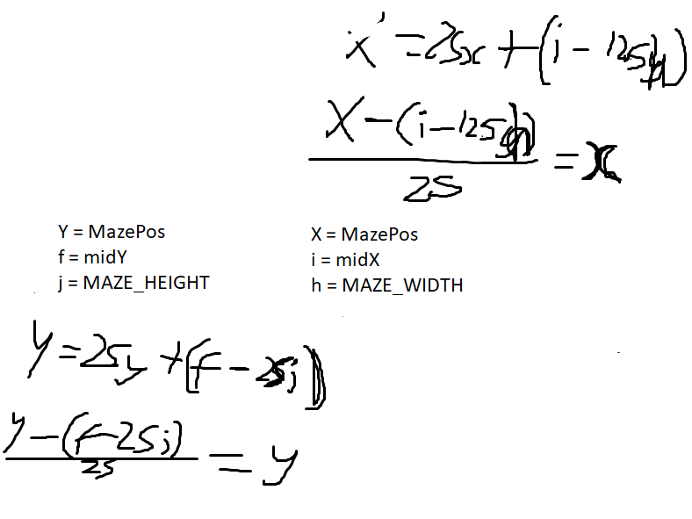

Appendix C (from Technical Solution section [page 114 - 221])

The program will be included in full here with line numbers and comments

However, before that, extra code which was required for modular testing will be detailed here:

**C1 - GAMESAVE_TEST:**

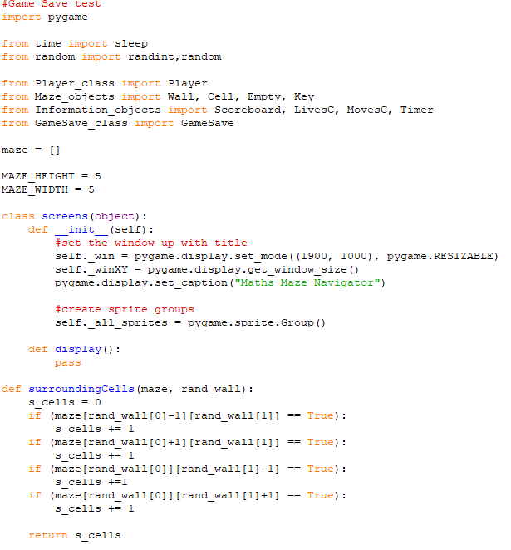

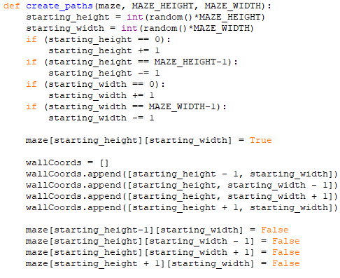

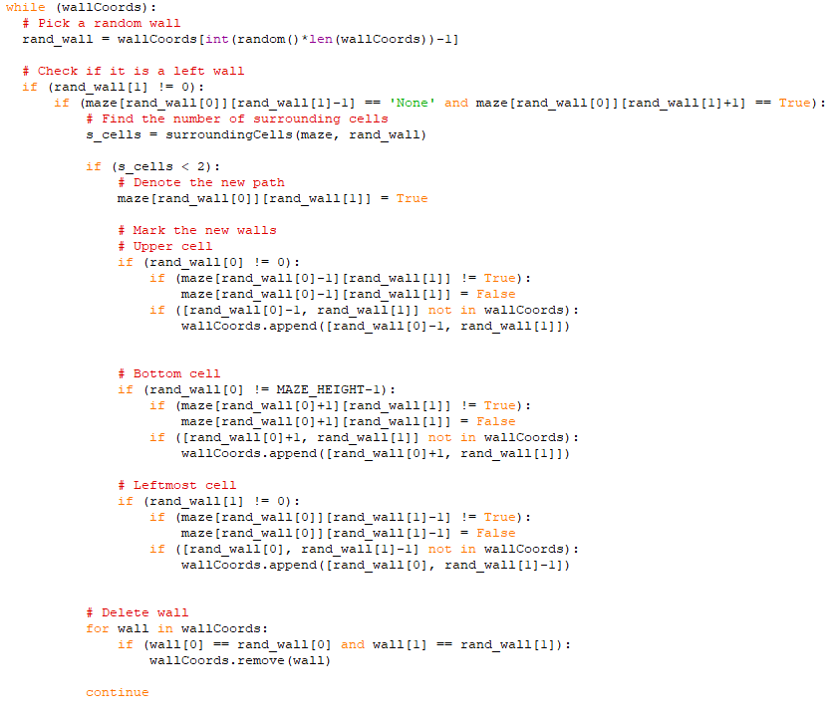

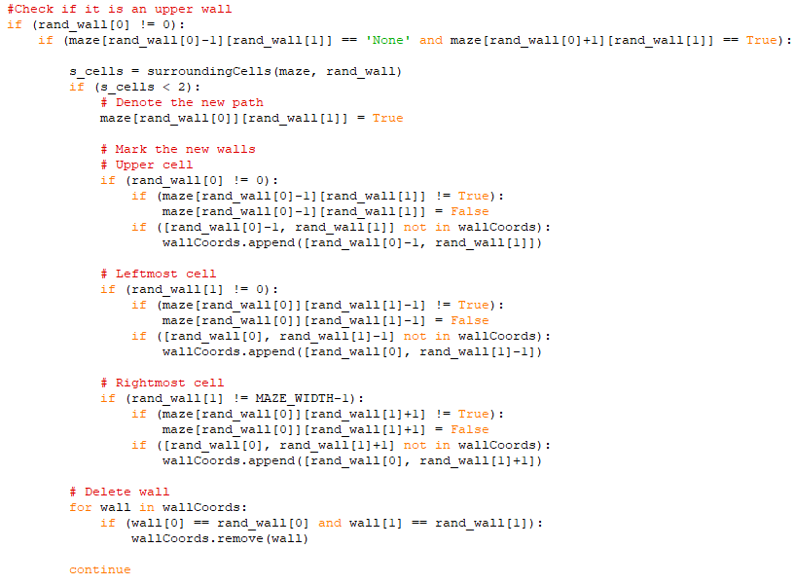

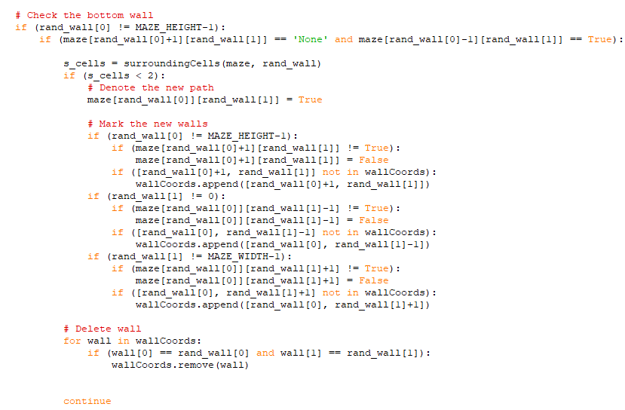

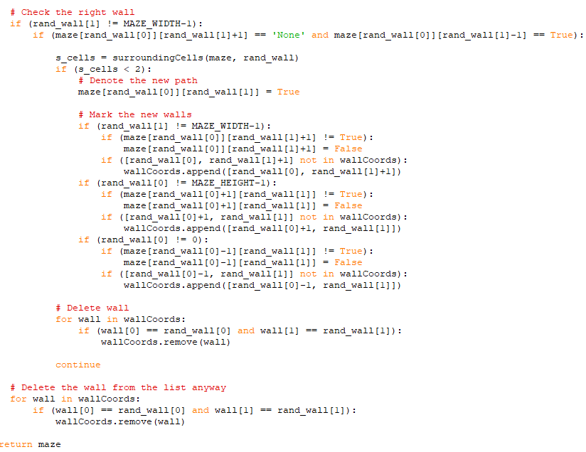

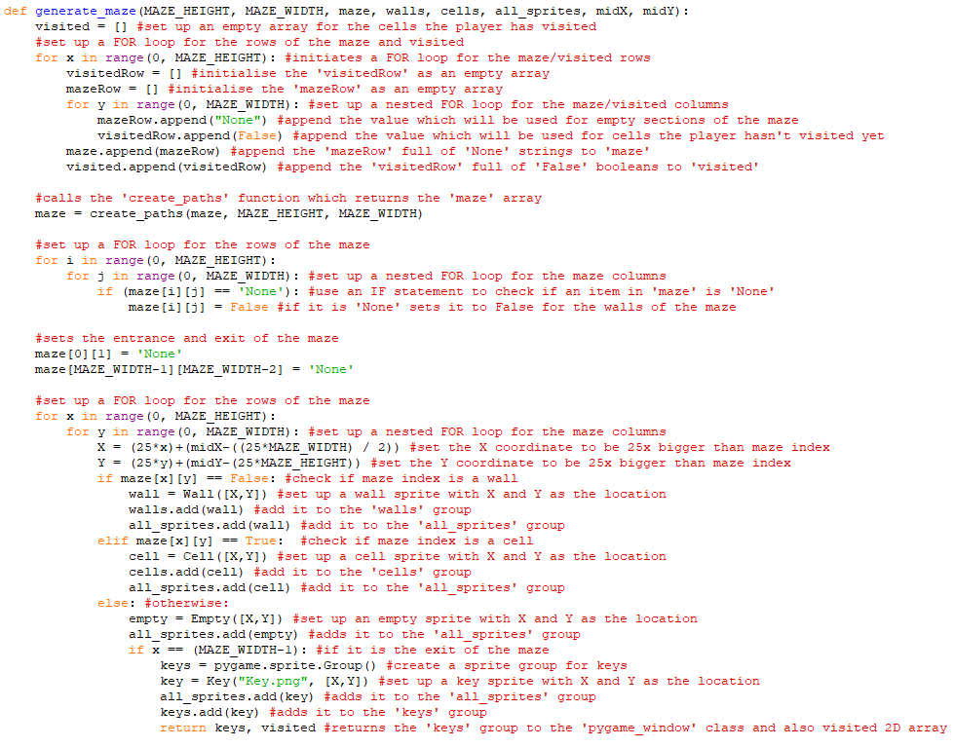

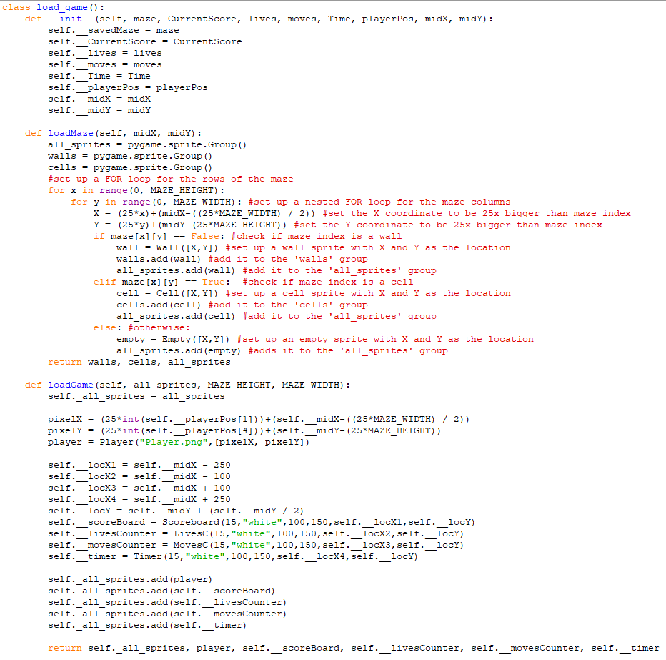

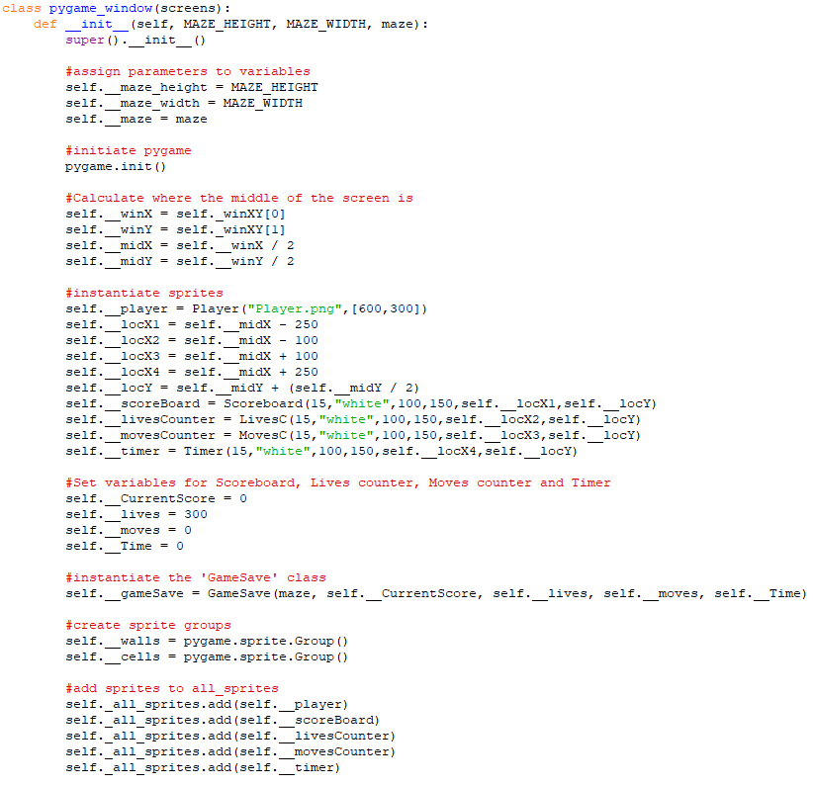

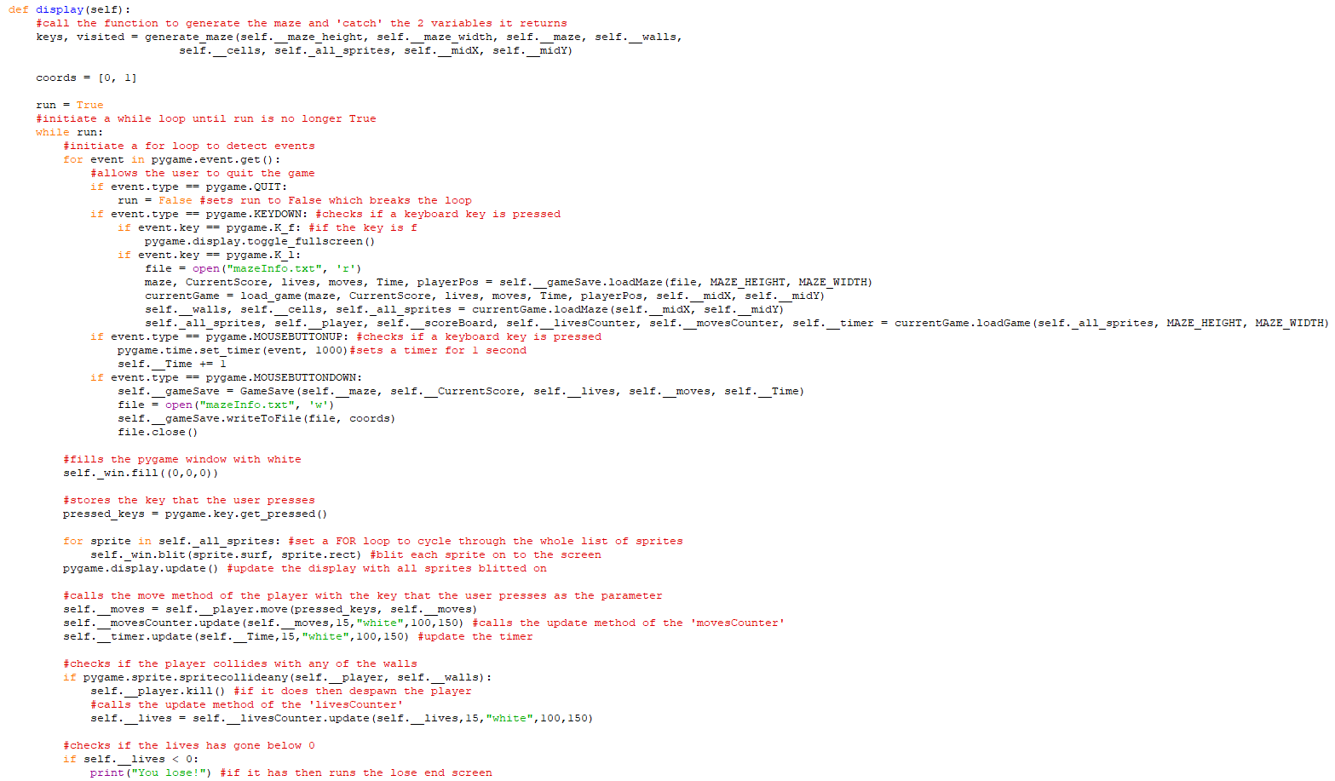

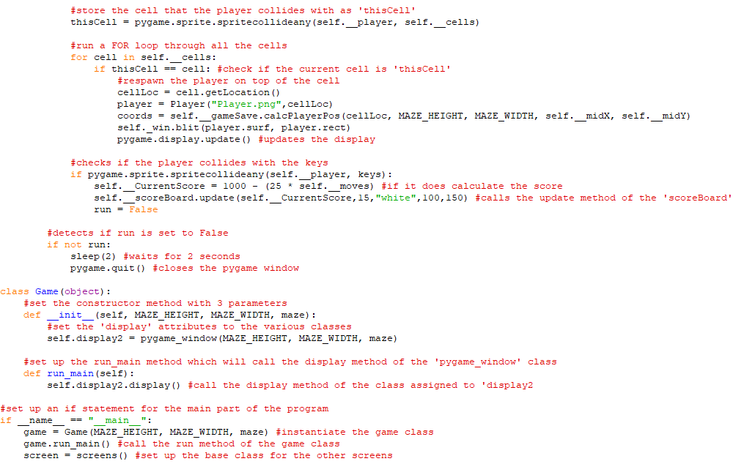

**C2 - HIGHSCORES_TEST:**

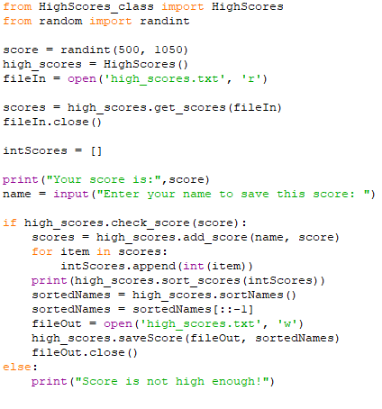

Then the Main code was to be provided in full starting with the Player class

**C3 - PLAYER CLASS:**

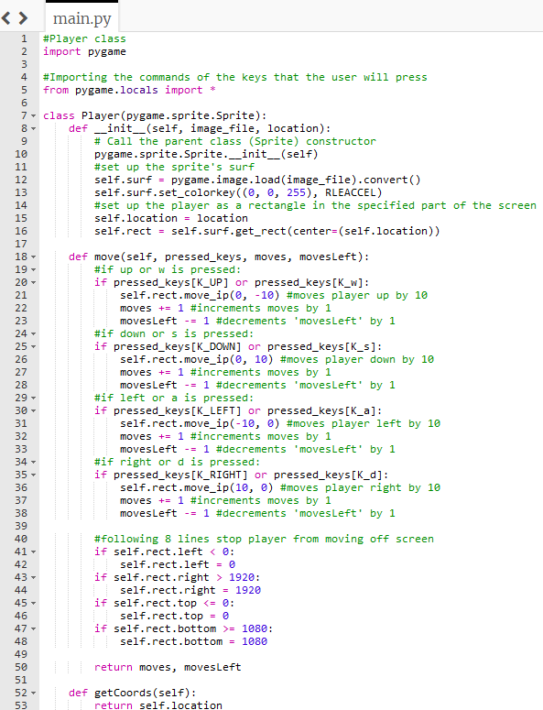

**C4 - MAZE OBJECTS:**

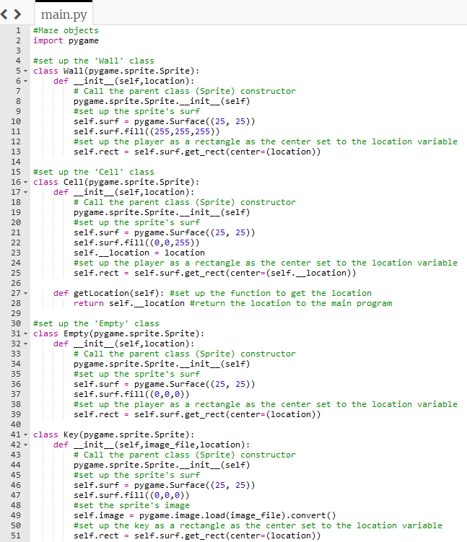

**C5 - INFORMATION OBJECTS:**

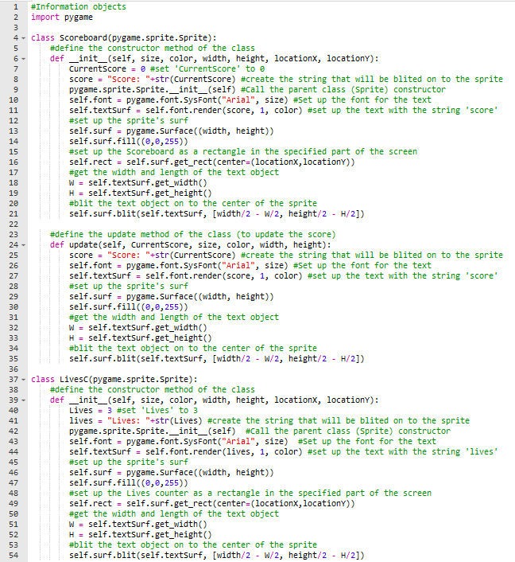

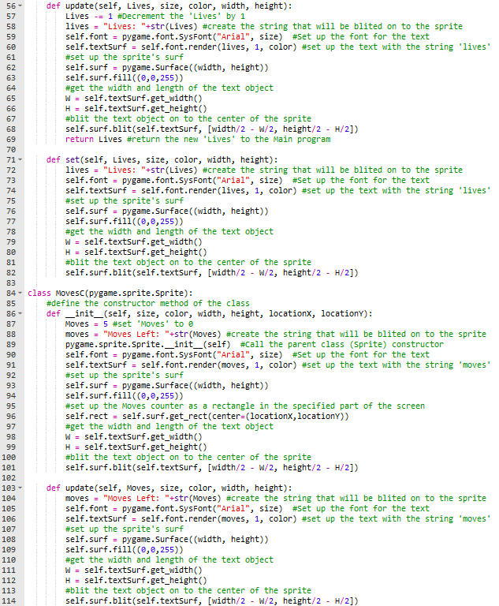

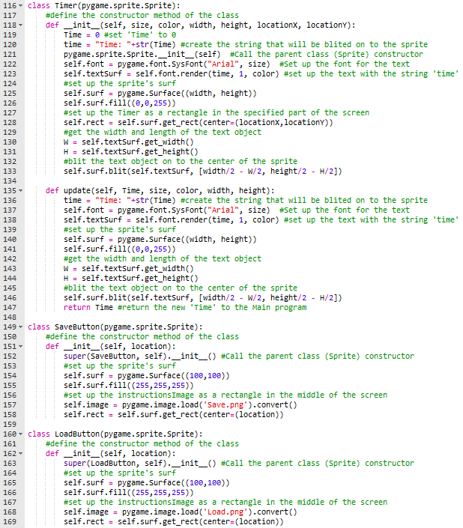

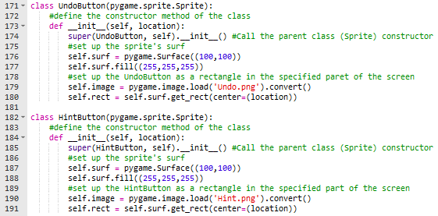

**C6 - STARTING OBJECTS:**

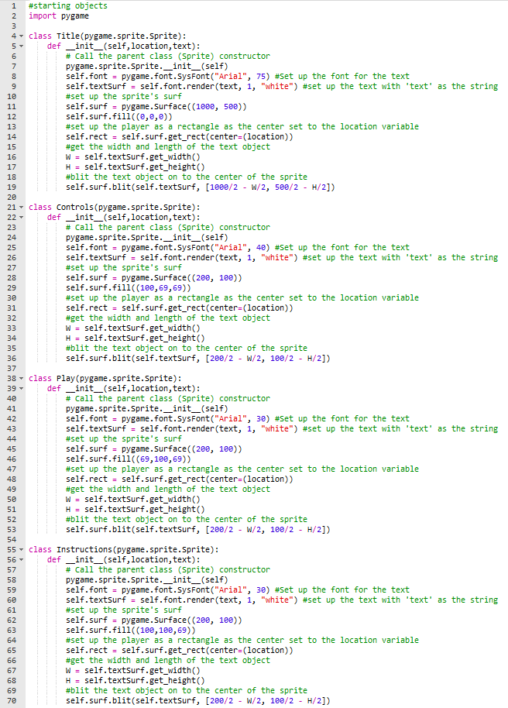

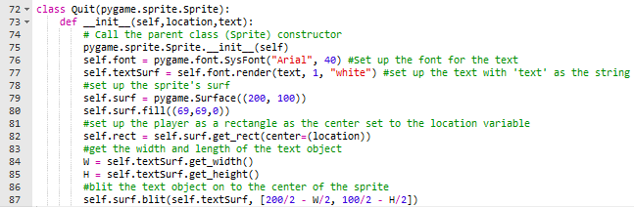

**C7 - OTHER OBJECTS:**

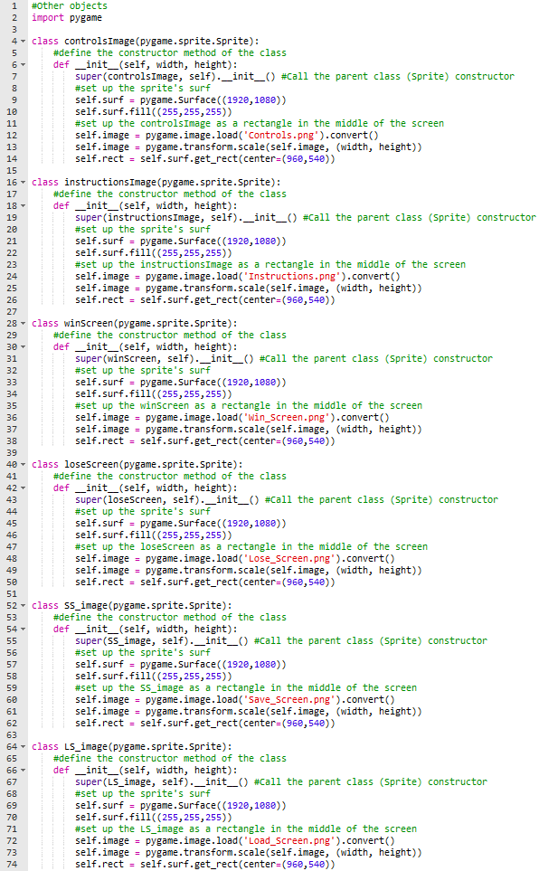

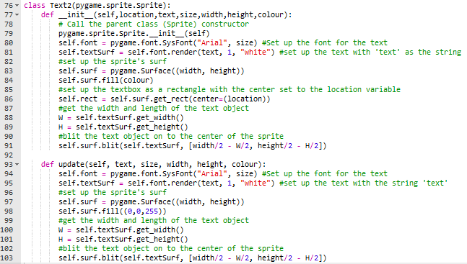

**C8 - QS OBJECTS:**

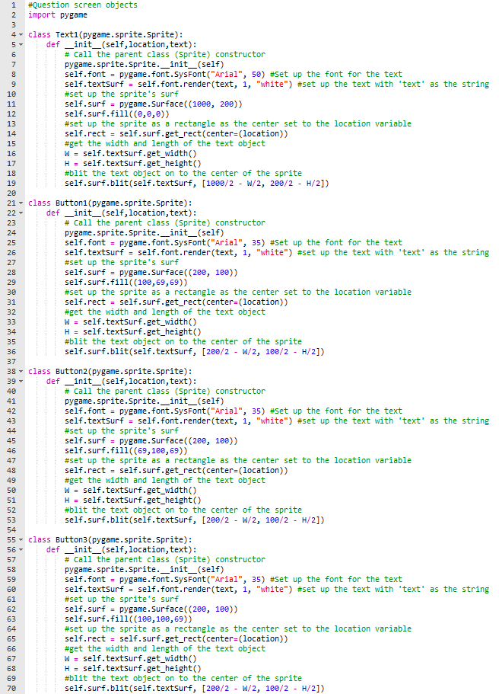

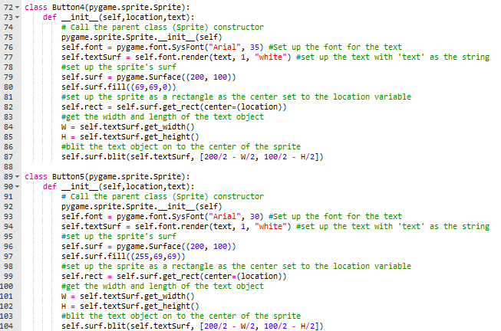

**C9 - GAME SAVE CLASS:**

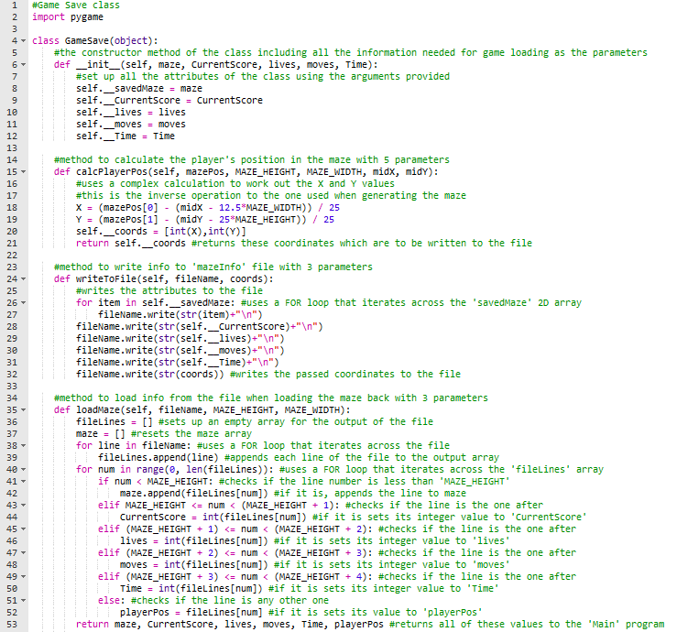

**C10 - HIGHSCORES CLASS:**

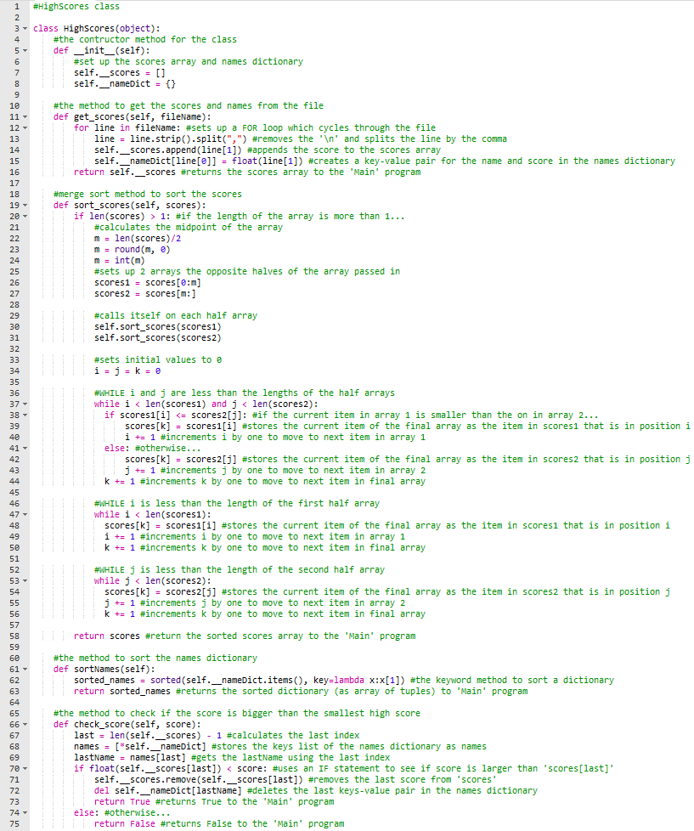

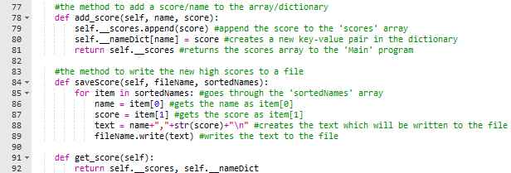

**C11 - MAIN:**

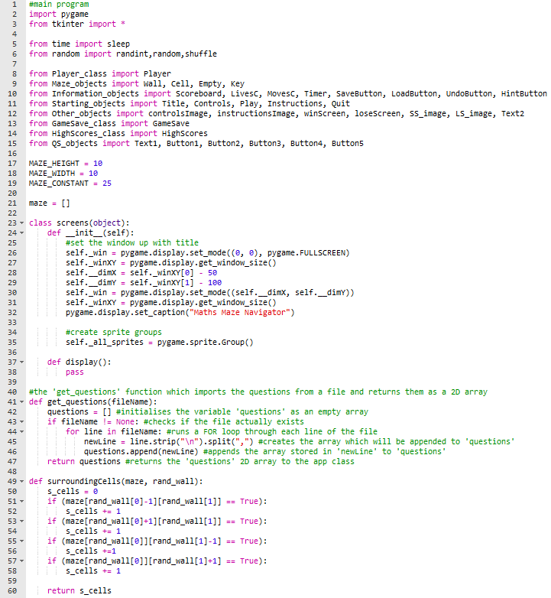

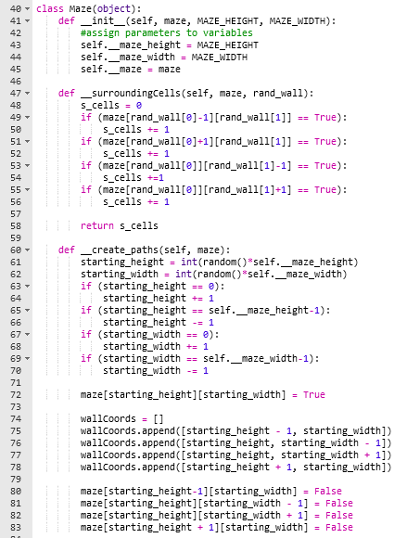

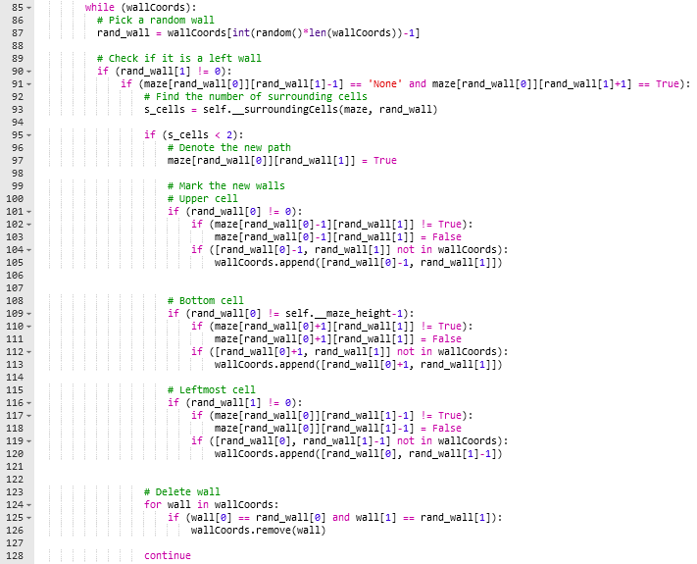

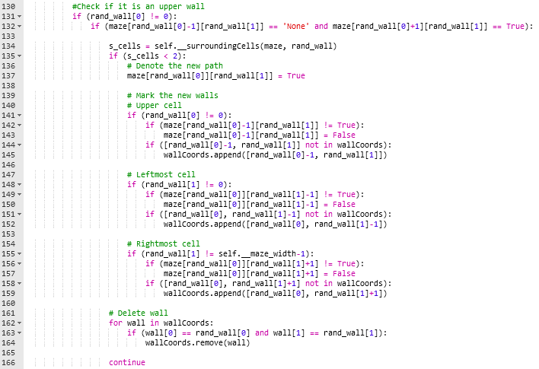

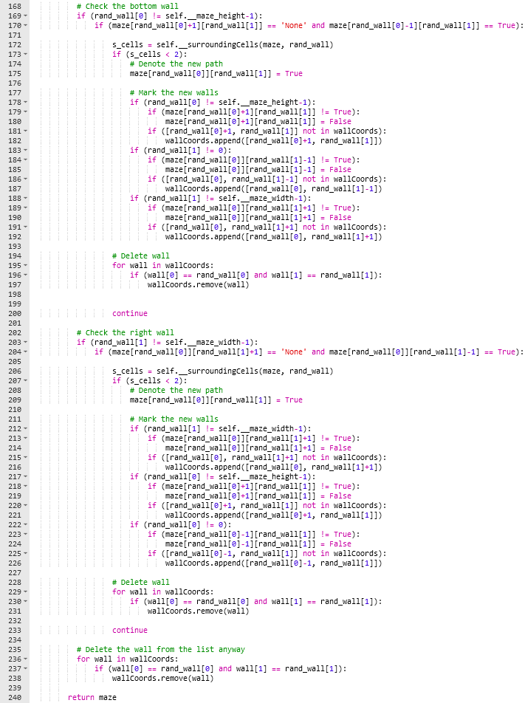

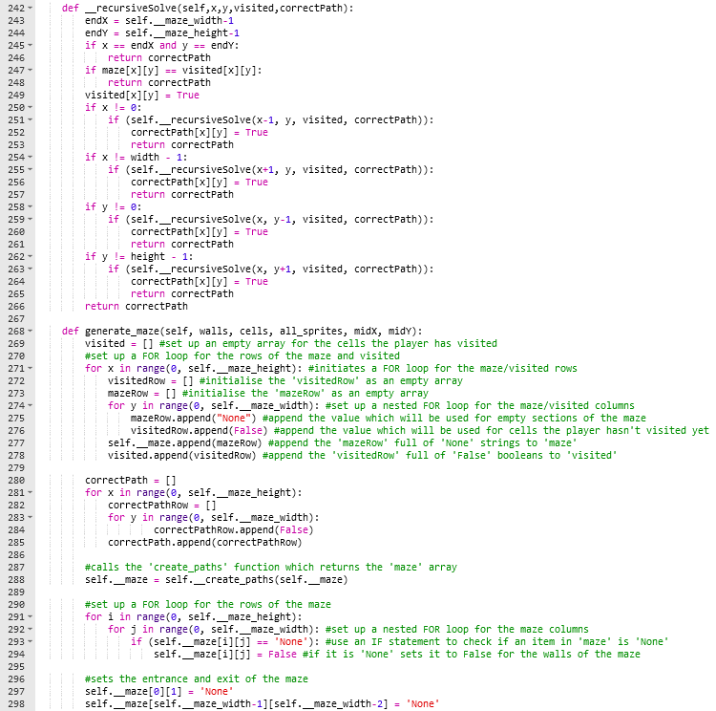

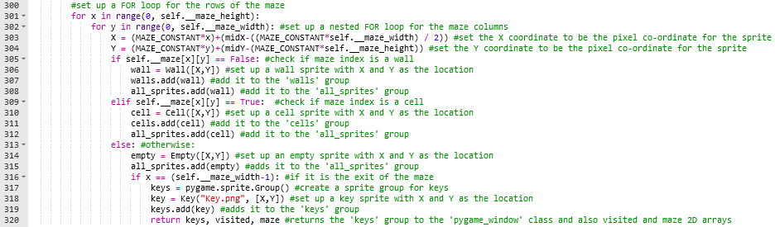

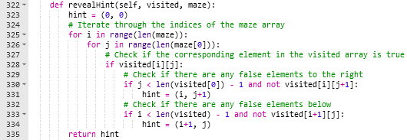

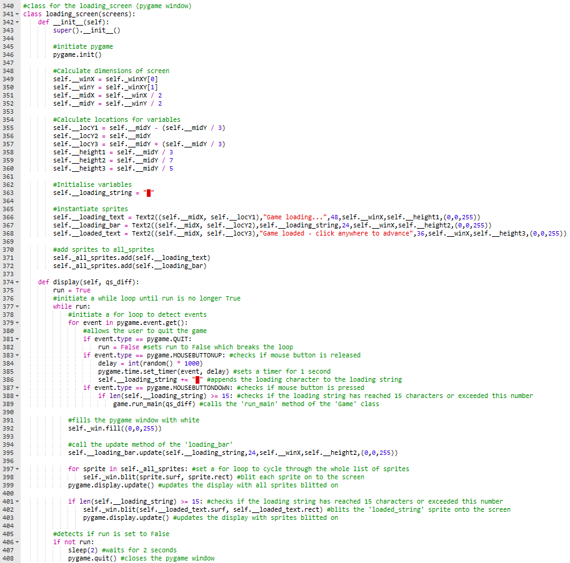

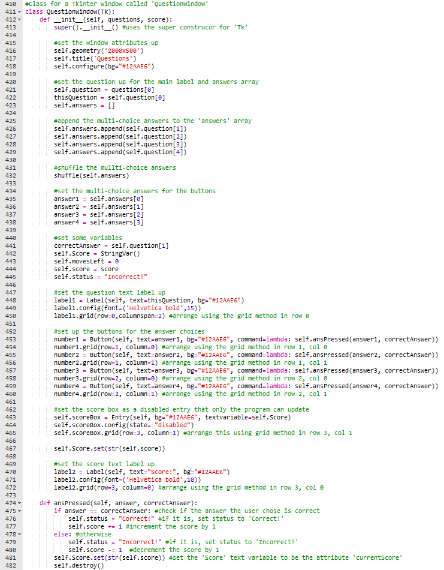

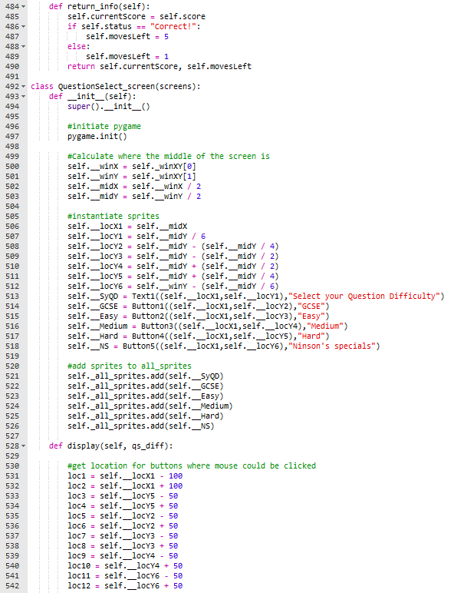

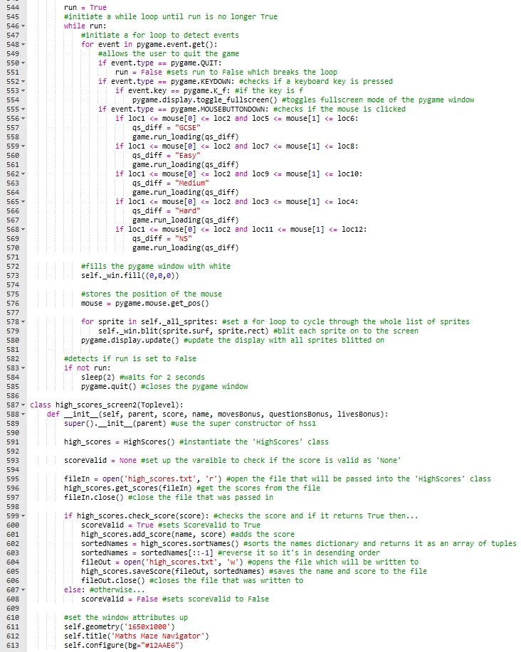

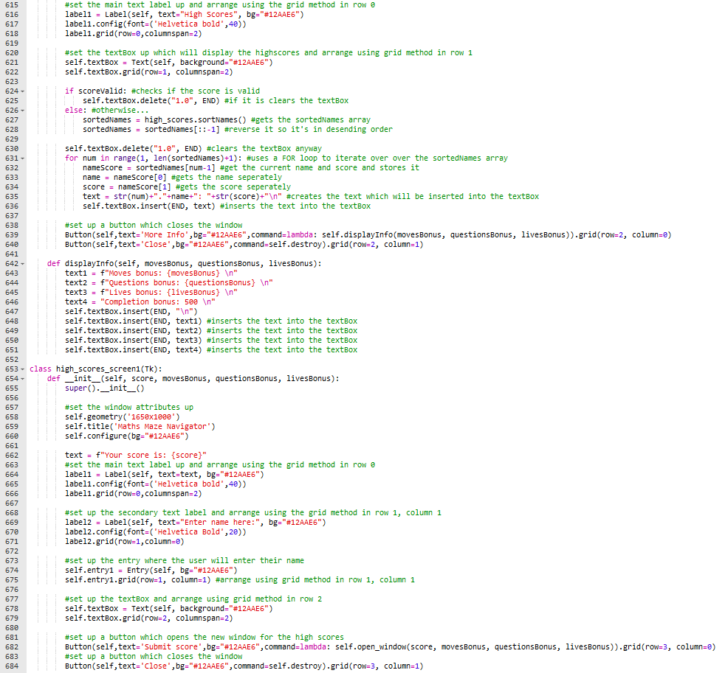

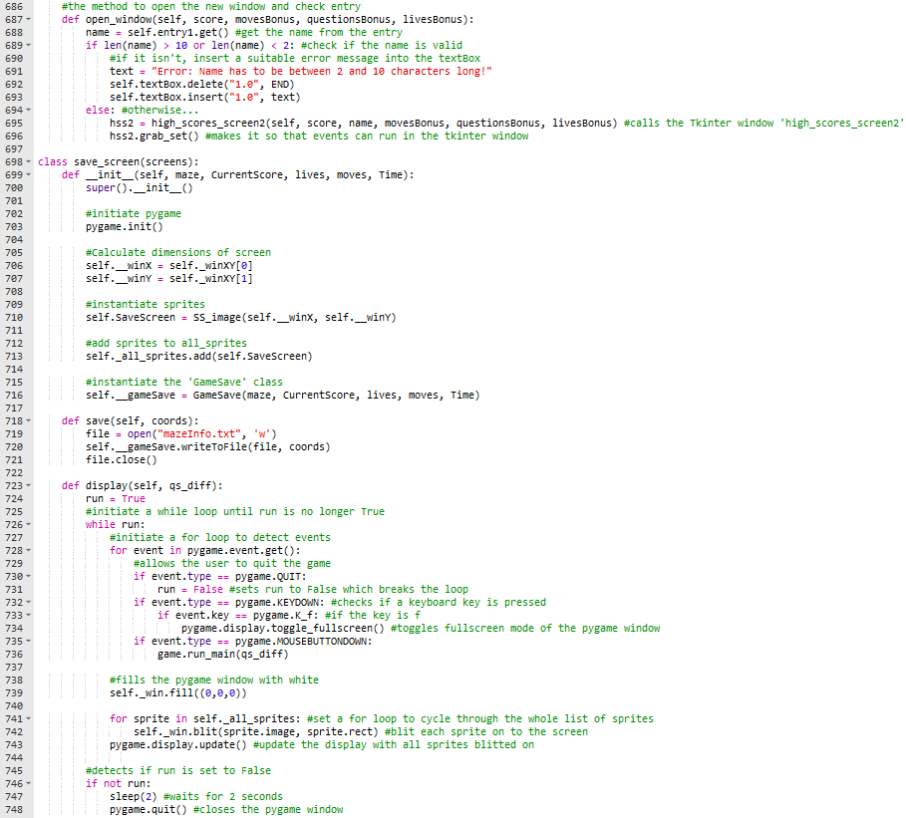

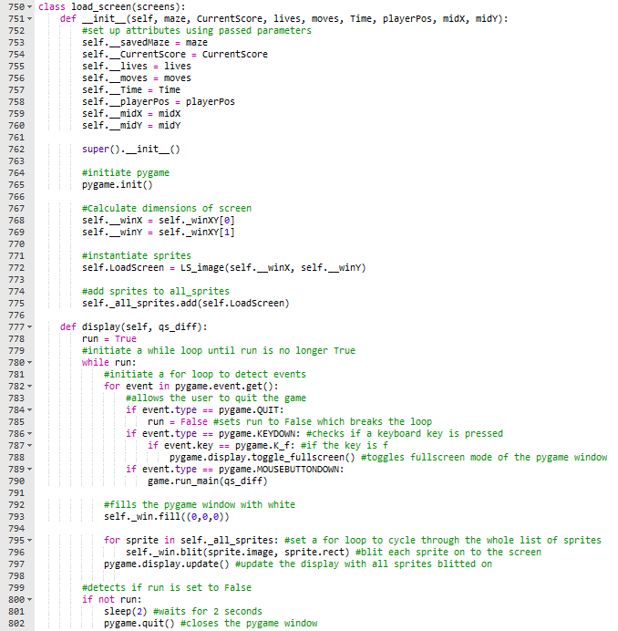

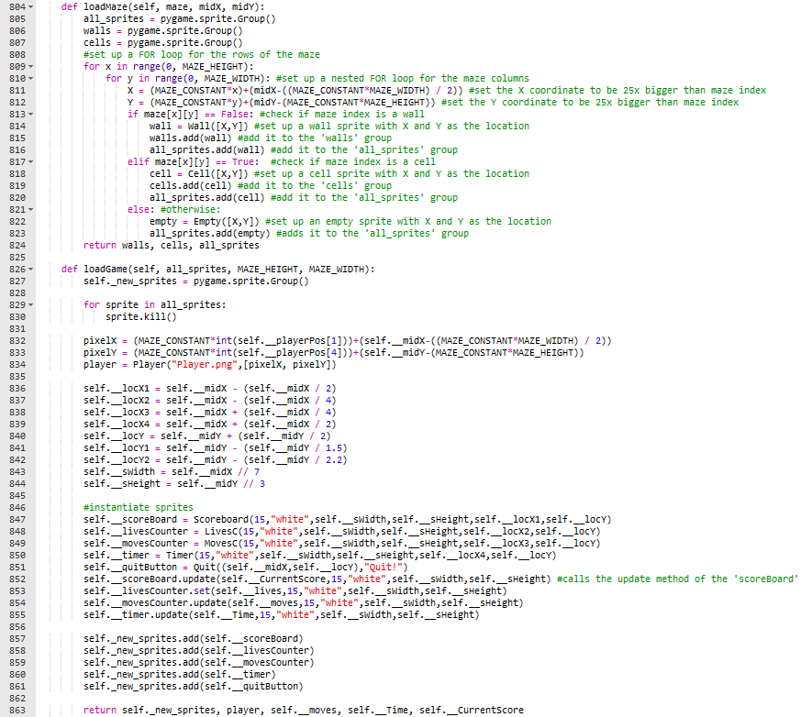

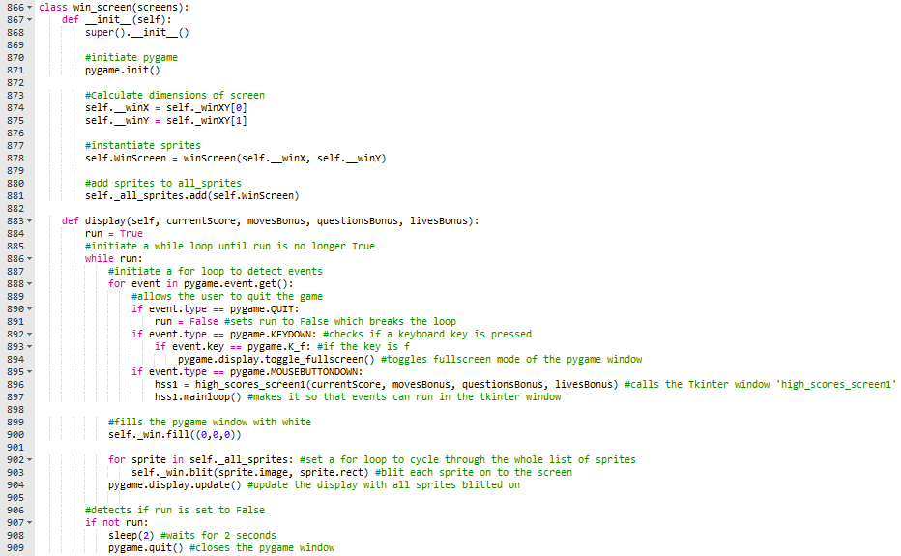

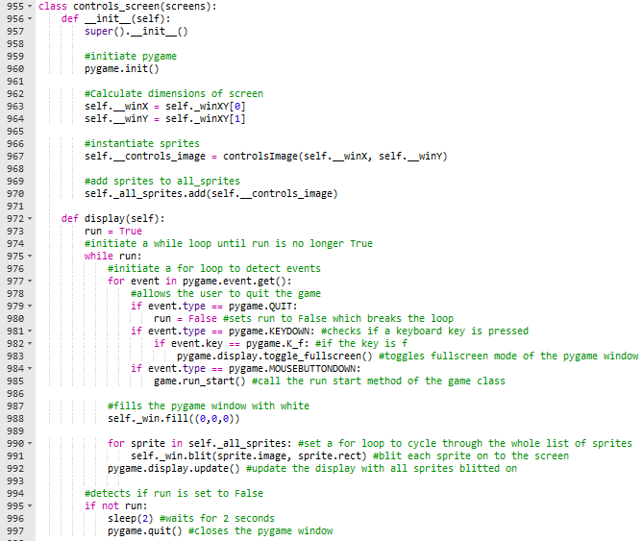

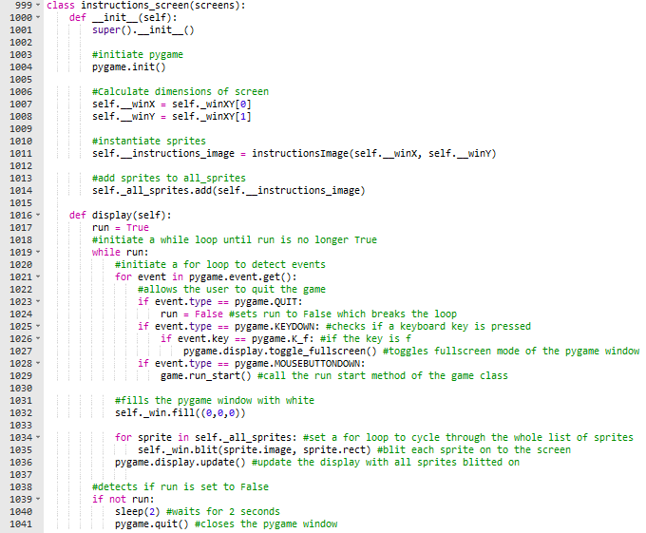

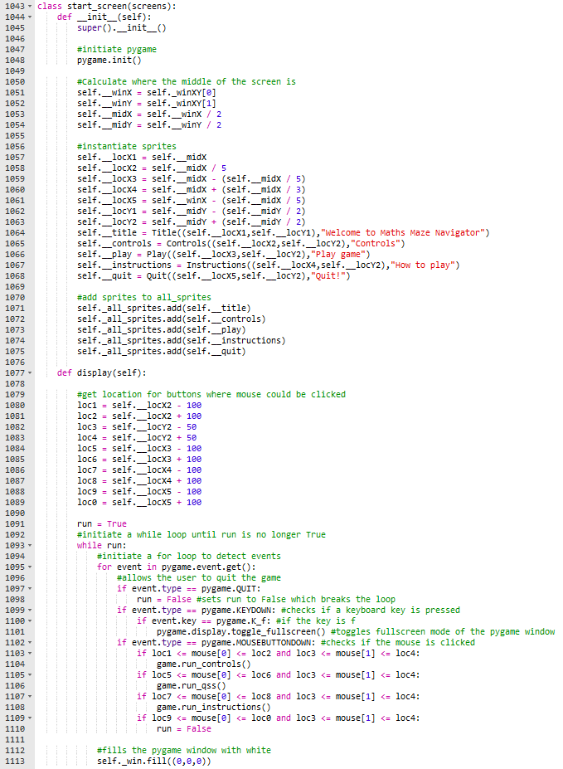

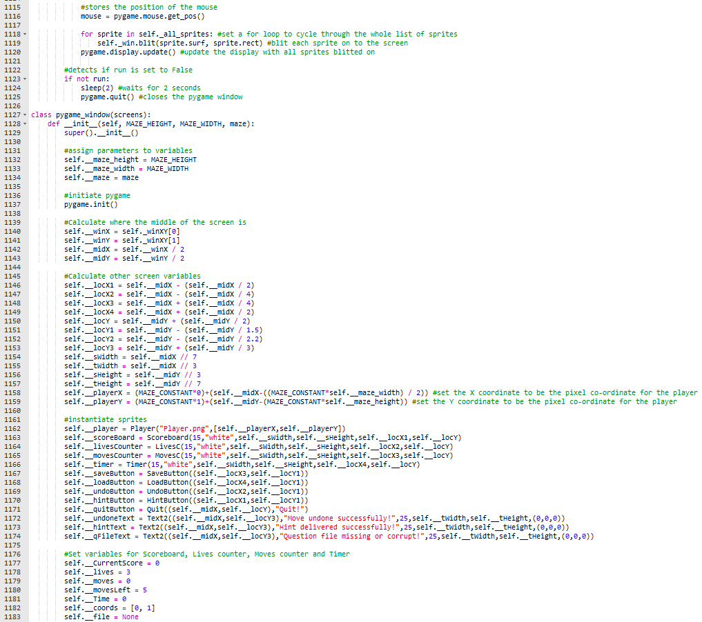

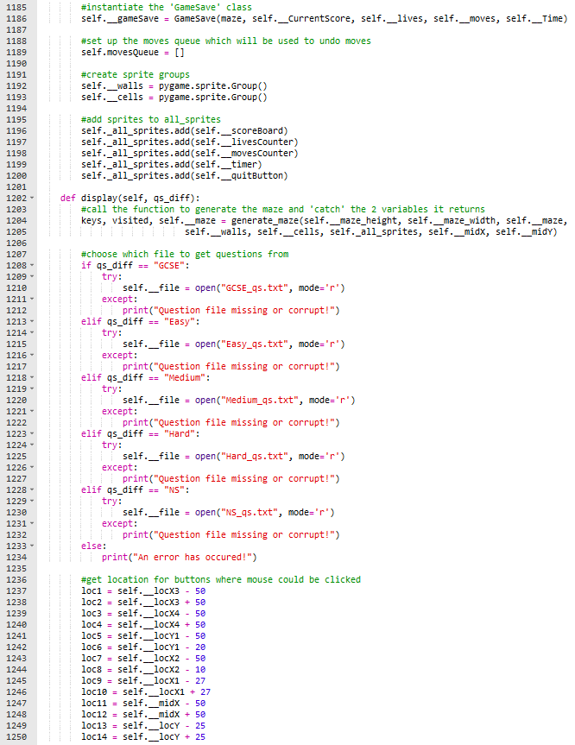

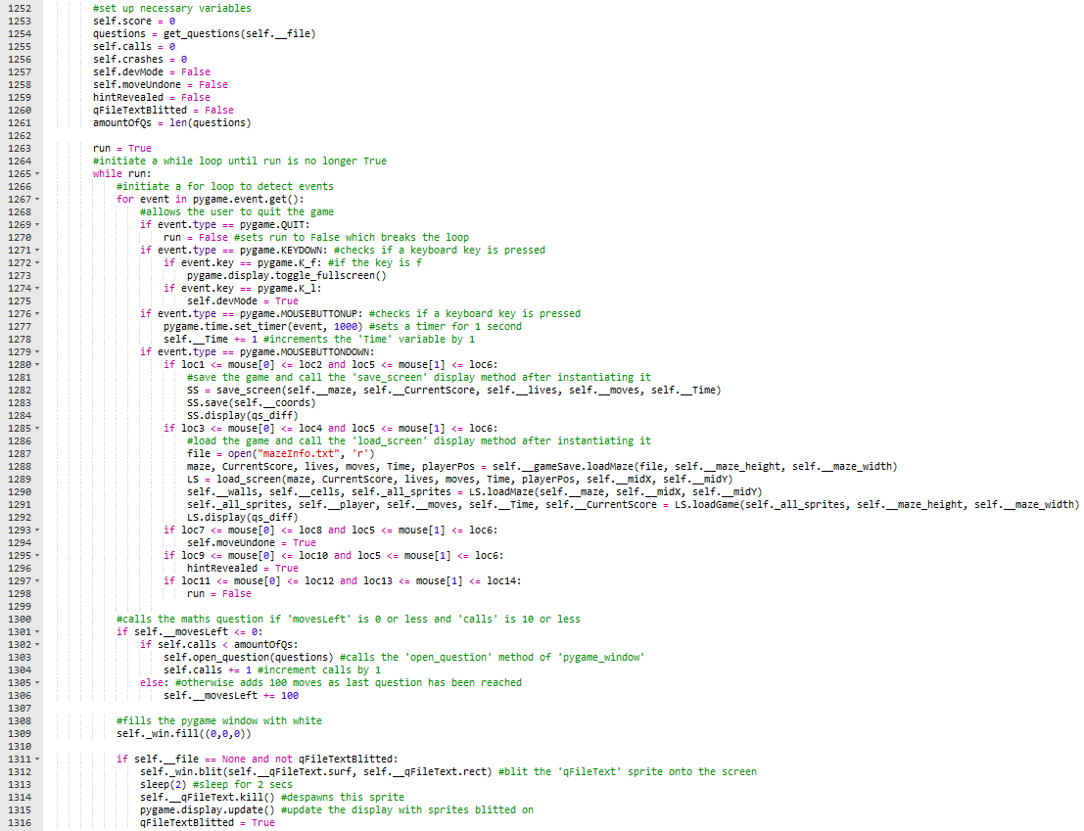

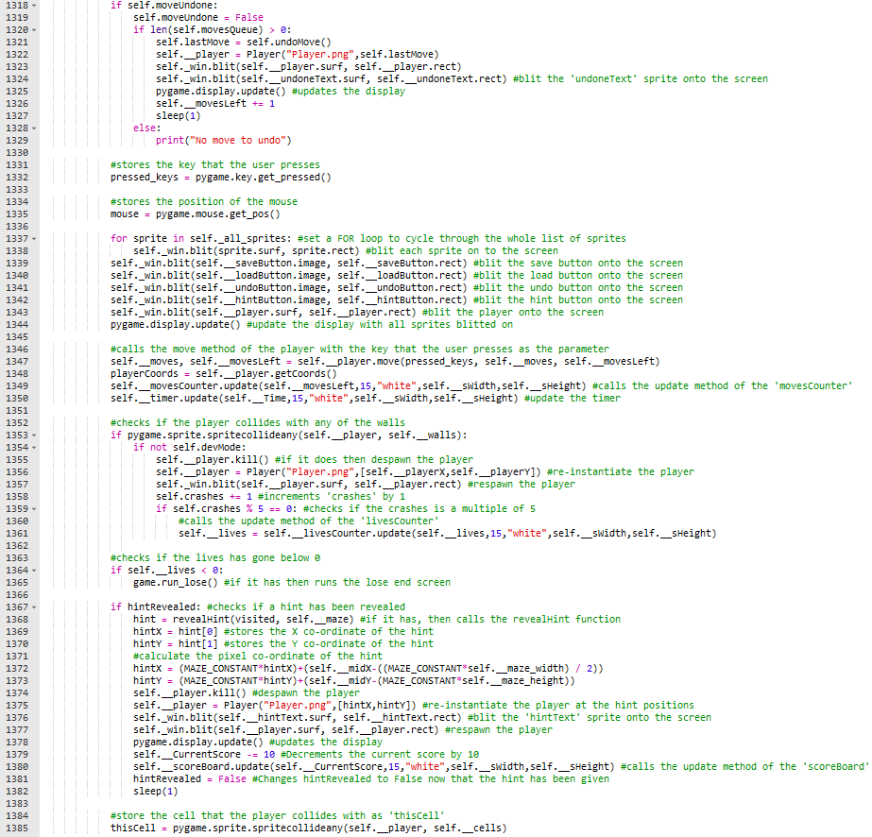

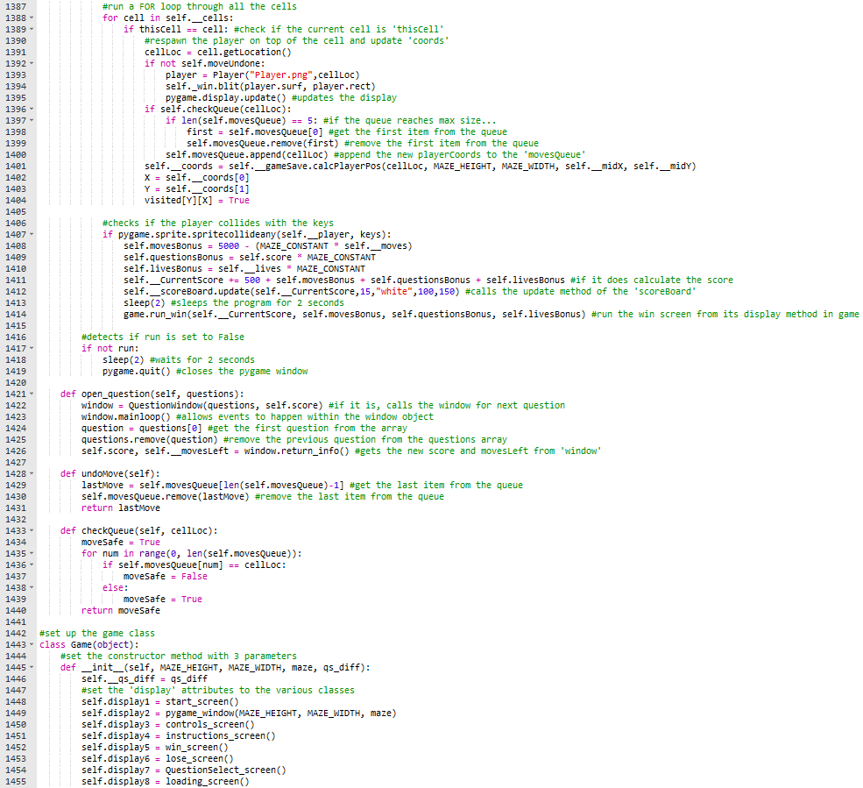

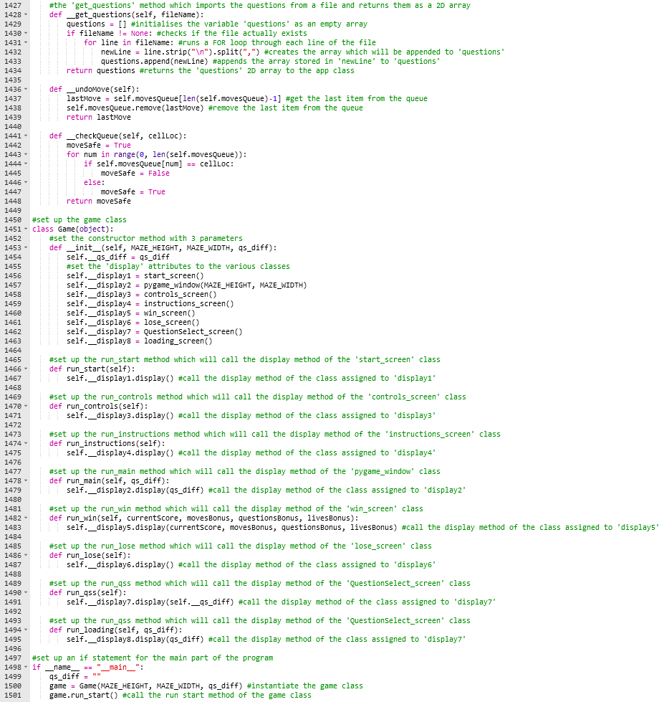

**C12 - STACK CLASS:**

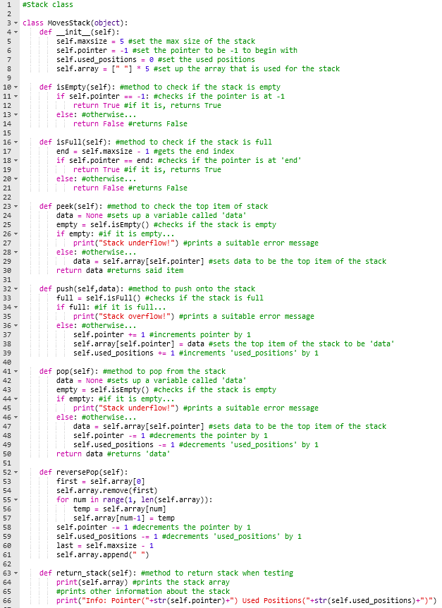

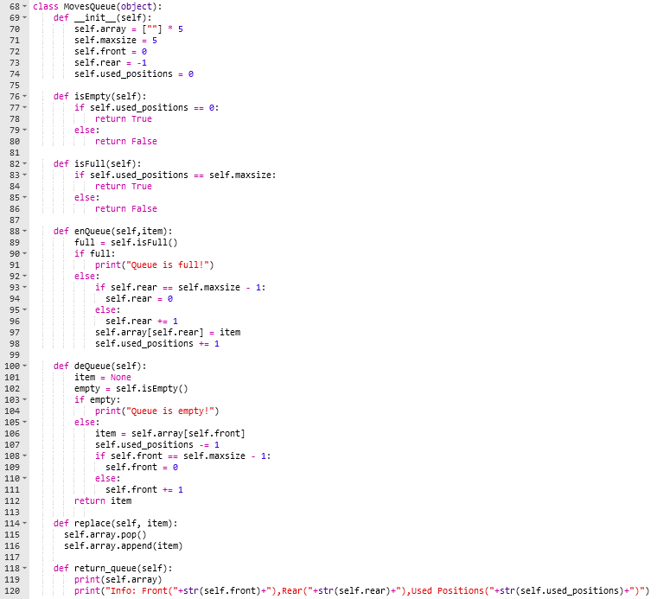

Appendix D (from Testing section [page 222 - 230])

D1 - MODULAR TESTING:

Earlier screenshots were unfortunately not captured. The first screenshot is from Phase 5 of the project.

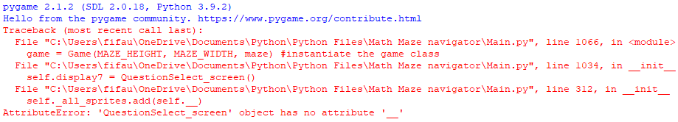

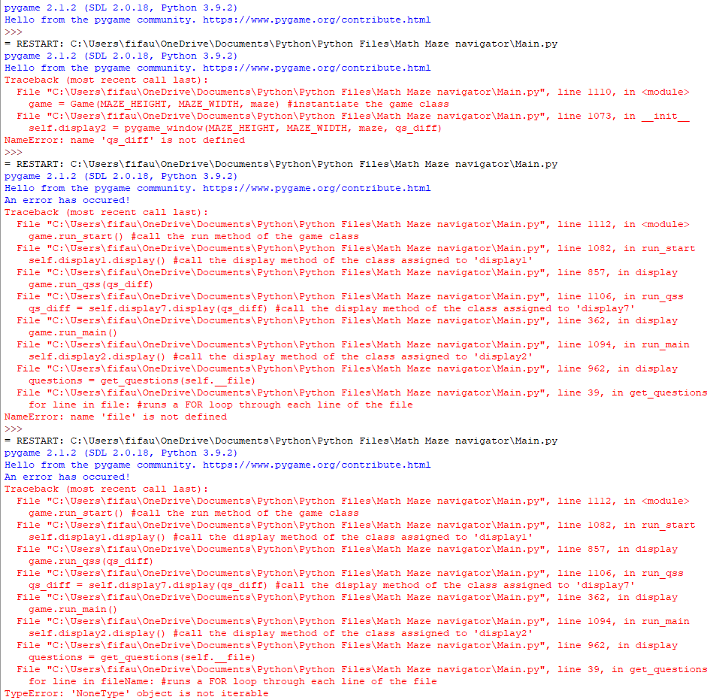

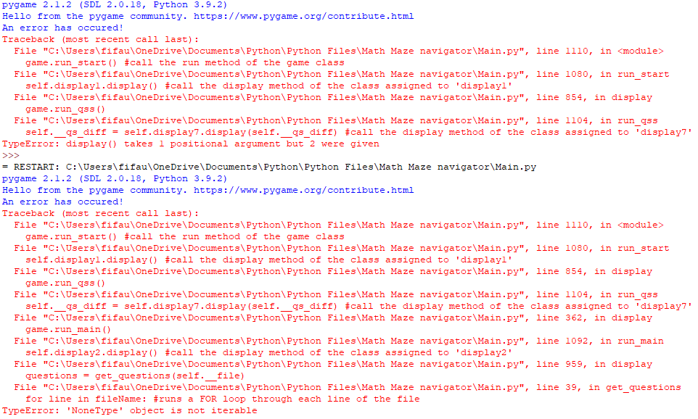

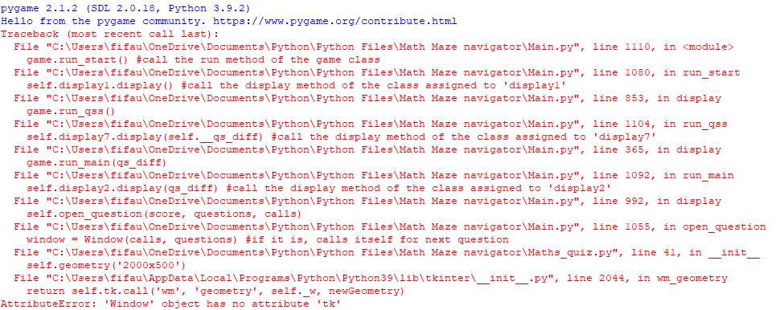

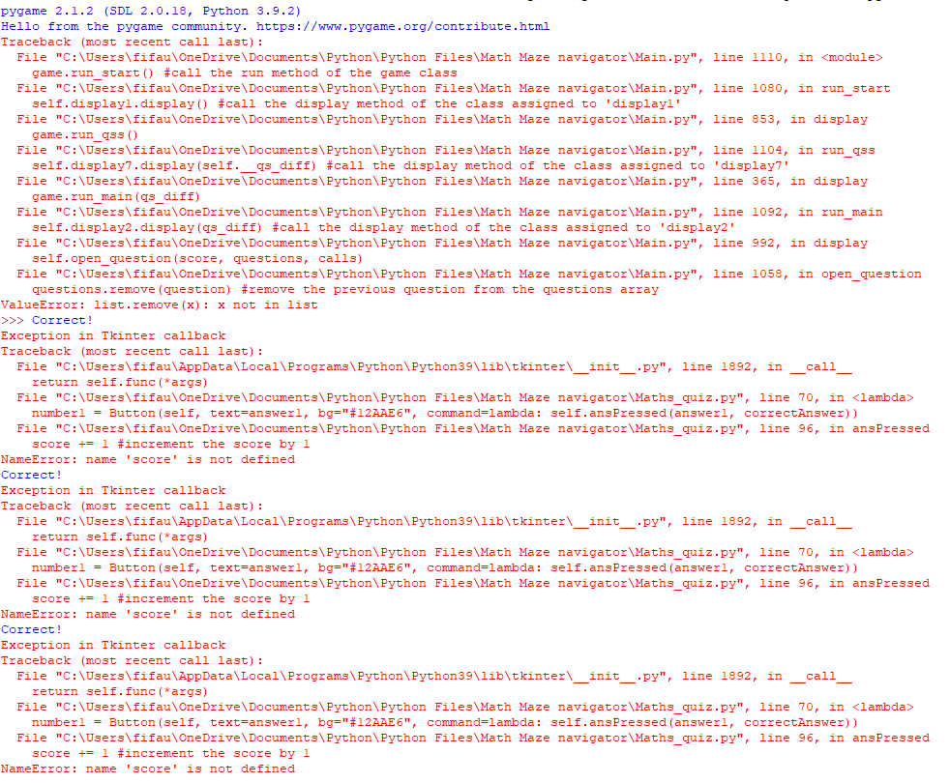

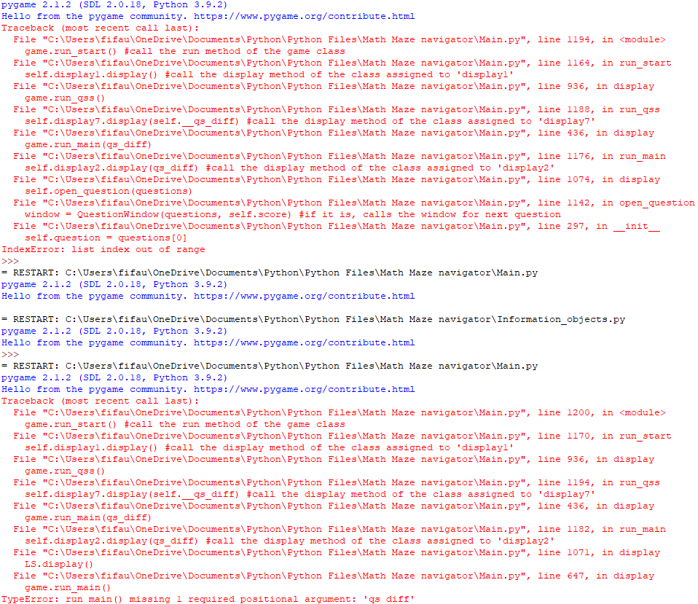

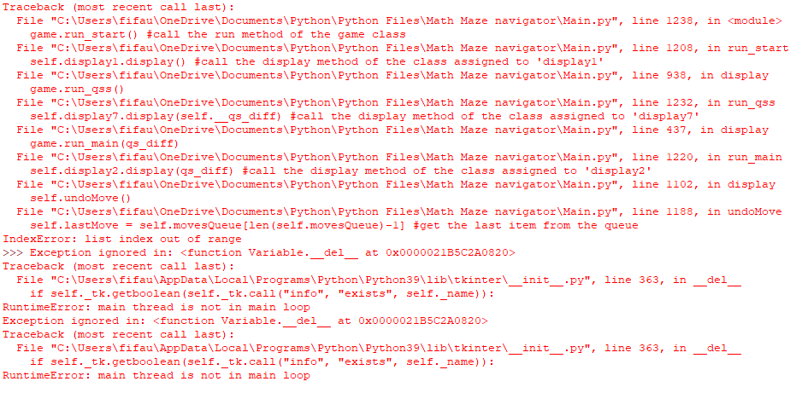

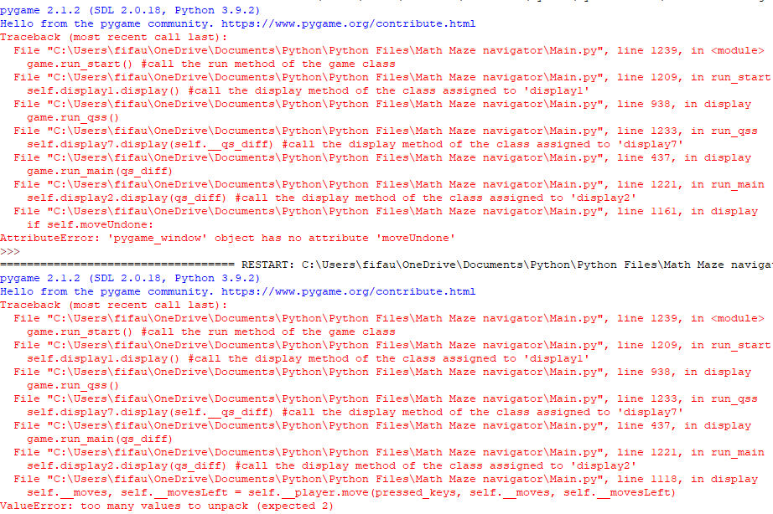

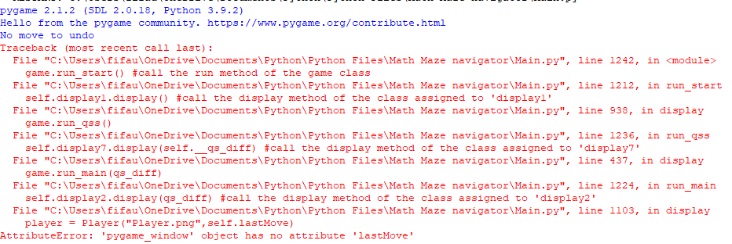

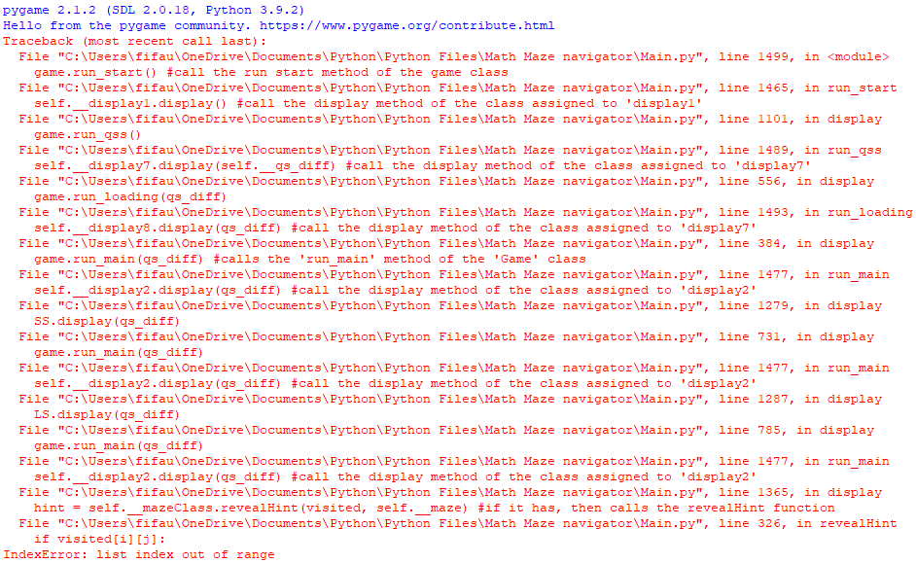

**D2 - Testing for High Scores class:**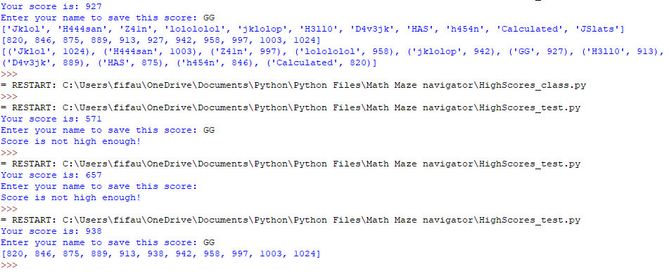

**Before:**

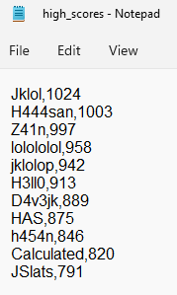

**After:**

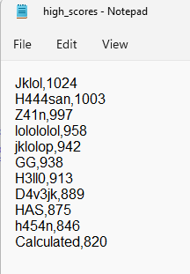

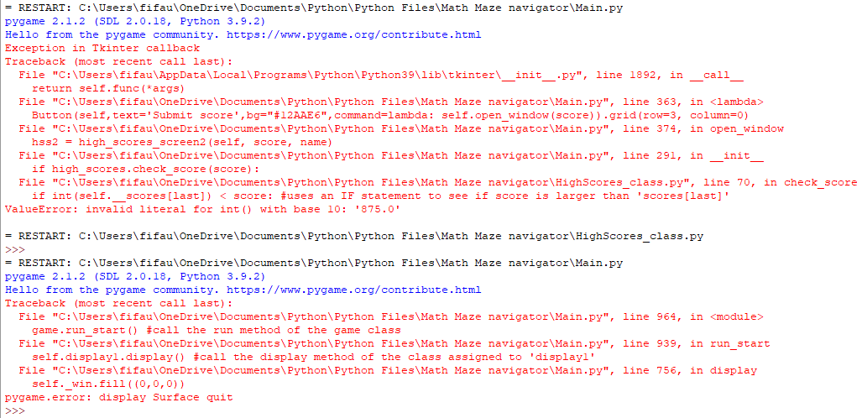

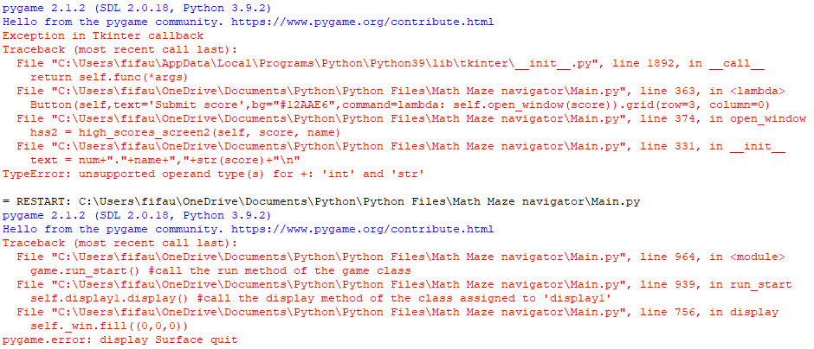

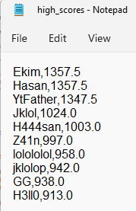

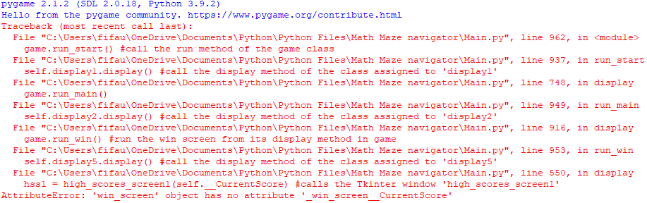

Appendix E (from Evaluation section [page 231 - 241])

**E1 - Evidence of End-User Discussion (Analysis) [page 13-15]**

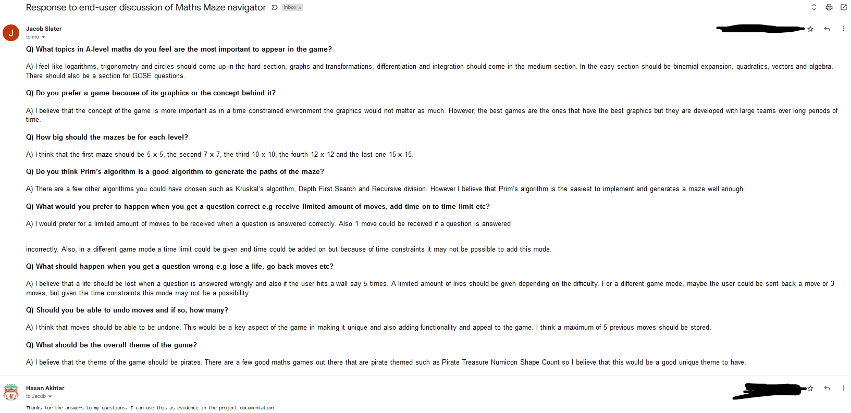

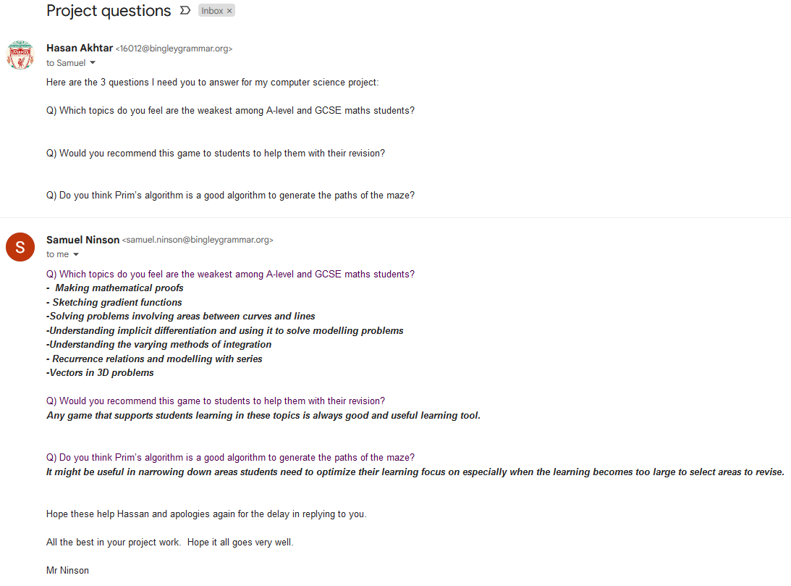

**E2 - Evidence of End-User Feedback [page ]**

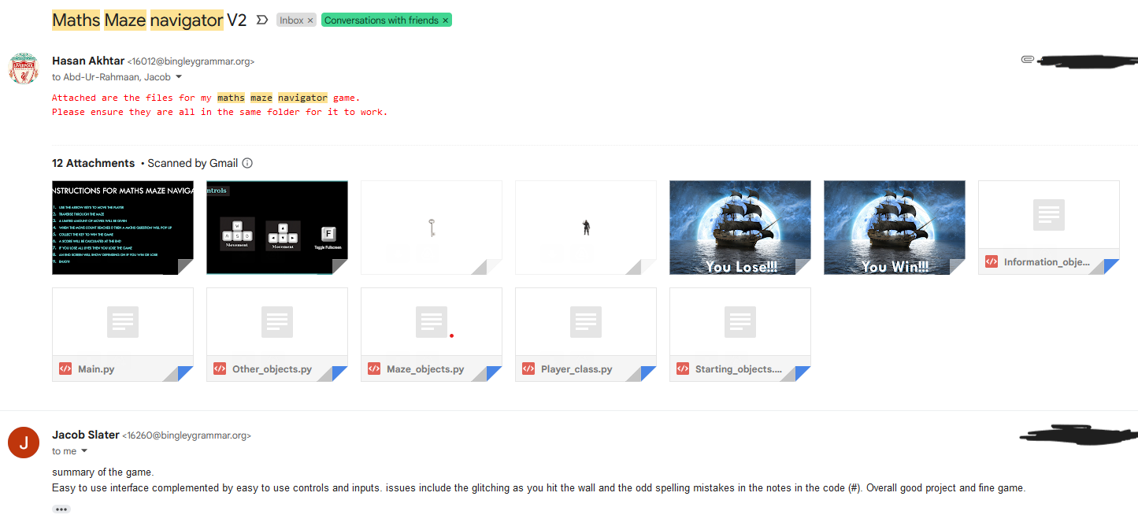

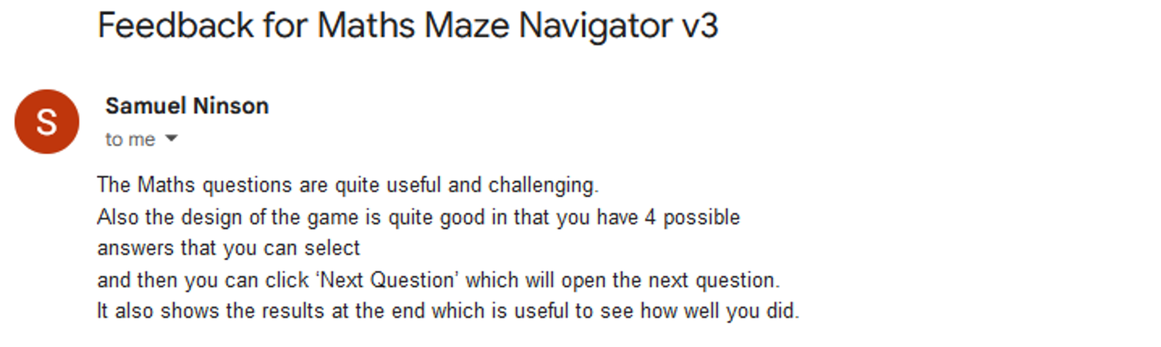

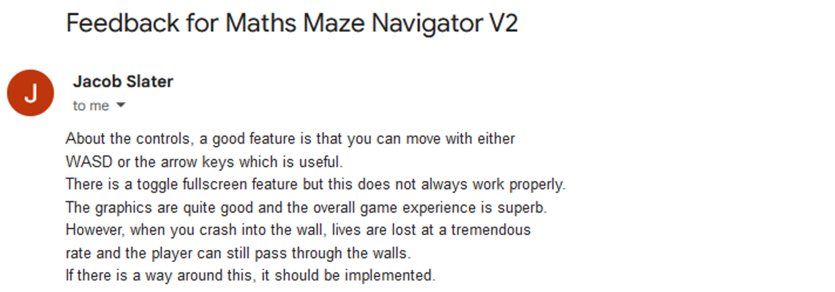

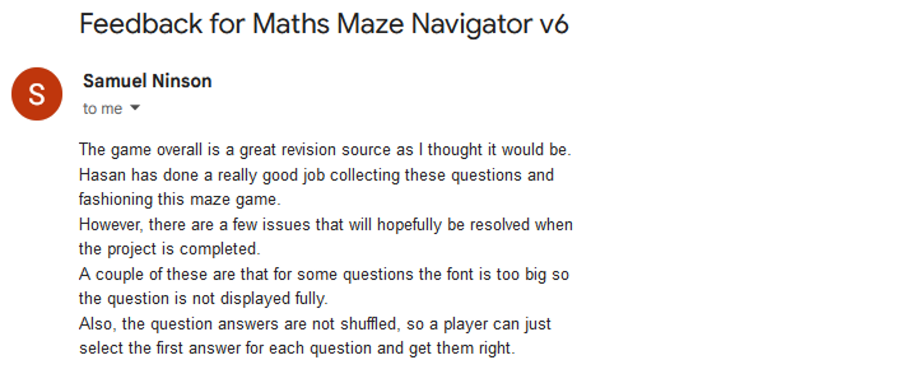

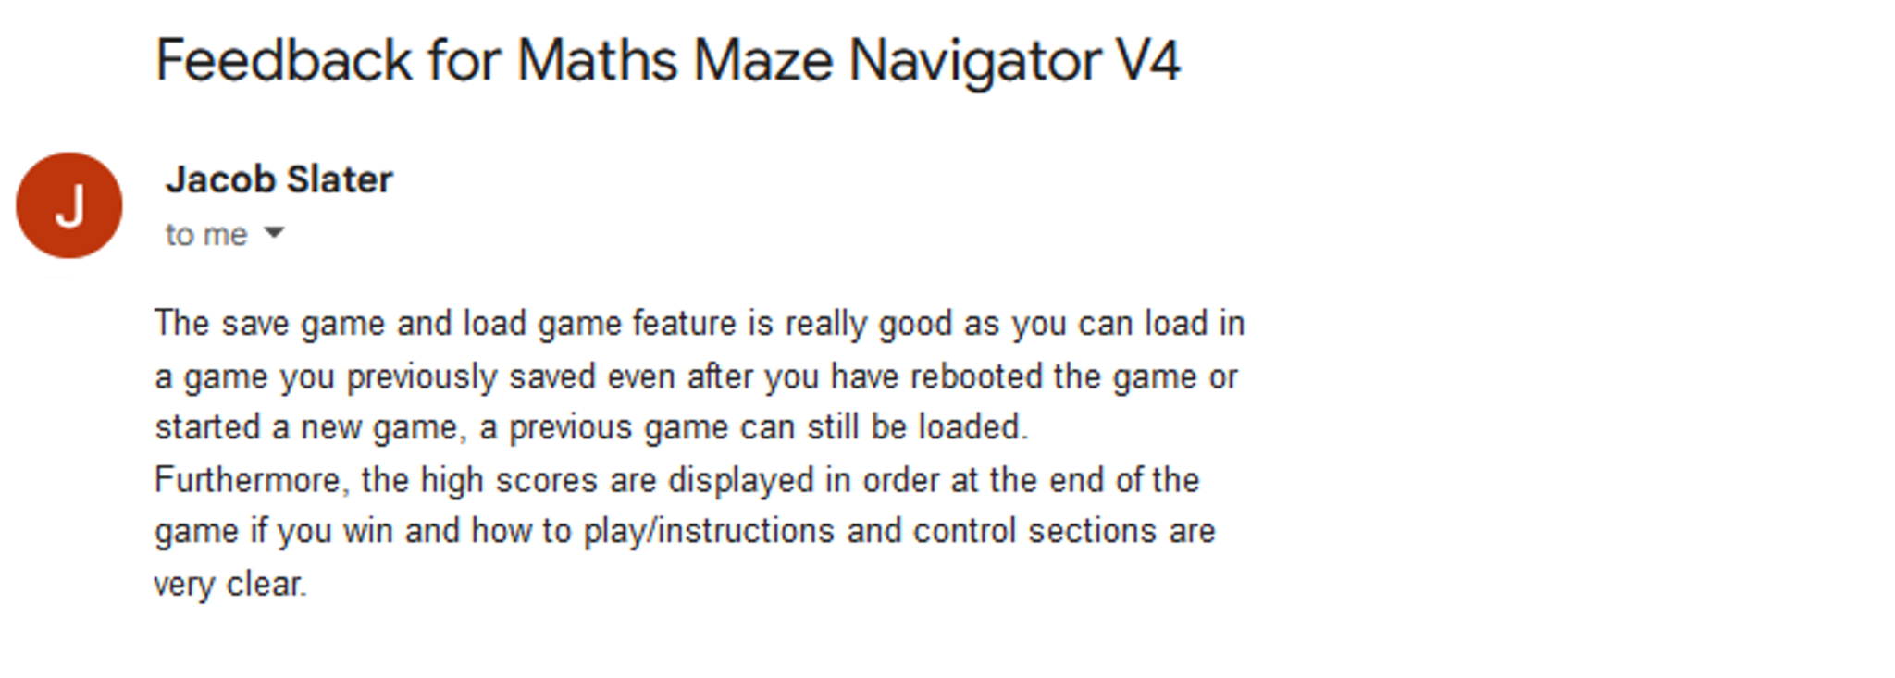



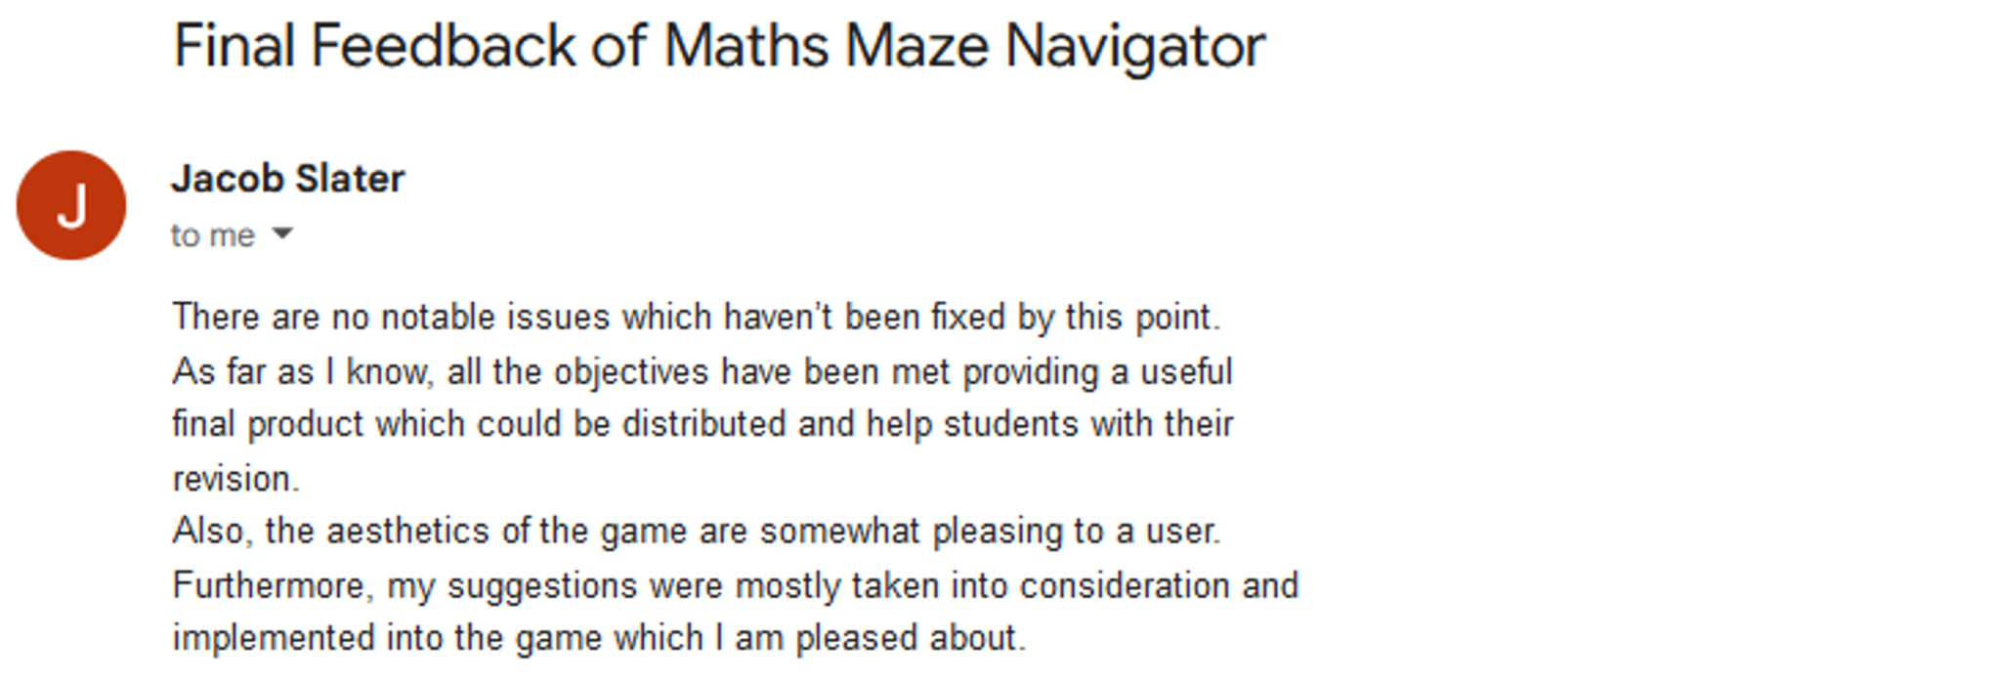

**E3 - Evidence of Supervisor feedback [page ]**

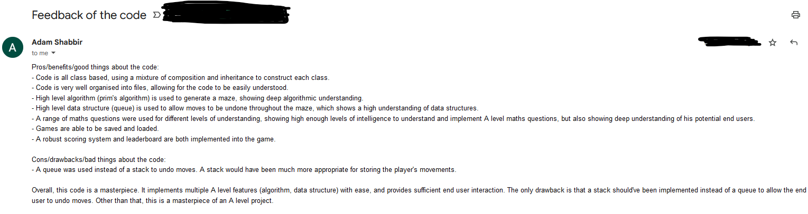

**End of document**